
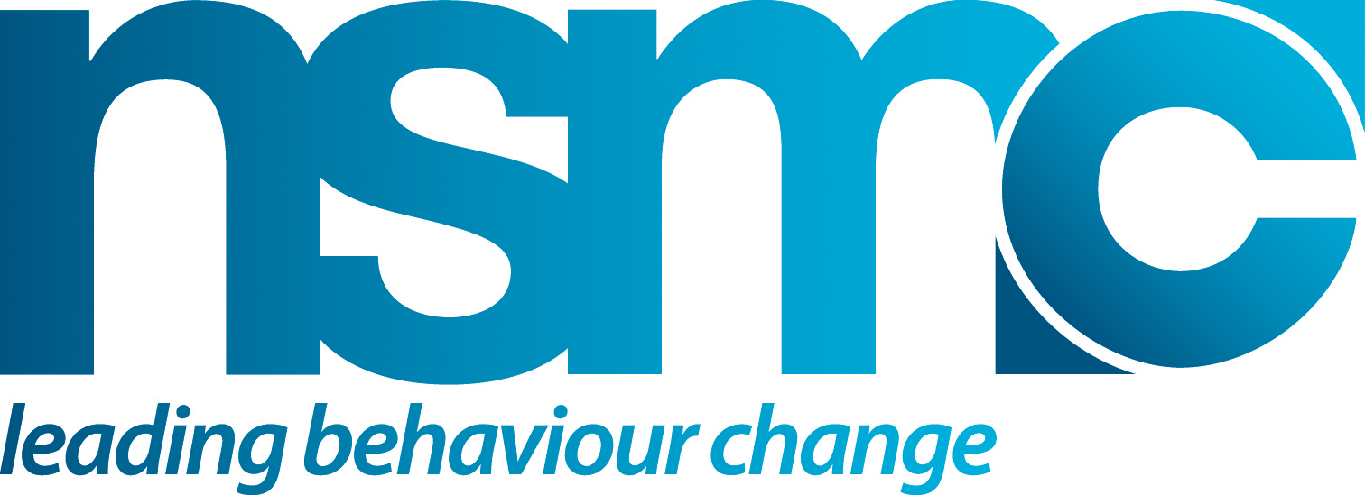

UNDERSTANDING CURRENT BEHAVIOUR

Purpose
This tool can be used to:

- Inform your literature review – to help capture relevant information
- Guide development of research questions
- Assist overall analysis and intervention development and design

How to use or apply
Work through as a checklist noting relevant issues and actions required asking yourself:

- What other questions/issues do we need to understand in relation to problem & positive behaviour?
- What gaps in understanding need to be filled?
- How are these to be addressed, given available resources?
Who has knowledge, understanding or insights into the people and their behaviour?

Source(s)/Reference(s)
- www.thensmc.com

THE BEHAVIOUR | Y/N | Issues/Action
RELATIONSHIP TO DESIRED OUTCOMES
- Is the relationship between the behaviour and the outcomes desired clearly understood and described? (eg how influences Health & well-being outcomes etc)
RELATIONSHIP BETWEEN PROBLEM & POSITIVE BEHAVIOUR
- Do we understand how dynamic or variable the interface between positive & problematic behaviour is? How robust is behaviour on either side? How fluid is the move between problem & positive behaviour?
AUDIENCE BENEFITS
- Are we able to distinguish between the rewards & benefits that are valued by those planning/developing work and those people actually being targeted?

UNDERSTANDING THE PROBLEM BEHAVIOUR | Y/N | Issues/Action
WHAT?
- Can we describe what problematic behaviour involves & its key features?
WHERE?
- Do we understand where problem behaviour occurs & the context influencing this?
WHEN?
- Do we understand when problem behaviour occurs & the context at those times?
BENEFITS & REWARDS:
- Do we know what benefits & rewards people get (or feel they get) from the problem behaviour?
CONSTRAINTS OR LIMITERS?
- Do we have an understanding of what constrains or limits those adopting or sustaining problem behaviour? ie: what blocks or barriers could be put in place or enhanced?
WHAT IS VALUED?
- Do we know for those with the current problem behaviour what they value as benefits and rewards in their lives – that might be helpful in seeking to encourage the desired behaviour?
- Do we know if those with current problematic behaviour would value the same benefits and rewards as those who are currently doing the desired behaviour?
WHY?
- Do we have a good understanding of why people who adopt or sustain the problematic behaviour do so?
ESTABLISHMENT & FORMATION?
- Do we know what influences or triggers the formation and establishment of the problem behaviour in the first place?
REINFORCEMENT & MAINTENANCE?
- Do we know the factors that help reinforce and maintain the problematic behaviour where it exists?
BEHAVIOUR CHANGE
- Do we understand what would encourage, support, or incentivise a change from problem to positive behaviour?
- Do we understand what limits/undermines the potential to change?
CONTROLS?
- Do we have a good understanding of how actual or potential behavioural controls (non-voluntary approaches) might impact on the problem behaviour?
KEY INFLUENCES & INFLUENCERS?
- Do we understand the key influences and influencers on the problem behaviour?

UNDERSTANDING THE POSITIVE BEHAVIOUR | Y/N | Issues/Action
WHAT?
- Can we describe what positive behaviour involves & its key features?
WHERE?
- Do we understand where positive behaviour occurs & the context influencing this?
WHEN?
- Do we understand when positive behaviour occurs & the context at those times?
BENEFITS & REWARDS:
- Do we know what benefits & rewards people get (or could get) from the positive behaviour?
CONSTRAINTS OR LIMITERS?
- Do we have an understanding of what constrains or limits those adopting or sustaining positive behaviour? ie: what blocks or barriers could be removed or limited?
WHAT IS VALUED?
- Do we know for those with the current positive behaviour what they value as benefits and rewards in their lives – that might be helpful in seeking to encourage the desired behaviour?
- Do we know if those with current problematic behaviour would value the same benefits and rewards as those who are currently doing the positive behaviour?
WHY?
- Do we have a good understanding of why people who adopt or sustain the positive behaviour do so?
ESTABLISHMENT & FORMATION?
- Do we know what influences or triggers the formation and establishment of the positive behaviour in the first place?
REINFORCEMENT & MAINTENANCE?
- Do we know the factors that help reinforce and maintain the positive behaviour where it exists?
BEHAVIOUR CHANGE
- Do we understand for those who have recently changed, what might lead to a return to previous problematic behaviour?
CONTROLS?
- Do we have a good understanding of how actual or potential behavioural controls (non-voluntary approaches) might impact on the positive behaviour?
KEY INFLUENCES & INFLUENCERS?
- Do we understand the key influences and influencers on the positive behaviour?

