SCOPING REPORT: STOCKPORT PCT
Tobacco

National Social Marketing Centre



By

Fiona Spotswood

Contents
1 | Introduction
2 | Background
2.1 | Background to Brinnington and Central Ward
2.1.1 | Key facts
2.1.2 | Summary: Picture of Brinnington
2.2 | Health in Brinnington
3 | Smoking: The bigger picture
3.1 | Summary
3.2 | National smoking rates
3.3 | Forecasting: trends
3.4 | Socio-economic groups and smoking
3.5 | Stockport smoking prevalence
3.5.1 | Stockport smoker profile
4 | The problem: Smoking prevalence in Brinnington
4.1 | Summary
4.2 | Brinnington smoking prevalence
4.3 | Implications
5 | Intervention review
5.1 | Prescribed pharmaceuticals
5.1.1 | Nicotine replacement
5.1.2 | Results
5.1.3 | Bupropion
5.1.4 | Results
5.2 | Non NHS Treatments
5.2.1 | NICE review
5.2.2 | Results
5.2.3 | Review of story-based interventions
5.2.4 | Results
5.2.5 | Buddy systems
5.3 | NHS Support Services
5.3.1 | Results
5.4 | Brief interventions
5.4.1 | Results
5.5 | Policy interventions
5.5.1 | Smokefree workplaces
5.5.2 | Results
5.5.3 | National smoking ban
5.5.4 | Results
5.6 | Social marketing interventions
5.6.1 | ISM Review
5.6.2 | Results
5.6.3 | Nice review of mass-media interventions
5.6.4 | Results
5.6.5 | Current government stop smoking campaigns
5.6.6 | Results
5.6.7 | Conclusion: What works best?
6 | Summary of Stockport smoking cessation services available
6.1 | Smoking cessation services available throughout Stockport
6.2 | The Stockport smoking cessation service model
6.2.1 | Specialist Services (known as level 3)
6.2.2 | Intermediate, or LES (Local Enhanced Scheme) (known as level 2)
6.2.3 | Brief interventions
7 | Brinnington cessation services
7.1 | General healthcare
7.2 | Cessation services
7.2.1 | GP service
7.2.2 | Quit for Life
7.2.3 | Break the habit
7.2.4 | Out of area cessation services
7.2.5 | Pharmacy services
8 | Evaluation of the success of SSSS
8.1 | Stockport cessation targets
8.2 | Stockport-wide cessation results
8.3 | Stockport Stop Smoking Equity Profile
8.4 | 2005-6 Cessation Service results
8.5 | Brief interventions
8.6 | Conclusion
8.7 | The SSSS Business Plan (2006-7)
9 | Brinnington cessation service analysis
9.1 | Quit attempts
9.2 | Successful quits
9.3 | GP service
9.3.1 | One-to-one service
9.3.2 | Quit for Life
9.3.3 | Suggested issues
9.3.4 | Recommendations from healthcare workers
9.4 | Break the habit
9.4.1 | Suggested issues
9.4.2 | Recommendations from healthcare workers
9.5 | Brief interventions
9.5.1 | Suggested issues
9.6 | Out of area services
9.6.1 | Suggested issues
9.7 | Conclusion: What worked best?
9.8 | Summary of further research questions
10 | Literature review
10.1 | Question 1: Why is smoking so prevalent in Brinnington?
10.1.1 | Brinnington is a deprived ward and the link between deprivation and smoking is well known and documented
10.1.2 | Implications
10.1.3 | Recommendations
10.1.4 | There is a high level of mental illness in Brinnington
10.1.5 | The link between smoking and mental illness is well known (ASH, 2004)
10.1.6 | Stress
10.1.7 | Depression
10.1.8 | Schizophrenia
10.1.9 | Recommendations
10.2 | Question 2: Why is the attendance of cessation services (quit attempts) by Brinnington residents lower than other areas?
10.2.1 | Mistrust in GPs a potential problem
10.2.2 | The lack of pharmacy service in Brinnington has an affect on quit attempts
10.2.3 | Recommendations
10.2.4 | Psychological factors associated with socio-economic status and health
10.2.4a | Chance health locus of control
10.2.4b | Seldom thinking about the future
10.2.4c | Seldom thinking about things that can be done to keep healthy
10.2.4d | Attitude towards smoking
10.2.4e | Motivation to quit
10.2.4f | Perceived self-efficacy to quit
10.2.4g | Beliefs in health benefits
10.2.4h | Perceived barriers to a healthy lifestyle
10.2.5 | Recommendations
10.2.6 | The link between mental illness and quit attempt levels
10.2.7 | Recommendations
10.3 | Question 3: Why are the quit success rates in Brinnington so low?
10.3.1 | Psychological barriers to cessation success
10.3.2 | Socio-cultural barriers to cessation success
10.4 | Question 4: What would be the best intervention mix for Brinnington residents
10.4.1 | GP interventions: advice and NRT
10.4.2 | Pharmacies
10.4.3 | Specialist services
10.4.4 | Policies
10.4.5 | Brief interventions
10.4.6 | Mobile cessation services
10.4.7 | Recommendations
10.5 | Summary of recommendations
10.5.1 – 10.5.9 | Primary research recommendations
11 | Final conclusions
11.1 | Living conditions
11.2 | Consumer-centric delivery
1 Introduction
The purpose of this rapid scoping report is to draw together key data on the problem behaviour of smoking within the defined target audience of adult smokers in Brinnington and Central ward within Stockport Borough. The scoping report will aim to make recommendations for further primary research which will form a foundation for the possible development and testing of a social marketing intervention strategy to tackle the problem behaviour. According to the Local Area Agreement Report, “Working Together for a Better Stockport” (progress from April – September 2006), social marketing is to form part of an overall drive to increase cessation rates in Stockport.

Health inequalities across the UK are still on the increase. Reports show that there is considerable energy and commitment within the network of Stockport’s key stakeholders to target Brinnington’s specific health problems and make real efforts to buck the national trend in this ward. The Social and Health Scrutiny Committee comment in their April 2006 report that “timely local data” is required to “help develop our understanding of how current services impact on individual’s health” and Stockport PCT are to be commended for their forward-thinking through their partnership with the National Social Marketing Centre.

Data for this report has been drawn from local information sources provided by Stockport PCT contacts, from national epidemiological and academic sources and first hand from local people involved with current interventions. No attempt has been made to paraphrase respected sources. This report is an internal document and not for publication at this stage.

2 Background
2.1 Background to Brinnington and Central ward
Brinnington and Central (Brinnington) forms one electoral ward of Stockport Borough. Although Stockport is considered to have an average level of deprivation (according to the 2000 Index of Multiple Deprivation), Brinnington is considered to be significantly deprived. Brinnington ranked in the top 2% most deprived areas for England and Wales in the Index of Multiple Deprivation (based on the 2001 Census).

Brinnington lies adjacent to Stockport Town Centre and the industrial, commercial areas of Portwood and Bredbury. To the south the area straddles the M60 motorway. The houses of Brinnington are mostly council-owned. The main estate area was built in the 1950’s and is made up of a mix of tower blocks, low rise flats, maisonettes and terrace houses. There is accommodation for homeless families in the area (the Council’s Homeless Families’ Hostel), and consequently a small but significant transient population. Some mention of asylum seekers and refugees is made in the literature but the percentage of non-white residents is low. In the centre of the estate are the “Top Shops” – a parade of about 20 shops and a number of community facilities including a library, housing office and information point.

2.1.1 Key facts
- Brinnington Neighbourhood Renewal Area has a total population (in 2003) of 7,813.
- The percentage of residents aged under 16 to 29 is 44.2% compared to the Stockport average of 35.4%.
- The percentage of residents aged over 60 is 17.5% compared the Stockport average of 21.7%.
- Residents in Brinnington are more likely to be single and unmarried than the Stockport and national average.
- 38.2% of residents are single (never married) compared to the Stockport average of 28.2%.
- 36.9% of residents are married compared to the Stockport average of 52.9% (not including people separated but still legally married).
- Residents in Brinnington are predominantly white (97.4%). From a population of 7,813 approximately 200 people are non-white.
- People in Brinnington consider themselves to have worse health than the Stockport and national average:
- 61% of people in Brinnington consider themselves to be of good health compared to the nation average of 68.8% and the Stockport average of 69.2%.
- 14% of residents consider themselves to be of “not good health” compared to the national average of 9.1% and the Stockport average of 9.0%
- More people in Brinnington consider themselves to be of “fairly good health” (25%) than the Stockport (21.7%) and national (22.2%) averages.
- Brinnington has higher levels of people who stated they have a limiting long-term illness than the Stockport and national average; 23.7% (1,860 people from a population of 7,813).

- The amount of people who state they provide unpaid care (9%) is in line with the Stockport (10.6%) and national (9.9%) averages.
- Brinnington has nearly twice the level of unemployment compared to the national average and over twice compared to the Stockport average.
- 6.2% of people in Brinnington are unemployed, compared to 2.5% within Stockport and 3.3% nationally.
- Brinnington has less residents (aged 16-74) in full-time education than the Stockport and national average.
- 4% of people in Brinnington aged 16-74 are in full-time education, compared to 5.5% in Stockport and 7% nationally.

- People in Brinnington are less likely to have formal qualifications than people across Stockport.
- 45.9% of residents have no qualifications compared to 25.7% in
- Stockport.
- 6.7% of people are qualified to Level 4/5 (i.e. First degree, NVQ levels 4 and 5) compared to 22.1% in Stockport and 19.9% nationally.
- School children in Brinnington receive slightly lower average results at Key
- Stage One (5-7) to the Stockport average, but this becomes more marked at Key Stages Three (11-14) and Four (14-16, GCSEs) (Stockport Council Education Services 2003).
- The average scores for reading, writing and maths at Key Stage One in Brinnington are 16, 15 and 16 compared to 17, 16, and 17 for Stockport.
- At Key Stage Three the average scores are 30, 29 and 30 compared to the Stockport average of 34, 34, and 36.
- At Key Stage Four 20% of students achieved 5 GCSEs graded A* to C compared to 51.3% across Stockport.

- More people live in one person households in Brinnington than across Stockport or England.
- Brinnington has higher numbers of households containing dependent children and no adults in employment than the Stockport average, and also has higher numbers of lone parent households.
- 11.9% of households compare dependent children and no adults in employment compared to the Stockport average of 3.8% and the national average of 4.8%.
- 37.8% one parent households compared to the Stockport average of 30.3%.
- Brinnington has a much higher amount of residents renting from the local authority (50.6%), and much lower ownership either outright, or by mortgage or loan than the Stockport and national average.

- Residents in Brinnington are less likely to own a car or van than people
- across Stockport and England.
- 51.3% of people in Brinnington have no car or van, compared to
- 23.6% in Stockport and 26.8% in England.
- 38.2% do have one car or van.
In addition, when asked the question 'How safe do you feel in Brinnington at night'? 32.3% of residents responded as feeling either very or fairly unsafe (Resident Survey 2003). 48.9% of residents consider the general appearance of the estate not to be good. However, 53.5% of people use the park and 22.5% use it regularly (Residents Survey 2003). The nationally acclaimed "Green Flag" has been awarded to the park. Still, the Top Shops have not yet been redeveloped and no regeneration funding was set aside for the activity.

2.1.2 Summary: Picture of Brinnington

 | Brinnington | Stockport | Comparison
Standard Mortality Rate  (2001 data) | 143 | 97  England average =100 | 1.47 times more
Education - GCSE attainment  (% of pupils gaining 5 A to C GCSEs -2002) | 21 | 52 | Less than half
% of population with no  Qualifications | 41.5 | 25.7 | 1.6 times more
% of 16 – 74 population  economically inactive but not retired | 28.3 | 16.1 | 1.75 times more
% young people registered unemployed for 6 months or more | 4.9 | 2.9 | 1.6 times more
Unemployment rate (%) | 6.4 | 1.7 | 3.8 times more
Number of adults claiming Council Tax Benefit and/or Housing Benefit with Income Support | 1469 (18.4%) | 13,040 (5.6%) | 3.28 more times
Reported domestic burglary rate per 1000 households | 34.4 | 28.8 | 1.2 more times
The December 2002 average house price (source: Land Registry) | £38,495 | £116,963 | Difference of £78, 458 (3 times less)

2.2 Health in Brinnington
The life expectancy for male and female inhabitants in Brinnington & Central ward is 68.8 and 74.8 years respectively. This is considerably lower than the Stockport average of 76.3 years for males and 81.3 years for females and considerably lower than the averages for the affluent Bramhall South ward of 79.0 and 83.9 years respectively. This represents almost a 10 year difference in average life expectancy between Brinnington and Bramhall South.

In line with this picture of health deprivation in Brinnington are the premature death data, which show that the average for the ward is above the regional and national averages. In line with the link between deprivation and ill health are the Brinnington mortality rates from cancer and CHD, both of which are higher for this ward than for the regional and national averages.

Circulatory System Disease (CSD) was the biggest single cause of death in Stockport between 2001 and 2003. 88 people died because of CSD in the Brinnington renewal area, 33.1% of all CSD deaths in Brinnington & Central. Comparisons with Bramhall South show that despite the younger age profile, the number of CSD deaths in Brinnington & Central (266) were higher than Bramhall South (166).

Coronary Heart Disease (CHD) is the biggest single cause of death within this category with 138 deaths in Brinnington & Central (7.3% of total CHD deaths in Stockport). CHD deaths in Bramhall South accounted for a smaller proportion of the Stockport total at 4.9%.

Cancer claimed 67 lives in Brinnington renewal area which accounts for 27.1% of the total deaths in the area. The ward data shows that 147 deaths were due to cancer. Lung, breast and prostate cancer accounted for 34.7%, 3.4% and 4.1% of the ward cancer deaths respectively. The Bramhall South figure and the Stockport proportions of cancer deaths were higher at 24.7% and 26.1% respectively, however the SMR values were higher in Brinnington (147.0) compared to Bramhall South (71.3) and the Stockport average (99.0). Also of particular note is the infant mortality rate, which at 10.3 is over twice the local average for Brinnington.

The table below shows diseases which were the cause of death for people in Brinnington, Bramhall South (the most affluent Stockport ward) and Stockport for comparison. It shows that for all causes except breast and prostate cancer, death rates are higher in Brinnington than the national average and in some cases over twice the national average, e.g. respiratory disease and lung cancer. As known results of smoking, these statistics are of particular concern. For some causes rates are three times higher in Brinnington than Bramhall and more than double the Stockport average.

 | Bramhall South |  | Brinnington &  Central |  | STOCKPORT
 | SMR | Deaths | SMR | Deaths | SMR | Deaths
Circulatory System  Disease | 87.7 | 166 | 170.9 | 266 | 104.2 | 3728
Coronary Heart  Disease | 99.5 | 93 | 180.9 | 138 | 107.1 | 1889
Cerebrovascular  Disease | 87.6 37 | 37 | 171.6 | 60 | 105.4 | 843
Respiratory disease | 64.1 | 41 | 209.2 | 110 | 99.2 | 1197
Malignant Neoplasm's | 71.3 | 88 | 147 | 147 | 99.0 | 2320
Lung Cancer | 75.8 | 20 | 243.2 | 51 | 102.6 | 508
Breast Cancer | 78.4 | 8 | 60.2 | 5 | 99.9 | 197
Prostate Cancer | 158.6 | 13 | 94.8 | 6 | 86.1 | 130
Digestive diseases | 84.3 | 18 | 204.3 | 37 | 98.7 | 408
Injuries and  Poisonings | 99.6 | 9 | 154.7 | 14 | 97.9 | 186
All causes | 74.2 | 356 | 164.6 | 659 | 97.3 | 8907

The Health Inequalities report also found a higher comparative number of deaths in people under 50 in Brinnington ward and a steeper rise in the curve for the 70s age group. Smoking remains the biggest cause of premature deaths.

GPS consulted for the Health Inequalities report commented that statistically there are higher numbers of people with mental health problems living in Brinnington than other areas of the borough.

Rates of mental illness in Brinnington compared with other Stockport wards
 |  | Brinnington Practices | Stockport Practices
People on the disease register for | Depression | 594 | 23,345
People on the disease register for | Mental Health | 111 | 3,929
People on the disease register for | Dementia | 116 | 1,442
Population |  | 8,566 | 294,752 (2.9%)
Crude rate | Depression | 69.3 | 79.2
Crude rate | Mental Health | 13.0 | 13.3
Crude rate | Dementia | 13.5 | 4.9

The GPs also raised their concern that despite this fact there was no additional resource and indeed the counselling service at the Health Centre is under threat.

Perceived health is also lower for Brinnington than other Stockport wards. The regional average percentage of individuals perceiving their health to be ‘not good’ on a three point scale is 12.0%. In Brinnington it is 15.4%, which ranks in the worst 4% of wards nationally.

Brinnington also has a higher rate of teenage conception than other Stockport wards.

3 Smoking: The bigger picture
3.1 Summary
This chapter outlines the national smoking landscape which can then be used to put the local picture in perspective. National smoking rates, trends and forecasts are described and the overall Stockport rates are described.

3.2 National smoking rates

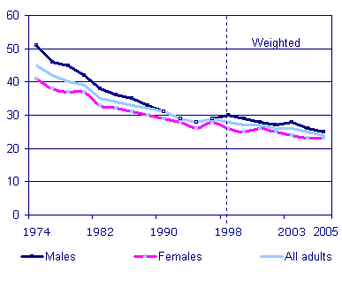
Percentage of adults who smoke cigarettes by sex: Great Britain 1974 to 2005
As the graph above shows, in 2005, 24% of adults aged 16 or over in Great Britain smoked cigarettes, indicating a slight fall in the prevalence of smoking among both men and women since the late 1990s.
The proportion of adults who smoked cigarettes fell substantially in the 1970s and the early 1980s – from 45% in 1974 to 35% in 1982. After 1982 it declined gradually until the early 1990s, levelling out during the 1990s. It then fell smoothly from 28% in 1998/99 to 24% in 2005.

In July 2004 the Government set a new target to reduce the overall proportion of cigarette smokers in England from 28% in 1996 to 21% or fewer by 2010 – with a reduction from 32 to 26% or less among manual occupation groups. In England in 2005, 29% of those in manual occupational groups were cigarette smokers, compared with 33% in 1998. Together with the fall in overall prevalence, this indicates some progress towards targets.
While men are still more likely than women to smoke cigarettes, the gap has narrowed. In 1974, 51 % of men and 41% of women smoked. In 2005, 25 % of men and 23 % of women were cigarette smokers.
Cigarette smoking continues to be more common among adults aged 20 to 34 than among other age groups. In 2005, 32% of adults aged 20 to 24 and 31% of adults aged 25 to 34 were smokers compared with 14% of those aged 60 and over.
The proportion of men who were heavy smokers (on average 20 or more cigarettes a day) fell from 14% in 1990 to 10% in 1998. Among women, the proportion fell from 9% to 7% over the same period. Since then the proportions have remained virtually unchanged, although there is a suggestion of a slight downturn in the last couple of years. The proportion of adults smoking fewer than 20 cigarettes a day has been around 17 to 19% of both men and women since 1998.

In 2005 just over two thirds (68%) of cigarette smokers in Great Britain said that they wanted to give up, but 56% said it would be difficult to go without smoking for a whole day. Overall, 16% of smokers said they had their first cigarette of the day within five minutes of waking up: this varied according to how much respondents smoked, ranging from only 2% of those who smoked fewer than 10 a day to 33% of those who smoked 20 or more cigarettes a day.

3.3 Forecasting: trends
A summary of changes over time:

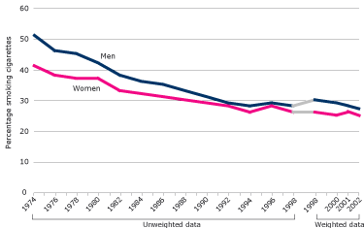
Prevalence of cigarette smoking by sex: Great Britain, 1974 to 2002
The prevalence of cigarette smoking decreased substantially in the 1970s and early 1980s, from 45% of all men and women aged 16 and over in 1974 to 35% in 1982.
Since then the proportion smoking decreased more gradually until the early 1990s, since when it has levelled out at around 26% to 28%. In 2002 26% of people aged 16 and over were cigarette smokers.

In 1974 51% of men smoked cigarettes compared with 41% of women. The difference between the proportions of men and women smoking has gradually reduced, although it has not disappeared completely. For example, 38% of men and 33% of women were smokers in 1982, compared with 27% of men and 25% of women in 2002.
Although there has consistently been a greater proportion of men smoking than women, this is not the case in every age group. In recent years there has been a significant drop in the proportion of men aged 16 to 19 smoking cigarettes (from 30% in 2000 to 22% in 2002).
Women aged 16 to 19 were significantly more likely to smoke cigarettes than men in this age group, with 29% smoking in 2002.
Since 1974, the greatest percentage decrease in the proportion smoking has been among people aged 60 and over, where the prevalence has more than halved from 34% to 15% in 2002. However, this reflects the fact that people in this age group are more likely to have been regular smokers in the past who have given up.
There has been an increase in the proportion of men and women aged 16 and over who have never smoked a cigarette. Among men, the proportion who have never smoked rose from 25% in 1974 to 46% in 2002. The increase in the proportion of women who have never smoked has been smaller, from 49% in 1974 to 54% in 2002.
The GHS has consistently shown that cigarette smoking is more prevalent among people in manual occupational groups than those in non-manual groups. In the 1970s and 1980s, the proportion of cigarette smokers in non-manual occupations fell more sharply than that for manual occupations.
Since the 1990s, however, proportions in both groups have remained relatively constant. In 2002, 20% of those classified as non-manual workers smoked cigarettes, compared with 31% of those classified in the manual group.
The introduction of the NS-SEC classification means that any comparisons over this period should be treated with caution.
Although the prevalence of cigarette smoking changed little during the 1990s, the GHS has shown a continuing fall in the reported number of cigarettes smoked. The fall in consumption has occurred mainly among younger smokers, while the number of cigarettes smoked by those aged 50 and over has changed very little since the mid-1970s.
Most of the decline in consumption in the 1990s is due to a reduction in the proportion of heavy smokers. The proportion of respondents smoking on average 20 or more cigarettes a day fell from 14% of men in 1990 to 11% in 1998, and from 9% to 7% of women over the same period. It has since remained virtually unchanged among both men and women. The proportion of respondents who were light smokers also changed little throughout the 1990s.

Filter cigarettes continue to be the most widely smoked type of cigarette. However, there was an increase in the 1990s in the proportion of people smoking hand-rolled cigarettes.
Among men the proportion increased from 18% in 1990 to 33% in 2002. Among women it increased from 2% to 13% during the same period. This increase may be partly due to the rising price of packaged cigarettes and the reduction of tar yield in packaged cigarettes (hand-rolled may be made with a higher tar yield).
A decline in the prevalence of pipe and cigar smoking among people aged 16 and over has been evident since the survey began, with most of the decrease occurring in the 1970s and 1980s. The proportion of men smoking pipes fell from 12% in 1974 to 6% in 1986.
In 2002 it was 1%. The proportion of men smoking at least one cigar a month more than halved from 34% in 1974 to 16% in 1978. By 2002 it had reduced to 5%. Only 3% of women smoked cigars in 1974, and since 1978 the proportion of women who smoke cigars has scarcely been measurable by the GHS.

3.4 Socio-economic groups and smoking
In England in 2001, 33% of men living in households in the manual group smoked cigarettes compared with 22% of those in non-manual households. The corresponding proportions for women were 30% and 20%.
The graph below shows the prevalence of cigarette smoking in 2001 in relation to SEC. There are striking differences between the various classes. Prevalence was lowest among those in higher professional and higher managerial households (15% and 16% respectively) and highest, at 35%, among those whose household reference person was in a routine occupation.
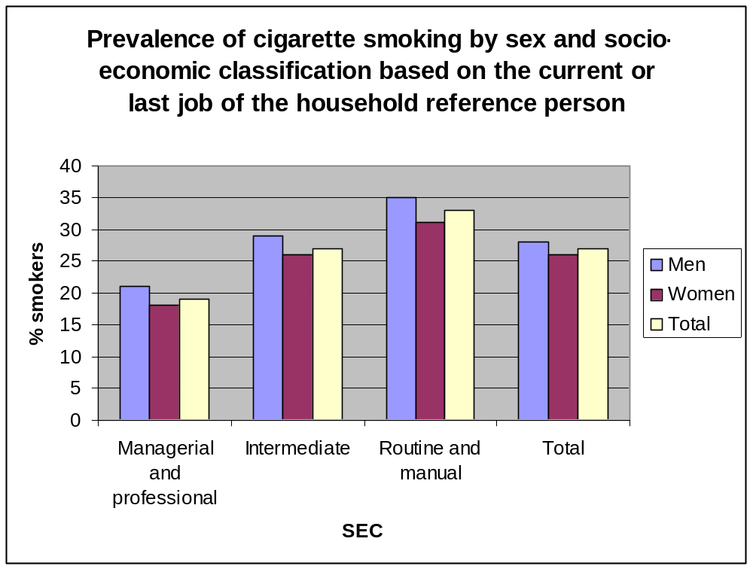
Source: Office of National Statistics

The economic burden of smoking weighs heaviest on the poorest. Smoking further impoverishes people who are already poor. It is estimated from the Family Expenditure Survey (FES) that in 1998/99 the average household spent around 1.5% of their weekly income on tobacco products (Department of Health 2000a). Among the poorest households however, it is estimated that around 15% of weekly income is devoted to purchasing cigarettes (Marsh and McKay 1994). The Independent Inquiry into Inequalities in Health reported that,

“Studies of the cost of meeting basic needs, which explicitly exclude spending on tobacco, indicate that Income Support levels are insufficient to secure a basic but adequate standard of living, especially if the households contain children. Not surprisingly therefore, low income households where parents smoke are much more likely to be lacking basic amenities, including food, shoes and coats than non-smoking parents on Income Support” (Acheson 1998).

3.5 Stockport smoking prevalence
As a percentage of respondents who answered the question on smoking, the Stockport Health Survey (2006) found a smoking prevalence of 19.1% for males, 14.8% for females and an overall prevalence of 16.2%. (It is noted that the Stockport respondents were weighted towards the higher SEC, so rates are likely to be higher than these). Overall, the SHS also found that there were twice as many ex-smokers as current smokers in Stockport. With a population of 230,000, it is posited that Stockport has at least 36,800 smokers.

3.5.1 Stockport smoker profile
The General Household Survey 1996 showed a peak smoking prevalence for Stockport in the 20-24 age-band with a reasonably steady decline in prevalence in each subsequent age group. Some 25-55 year olds (the target group for this report) could be naturally approaching the preparation stage of change.

In line with national data, the SHS suggested that in Stockport a lower percentage of females than males smoke.

Again in line with national statistics, the GHS also found that 12% of Stockport males in professional jobs smoked compared with 40% of Stockport males in unskilled manual jobs. Across Stockport, there was a clear link between decreasing deprivation and decreasing smoking prevalence (see Appendix 1).

4 The problem: Smoking prevalence in Brinnington
4.1 Summary
The recorded 40.1% prevalence of smoking amongst 25-55 year old adults in Brinnington and Central is higher than any other ward in Stockport and significantly higher than the local average of 16.2% (SLS) and national average of 24%. The Greater Manchester prevalence is 31%.

4.2 Brinnington smoking prevalence
The SHS found that smoking prevalence in Brinnington was 40.1% (as a percentage of respondents answering the question on smoking). Using the key below, the ASH data illustrated in the graph clearly shows that Brinnington’s smoking prevalence is the highest in Stockport.

A | West Bramhall
B | East Bramhall
C | Cheadle
D | Cheadle Hulme South
E | South Marple
F | North Marple
G | Heald Green
H | Heaton Moor
I | Heaton Mersey
J | Cheadle Hulme North
K | Hazel Grove
L | Romiley
M | Davenport
N | Bredbury
O | Great Moor
P | Manor
Q | Edgeley
R | North Reddish
S | South Reddish
T | Cale Green
U | Brinnington

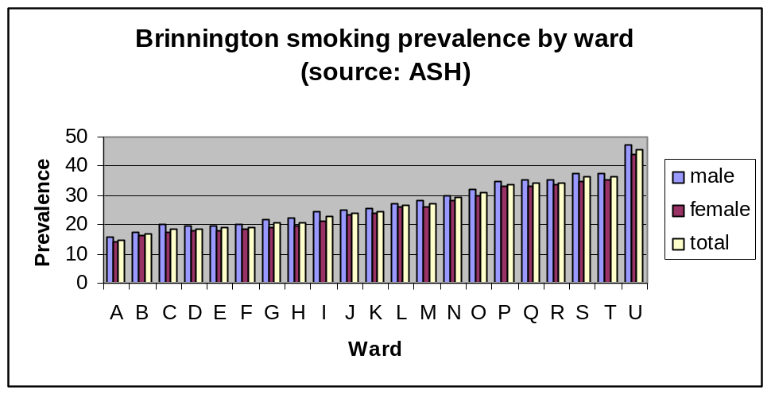
This SHS data, illustrated in the diagram below, corroborates ASH’s findings:
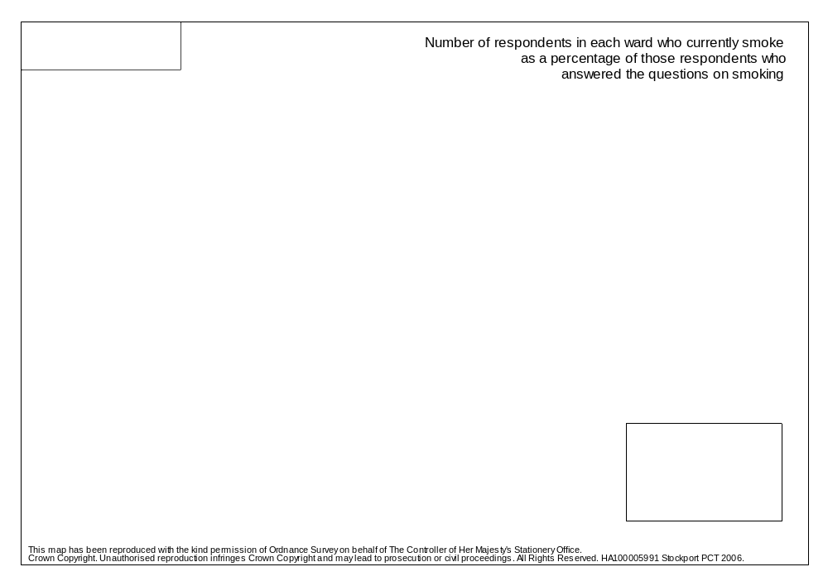

TOTAL: 600 | CURRENTLY SMOKE | 311 (51.8%)
TOTAL: 600 | I USED TO SMOKE, BUT HAVE GIVEN UP | 66 (11.0%)
TOTAL: 600 | I HAVE NEVER SMOKED | 223 (37.2%)
TOTAL: 600 | INTENTION TO STOP SMOKING IN THE NEXT THREE YEARS
TOTAL: 311 | 1 - YES DEFINITELY | 52 (16.7%)
TOTAL: 311 | 2 - YES PROBABLY | 77 (24.8%)
TOTAL: 311 | 3 - NOT SURE | 71 (22.8%)
TOTAL: 311 | 4 - PROBABLY NOT | 46 (14.8%)
TOTAL: 311 | 5 - DEFINITELY NOT | 65 (20.9%)
TOTAL: 246 | WHAT WOULD BE YOUR MAIN REASONS FOR STOPPING SMOKING?
TOTAL: 246 | COST OF CIGARETTES | 90 (36.6%)
TOTAL: 246 | YOUR CURRENT HEALTH | 42 (17.1%)
TOTAL: 246 | YOUR LONG TERM HEALTH | 85 (34.6%)
TOTAL: 246 | HEALTH OF OTHERS | 47 (19.1%)
TOTAL: 246 | PRESSURE FROM FAMILY OR FRIENDS | 20 (8.1%)
TOTAL: 246 | SMOKING IN PUBLIC IS INCREASINGLY DIFFICULT | 8 (3.3%)
TOTAL: 246 | SUPPORT TO HELP STOP SMOKING IS AVAILABLE | 8 (3.3%)
TOTAL: 246 | OTHER | 1 (0.4%)
TOTAL: 246 | DON'T KNOW | 59 (24.0%)
TOTAL: 246 | REFUSED | 1 (0.4%)
A January 2007 survey of 600 Brinnington residents, however, found that over half currently smoke:

The statistics from the January survey suggest that a key problem for Brinnington is the sheer number of smokers in the population. The data also suggests that health or cost may be motivators to cessation but also that over a third of those interviewed probably or definitely have no intention to stop smoking in the next 3 years.

To conclude, it is noteworthy that the national smoking rate in working class communities is 33%, 7% lower than the most conservative Brinnington rate. The Greater Manchester smoking rate is only 31%.

Attempt and successful quit rates will be analysed in section evaluating different cessation services.

4.3 Implications
Smokers have reduced life expectancy. The mortality ratio from all cancers for Brinnington ward is 147.0 compared with an England and Wales ratio of 100.0, a North West ratio of 109.7 and a Stockport ratio of 102.0. The wealthy ward of Bramhall South has a mortality ratio from cancer of just 71.3. These statistics suggest that health behaviours contributing to cancer, such as smoking, are particularly prevalent in Brinnington and warrant particular attention by policy makers and health professionals alike.
5 Intervention review
In this section, various smoking cessation interventions will be reviewed. These interventions include:
- Nicotine replacement and other prescribed pharmaceuticals
- Non- NHS support, including community support groups, aromatherapy and hypnosis
- NHS support, including pharmacies, GP support and health visitors
- Brief interventions by a spectrum of health workers
- Policy interventions, including smoke free workplaces and the imminent English national ban
- Other social marketing interventions, including mass media and school-based interventions

In general, it is noted that NICE have reviewed reports which found that previous quit rates, age, gender and level of addictedness are external factors which consistently influence the success of any intervention. Females, for example, set more quit rates than males but are less likely to succeed in quitting. Older smokers are more likely to quit than younger smokers. Heavily addicted smokers find it hard to quit.

It was also found that several sub-populations face unique barriers in attempting to quit smoking. Pregnant women, smokers with manual occupations and institutionalised populations all face substantial barriers impeding cessation attempts. (source: NICE)

5.1 Prescribed pharmaceuticals
5.1.1 Nicotine replacement
Nicotine in cigarettes renders them addictive so that smokers generally find it extremely difficult to give up their habit. Most smokers (~70%) say they would like to stop but some express an unwillingness or inability to do so in the near future. Nicotine replacement therapies attempt to substitute the nicotine obtained from smoking with that derived from gum, inhaler or patch, so that smokers are enabled to quit smoking and then gradually become independent of nicotine.

There are two broad types of NRT use; that which enables determined quitters to stop smoking abruptly, and that which enables unwilling quitters to cut down their smoking over an extended period while supported by NRT so that they may eventually become able and willing to attempt to quit altogether. It has also been commented that NRT could be used in a new way, to prompt unwilling quitters to smoke by reducing their craving.

5.1.2 Results
A Cochrane Review based on 123 trials, (103 of which contributed to the primary comparison between NRT and a placebo or non-NRT control group) found that NRT achieved 1.5- to >2- fold increases in smoking cessation rates. The main outcome measure used was abstinence from smoking after at least six months of follow up. It was also mentioned that there is some evidence that a combination of the possible delivery methods (gum, patch, nasal spray, inhaler, sublingual tablet or lozenges) is more effective than one alone.

A NICE report reviewed 7 randomised placebo controlled trials, although none of were primarily designed to investigate effectiveness of a smoking reduction in terms of sustained smoking cessation. In five trials, smokers received NRT gum or placebo, in two an inhaler or placebo and in one, smokers exercised free-choice of NRT or placebo type. Results for sustained abstinence from smoking, point prevalence of smoking abstinence, sustained smoking reduction and point prevalence of smoking reduction, demonstrated statistically significant superiority of NRT relative to placebo.

However, the proportion of participants that achieved sustained abstinence within 6 weeks was low (about 2% of those in receipt of NRT). Even with NRT support, smokers who had expressed unwillingness or inability to quit in the short term would be unlikely to stop within six weeks. Using a more relaxed criterion of 12 months for sustained abstinence, the review indicated statistically significant superiority of NRT vs. placebo. It was acknowledged that counselling may also be required to eventually achieve a successful cessation. NRT was analysed as being economically viable.

5.1.3 Bupropion

Buproprion, also known as Zyban, does not replace the nicotine a quitting smoker would otherwise inhale through smoking but rather affects some of the messages in the brain to reduce the craving itself. 1 150mg tablet is prescribed to smokers (willing quitters) over 18 years old for a week followed by 2 tablets the next week. In week 2, smoking is stopped. There are side effects with Bupropion such as fitting, and the drug is ill-advised to be prescribed to a patient taking other medication.

5.1.4 Results

NICE reported clear evidence that Bupropion is more effective than the placebo. It was shown to be effective in smokers with chronic obstructive pulmonary disease, cardiovascular disease and those who have failed in the past to achieve abstinence. It was not, though, found to be superior to NRT.

  - Non-NHS treatments
    - NICE review
There are many smoking cessation services outside the NHS which boast success rates higher than the 15% long-term abstinence rate achieved by the NHS services. NICE performed a systematic review of reviews to assess the success of acupuncture, Allen Carr’s Easyway, hypnosis, NicoBloc, Nicobrevin, St. John’s Wort, aversive smoking, cytosine and glucose in achieving comparable smoking cessation rates.

5.2.2 Results
The NICE review suggested that acupuncture, St John’s Wort and NicoBloc are probably not effective. There was insufficient evidence to determine the effectiveness of Allen Carr’s Easyway Program and Nicobrevin. Hypnosis has not been found to be more effective than simple advice. Studies of glucose showed mixed evidence of efficacy. Rapid smoking may have some efficacy, but its implementation within the contemporary treatment format is problematic. Cytisine (Tabex) also showed evidence of efficacy.

5.2.3 Review of story-based interventions
Ritchie et al (2007) suggest that stories between smokers at different stages of change can be effectively used to prompt cessation by being used to locate the process of change within people's daily lives as well as to enable people to engage in a supportive process with others. The intention to change is perceived by many smokers to be unstable and requires opportunities for longer-term support. Including people at the different stages of change seems to be positive and the report suggests that participants appear to incorporate without difficulty those who are still smoking with those who have stopped.

5.2.4 Results
Ritchie et al (2007) claim that the findings of this study challenge current smoking cessation guidelines and suggest highly structured standardized 6-8 week programs in smoking cessation are insufficient to meet the needs of many smokers. The hypotheses generated by the work suggest that flexible services that offer support to a range of smokers are beneficial and valued. In addition, programs that are tailored to the individual's context and culture, as well as the individual's personal life situation, through the medium of the story, are valued and acceptable to the participants.

5.2.5 Buddy systems
Buddying is a volunteer-based approach to deliver emotional and practical support. It allows interventions to be delivered within the community and ASH recommend that it is found to be particularly useful in low-income groups.

The ‘buddy’ is an individual who is given special responsibility to help a smoker in their attempt to stop, by providing support at regular intervals or as problems arise. They can be from an existing social structure or someone previously unknown to the smoker. They may be a non-smoker, another smoker trying to stop, an ex-smoker, or even a current smoker. In the ASH Scotland Project, ‘buddies’ are members of the public who have undertaken training to support smokers in their attempts to stop, who are committed to helping and who are non-smokers or ex-smokers.

No results have been found which demonstrate the effectiveness of buddying.

5.3 NHS Support Services

The NHS services in England provide various interventions designed to encourage smoking cessation. These include one-to-one counselling sessions or group counselling session. They can be GP, pharmacy or nurse-led.

5.3.1 Results

Indicative results suggested that NHS Support Services are effective in the short term of 4 weeks. In the long term of 52 weeks, between 13-23% of the short term successful quitters remain abstinent (based on self-report).

- It was found that 20% of pharmacy-delivered interventions achieved CO-validated cessation rates at 4 weeks.
- It was found that group intervention may be more effective than those delivered one-to-one, although “both types of intervention are essential for the continuation of the services.” ‘Buddy’ systems were not found to increase the effectiveness of group interventions but did increase the effectiveness of one-to-one interventions.
- There was indirect evidence suggesting that inpatient interventions in hospital settings are effective.
- External factors such as timeliness and target setting seem to have influenced the effectives of intensive smoking cessation interventions.
- There was no significant difference in the effectiveness of individual counselling and group therapy.

  - Brief interventions
The NHS also provide brief interventions, where health professionals suggest smoking patients access a cessation service whilst treating them for sometimes unrelated ailments. Brief interventions can be implemented by any health professional from a physiotherapist to a health visitor. NICE recommendations include:

- Everyone who smokes should be advised to quit, unless there are exceptional circumstances
- People who smoke should be asked how interested they are in quitting.
- GPs should take the opportunity to advise all patients who smoke to quit when they attend a consultation.
- Nurses in primary and community care should advise everyone who smokes to stop and refer them to an intensive support service (for example, NHS Stop Smoking Services).
- All other health professionals, such as hospital clinicians, pharmacists and dentists, should refer people who smoke to an intensive support service (for example, NHS Stop Smoking Services).
- Community workers should refer people who smoke to an intensive support service (for example, NHS Stop Smoking Services).
- Smoking cessation advice and support should be available in community, primary and secondary care settings for everyone who smokes. Local policy makers and commissioners should target hard to reach and deprived communities, including minority ethnic groups, paying particular attention to their needs.

5.4.1 Results
ASH tells us that brief opportunistic advice has a low efficacy but because of the huge number of people health professionals see in the course of any year, it can have a very significant public health impact. Brief advice mainly triggers attempts to quit (and may do so in 40% of smokers given such advice) but many smokers will need further support.

Takahashi et al (2006) report on a study where brief interventions were found to be effective. They talk about the 5As (asking, advice, assess, assist, and arrange follow up).

5.5 Policy interventions
5.5.1 Smokefree workplaces
NICE reviewed evidence on the extent to which workplace policies stimulate, support and utilise smoking cessation with a view to determining the likely effects of the introduction of national smoke-free legislation in England in 2007.

5.5.2 Results
It was found that cessation programs aimed at the individual when combined with an institutional approach (providing environmental support) were effective in facilitating smoking cessation. It was also found that smoking restrictions positively impacted the uptake of smoking cessation resources. In addition, Moher et al (2003) found consistent evidence that workplace tobacco policies and bans can decrease cigarette consumption during the working day by smokers. They found conflicting evidence, however, about whether they decrease prevalence of smoking or overall consumption of tobacco by smokers.

The most effective workplace programs were those with proven effectiveness in other settings. Financial incentives can improve recruitment rates (if not cessation rates), whereas ‘buddy’ support seems to have had limited effect. Intensive interventions were more effective than minimal interventions and workplace health assessments with feedback may also have a role to play, although evidence was inconclusive. NICE acknowledged the potential for Allen Carr seminars, online smoking cessation support and integrated smoking cessation and occupational health and safety programs, although evidence on the effectiveness of these was limited.

5.5.3 National smoking ban:
The English smoking ban will come into effect on July 1st 2007, making smoking in public places illegal.

5.5.4 Results
Research from other countries, including Norway, suggests that attempts to quit will increase if treatments are made easily accessible. Andrew Hyland, associate member of the Roswell Park Cancer Institute, New York, explained what has been seen in the wake of smoking bans elsewhere:
The air is cleaner and health improves, people support the regulations and support increases over time. Hospitality economies are not devastated and appear to suffer no adverse consequences.
When smokers decide they are ready to quit, a smoke-free environment makes it easier for them to stop successfully. For some people, they will decide to quit right away when the law is implemented or even beforehand, but for many others they will make that decision in the weeks, months and years ahead.
The Pharmaceutical Journal goes on to explain that easily accessible and flexible smoking cessation services will be essential if smokers are to be motivated to quit in the wake of the smoking ban in bars and public houses in England.
5.6 Social marketing interventions
5.6.1 ISM review
Stead et al from the Institute of Social Marketing reviewed 35 social marketing interventions aimed at reducing alcohol, tobacco and substance misuse. 35 studies were found to meet the NSMC’s benchmark social marketing criteria and therefore could be called social marketing interventions. 9 of these were smoking cessation interventions. It is important to note that many interventions were non-UK based.

Key techniques used:
- School-based approaches
Most of the school-based programs were informed by the social influences approach which comprises 3 components; psychological inoculation, normative education and resistance skills training. Stead et al found that school-based programs using this approach are consistently more effective than curricula adopting other approaches.

2. Community programs
These interventions were generally underpinned by theories of community organisation and community participation.

3. Media advocacy

4. Family-focused interventions
These interventions drew on models of problem behaviour to develop models of factors which would protect against the development of substance use, such as family cohesion and managing emotions and conflict.

5.6.2 Results
- 2 had significant impact on cessation
- 5 had modest or weak impact
- 2 had no or unclear effects

Of the interventions with significant impact, 2 were mass-media based programs. The North Coast Quit for Life program was a 2 year mass media campaign in Australia. Lower smoking prevalence in the intervention communities was found after 2 years. Similarly, a media program for Vietnamese American men found higher likelihood of being a quitter in the intervention communities after the 2 year intervention.

Those interventions with modest of weak effects included:
- A church-based community project based around church coalitions and individually-focussed activities.
- 3 multi-component community cardiovascular disease interventions.
- The Stanford Five-City Project; a 5 year long multi-community intervention
- The Minnesota Heart Health Program; comprising media, community organisation, training of professionals and community cessation support. This had a significant impact on women’s smoking prevalence but not on men’s.
- COMMIT trial had limited effect on heavy smokers but significant effect on moderate smokers after its 5 year period.
- Hispanic Americans mass media-based program.

Those interventions which appeared to be ineffective:
- The Pawtucket Heart Health Program: A community trial with no impact on smoking prevalence
- US university worksite intervention

5.6.3 NICE review of mass media interventions
Nice reviewed mass media interventions which aimed to help people quit smoking and also prevent relapse. The systematic review takes 1 of 7 media in turn and assesses it for its content, message and overall effect.

5.6.4 Results
Educational interventions
No effect of multi-channel mass media on cessation was found, nor any effect on the smoking intentions of children.

No-smoking days
It was found that a quit rate of 11% at three months could be achieved with a No Smoking Day in the UK. [Ben Youdan, chief executive of No Smoking Day, the charity which co-ordinates the campaign, said the introduction of NHS stop smoking services had helped many people to quit:
We know that stopping together with others gives smokers an extra boost, and our figures show that you're twice as likely to succeed if you give up today, No Smoking Day.]

Quitlines (for targeted populations)
There was evidence suggesting that for pregnant women and their partners from lower socio-economic groups, multi-channel mass media advertising has no evidence of effect on changing smoking behaviour but calls to quit lines increased by 14%. Similarly, this medium had little effect on quit rates for women with young children. It was found, however, that on No Smoking Day, calls to national smokers’ help lines are typically four times the normally level.

Competitions and incentives
There was found to be a small effect of ‘Quit and Win’ contests of community prevalence of smoking. Less than 1 in 500 quits were achieved because of the contests. The competition and incentive intervention was not found to be effective beyond 6 months but were found to be effective in the short term, as 35% of the population self-reported that they had quit two months after the contest.

Multi-component interventions/community interventions
It was found that multi-media mass media campaigns (combined with other interventions) are effective in increasing tobacco use cessation. Cessation rates ranged from 3.9% to 50% in follow-up periods of 6 months to 5 years. It was found that adding peer group support and lottery incentives to mass media-based self help interventions led to abstinence levels of 19.5% in control group compared with 30% in intervention group at 2 years.

Interventions targeting young people
It was found that dissonance arousing messages targeting girls can have positive short term effects on quit rates. Graphic mass media messages about the negative consequences of smoking among adults were found to have a positive effect on quit attempts among young people and media campaigns advertising internet websites can increase quit attempts.
Interventions targeting ethnic/cultural groups:

Campaigns targeting male rural oral tobacco users with culturally appropriate materials were found to be positive.

5.6.5 Current government stop smoking campaigns
A key strand of the Government’s tobacco control program is the provision of an ongoing media/education campaign. There are four overall strands to the campaign, as recommended by international best practice.
- Motivation: provides smokers with new and motivating reasons to quit
- Support: outlines the choice of NHS support available
- Reducing exposure to second-hand smoke: demonstrating that second-hand smoke is dangerous, not just unpleasant
- Product and Pack: links the health messages back to the product, giving the smoker another reason to quit.

The campaigns, which include advertising, PR and direct marketing, aim to motivate smokers to quit, to highlight the NHS support available to them, as well as to educate the public about the dangers of secondhand smoke.
The current campaign is ‘Get Unhooked’:

TV ad campaign:






Advertising Posters:

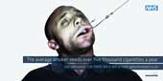

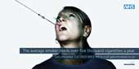
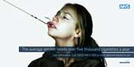

5.6.6 Results
In 2005, advertising continued to be the biggest prompt for people giving up smoking (27%) ahead of 'something said by doctor' (22%) and 'something said by friend or family member' (20%). Campaigns also helped generate nearly 400,000 calls to the NHS Smoking Helpline, and nearly 600,000 visits to the campaign website: www.givingupsmoking.co.uk.
It is important to note that the prominence of anti-smoking national media is likely matched by other media campaigns targeting problem health behaviours in Brinnington. A full competition analysis in this respect has not been done here, but social marketing interventions should take into consideration other potential influences over the target market’s attention.

5.7 Conclusion: what works best?
The Stockport Stop Smoking Service (SSSS) Equity Profile tells us that it is now considered that the optimal treatment for tobacco dependence consists of structured behavioural support, especially when combined with nicotine replacement therapy or bupropion.
Moher et al (2003) concur with this combination, as they found strong evidence that interventions directed towards individual smokers increase the likelihood of quitting smoking. These include advice from a health professional, individual and group counselling and pharmacological treatment to overcome nicotine addiction. Self-help interventions are less effective. There was limited evidence that participation in programs can be increased by competitions and incentives organised by the employer.

Similarly, in her ASH report, McNeill states that:

Evidence based and professionally endorsed national smoking cessation strategy involving brief opportunistic advice to quit from health professionals, with a prescription for effective pharmacological treatments, backed up by intensive specialist cessation support for those smokers who need it.

6 Summary of Stockport smoking cessation services available

The Stockport PCT is in the second year of the three-year LDP target to achieve 5908 quitters at 4 week follow up by April 2008.

6.1 Smoking services available throughout Stockport

There are 31 pharmacy smoking cessation services across Stockport. 20 of these services are in the deprived areas of
- Reddish North (3)
- Reddish South (2)
- Brinnington and Central (4)
- Manor (1)
- Edgeley and Cheadle Heath (3)
- Cheadle Hulme North (1)
- Davenport and Cale Green (2)
- Marple South (1)
- Heald Green (1)
- Cheadle and Gatley (2)

There are 54 GP practices (as of November 2006) across Stockport, all with a nurse trained in smoking cessation and with a smoking cessation service.

6.2 The Stockport Smoking Cessation Service model
The model for the Smoking Cessation Service in Stockport operates on 3 levels and which have been in existence since 1997 and are funded by the DH.

6.2.1 Specialist Services (known as level 3)

The Specialist Service takes referrals from health professionals or individuals may access the Service directly. All smokers referred to the Service are contacted asking them to ring to arrange an appointment. When the individual contacts the Service, the method of consultation (either group or one-to-one) is agreed and an appointment time issued.

Smokers opting for one-to-one consultations have an initial assessment, which lasts 45-60 minutes, when a quit date is set. Follow-up appointments of 30 minutes are then available as necessary. The one-to-one service is nurse led. Those choosing group consultations are offered three sessions lead by a clinical psychologist. The first session is for providing information and setting a quit date. The second is for support during the quit attempt and the third is the four week follow-up. Smokers may re-attend session two if necessary and they can also obtain telephone support from the clinical psychologist.

There is a Specialist Service in Chestergate and one at Stepping Hill Hospital.

6.2.2 Intermediate, or LES (Local Enhanced Scheme) (known as level 2)

All GP surgeries across Stockport now have a cessation service with either a one-to-one or group model. The surgeries have practice nurses trained by the SSSS and paid by them to offer dedicated smoking cessation clinics.

2006 saw the introduction of the pharmacies program, where pharmacies were undertaking structural work, staff training or replacement to provide cessation services.

6.2.3 Brief interventions (level 1)
Health professionals and other relevant practitioners provide level 1 smoking cessation advice as a routine part of their normal duties and refer where necessary to other parts of the service. This service primarily involves signposting cessation services during the course of treatment for other health issues.

7 Brinnington cessation services
7.1 General healthcare

Healthcare provision in general in Brinnington seems fairly comprehensive. There are reportedly 8500 individuals registered with the Health Centre. There are 3 male and 3 female GPs in Brinnington. There are 3 practices in the ward, 2 of which are based at the Brinnington Health Centre and managed by the same practice manager. The Quality Outcome Framework (QOF) results show that 2 GP surgeries in Brinnington are achieving 100% of the total quality of care points available which is higher than the ward average of 85.7%.

7.2 Cessation services
7.2.1 GP service
The 2 GP practices based at Brinnington Health Centre run both a one-to-one smoking cessation service in 3 different daily slots (5 days a week) and jointly organise a group service (the Quit for Life session) once a week on a Monday morning. The Health Centre also displays smoking information as well as have at least one trained nurse.

There is a separate single-GP practice run by Dr Azmy which also has a cessation service run on an entirely one-to-one basis. All Dr Azmy’s cessation attendees are referred by him and see him on a one-to-one basis.

7.2.2 Quit for Life
On the recommendation of 3 local community members, a Quit for Life group was started, based at the Health Centre on Monday mornings. The group runs ‘like weight watchers’ with a health worker in attendance (Maggie McMasters) to organise the prescription of NRT when required. Maggie is a trained Community Psychiatric Nurse. Quit for Life is run jointly by Maggie and a patient-volunteer, Mary Dutton, although is considered by the PCT as the service attached to the Brinnington Health Centre.

Mary had previously tried to set up a Quit Smoking Group, which failed. Mary and the other community members who recommended and started the group are well respected. Amanda Huddleston described Brinnington as having a great “community spirit and hierarchy”, (although the survey in Appendix 2 shows that very few Brinnington residents get involved with local events). The community members lead the group and quits are counted towards the PCT total. The holistic approach of the group means they also make recommendations regarding additional lifestyle factors such as weight and physical activity. Appendix 2 shows physical activity levels in Brinnington, as well as fruit and vegetable intake, are low. The GPs are happy to refer to the Quit for Life group (in fact originally the group was supported by a practice nurse but schedules meant this was not sustainable).

Quit for Life is run on Monday mornings only and attendance can fluctuate between 8-15 people. The Quit for Life group is informal with no appointment necessary. It runs as a drop in session and there is no need to see a doctor, although referrals from the doctor can also be made.

7.2.3 Break the Habit
3 Break the Habit sessions have been run in Brinnington as part of a pilot 3 week course funded by the Healthy Living Scheme (National Lottery Funding). The sessions came about due to information provided to volunteers and health workers on training sessions for smoking cessation. Neuro-linguistic programming and aromatherapy were the techniques used.

Significant advertising for participants was undertaken in the weeks prior to the sessions and 9 participants were eventually enrolled. The maximum number possible was 10. No screening for motivation levels was undertaken prior to enrolment although all quitters were asked that they be ‘ready to quit’.

7.2.4 Out of area cessation services
Brinnington inhabitants are freely able to attend smoking cessation services in other areas of Stockport, particularly the central Stop Smoking Specialist Service, near the shopping area in the centre of town. Although technically still in Brinnington and Central ward, this service (and the 3 pharmacy services in the central area) are a considerable bus journey from the hub of the Brinnington estate. There are 3 GP practices outside Brinnington ward which are accessed by Brinnington residents.

7.2.5 Pharmacy services
Rosie George, the Pharmacy service Health Promotion Advisor, explained that although there are 3 pharmacy services in the southern area of Brinnington and Central ward, in the centre of Stockport, there is currently no pharmacy-led smoking cessation service on Brinnington estate itself. However, there is a Co-op pharmacy in the area and the manager has been provided with three opportunities to come on board and initiate a stop smoking service. For a variety of reasons he has declined. However, the Co-op pharmacy is due to move into the new Community First building and the manager has suggested he will re-evaluate his involvement in a smoking cessation service after the move has taken place.

8 Evaluation of the success of SSSS

All PCTs are required to participate in a local health services patient survey. In the survey for 2005, the national average showed 40% pf current smokers had been offered help or advice to stop smoking by someone at their GP surgery/health centre over the 12 month period prior to the survey. However 55% of Stockport smokers had been offered support, Stockport’s performance was in the 20% best for PCT’s.

However, success rates from those accessing cessation services are low. The Local Area Agreement claimed that “overall performance [of smoking cessation services in Stockport] is down and this is a pattern being seen across the country, driven by a number of factors including the lack of a national advertising campaign this year and anecdotal evidence that due to the ban on smoking in public places coming into force in July 07 people are delaying their quit attempts”.

8.1 Stockport cessation targets
- Stockport PCT is in the second year of the three-year LDP to achieve 5,908 quitters at 4 week follow up by 2008. (1960 in 2005-6, 1969 in 2006-7 and 1979 in 2007-8).
- In year 1 (2005-6), the PCT achieved 106% of the target (2071 quitters).
- The annual target of 1,969 4 week quitters in 2006-7 is distributed so that 70% of target is to be achieved over the first three quarters of the year and the remaining 34% of target in the final quarter. (This equates to 492 for quarter 1, 443 in quarter 2 and 3 and 591 in quarter 4). This reflects seasonal variations in quit attempts.

8.2 Stockport-wide cessation results
8.3 Stockport Stop Smoking Equity Profile
A full Equity Profile has not been performed since 2002/3. Although out of date, this does give an indication of the role of the Stockport smoking cessation services in achieving the quit rates:
Numbers of smokers referred to, accessing, using and successfully stopping smoking with the SSSS from 01/04/02 to 31/03/03.
 | Referred | Accessing service | Using service | Successfully stopping smoking
Specialist Service | 1,324 (1.76% of smokers) | 589 (44.5% of referrals) | 484 (37% of referrals) | 254 (43% of referrals)
Community-based service | - | 437 | 429 (98%) | 176 (40%)
Total | 1,324 | 1,026 | 913 | 430 (42%)

Good access rates
- 55.5% are lost at the referral stage. They do not go on to access the service following referral. This is a decrease from the previous equity profile when 62.5% of those referred to the Service did not go on to access the Service. This may suggest that the services have become more accessible since the previous profile.
- At this time, the Specialist Service appeared to be more effective than the Community-based Service at helping smokers to successfully stop smoking once a quit date had been set.
- The Service appears to have improved effectiveness with increasing age.
The following graph illustrates the success of the SSS services in 2002/3 by age.

Rate of accessing, using and successfully stopping smoking with the Stockport Stop Smoking Service for the different age groups 2002-3
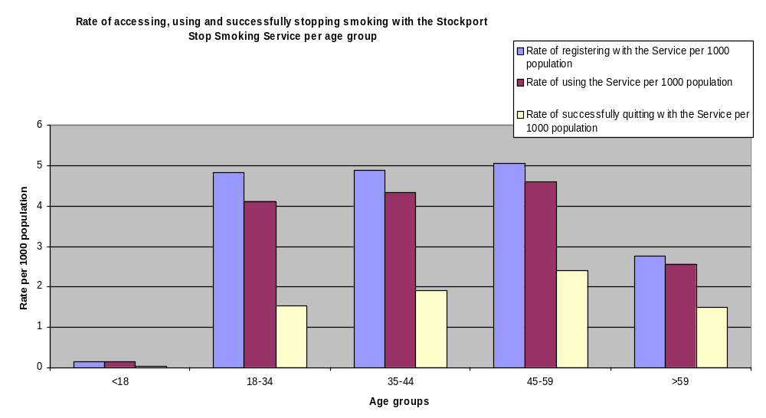
Source: Stockport Stop Smoking Service database

- Females are slightly more likely than males to access the services.
- The Service is more effective for males than females as men have a marginally higher success rate than women.

Of particular note is the following finding:

More smokers in the deprived groups access the service and set a quit date. However, of those setting a quit date fewer smokers in the deprived groups successfully stopped smoking. The service appears to have increasing access and use with increasing deprivation but decreasing effectiveness with increasing deprivation.

Quit rate
The table above shows a 42% successful quit rate from those accessing the SSSS during that period.

  - 2005-6 Cessation Service results
Decreasing access rates
The activity in quarter 1 of 2006-7 was 342, 70% of quarterly target of 492 quitters, less than in the same period the previous year. Quarter 2’s activity was 270, 61% of the quarterly target. As the table below shows, overall performance was 30% below last year’s activity:

 | 2005-6 | 2006-7 | Q1 | Q2 | Q3 | Q4 | 2008-9
Annual Target | 1,960 | 1,969 | 492 | 443 | 443 |  | 1,979
Cumulative | 1,960 | 3,929 |  |  |  |  | 5,908
Performance | 2071 |  | 342 | 270
Variation | + 111 |  | -150 | -173
Cumulative | +111 |  | -33 | -212

Quit rates
2005-6 data also suggests a 42% quit rate is still being evident from the combination of the Stockport-wide cessation services. 42% is significantly lower than national and regional quit rates from cessation services.

2005/6 4 week quit analysis of Stockport cessation schemes:
 | People setting a quit date | People were quit at 4 weeks | % successful quits | People did not quit | People were lost to follow up
Stockport Pharmacy data | 635 | 273 | 42% | 127 (20%) | 235 (37%)
Specialist service data | 605 | 254 | 42% | 274 (45%) | 77 (13%)
GP data | 3331 | 1399 | 42%
Overall Stockport data | 4571 | 1926 | 42%
National pharmacy quit rate |  |  | 52%
National overall data |  |  | 54% | 24% | 21%
Greater Manchester data |  |  | 47%
Lowest local data (Trafford South) |  |  | 39%
Highest local data (Oldham) |  |  | 59%

In addition, some data is available on services for pregnant women in 2005-6.
6 women who were pregnant were seen through the pharmacy scheme:
- 3 were seen at ASDA and 1 was quit at 4 weeks
- 2 were seen at Cohen’s North Reddish – none were quit at 4 weeks
- 1 was seen at Gorton Road Reddish Co-op who was not quit at 4 weeks

Across all the intermediate services (these figures include the 6 from pharmacy) 139 women who were pregnant were seen of whom 47 were quit at 4 weeks (42% quit rate). Nationally: 17,917 pregnant women set a quit date, 9,592 successfully quit = 54% quit rate.

8.5 Brief interventions
It is currently not possible to electronically track brief intervention/referral against outcome of referral. Anecdotally the workers in the specialist service say the vast majority of clients are made aware of the specialist service via their GP.

The biggest proportion of quit attempts take place in general practice. In theory a lot of brief intervention and referral takes place within practices however in reality it is difficult to extrapolate data. GPs are encouraged to record their interventions on their patient information systems and have been supplied with read codes to assist them to record their interventions.

8.6 Conclusion
The data suggest there are 2 key issues:

Quit attempts:
The number of quit attempts has decreased considerably since the last Equity Profile.

Quit successes:
Also, the Stockport quit rate data shows a significant gap between national rates and the actual quit rates in the borough. Even allowing for some regional variation, the data shows that Stockport does not match Greater Manchester data. The trend is clearly that the Manchester area rates are lower than national averages but the Stockport data is still 5% lower than Greater Manchester overall quit rates for this period.

However, it is important to note that The Equity Profile concluded that Stockport’s smoking cessation services are in line with recommendations that where possible, smokers should have access to a specialist smoker’s clinic staffed by individuals specially trained and employed for the purpose.

8.7 The SSSS business plan (2006-7)

In light of the poor performance by Stockport cessation services, the Stockport Stop Smoking Services business plan was designed to improve the impact of existing services and to achieve 110% of target by Quarter 4 of 2006/7. The plan includes the consolidation of existing services, continued expansion of the LES pharmacy and new initiatives in disadvantaged areas. The table below shoes the target deficit faced at the time of the plan’s inception:
 | Proposed no. of quitters | Quarter 1  Actual | Quarter 2  actual
- Specialist service  Including workplace and hospital program | 250 | 73 | 24
- Locally Enhanced Service  delivered across 100% of practices | 1300 | 221 | 143
- Pharmacy across target 30 pharmacies (26 operational 11/06) | 400 | 35 | 21
- Clinical Services inc  Health Visitors, district nurses and Public Health Practitioners including sure start | 50 | 11 | 3
- Miscellaneous intermediate | 40 | 4 | 2
- Community program | 40 | Performance measure to be agreed | Performance measure to be agreed
Total activity | 2080 | 342 | 193

The plan is being implemented on schedule and although overall results are not on target, major achievements include the following

- All Stockport GP’s operate the smoking GMS-Local Enhanced service,
- 50% of pharmacies are trained to deliver the Pharmacy LES and 26 are fully operational.
- Joint work with Stockport’ Councils media department to increase media coverage of smoking cessation services has resulted in 11 press articles since August 2006 and a joint publicity website.

Three major new work programs are being developed throughout 06-7. These will have some immediate impact on quarter 3 and 4 but will have longer term impact in helping to achieve the LDP figures for 2007/08.

- LAA plan to target disadvantaged areas
- Development of social marketing program
- Maximising the impact of smokefree legislation

In addition, a local Area Agreement (2006-09) has been agreed to develop a community based model of smoking cessation support and implement this in key disadvantaged areas (for the 40% most deprived lower SUPER output areas) A target of 200 additional quitters from disadvantaged areas must be met from baseline of 691 by 2009.

The development of a social marketing program for which this scoping report is the first stage, also forms a part of the plan.

9 Brinnington cessation service analysis
9.1 Quit Attempts
The table below shows that quit attempts are lower in the most deprived quintile of Stockport (1) than for the other areas.
Quintile of Deprivation (1=most deprived) | 05/06 number of quit attempts | Estimated number of 18+ smokers | Estimated quit attempt rate
1 | 843 | 10091 | 8.4%
2 | 1150 | 10649 | 10.8%
3 | 1023 | 10897 | 9.4%
4 | 552 | 6114 | 9.0%
5 | 611 | 7327 | 8.3%
1&2 (40%) | 1993 | 20741 | 9.6%
Stockport | 4179 | 45078 | 9.3%
 | 05/06 number of quit attempts | Crude estimated number of 18+ smokers (16.1%) | Estimated quit rate
Service total | 4986 | 37267 | 13.4%

[However, the graph below shows that quit attempts are actually relatively high in Brinnington compared with other wards. This is likely to be because that there are a greater number of smokers in Brinnington than other wards. As a percentage of total Brinnington smokers, only 9.5% actually made quit attempts using a cessation service in 2005-6.]

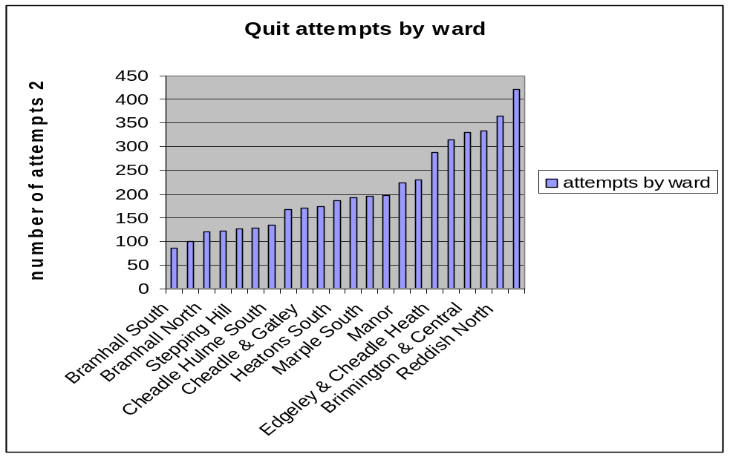
9.2 Successful quits
The 2002/3 Equity Profile suggested that the rate of successful quits from people from deprived areas having accessed the SSS services were lower than non-deprived areas. This finding is in line with the minutes from the Health Inequality workshop in December 2006, where it was noted that in 2005/6, 47% of Stockport’s SSS users were from disadvantaged areas but that the overall quit rate was 42% quits compared with Brinnington, which only has a 35% quit rate out of people using SSS services.

 | Quit attempts | Successful quits | % success rate
Stockport Borough | 4604 | 1932 | 41.96
Brinnington Ward | 330 | 117 | 35.45

The comparison graph below shows that Brinnington has the second lowest success rate after Cheadle and Gatley.

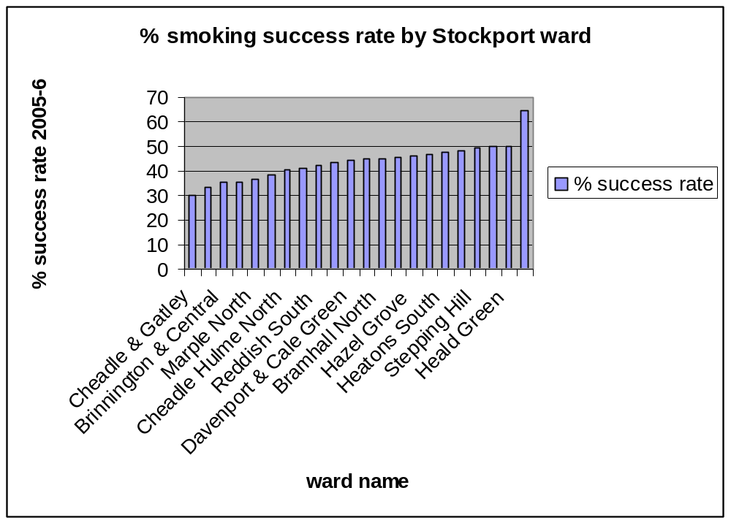
These figures suggest that not only are attempt rates in Brinnington likely to be lower than the Stockport average but that the successful quit rate is also lower. The figures for each service with Brinnington clients corroborate these aggregated results. For example, the pharmacy data suggests an overall 56% successful quit rate for all pharmacies across Stockport, but the Brinnington residents only achieved a 50% success rate. Similarly, the average successful quit rate from the GP services across all 18 Stockport wards is 42.12%, nearly 10% higher than Brinnington’s 33.76%.

These figures are in line with the Independent Inquiry into Inequalities in Health, which identified the fact that not only is smoking prevalence higher among men and women in lower socio-economic groups, they also have lower cessation rates. Since 1973 rates of cessation have more than doubled in the most advantaged groups, from 25% to over 50%. In the least well off groups, there has been a very limited increase in cessation rates from 8% to 9% cessation in 1973 to 10% to 13 % in 1996 (Acheson 1998). Lowey et al (2003) wrote that “For smoking cessation to optimally tackle inequalities, services need a greater understanding of why, once in contact with services, people from deprived areas are less likely to quit and how services may be changed to improve success for these key groups”.

An evaluation of each Brinnington cessation service will now be explored. On the basis of the evaluations, recommendations for further research will be posited which will then be discussed further and explored with a literature review.

  - GP service

Attempts | Quits | % | GP practice
75 | 29 | 38.67 | Brinnington Health Centre
159 | 59 | 37 | Non-Brinnington GP practices (seeing Brinnington residents)
35 | 11 | 33 | Dr Azmy
269 | 99 | 37% | Totals

The quit results shown above suggest that the quit rates for GPs, both group and one-to-one sessions, are lower than the Stockport average of 42%.

159 Brinnington residents did access out of area GP practices for cessation services. Data for the most popular are as follows:
Health Centre name | Attempts | Quits | Successes %
Heaton Norris Health Centre (Drs Adya/Marshall/Murthy): | 49 | 10 | 20
Manor Medical Centre  (Dr Parkinson & Partners): | 22 | 9 | 41
Shaw Villa Medical Centre  (Dr Travenen): | 10 | 5 | 50

These GP practices are plotted on the map below, showing their proximity to Brinnington. Their quit rates were not significantly different to the Brinnington Health Centre.
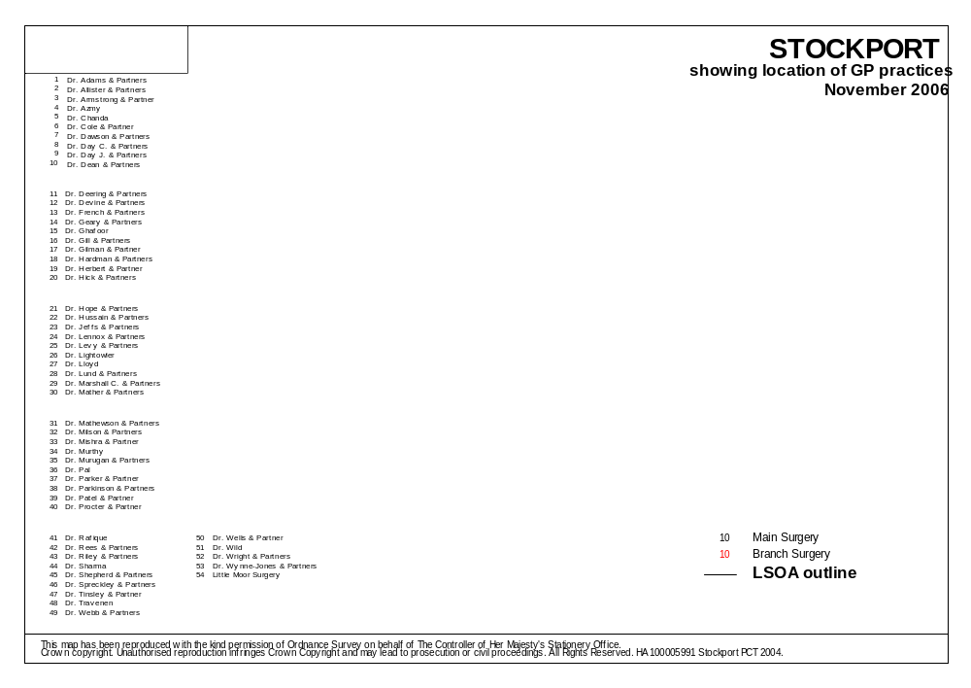
Brinnington Health Centre
Dr Murthy/Marshall/ Adya (Heaton Norris Health Centre)
Brinnington

Dr Travenen (Shaw Villa Medical Centre)
Dr Parkinson & Partners (Manor Medical Centre)

The data (in the graph below) suggests that the Brinnington Health Centre is accessed by more women than men, and that there are more white British service users than with other ethnic origins. There are, however, very low numbers of non British white residents of Brinnington.

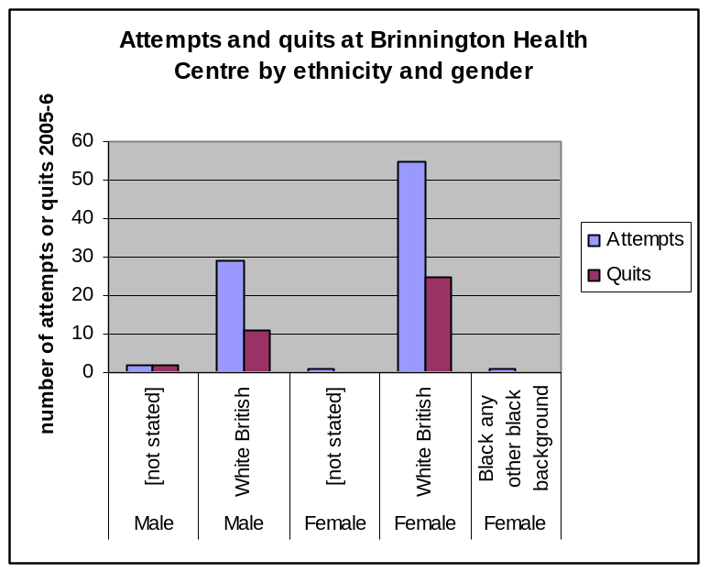

The data (in the graph below) also suggests that women and men in the 35-44 age group are most likely to attempt to quit and that women in that age group are most likely to succeed. Although not as many attempt, the 55-64 year old age group for both genders is most likely to succeed. There were the least attempted quits in the 65-74 age group for both genders and for the 16-34 age group amongst males only. There were a surprisingly high number of attempts made in the 16-34 age group amongst women but fewer successful quits. 45-54 year olds amongst both genders showed both few attempts and few (none in the case of males) successful quits. IT would be useful to view data on the employment status of people who accessed the service. It may be, for example, that employed people do not access the Quit for Life service because it is run on a Monday morning during working hours.
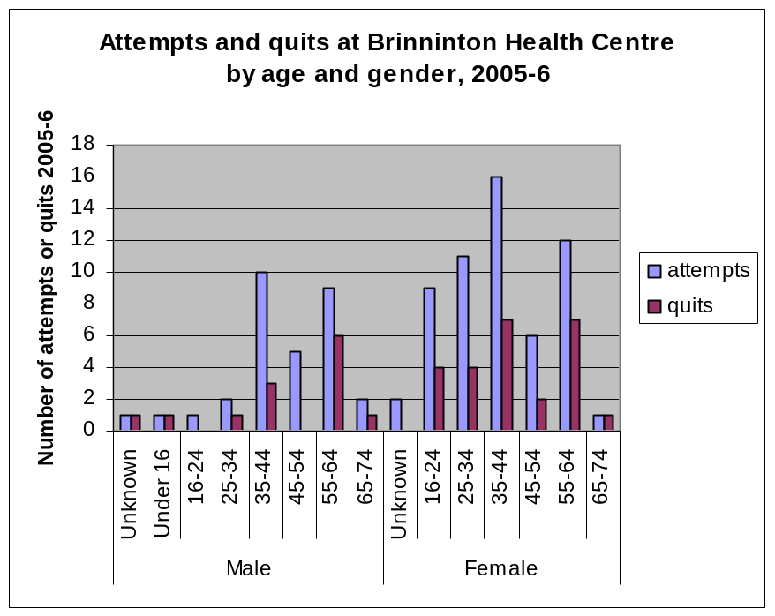

    - One-to-one sessions
Paul Ansbro, Practice Manager for the 2 GP practices at the Brinnington Health Centre, explained that Maggie McMasters also has one-to-one clients at a smoking cessation clinic 5 days a week in one of 3 different time slots – either morning, lunch time or mid-afternoon. The figures for these sessions are combined with the Quit for Life sessions, evaluated below. Ideally, the demographic break down for both services separately would be able to be viewed separately and assessed for obvious gaps in the reach of the service.

Paul Ansbro claimed, anecdotally, that about 10 smokers see Maggie each week through either GP referral or self-referral. When patients are unable or unwilling to visit the one-to-one clinic or group clinic, a nurse is on hand to discuss cessation advice and prescribe NRT.

9.3.2 Quit for Life
The Quit for Life service is considered to be part of Brinnington Health Centre’s cessation offering. Maggie McMasters, the health worker who joint-runs the Quit for Life service, has recently evaluated the service and has already met her yearly targets. Part of her winning formula, she feels, is her active follow up of clients, often leading to referrals by clients of members of their family or social group. Her evaluation results have not yet been made available.

9.3.3 Suggested Issues
- Anecdotally, attendees are older community members, although Public Health Nurse Amanda Huddleston emphasised that there is no current understanding of the spectrum of quitters attending the Quit for Life group.
- There is no real comprehension as to whether smokers in Brinnington would require further group cessation services.
- Amanda emphasised that even if there were found to be a further requirement for group services but that there is no availability of staff at the moment. There is limited funding, and out of hours staffing is more expensive.
- She also emphasised that a service in the evening would be ideal, as Monday mornings are only accessible by unemployed or retired people. However, in addition to not having the staff resource, there are currently no safe venues for evening sessions.

9.3.4 Recommendations from healthcare workers
The Community First building is due to open in April 2007. This building will contain a community library, gym, coffee shop and meeting rooms. Amanda Huddleston suggested that if further research shows the Quit for Life model to be appropriate for (and desirable by) the target groups, this building would be ideal for out of hours smoking cessation support groups.

9.4 Break the Habit
Break the Habit has only been run once, as a once-per-week alternative therapy session for 3 weeks running. All the 9 participants either quit successfully or significantly reduced their smoking.

9.4.1 Suggested Issues
Maggie feels that young mums are the hardest group to reach and that Cannabis use is prevalent in Brinnington and overlooked by the standard services. Many of her clients at the Quit for Life service, she explained, have been prolific cannabis users.

Maggie also made the point that mental health and smoking prevalence are closely linked. It is known that Brinnington has a high number of residents with mental health illnesses and anecdotally, Maggie claims most of her clients at Quit for Health have mental health issues. Maggie explained that in her experience, smoking by and large is linked to anxiety and stress and that smoking is used as a management tool for mood and emotions and to overcome depression and self-esteem problems. She found that with success in changing smoking behaviour, that weight management, eating behaviours and other health behaviours were also improved and that more of a health life balance could be approached.

9.4.2 Recommendations from healthcare workers
Maggie feels strongly that the success of the Break the Habit sessions indicates that there should be more provision for alternative therapies in Brinnington. As a trained Community Psychiatric Nurse, she feels she could use the further benefits of aromatherapy, neuro-linguistic programming and hypnotherapy to increase quit rates in Brinnington. Maggie felt strongly that an integrated approach between smoking cessation services and other healthy living services is necessary.

9.5 Brief interventions
There has been no tracking of the referral rate and subsequent quit rates from incidental brief interventions. Paul Ansbro claims that all patients at the Brinnington Health Centre are asked their smoking status during consultation.

9.5.1 Suggested Issues
Amanda Huddleston felt that there is still a prevalence of smoking amongst health workers, who therefore feel uncomfortable directing patients to cessation services due to ‘internal guilt.’

9.5.2 Recommendations from healthcare workers
Amanda Huddleston mentioned she would like to see more training given to health workers across all disciplines to encourage more consistent brief interventions (signposting smoking cessation services).

9.6 Out of area services
Other smoking cessation services are open to Brinnington residents. Of particular note is the central Specialist Service, which is open to anyone in Stockport and technically is in the Brinnington and Central ward although actually is some way from the hub of the estate itself. The table below illustrates the results for the central services (Chestergate) and 4 other services which have been accessed by Brinnington residents.

Attempts | Quits | % | Service
49 | 18 | 36.73 | Chestergate specialist service
17 | 5 | 29.41 | Antenatal associate
1 | 0 | 0 | Occupational health associate
1 | 0 | 0 | Young People’s stop smoking advisor
2 | 2 | 100 | Health visitor
70 | 25 | 36 | Totals

The results show a 36.73% success rate, which is above the average success rate for Brinnington, although still lower than the average Stockport success rate of 42%.

9.6.1 Suggested Issues
Amanda Huddleston pointed out that 2 buses are required to reach the centre from Brinnington. Although the journey itself is only a few miles, the bus trip is slow and laborious and can take up to an hour.

However, as has been pointed out, a surprisingly high number of Brinnington residents did attend the Chestergate service. Also, it is important to note that 159 Brinnington residents did seek quit smoking services at GP practices other than the Brinnington Health Centre in the 2005-6 period compared with 75 at Brinnington Health Centre.

There is no pharmacy scheme on the Brinnington estate itself. However, the figures below show Brinnington residents who accessed pharmacy schemes in other parts of Stockport. Although low numbers with only 26 attendees, the figures suggest a high success rate of 50%.

Brinnington ward clients only
Attempts | Quits | % | Pharmacy name
12 | 8 | 66.67 | Asda, Stockport
2 | 2 | 100 | Boots, Cheadle
3 | 0 | 0 | Boots, Merseyway
1 | 1 | 100 | Cohen's, Reddish
1 | 1 | 100 | Co-op, Reddish
7 | 1 | 14.29 | Superdrug, Mersey Square
26 | 13 | 50 | Totals

The figures below show results for all pharmacy schemes across Stockport, and show a 56% success rate overall, 6% higher than the Brinnington-only results.

All clients (Brinnington and non-Brinnington together)
Attempts | Quits | % | Pharmacy name
16 | 9 | 56.25 | Adswood
61 | 38 | 62.30 | Asda, Stockport
39 | 22 | 56.41 | Aubrey Glass, Cheadle Hulme
3 | 0 | 0.00 | Boots, Edgeley
10 | 6 | 60.00 | Boots, Cheadle
6 | 5 | 83.33 | Boots, Heaton Moor
38 | 16 | 42.11 | Boots, Merseyway
135 | 59 | 43.70 | Cohen's, Reddish
43 | 23 | 53.49 | Co-op, Reddish
5 | 3 | 60.00 | Co-op, 26 Reddish Road
3 | 2 | 66.67 | Co-op, Hazel Grove
12 | 9 | 75.00 | Co-op, Marple, 'The Hollins'
2 | 2 | 100 | Lloyds, 236 Wellington Rd South
27 | 6 | 22.22 | Lloyds, Edgeley
94 | 30 | 31.91 | Lloyds, Cheadle
40 | 11 | 27.50 | Superdrug, Mersey Square
11 | 8 | 72.73 | Tims and Parker, Heald Green
2 | 2 | 100 | Village Pharmacy, Bramhall
547 | 251 | 56 | Totals

9.7 Conclusion: What works best?
The evaluation above suggests the following attempt and quit rates for cessation services accessed by Brinnington residents in the 2005-6 period:
 | Service | Attempt figure | Quit rate
 | GPs (including Dr Azmy) | 269 | 37%
 | Break the habit | 9 | 100%
 | Brief interventions | Untracked
Out of area services | Chestergate Specialist Service | 49 | 37%
Out of area services | Antenatal | 2 | 29%
Out of area services | Health Visitor | 2 | 100%
Out of area services | Pharmacies | 26 | 50%

The results clearly show that even with Dr Azmy’s incomplete results most likely bringing down the attempt rate for GP practices, the attempt rates for Brinnington residents are the highest at the GP run services. We do not know the break down between one-to-one services and group services.

The low sample numbers for the antenatal, Health Visitor and Break the Habit services make the quit rate results unreliable and further tracking is required. The quit rate results for GP services and the Chestergate Specialist service are the same. Although the pharmacy quit rate is higher, the extra effort required to reach these out of area service may suggest that attendees were particularly motivated. The low number also means the results are not necessarily reliable. Overall, it can be said that the GP results show the best attempt and quit rates for Brinnington, although the high results for the out of area pharmacies suggest that further investigation should be organized to ascertain the potential for a pharmacy service in the hub of the Brinnington estate itself.

9.8 Summary of further research questions
The research questions below are drawn from the previous discussion. The purpose of the research is to answer the following 4 research questions:
- Why is smoking particularly prevalent in Brinnington?
- Why is the attendance of cessation services (quit attempts) by Brinnington residents lower than other areas?
- Why are the success rates of people from deprived communities successfully quitting as a result of their attendance of a Stockport SS Service so low?
- What would be the best intervention mix for Brinnington residents?

A further expansion of these questions is demonstrated below:
Research question |  | Suggested method
Question 1 | Class-related cultural, social and psychological factors
Question 1 | Why are smoking rates high in Brinnington? | Explore secondary data on the link between deprivation and smoking.  Explore secondary data on smoking as a social norm in working class culture.
Question 2 | Why are there low numbers of quit attempts in Brinnington compared with other wards? | Analyze current intervention data to explore possible reasons for low numbers of quit attempts.  Explore secondary data on psychological factors which may impact on willingness of Brinnington residents to attempt to quit.
Question 3 | Why are there lower success rates from the Brinnington ward compared with other Stockport wards? | Explore secondary data on psychological factors which may impact on success rates.  Explore secondary data on the mental health of Brinnington residents and the link between smoking and mental illness.
Question 4 | a. Services in comparable communities
Question 4 | Which services or combination of services could achieve the best results for Brinnington residents? | Explore secondary research to assess successful interventions in comparable deprived areas.
Question 4 | b. Current Brinnington services
Question 4 | What would the impact be of holding Quit for Life sessions at different times? | Recommend primary research to assess the impact of increasing the scope of the Quit for Life sessions.
Question 4 | What would the impact be of holding Quit for Life sessions in the Community First building
Question 4 | Would an increase in cessation services (and an increase in a quit culture) in Brinnington increase quit attempts? | Recommend primary research and further exploration.
Question 4 | What is the perception of cessation services out of the hub of the Brinnington estate? | Recommend primary qualitative research to ask Brinnington smokers which cessation services are most appealing

10 Literature review
This section will explore existing literature relating to the research questions identified though the exploration of the current smoking problem in Brinnington amongst adults.

10.1 Question 1
Why is smoking so prevalent in Brinnington?

2 key reasons are suggested for the high prevalence of smoking in the Brinnington ward: Its level of deprivation and the high level of mental illness in the ward.

10.1.1 Brinnington is a deprived ward and the link between deprivation and smoking is well known and documented.

To recap on the statistics, the ONS tells us that in England in 2001, 33% of men living in households in the manual group smoked cigarettes compared with 22% of those in non-manual households. The corresponding proportions for women were 30% and 20%.
In 2006, ASH proved a cast iron link between deprivation and smoking in the UK by mapping deprivation levels (according to the Index of Multiple Deprivation) and smoking levels. The link is clear and the map shown in Appendix 1 which links Brinnington’s deprivation level with its smoking rate. On both maps, Brinnington is shaded the darkest to indicate the highest prevalence of smoking and the highest level of deprivation. The ASH maps show how even relatively small areas of deprivation coincide with areas of heavy smoking.
In 2002, Cancer Research UK disclosed the North/South divide in terms of lung cancer rates and blame smoking for 9 in 10 cases of lung cancer. They claimed once again that “The reason for this north-south divide is down to smoking patterns. Smoking levels are higher in deprived communities and among manual workers”. Professor Martin Jarvis, the then assistant director of the Cancer Research UK Health Behaviour Unit is quoted as saying :
More people in the south work in 'white collar' industries which generally have lower levels of smoking. The north has a higher level of deprivation, but also a higher level of manual workers. Studies have shown that manual workers are twice as likely to smoke as people working in an office. We can see these smoking patterns mirrored in the number of lung cancer cases.
Academics have also found significant links between socio-economic status and smoking. One recent European study (Laaksonen et al, 2005) explored different aspects of socio-economic status and found that smoking was associated with structural, material (actual housing conditions and financial prosperity) as well as perceived dimensions of socioeconomic disadvantage (such as perceptions of risk from ill health).
As a deprived ward in the North of England with high numbers of residents in working class occupations, the smoking prevalence would be expected to be higher than the Stockport average, which is particularly low at 16%.
10.1.2 Implications
It is clear that it is a social norm in Brinnington to smoke. It has been suggested that smoking has become an integral part of the cultural framework of working class life in Britain. As Copeland et al (2005) suggest,
The advantages in drastically reducing smoking rates would obviously be found in the arena of the population’s health but the wider implications for society can be seen if we look at breaking the pattern of the social norms surrounding smoking in certain groups of the population, particularly those living in deprived circumstances.

It is suggested that that smoking forms an integral part of working class culture in the UK because of its value to the “symbolic order within which [each class] conducts its practices” (Sulkunen, 1982). In other words, smoking has symbolic importance specific to working class culture. As Professor of Epidemiology and Health at University College, London, Martin Jarvis commented that “Whatever the individual intent, the act of smoking remains a symbolic declaration of personal identity”. The marketing literature supports this observation by documenting how the consumption of objects or behaviours as symbols is purposefully used to associate (or disassociate) with a particular group. Piacentini and Miller (2004), for example, explain that consumers use “goods as symbols for communicating with other consumers”. They also explain that “individuals use products and brands as materials with which to cultivate and preserve their identities”.

In his 2006 paper, Socioeconomic Distinction, Cultural Tastes, and Cigarette Smoking, Fred Pampel set out to find a link between smoking and the cultural preferences of different class groups. His aim was to test the link between smoking and deprivation by seeking a link between smoking as a cultural asset and the cultural framework of deprived communities. He used the 1993 General Social Survey to estimate relationships between musical likes and dislikes with smoking while controlling for SES and social strain. His findings were that preferences for classical music are associated with lower smoking rates, while preferences for bluegrass, jazz, and heavy metal music are associated with higher smoking. He concludes that that SES groups may use smoking, like other cultural tastes, to distinguish their lifestyles from those of others.

It is suggested that for Brinnington residents smoking, on some level, associates them symbolically with the working class community members. Put another way, the cultural framework of working class life in Britain supports smoking. Bourdieu termed this cultural framework ‘habitus’;
The habitus of a group or a class defines a symbolic order within which it conducts its practices – in everyday life as well as in the feats. It provides a common framework within which the members of the group understand their own and each other’s actions.
(Sulkunen, 1982)

Since smoking rates are dramatically lower in middle class groups, it may be that working class smokers find it difficult to imagine themselves quitting because their association is that abstinence from smoking has strong middle class connotations. It is unknown whether this image-incongruency with abstinence is innate or objectively acknowledged in working class society.

10.1.3 Recommendations
Further primary research is recommended to explore whether Brinnington residents consider the image of a non-smoker or non-smoking incongruous with their own self-image. Social marketers are advised to take the results of these findings and design interventions accordingly. For example, an intervention may seek to present abstinence as culturally acceptable behaviour in working class society in Brinnington and disassociate it with middle class life elsewhere.

10.1.4 There is a high level of mental illness in Brinnington
At the Brinnington community meeting during the LAA planning stage, local GPs commented that there is a higher than average number of people in Brinnington with mental health problems. This was corroborated in one-to-one interviews with Brinnington-based health professionals. It was suggested by Maggie McMasters that a high proportion of the Brinnington residents she has seen at the Quit for Life cessation session have had a mental illness of some degree. Maggie suggested that smoking is used as a coping strategy to regulate mood.

10.1.5 The link between smoking and mental illness is well known (ASH, 2004)
An ASH report suggests that in line with Maggie McMasters’ anecdotal findings, smoking is often used by people with a mental health illness as a coping strategy. McNeill’s ASH report suggested that from her literature review, “All categories of mental health problems had higher levels of smoking than the general population. Forty percent of those diagnosed as having any neurotic disorder were smokers.” She also commented that as the severity of the mental illness increased, so did the smoking prevalence. It seems apparent that smoking is higher amongst people suffering from mental illness because, as Maggie McMasters suggested, smoking is used to moderate emotion and mood and act as a coping strategy. (70% of homeless people are said to smoke, along with 84% of night shelter service-users and 91% of rough sleepers. These groups have extremely high levels of mental illness.)

If the lifestyle in deprived communities is perceived as being stressful (low income, limited opportunity, ill-health and a negative physical and social environment), and coping ability is perceived as low (as will be discussed later), this be an explanation for the prevalence of smoking in Brinnington.

10.1.6 Stress
According to ASH, smokers often report that smoking tobacco helps to relieve feelings of anxiety and stress. However, smokers exhibit higher levels of stress in their lives than non-smokers. The high smoking prevalence among people facing social and economic deprivation suggests that smoking may be used as a stress coping mechanism. However, the stress reducing properties of nicotine seem more illusory than real.

Nicotine stimulates the brain to release dopamine, which is associated with pleasurable feelings, and smokers quickly develop regular smoking patterns. Eventually, smokers need increasing levels of nicotine to feel ‘normal’. As the nicotine content in their blood drops below a certain level, they begin to crave for a cigarette. This craving makes the smoker feel ‘stressed’ until the craving is relieved. The relief felt when this craving is finally satisfied is the feeling that smokers commonly mistake as ‘relaxing’.

10.1.7 Depression
When individuals with a history of depression stop smoking, depressive symptoms and, in some cases, serious major depression may ensue. This accounts for the lower smoking cessation rates in depressed individuals as compared with smokers who do not have depressive symptoms. A study by Kinnunen et al showed that only 37% of the depressed smokers in their sample population were able to abstain for one week, whereas 56% of non-depressed were able to do so. With higher rates of mental illness in Brinningon, this link may explain the high smoking rates.

[It is worth mentioning that some researchers believe that smoking itself could act as a trigger for mental illness. In a review of the evidence to assess the links between tobacco smoking and mental disorder, two public health researchers concluded that nicotine dependence is indeed a mental disorder, from which most smokers suffer. They found that nicotine dependence was strongly associated with a variety of other mental disorders. Mental disorder was linked with an increased propensity to smoke and a reduced likelihood of cessation.]

10.1.8 Schizophrenia
Patients with schizophrenia have an extremely high prevalence of smoking; a US study in 1986 found about 88% of patients were smokers compared with only 33% in the general population. The reason for this is unknown, although the increase in dopamine release induced by smoking may be helpful in alleviating some schizophrenic symptoms. Therefore, schizophrenics may smoke in an attempt to self medicate.

10.1.9 Recommendation
Primary research may be required to assess the level of mental illness of Brinnington smokers. Social marketers may then choose to use this information to target smoking addiction and mental health illness together. The PCT may choose to use the results of this research to rethink their provision of cessation services, and include a stronger focus on encouraging treatment for mental illness in their social marketing campaigns. Robert West, Professor of Health Psychology at University College London, emphasised recently that
Although most smokers believe that cigarettes help them cope, the evidence shows that it makes things worse and that ex-smokers have lower stress levels than smokers who are constantly having to go through a cycle of withdrawal symptoms and smoking to relieve these.

  - Question 2
Why is the attendance of cessation services (quit attempts) by Brinnington residents lower than other areas?

It is noteworthy that national studies show that more people living in deprived areas are contacting smoking cessation services than in non-deprived areas. Lowey et al’s study (2003) shows that NHS smoking cessation services are successfully attracting significant numbers of people from deprived areas. This contradicts the data from Stockport, which shows that a lower number (8.4%) of people who made a quit attempt in 2005-6 were from the most deprived quintile compared with the other quintiles. (However, the second most deprived quintile had the highest percentage of quit attempts). Brinnington falls within the most deprived quintile, which suggests that there is a specific problem in the ward with low numbers of smokers making quit attempts.

It is suggested here that although the GP service is clearly attracting significant numbers, secondary research suggests that there maybe a mistrust of GPs amongst deprived communities, and a lack of an alternative service at the pharmacy may be causing low attempt rates overall. It is also suggested that low quit attempts may be due to the lack of pharmacy service in Brinnington and that psychological, social and cultural factors which have particular impact on the quit culture of deprived communities.

10.2.1 Mistrust in GPs a potential problem
The analysis of the Brinnington cessation services poses the suggestion that there may not be enough of a presence of smoking cessation services within Brinnington. To recap, on the hub of the estate itself, there is only the one-to-one service run at the health centre, the Quit for Life group sessions held on a Monday morning also at the health centre and Dr Azmy’s one-to-one clinic. There is no pharmacy service. Brief interventions may be taking place but are untracked and it has been suggested they have limited impact. Crucially, there is no pharmacy service.
A key finding which arose through discussion with health workers, was the possibility that some Brinnington residents are fearful of telling their GP about their smoking habit for fear of denial of other treatments. In their paper ‘We shed tears, but there is no one there to wipe them from us’: narratives of (mis)trust in a materially deprived community, Ward and Coates (2006) describe their qualitative study of a materially deprived locality in northern England, where mistrust in local general practitioners (GPs) was widespread. A widespread mistrust of 'authority' was narrated through a shared history of disinvestment and loss of services in the locality and 'broken promises' by a range of institutions, which precipitated feelings of social exclusion.

In addition, a study by researchers at Johns Hopkins School of Medicine in the US corroborates that GPs are often not best placed to refer smokers to cessation services. The report, discussed in an article in the Sidney Herald, Australia (January 26th, 2007), found a big gap between what patients tell their GPs and the reality. The article claims that “Patients… lie about how much they smoke and whether they are taking their medicine. They minimise how much they drink and overstate how much they exercise”. Whether these results were due to fear or mistrust or other reasons, a major repercussion of this dishonesty is the difficulty of making referrals to cessation services.

In addition, Pilnick and Coleman (2006) describe their findings which state that the issue of smoking is often de-emphasised by patients in front of their GP in the face of other 'troubles'. They also found that 'defensive expansion' is prevalent, where the patient over-emphasises deficiencies to avoid discussion of their smoking addiction.

Pilnick and Coleman (2006) explored the perspective of GPs in consultation with a suspected smoker. They suggested that GPs often can not pursue the topic of smoking because of an overarching fear of damaging the GP/patient relationship. The second reason related to clinical judgement, where it was feared that an attempt to stop smoking might exacerbate a patient's existing condition, particularly their mental health.

If found to be true for Brinnington residents, evidence of mistrust or at the least miscommunication may have significant impact on quit attempts through the cessation services, given that referrals to the one-to-one service are always made through the GP. The Quit for Life scheme, although run as a drop in session, is also held at the Brinnington Health Centre so there may be perceived connotations with the GPs. Dr Azmy’s clinic is populated entirely by his referrals.

    - The lack of pharmacy service in Brinnington has an effect on quit attempts
It would appear that the lack of pharmacy service on the Brinnington estate has had a major impact into smoking cessation rates. According to the location map from December 2006, there are 3 pharmacy cessation services in Brinnington and Central ward. These are at the Asda pharmacy, Boots the Chemist and the Superdrug store. However, these pharmacies are all centrally located in the shopping area of Brinnington, away from the hub of the Brinnington estate itself. As a result, the numbers of Brinnington residents who have attended them are small at only 26.

It appears that the lack of pharmacy services has a significant impact on the number of smokers making quit attempts. The map below illustrates the prevalence of quit attempts by area (2005-6) and clearly shows that the southern part of Brinnington and Central ward had 40-60 quit attempts whereas the northern part only 20-40. Given that there are no pharmacy services in the northern part of the ward, it may be that that the pharmacy cessation services increased the number of quit attempts. [There are 2 GPs in both the southern part (Dr Azmy and Dr Pal) and northern parts (Dr Allister & Partners and Dr Gilman & Partners) of the ward].

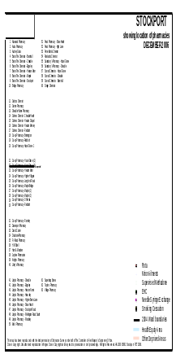
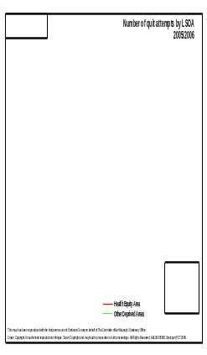
Location of pharmacy services (southern part of ward)
40-60 quit attempts (dark blue) compared with 20-40 attempts further north (lighter blue)

The introduction of a pharmacy cessation service in the northern hub of the Brinnington estate may increase the number of quit attempts.

[It is important to note that the success of the quit attempts does not correlate with the existence of pharmacy services. In the area with 3 pharmacy services, the quit success rate is only 25-45% whereas the area to the north which has no pharmacy services has a quit success rate of 55-100%.

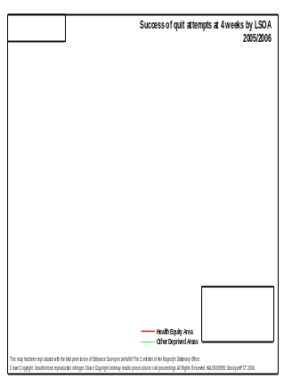
34-45% successful quit rates (where there are no pharmacy services)
34-45% successful quit rates (where there are no pharmacy services)

55-100% successful quit rates (where there are no pharmacy services)

This anomaly may be because the Brinnington Health Centre and GP practice, which have the highest attempt and quit rates, are based in this dark blue area.]

10.2.3 Recommendations
It is recommended that primary research is undertaken to fully understand the perception of Brinnington residents into accessing cessation services via their GP and their perceptions of accessing cessation services via a pharmacy.

10.2.4 Psychological factors associated with socio-economic status and health

10.2.4a Chance Health Locus of Control
The Health Locus of Control Model may be helpful in explaining the low numbers of quit attempts by people in Brinnington. Steptoe and Wardle (2001) explain that individuals have different types of perceived control over their health:
- Internal control: A person believes they have control over their current and future health through their own choices and behaviour.
- External control: A person believes that powerful others, such as doctors or family, have control over their health.
- Chance control: A person believes the state of their health is down to chance, such as genetics.

Steptoe and Wardle found that people with high internal health locus of control will choose to engage in health promoting activities such as enrolling in a cessation service, while people with external or chance loci believe they have limited control over their own health. The model itself does not attempt to draw a link between class and locus of control, but Steptoe and Wardle (2003) in later national cross-sectional research did find that the “strong beliefs in the importance of chance in health were inversely associated with social class”.

If chance control is linked both to lower socio-economic groups and to unwillingness to engage in healthy behaviours, it is likely that Brinnington residents also experience chance locus of control which may contribute to an unwillingness to engage with local smoking cessation services. It is suggested this may be found to be correct given the figures relating to uptake of cervical and breast cancer screening. In Brinnington cervical screening was at 83.0% and breast cancer screening at 65.3%. Both were lower than the Stockport averages of 84.1% for cervical and 72.0% for breast screening. This information may be indicative that Brinnington residents have limited internal health locus of control.

10.2.4b Seldom thinking about the future
Steptoe and Wardle (2003) also found a strong correlation between the likelihood of seldom thinking about the future and socio-economic status. This has been corroborated by other research, which found a prevalence of fatalism amongst groups with lower socio-economic status (Pierpont and Davidson, 2004; Klein, 1948). The link between fatalism and lower socio-economic status is likely to have significant impact over Brinnington smokers’ willingness to visit cessation services, because of a subsequent limited drive to voluntarily act to improve life expectancy through changing a health-related behaviour.
10.2.4c Seldom thinking about things that can be done to keep healthy.

Strongly linked to the previous two psychological barriers to uptake of smoking cessation services is the link found by Steptoe and Wardle (2003) between low socio-economic status and consideration of actions possible to improve health. Steptoe and Wardle (2003) found that “the odds of seldom thinking about things that can be done to keep healthy were greater in classes III and IV/V than in classes I/II”, which suggests a chance that Brinnington smokers may not actively think about using a cessation service to improve their own health.

10.2.4d Attitudes towards smoking
As has been discussed in the previous section, the social norm amongst deprived, working class communities is often to smoke. This is corroborated by the prevalence of 40% in Brinnington. Attitude to smoking, therefore is unlikely to be negative.

The Theories of Reasoned Action and Planned Behaviour tell us that attitude leads to intention which leads to action:

If the attitude of Brinnington smokers is that smoking is an accepted behaviour, this will have significant impact on intention to give up and therefore enrolment in a cessation program.
10.2.4e Motivation to quit
Smoking is now commonly recognised as nicotine addiction and, as an addiction, produces symptoms of dependence and withdrawal germane to addictive behaviour and obstructive to cessation attempts. Like other addictions, trying to give up smoking has a remitting and relapsing element. For an attempt to stop smoking to be successful, the smoker must want to stop. Allegedly, over 70% of smokers say they would like to quit.

As the TRA above indicates, motivation to comply with the social norm has an effect over attitudes and subsequently intention and action to change behaviour. The 40% smoking rate in Brinnington indicates that it is the social norm to smoke. It is posited here that the social norms within deprived housing estates such as Brinnington can be strengthened as a result of the particular type of social capital particular to people living in these conditions. Motivation to comply with social norms, therefore, can be particularly strong.

Research has proven that there is wide knowledge of the health dangers of smoking (Lambert et al, 2002). Given the constant exposure to the anti-smoking message in the national media, it could be logically asked why greater numbers of working class people do not make lifestyle choices to defy their social norm, thereby organically shifting quitting towards the tipping point of cultural acceptance.

It is posited here that working class people such as those living in Brinnington have limited social capital, which affects their perceived self-efficacy to quit. Perceived self-efficacy (PSE) can be described as motivation or personal drive. It is important to consider PSE on 2 levels. Firstly, a smoker in Brinnington must have the PSE to overcome social norms. Secondly, a smoker must have the personal drive and PSE to overcome their addiction. In this section the first issue (overcoming social norms) will be discussed and in the next, personal motivation will be explored.

It is suggested here that working class residents of Brinnington will have both limited social capital and bonding social capital. It will be discussed here how a combination of these leads to the type of social capital which appear to lead to limited meaningful visibility of alternative lifestyle choices, including non-smoking. This limited visibility is likely to strengthen the working class social norm of smoking.

Social capital refers to the “networks that link individuals and the resources embedded in those linkages (Kraig and Hipp, 2005). Someone with a large and diverse social network can be said to have a great deal of social capital. Someone with a small and analogous social network can be said to have limited social capital. The positive benefits of social capital are well documented as Kraig and Hipp (2005) explain:
Social capital promotes social support, boosts physical health, improves academic performance and increases job contacts.

It is no coincidence that the listed benefits are often associated with middle class existence: Middle class people are known to be healthier than working class people, have higher academic qualifications and by definition more rewarding jobs. It is a settled view that middle class people have more social capital than their working class counterparts.

The reasons for Middle Class people having more social capital are logical. As a result of their extended network, they are often able to pursue a far greater number of different opportunities, hobbies, activities, holidays, sports, clubs and interests. The result of diverse and numerous opportunities is a broad horizon which in turn places middle class groups in contact with a diverse and extended group of people (and more social capital).

By this argument, working class people, with less social capital, will be presented with fewer fresh opportunities and therefore fewer chances to increase and diversify their social capital.

As the discussion has shown, it is likely that the social networks of working class people are considerably more compact than middle class social networks because there is a tendency for working class people to settle in the same small geographical area in cascading generations; (whereas middle class school leavers scatter as they attend universities across the country). This may be largely due to a lack of income, which limits housing choice to council housing estates.

It is also suggested here that although the working class group have far smaller and less diverse social networks, the social bonds which tie community members together can be extremely strong. The key social network of many working class people is with family, who often live on the same housing estate. The simplistic diagram below illustrates that a middle class individual’s social bonds, apart from the strong bonds with close friends, are likely to be more diverse and less tight than the strong but analogous bonds of a working class individual.
Model to illustrate the bonding and limited social capital of working class groups

Robert Putnam distinguished between these two types of social capital. He suggests there is ‘bridging’ social capital and ‘bonding’ social capital. It is suggested that there is a high chance that Brinnington residents will have considerable ‘bonding’ social capital, “in which linkages are mainly or exclusively among members of the same group” (Kraig and Hipp, 2005). These bonds are strong but condensed and not diverse. By contrast, evidence suggests that as well as having more social capital, middle class people have more of the ‘bridging’ type, “in which linkages exist among members of different communities” (Kraig and Hipp, 2005). [It is noteworthy that middle class society can be lonelier than working class life because of the weaker nature of their social bonds.]

Description of the social capital owned by different classes
Description of the social capital owned by different classes

Middle class social capital | Large social networks  Diverse social networks  Considerable social capital  Bridging social capital
Working class social capital | Smaller social networks  Less diverse social networks  Less social capital  Strong bonds: Bonding social capital

There may be significant implications of these differences on the working class social norm and their image incongruency with non-smokers. Putnam suggested that “if there is only bonding social capital it can result in hermetically sealed communities, like in Belfast or Bosnia.” It is suggested that working class communities such as Brinnington, although not to the extent of Belfast or Bosnia, can appear hermetically sealed.

A result of a limited but strongly bonded ‘hermetically sealed’ community, coupled with the negative environment of deprivation, is a lack of visibility of a life where other social norms exist, such as not smoking. This lack of visibility is very likely to strengthen social norms within the group and prevent individuals from defying that strong social norm.

To conclude, the bonding and limited social capital of working class people suchas Brinnington residents is likely to lead to strong social norms. Motivation to comply with social norms is therefore likely to be high in Brinnington. This would impact smokers’ motivation to defy the social norm by enrolling with a cessation service to quit smoking.

10.2.4f Perceived self-efficacy to quit
As mentioned in the previous section, motivation or drive stretches beyond an individual’s ability to defy social norms to their ability to personally change their unhealthy behaviour. Perceived self-efficacy is a frequent feature of the behaviour change literature, as it is considered central to the success of change. Key mentions of the construct are in the Social Cognition Theory and Transtheoretical Model.

The Transtheoretical Model (Stages of Change Model) focuses on the “varying degrees of readiness experienced by individuals engaged in a new behaviour” (Marcus et al, 1994).
The Transtheoretical Model

The model specifies that a person’s ability to move through the stages is dependent on their perceived self-efficacy. As the stages are conquered, self-efficacy is said to increase. Similarly, pre- or serial-contemplators who have a history of failure will likely have low perceived self-efficacy (Prochaska et al, 1991; Marcus et al, 1994).

Schwarzer and Fuchs (1995) explain that the Social Cognition Theory’s key component; perceived self-efficacy:
Perceived self-efficacy represents the belief that one can change risky health behaviours by personal action, e.g., by employing one's skills to resist temptation.
Schwarzer and Fuchs explain that efficacy beliefs will affect the intention to initiate exercise, and dictate the amount of effort that can be expended to attain the goal, and the persistence to continue striving in spite of barriers that undermine motivation.
Bandura explained that low perceived self-efficacy can lead to failure:
Those who judge themselves as inefficacious are more inclined to visualise failure scenarios that undermine performance by dwelling on how things will go wrong.
(Bandura, 1989)

This model implies that given the prevalence of smoking amongst C2DE group (to recap, 35% compared with 15% amongst ABC1 adults nationally), it is possible that low perceived self-efficacy is a characteristic of target group members.

The Theory of Planned Behaviour builds on the Theory of Reasoned Action by including the concept of perceived behavioural control, which has been said to be similar to perceived self-efficacy.

Griffen (2004) explains that “PBC represents the relative controllability of behaviour and is based on a perception of ease or difficulty in performing behaviour.” PBC is related to past experience, skill, ability and confidence and is a “reflection of perceived barriers, such as time, opportunity and money” (Griffen, 2004).

The literature suggests that working class people may demonstrate lower perceived self-efficacy than middle class people. There are 3 suggested reasons for this:

i Low social capital can lead to low self-efficacy.
It is suggested that low social capital creates limited exposure to different opportunities, activities or experiences. A natural consequence of this limited experience is a lack of confidence because trial leads to self-awareness, competency and prowess. Wide experience also dilutes failure with successes of different magnitudes. A lack of confidence is a prime cause of low perceived self-efficacy and may in part be caused by unemployment, which is an immediate limiter of the experience of success and also a limiter of social capital. It has already been noted that there is high unemployment in Brinnington.

ii Money can buy opportunities, increasing social capital and therefore confidence
It is undeniable that financial capital can open doors to more opportunities. Holidays, hobbies, activities and travel all costs and being able to afford these opportunities (as middle class people with higher incomes are likely to be able to do) leads to increased social capital, confidence and PSE.

iii Unrewarding employment leads to low self-esteem and lack of self-efficacy
It has been discussed that financial capital can lead to improved PSE. Middle class financial capital is most likely to have been earned through a well remunerated occupation, and it is suggested that other aspects of a rewarding job also contribute to higher confidence and PSE. A well paid occupation most likely involves responsibility, job security and prospects. Indeed these elements were used by Goldthorpe, in addition to occupation and income, to differentiate between working and middle classes (Goldthorpe, 1987).

Boardman and Robert (2000) corroborate the suggested link between low PSE and socio-economic status in their research, which indicates that high proportions of neighbourhood unemployment and public assistance are associated with low levels of self-efficacy.

It is therefore suggested that the smokers in Brinnington may not have high enough levels of PSE to drive themselves along the stages of change to quit. Boosting their PSE, therefore may be necessary to have a positive effect on desire to quit and subsequent enrolment in available cessation services.

10.2.4g Beliefs in health benefits
The Health Belief Model states that motivation to change an unhealthy behaviour principally depends on how much an individual believes he or she is at risk from a health problem (Elder et al, 1999). The literature suggests that when smoking is prevalent in an individual’s life, such as when family members, community members or neighbours are seen to be smoking regularly, perceived risk is lessened (Rodriguez et al, 2007). It is likely that given the high smoking prevalence, this situation is true for Brinnington. It may be that the low attempt-to-quit rate is as a direct result of Brinnington smokers not perceiving themselves to be at risk from the well-documented health risks of smoking. This is of course strongly linked with the sense of fatalism discussed in the previous section on health locus of control.

10.2.4h Perceived barriers to healthy lifestyle
The difficulty of life in a deprived environment must not be underestimated. With serious financial limitations, limited opportunities, low education levels, unrewarding or no employment, poor quality housing, a dirty and dangerous neighbourhood and few quality yet affordable public facilities, taking control of health may seem beyond the personal scope of residents. Maslow’s hierarchy of needs is a useful way of looking at this problem.
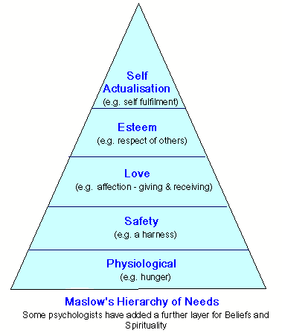
This model suggests that when the physiological or safety layers are a daily battle, those of self-esteem or self-actualisation, including taking care of personal health, go unheeded. The struggle to meet physiological or safety needs in deprived communities is yet another factor contributing towards low self-esteem (and therefore low perceived self-efficacy), mental health illness, lack of visibility of alternative behaviours and lack of health belief. It may be that Brinnington residents demonstrate a lack of willingness to enrol in cessation projects because giving up smoking is not a priority when there are other daily struggles to overcome.

A summary of the previous discussion is included in 10.3.

10.2.5 Recommendations
It is recommended that primary research is undertaken in Brinnington to assess the extent to which these psychological factors have impacted the uptake (and as will be explored in section 10.3, success) of local cessation services.

10.2.6 The link between mental illness and quit attempt levels.

An informative ASH report by Dr Ann McNeill states that with the right treatment, mental illness does not necessarily reduce quit success rates but rather attempts:
There is some suggestion that mental health problems may undermine attempts at quitting rather than ability to stop.

McNeill quotes a US study which found that quit rates amongst mentally ill people can be high. The study found that over a third of patients with any history of mental illness reported having quit and that 30% of those with mental illness in the last month reported having quit. Quitting isn’t the problem, then, but rather making the attempt.

It was suggested in the previous section that mental ill-health often leads to smoking and that the high levels of mental illness in Brinnington may be one reason why smoking rates are especially high. Here, it is suggested that the mental ill-health of many Brinnington residents also leads to lower attempt rates but that the right treatment can be successful. Dr McNeill reported that in a survey of schizophrenics, around half wanted to give up and most were aware of the health risks. She suggested that access to appropriate services may be the problem.
It is important to be able to respond appropriately to requests for support and also to be proactive in reaching out to smokers with mental health problems in the community.

Her key findings were that
- although the link between mental illness and smoking is known, there is “no guidance for health professionals running cessation services as to how best support smokers with mental health problems”.
- psychiatric nurses were in the ideal position to intervene to start a cessation program (but that timing is crucial so as not to exacerbate vulnerable illnesses). “Mental health professionals have an important role to play in encouraging supporting smokers attempts to stop”.
- there is significant evidence that combining behavioural treatments for mental illness with smoking cessation treatment had excellent results. “Effective treatments include group therapy, NRT and Buproprion. There is some evidence that adapting the treatment program for smokers with mental health problems may enhance efficacy.”.

10.2.7 Recommendations
In line with the advice in Dr McNeill’s ASH report (and suggestions from the previous section), it is recommended that primary research be undertaken to fully understand the scope of the mental health problem in Brinnington and that more thought be given into how to reach smokers in Brinnington who have a mental health illness.
There is some evidence from a qualitative Australian study that smokers with mental health problems feel excluded from mainstream smoking cessation programs.

  - Question 3
Why are the quit success rates in Brinnington so low?

Smoking is extremely addictive. Commenting on the New Year ‘hooked’ anti-smoking advertising campaign, Robert West, Professor of Health Psychology at University College London, said that "smoking is not just a habit - for many smokers it's a complex and powerful addiction. The nicotine in cigarette smoke can be as addictive as heroin and crack cocaine.” To the question ‘why do most attempts [to quit] fail, Copeland et al (2005) suggest that “many smokers appear to use the most ineffective method - cold turkey - and few smokers report receiving help”. This suggests that giving up smoking is extremely difficult and that considerable psychological strength and socio-cultural support is likely to be required to succeed.

For his ASH report, Crozier (2001) concurred with the suggestions made in the previous sections by suggesting that possible explanations for the lower quit rates observed among people from the lower socio-economic groups include
- levels of motivation to quit
- higher levels of dependence on nicotine
- greater stress.

He mentioned research which has shown that poorer smokers are indeed more dependent on nicotine. Commentators have argued that this may be due to a number of factors, including the use of cigarettes as a form of self-medication for stress. It may be due to the earlier age of starting to smoke observed among poorer smokers. Also, it may be due to economics: each cigarette is worth more, and therefore smoked more intensively (Jarvis 2000).

The following discussion builds on Crozier’s findings and the previous suggestions to explain the lower levels of cessation success in Brinnington.

10.3.1 Psychological barriers to cessation success
It is suggested that some of the psychological barriers to attempting cessation discussed in the previous section are also related to the low success rates of these attempts. The table below both summarises the suggestions made in the previous section and relates some of them to the issue of failure to quit.

 | Issue relating to low  attempt rates | Related to low success rates
Change locus of control | Increased internal control would improve an individual’s belief that they are directly responsible for their own health and therefore attempts to quit, rather than ‘blaming’ conditions perceived to be beyond their control.
Seldom thinking about the future | With little planning or consideration for the future long-term problems associated with smoking, giving up smoking for healthy people is not going to be a present priority.
Seldom thinking about things that can be done to keep healthy | Quitting smoking is an action which is associated with improving health. If considerations about health are rare, quitting is unlikely to be considered.
Attitudes towards smoking | If the attitude towards smoking is not negative (positive or ambivalent), quitting will not be a priority.
Beliefs in health benefit | A cessation attempt is unlikely if there is limited belief that smoking is damaging to health, or that the individual is susceptible to ill-health through smoking.
Perceived barriers to healthy lifestyle | If a healthy lifestyle is considered to be impossible to realise, attempts to achieve a healthy lifestyle will be limited, including cessation attempts.
Motivation to quit | If motivation to quit is low, cessation services are unlikely to be attended. | If motivation to quit is low, successful quitting is unlikely.
Perceived self-efficacy to quit | If perceived self-efficacy to quit is low, cessation attempts may be avoided altogether. | If perceived self-efficacy to quit is low, cessation attempts are less likely to succeed.

This table suggests that a low motivation to quit and low perceived self-efficacy to quit (which are strongly linked) are significant barriers to successful quitting. Both have already been discussed, but to recap, it is worth repeating the quote by Bandura, who stated that
Those who judge themselves as inefficacious are more inclined to visualise failure scenarios that undermine performance by dwelling on how things will go wrong.
(Bandura, 1989)

10.3.2 Socio-cultural barriers to cessation success

In addition to the psychological barriers to cessation success, the strong cultural and social barriers to cessation attempts may also be construed as barriers to success. In the previous section the symbolic significance of smoking in working class life was explored. It was then suggested later that motivation to defy this social norm was not high because the nature of the social capital common in working class society means the social norm is particularly strong and constantly reaffirmed through high levels of observable smoking behaviour. Phrasing this problem differently, it is possible to see that an attempting quitter would have difficulty overcoming such a strong social norm and that this norm may in itself prove to be a barrier to success as well as to attempts.

  - Question 4
What would be the best intervention mix for Brinnington residents?

There are 2 parts to this section. The first part will explore interventions which have worked best in similar deprived communities across the UK. The second will suggest research to design the best combination of interventions for Brinnington

    - GP interventions: advice with NRT
As an instrument of health directives from government bodies, healthcare workers have a vital role in the success of smoking cessation interventions in all groups of society, perhaps even more so in disadvantaged communities. Demographic characteristics of these communities such as low income or unemployment can result in more frequent consultations with GPs than occur in more affluent communities.

Involving GP surgeries in increased provision of smoking cessation services has the obvious benefit of using an infrastructure that is already in place and is accessed regularly by those living in disadvantaged communities and is in keeping with the recommendation to expand smoking cessation services

In particular, it has been recognised that GPs are usually the first point of contact for smokers with health problems and as such GPs have recently been encouraged to give smoking cessation support for patients. Recommendations urge GPs to discuss smoking repeatedly and as frequently as possible. It has been shown that brief GP advice during a consultation can aid smoking cessation and is very cost-effective. As well as the advice-only approach there are effective approaches to smoking cessation which include behavioural intervention and pharmacotherapy and can involve the GP.

Copeland et al’s 2005 study focused on smokers from a practice in North West Edinburgh with over 10,000 patients managed by 7 GPs in 2003. The practice is situated in an area which is recognised as having markers of socio–economic deprivation such as high unemployment, heavy use of primary care services and a high prevalence of smoking. For the main analysis purposes the sample size consisted of the 101 who used their prescription and completed follow up forms (40 males and 61 females). Initial motivation was found to be strong in male participants with 20 (50%) describing themselves as “very determined” to stop and 18 (45%) as “determined”, and two (5%) as “quite determined”. For females, initial motivation was even stronger, with 42 (68.9%) describing themselves as “very determined”, 15 (24.5%) as “determined”, and four (6.6%) as “quite determined”.

Outcome in terms of smoking cessation was as follows: 35 (35%) smoked the same, 46 (45%) were smoking less and 20 (20%) had stopped. This graph illustrates the results of this study:
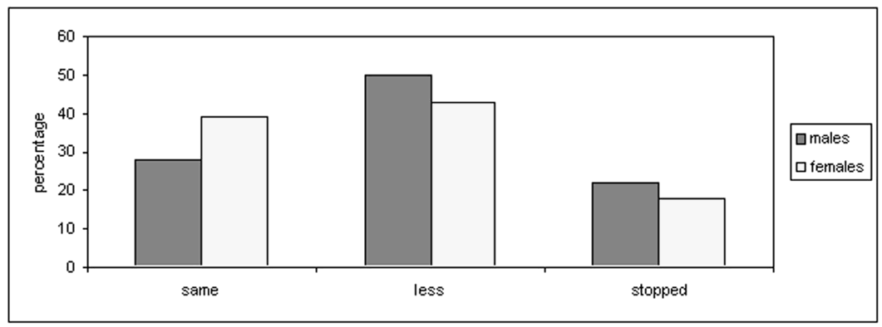
For those who had managed to stop smoking with the help of NRT patches, the following reasons for their success were given in qualitative responses:
- 1 (5%) felt patches helped stop craving;
- 5 (25%) said the patches were easy to use,
- 5 (25%) said they had a noticeable improvement in health (no details were given as to what this was)
- 9 (45%) said they had managed to stop because of a strong determination to quit.
It was apparent, therefore, that nearly half of those who had been successful felt that their own will power was a very important influence on outcome. It is also interesting to note that initial motivation was similarly distributed in all three outcome groups with 31 (89%) of those smoking the same, 45 (98%) of those smoking less and 19 (95%) of those who stopped describing themselves as either “very determined” or “determined” to stop.

It is noteworthy that The Independent Inquiry into Inequalities in Health recommended both for the short and longer term the provision of Nicotine Replacement Therapy (NRT) on prescription to reduce nicotine dependence, which is likely to be stronger in disadvantaged smokers (Jarvis and Wardle, 1999).

    - Pharmacies
Bellingham (2004) quotes Nicola Gray, lecturer in pharmacy practice at the school of pharmacy, University of Nottingham: “Pharmacies in deprived communities can become a focal point for the community. One possibility is to bring other services into the pharmacy, such as nurses, counsellors and even things like the Citizens Advice Bureau.”

In Dundee, a community pharmacy that specialises in health promotion has demonstrated exactly this. It was refurbished two years ago and the outcomes seen so far are positive. A survey found that 30 per cent of customers used the pharmacy more frequently since the new services were introduced and 80 per cent are comfortable about talking to pharmacy staff about health promotion. Among the services the pharmacy offers are blood pressure monitoring, testing peoples’ inhaler technique, group smoking cessation, glucose monitoring meter servicing and drug misuse services. It also offers chiropody clinics and welfare rights’ surgeries. A large section of the pharmacy has been sectioned off for health promotion where over 500 customers a month access touch-screen health information.
Pharmacy’s accessibility is a key strength in providing public health services to as large a proportion of the general public as possible.

10.4.3 Specialist services
The Independent Inquiry into Inequalities in Health recommended community based interventions to tackle smoking prevalence in low income groups. No specific review of Specialist Services for disadvantaged groups was found, but it is often mentioned in the literature the importance of designing services specifically to attract economically disadvantaged smokers. Findings from Pound et al (2005) found that in all 19 of the Health Authorities they studied, evidence of 'positive discrimination' towards the most disadvantaged two quintiles was identified and supported. While the results demonstrate evidence of effectiveness of reach, they do not address the issue of whether disadvantaged smokers were quitting with support from NHS smoking cessation services.

    - Policies
The Independent Inquiry into Inequalities in Health recommended policies to improve the living standards of low income households and policies to help smokers in these households become and remain ex-smokers. It is expected that the national smoking ban and workplace smoke free policies will positively effect attempt and quit rates in lower income groups because of the importance and strength of the social norm amongst these groups. With peer support, attempt and quit is more likely.

Several sources suggested that a dramatic increase in the cost of cigarettes, or cigarettes bought in small packs, would not necessarily reduce smoking prevalence amongst deprived communities. It has been suggested that already the percentage spent on smoking by lower socio-economic groups is far higher than those in more privileged communities and that addiction can be more gripping for vulnerable people, rendering smoking far less a choice and more something physiologically necessary.

    - Brief interventions
The efficacy of brief interventions is low, but the potential for reaching large numbers of people is high. All health workers, no matter what their discipline, should be trained in line with NICE guidelines to sensitively assess smoking status and signpost cessation services. Relationships of trust, for example between new mothers and health visitors, may provide health workers with excellent opportunities to signpost cessation services.

Based on the earlier discussion of relationships of trust and mistrust between people from deprived communities and health authority figures, it would be important to ascertain the views of Brinnington residents on their local health community leaders to see if alternative ‘voices’ would be more appropriate. Hastings and McLean suggest that initiatives targeting low socio-economic groups should not sever links with successful quitters but build relationships with them, recruit them as volunteers or paid helpers:
They could boost attendance at the SCS, increase empowerment (they are living, breathing testimonials) and even set up additional services such as self- help groups.

    - Mobile cessation services
In 2005, the Livingston stop smoking project in Scotland was voted to be the best in Britain. Called the Stop for Life project, based in St John’s Hospital in Livingston, West Lothian, it won the QUIT award for being the best smoking cessation project in the UK. Stop for Life is a smoking cessation scheme for mums-to-be and new mothers, their partners are also encouraged to attend. Stop for Life is funded by ASH Scotland’s Partnership Action on Tobacco and Health (PATH) initiative.
The QUIT awards go to smokers who have overcome great challenges in stopping smoking and the best and most innovative smoking cessation projects.
It was thought that smoking cessation services are seen by many as either too far away or only available at inconvenient times. This was though to be especially true for those from low income backgrounds where there is a greater likelihood of not having access to transport or not being able to afford childcare. Stop for Life sought to solve this problem by getting smoking cessation services for pregnant women and new mothers out into the community.
Rather than expecting people to come to them, Stop for Life takes their program of one-to-one medical advice and support groups into whatever setting is necessary. The two midwives seconded to the project received smoking cessation training and helped people in their own homes, local community centers or nearby GP clinics.
This project was a pilot and one of the first of its kind in the UK, its preliminary findings are that it is a more successful way to help pregnant women and new mums quit smoking.
10.4.7 Recommendations
It is recommended that, where feasible, interventions and intervention mixes are tested in Brinnington in line with knowledge from successful interventions targeting comparable deprived communities.

It is recommended that primary research be undertaken to establish the perceptions of Brinnington towards various interventions:

Future primary research might involve the following:
What would the impact be of holding Quit for Life sessions at different times? | Recommend primary research to assess the impact of increasing the scope of the Quit for Life sessions.
What would the impact be of holding Quit for Life sessions in the Community First building
Would an increase in cessation services (and an increase in a quit culture) in Brinnington increase quit attempts? | Explore the causation between a more accessibility of services and quit attempts.
What is the perception of cessation services out of the hub of the Brinnington estate? | Recommend primary qualitative research to ask Brinnington smokers which cessation services are most appealing

  - Summary of recommendations
10.5.1
Further primary research is recommended to explore whether Brinnington residents consider the image of a non-smoker or non-smoking incongruous with their own self-image. Social marketers are advised to take the results of these findings and design interventions accordingly.

10.5.2
Primary research may be required to assess the level of mental illness of Brinnington smokers. Social marketers may then choose to use this information to target smoking addiction and mental health illness together.

10.5.3
It is recommended that primary research is undertaken to fully understand the perception of Brinnington residents into accessing cessation services via their GP and their perceptions of accessing cessation services via a pharmacy.

10.5.4
It is recommended that primary research is undertaken in Brinnington to assess the extent to which these psychological factors have impacted the uptake of local cessation services.

10.5.5
It is recommended that measures are taken to try and overcome the likelihood of these psychological factors impacting the take up and success of cessation services.

10.5.6
It is recommended that primary research be undertaken to fully understand the scope of the mental health problem in Brinnington and that more thought be given into how to reach smokers in Brinnington who have a mental health illness.

10.5.7
It is recommended that, where feasible, interventions and intervention mixes are tested in Brinnington in line with knowledge from successful interventions targeting comparable deprived communities.

10.5.8
It is recommended that primary research be undertaken to establish the perceptions of Brinnington towards various interventions:

10.5.9
Future research might involve the following:
What would the impact be of holding Quit for Life sessions at different times? | Recommend primary research to assess the impact of increasing the scope of the Quit for Life sessions.
What would the impact be of holding Quit for Life sessions in the Community First building
Would an increase in cessation services (and an increase in a quit culture) in Brinnington increase quit attempts? | Explore the causation between a more accessibility of services and quit attempts.
What is the perception of cessation services out of the hub of the Brinnington estate? | Recommend primary qualitative research to ask Brinnington smokers which cessation services are most appealing

- Final Conclusions
  - Living conditions
As ASH Scotland's Women, Low Income and Smoking project has shown, effective tobacco control strategies in poorer communities can only succeed if there is an improvement in the overall socio-economic circumstances of those who are most disadvantaged and if low income smokers have access to free, local support services. Jarvis (2000) also identifies reducing poverty as a key part of a three-fold strategy to reduce health inequalities from smoking.

11.2 Consumer-centric delivery

National guidance recommends providing cessation services to meet the needs of local populations, so each health authority has developed their own (Lowey et al, 2003). For example, from the discussion of psychological, social and cultural barriers to cessation which may be specific to the target group, it may be that smoking cessation interventions have the following goals:
- to influence an attitude of social unacceptability towards smoking and therefore intention to quit. (“Social marketers often target individuals’ attitudes as a means of influencing social behaviours” (Griffen, 2004).)
- to increase internal health locus of control.
- to increase the sense of responsibility of residents over their life-expectancy and future health.
- to increase residents’ thoughts about how they can actively improve their health.
- to encourage integration into communities with a more diverse spectrum of society.
- to increase perceived self-efficacy to improve self-belief that successful quitting is possible. (Of note is the literature on adolescent smoking prevention programs, which often teach refusal skills in order to help youth resist peer pressure to smoke. Findings suggest that teaching general competence skills as well may help to reduce smoking because youth with better personal efficacy and decision making skills are better able to implement smoking refusal strategies (Epstein et al, 2000).)
- to improve knowledge of the health dangers caused as a direct result of smoking.

Hastings and McLean, in their 2006 paper, ‘Social marketing, smoking cessation and inequalities’, suggest there is a “diversity of needs” amongst smokers, so “we have to question the current policy of offering a standard, one-size-fits-all service”.

Hastings and McLean, claim that UK Smoking Cessation Services make only a marginal impact at a population level. They suggest that even if 40% of smokers were to sign up (currently approximately 7%) prevalence would drop by only 1%. Social marketing suggests that the way to move beyond this limited role is to become more 'consumer orientated' by understanding that all smokers are not the same. Hastings and McLean also question the mismatch between the 6 week length of the service and the outcome, cessation at 12 months.

Hastings and McLean compare smoking cessation with a driving school and suggest;

You would not expect to be told that you had six lessons to learn to drive, then you would sit your test whether you felt ready or not, and pass or fail the driving school would wash their hands of you. Rather, you would expect them to customize their offering to meet your particular needs—which ultimately is not for driving lessons, but a driving licence.

If a more bespoke service is the answer, knowledge about why people do or do not use cessation services is essential. We need to know what service users like, how they felt and if they would repeat their experience.

Hastings and McLean suggest that measuring success with throughput and quit rates is dangerous because it puts the focus on yesterday rather than tomorrow, may encourage unscrupulous ‘selling’ and may drive down quality.

Based on the relationship marketing model, Hastings and McLean advocate the concept of building relationships with cessation service users. They ask,
What do smoking cessation services do with customers who come to the end of their course? Some offer 'relapse prevention' or longer-term follow-up, but mainly they simply say 'goodbye'. Business, with its emphasis on relationship- building, would not be so profligate.

Most smokers do not succeed, so re-engaging with them at an appropriate point in the future would leave them with the sense of hope rather than abandoned failure.

Derek Wanless’ (2004) review of the UK health scene, talked about 'full engagement' and how this could bring about a 'step change' in health improvement; the White Paper advocated social marketing.

Appendix 1

ASH deprivation map.
http://www.ash.org.uk/html/policy/menlitrev.pdf

Appendix 2:

Raw data for health-related questions from Brinnington survey Jan 2007

TOTAL: 600 | CURRENTLY SMOKE | 311 (51.8%)
TOTAL: 600 | I USED TO SMOKE, BUT HAVE GIVEN UP | 66 (11.0%)
TOTAL: 600 | I HAVE NEVER SMOKED | 223 (37.2%)
TOTAL: 600 | INTENTION TO STOP SMOKING IN THE NEXT THREE YEARS
TOTAL: 311 | 1 - YES DEFINITELY | 52 (16.7%)
TOTAL: 311 | 2 - YES PROBABLY | 77 (24.8%)
TOTAL: 311 | 3 - NOT SURE | 71 (22.8%)
TOTAL: 311 | 4 - PROBABLY NOT | 46 (14.8%)
TOTAL: 311 | 5 - DEFINITELY NOT | 65 (20.9%)
TOTAL: 246 | WHAT WOULD BE YOUR MAIN REASONS FOR STOPPING SMOKING?
TOTAL: 246 | COST OF CIGARETTES | 90 (36.6%)
TOTAL: 246 | YOUR CURRENT HEALTH | 42 (17.1%)
TOTAL: 246 | YOUR LONG TERM HEALTH | 85 (34.6%)
TOTAL: 246 | HEALTH OF OTHERS | 47 (19.1%)
TOTAL: 246 | PRESSURE FROM FAMILY OR FRIENDS | 20 (8.1%)
TOTAL: 246 | SMOKING IN PUBLIC IS INCREASINGLY DIFFICULT | 8 (3.3%)
TOTAL: 246 | SUPPORT TO HELP STOP SMOKING IS AVAILABLE | 8 (3.3%)
TOTAL: 246 | OTHER | 1 (0.4%)
TOTAL: 246 | DON'T KNOW | 59 (24.0%)
TOTAL: 246 | REFUSED | 1 (0.4%)
TOTAL: 600 | HOW OFTEN DO YOU TAKE MODERATE PHYSICAL ACTIVITY FOR 30 MINUTES OR MORE IN TOTAL IN A WEEK (THIS COULD BE 3 LOTS OF 10 MINUTES OR 2 LOTS OF 15 MINUTES OF ACTIVITY)?
TOTAL: 600 | LESS THAN ONCE A WEEK | 205 (34.2%)
TOTAL: 600 | 1-2 TIMES A WEEK | 193 (32.2%)
TOTAL: 600 | 3-4 TIMES A WEEK | 150 (25.0%)
TOTAL: 600 | 5 OR MORE TIMES A WEEK | 52 (8.7%)
TOTAL: 600 | ON A TYPICAL DAY, HOW MANY PORTIONS OF FRUIT AND VEGETABLES DO YOU EAT?
TOTAL: 600 | ONE | 35 (5.8%)
TOTAL: 600 | TWO | 193 (32.2%)
TOTAL: 600 | THREE | 177 (29.5%)
TOTAL: 600 | FOUR | 94 (15.7%)
TOTAL: 600 | FIVE | 77 (12.8%)
TOTAL: 600 | NONE | 19 (3.2%)
TOTAL: 600 | DON’T KNOW | 4 (0.7%)
TOTAL: 600 | REFUSED | 1 (0.2%)
TOTAL: 600  MEAN: 363.7  STANDARD ERROR: 19.45 | THINKING NOW ABOUT AN AVERAGE DAY, PLEASE TELL ME APPROXIMATELY HOW MANY HOURS YOU SPEND ALONE? BY ALONE I MEAN DURING WAKING HOURS WITHOUT ANYONE ELSE FOR COMPANY IN YOUR HOME?
TOTAL: 600  MEAN: 363.7  STANDARD ERROR: 19.45 | NONE | 5 (0.8%)
TOTAL: 600  MEAN: 363.7  STANDARD ERROR: 19.45 | ONE | 18 (3%)
TOTAL: 600  MEAN: 363.7  STANDARD ERROR: 19.45 | TWO | 68 (11.3%)
TOTAL: 600  MEAN: 363.7  STANDARD ERROR: 19.45 | THREE | 62 (10.3%)
TOTAL: 600  MEAN: 363.7  STANDARD ERROR: 19.45 | FOUR | 73 (12.2%)
TOTAL: 600  MEAN: 363.7  STANDARD ERROR: 19.45 | FIVE | 33 (5.5%)
TOTAL: 600  MEAN: 363.7  STANDARD ERROR: 19.45 | SIX | 39 (6.5%)
TOTAL: 600  MEAN: 363.7  STANDARD ERROR: 19.45 | SEVEN | 10 (2.5%)
TOTAL: 600  MEAN: 363.7  STANDARD ERROR: 19.45 | EIGHT | 15 (2.5%)
TOTAL: 600  MEAN: 363.7  STANDARD ERROR: 19.45 | NINE | 2 (0.3%)
TOTAL: 600  MEAN: 363.7  STANDARD ERROR: 19.45 | TEN | 13 (2.2%)
TOTAL: 600  MEAN: 363.7  STANDARD ERROR: 19.45 | TWELVE | 31 (5.2%)
TOTAL: 600  MEAN: 363.7  STANDARD ERROR: 19.45 | THIRTEEN | 1 (0.2%)
TOTAL: 600  MEAN: 363.7  STANDARD ERROR: 19.45 | FOURTEEN | 7 (1.2%)
TOTAL: 600  MEAN: 363.7  STANDARD ERROR: 19.45 | EIGHTEEN | 2 (0.3%)
TOTAL: 600  MEAN: 363.7  STANDARD ERROR: 19.45 | TWENTY | 1 (0.2%)
TOTAL: 600  MEAN: 363.7  STANDARD ERROR: 19.45 | TWENTY-FOUR | 2 (0.3%)
TOTAL: 600  MEAN: 1.3  STANDARD ERROR: 0.03 | DURING THE PAST 4 WEEKS, HOW MUCH HAVE YOU BEEN BOTHERED BY PERSONAL OR EMOTIONAL PROBLEMS (SUCH AS FEELING ANXIOUS, DEPRESSED OR IRRITABLE)?
TOTAL: 600  MEAN: 1.3  STANDARD ERROR: 0.03 | NOT AT ALL | 504 (84%)
TOTAL: 600  MEAN: 1.3  STANDARD ERROR: 0.03 | VERY LITTLE | 38 (6.3%)
TOTAL: 600  MEAN: 1.3  STANDARD ERROR: 0.03 | MODERATELY | 41 (6.8%)
TOTAL: 600  MEAN: 1.3  STANDARD ERROR: 0.03 | QUITE A LOT | 9 (1.5%)
TOTAL: 600  MEAN: 1.3  STANDARD ERROR: 0.03 | EXTREMELY | 5 (0.8%)
TOTAL: 600  MEAN: 1.3  STANDARD ERROR: 0.03 | REFUSED | 3 (0.5%)
TOTAL: 93 | DURING THE PAST 4 WEEKS, HOW MUCH DID YOUR PERSONAL OR EMOTIONAL PROBLEMS LIMIT YOUR SOCIAL ACTIVITIES WITH FAMILY OR FRIENDS?
TOTAL: 93 | NOT AT ALL | 20 (21.5%)
TOTAL: 93 | VERY LITTLE | 32 (34.4%)
TOTAL: 93 | MODERATELY | 30 (32.3%)
TOTAL: 93 | QUITE A LOT | 10 (10.8%)
TOTAL: 93 | COULD NOT DO ANY SOCIAL ACTIVITIES | 1 (1.1%)
TOTAL: 93  MEAN: 2.1  STANDARD ERROR: 0.1 | DURING THE PAST 4 WEEKS, HOW MUCH DID PERSONAL OR EMOTIONAL PROBLEMS KEEP YOU FROM DOING YOUR USUAL WORK, SCHOOL OR OTHER DAILY ACTIVITIES?
TOTAL: 93  MEAN: 2.1  STANDARD ERROR: 0.1 | NOT AT ALL | 28 (30.1%)
TOTAL: 93  MEAN: 2.1  STANDARD ERROR: 0.1 | VERY LITTLE | 31 (33.3%)
TOTAL: 93  MEAN: 2.1  STANDARD ERROR: 0.1 | MODERATELY | 27 (29%)
TOTAL: 93  MEAN: 2.1  STANDARD ERROR: 0.1 | QUITE A LOT | 6 (6.5%)
TOTAL: 93  MEAN: 2.1  STANDARD ERROR: 0.1 | REFUSED | 1 (1.1%)
 | HAVE YOU, YOUR PARTNER, OR ANY OF THE SCHOOL AGED CHILDREN IN YOUR HOUSEHOLD BEEN ACTIVELY INVOLVED IN AT LEAST ONE LOCAL COMMUNITY OR VOLUNTARY ORGANISATION IN THE PAST 12 MONTHS? ("INVOLVED" MEANS ATTENDED EVENTS OR HELPED IN ACTIVITY AT LEAST THREE TIMES IN THE LAST YEAR. "LOCAL" MEANS IN THE BRINNINGTON AREA). PLEASE CODE ALL THOSE THAT APPLY)
RESPONDENT  TOTAL: 600 | YES | 34 (5.75%)
RESPONDENT  TOTAL: 600 | NO | 565 (94.2%)
RESPONDENT  TOTAL: 600 | REFUSED | 1 (0.2%)
PARTNER TOTAL: 427 | YES | 13 (3%)
PARTNER TOTAL: 427 | NO | 329 (77%)
PARTNER TOTAL: 427 | REFUSED | 9 (2.1%)
CHILD 1 TOTAL: 241 | YES | 1 (0.4%)
CHILD 1 TOTAL: 241 | NO | 227 (94.2%)
CHILD 1 TOTAL: 241 | REFUSED | 13 (5.4%)
CHILD 2 TOTAL: 143 | YES | 0 (0%)
CHILD 2 TOTAL: 143 | NO | 142 (99.3%)
CHILD 2 TOTAL: 143 | REFUSED | 1 (0.7%)
CHILD 3 TOTAL: 57 | YES | 0 (0%)
CHILD 3 TOTAL: 57 | NO | 54 (94.7%)
CHILD 3 TOTAL: 57 | REFUSED | 3 (5.3%)

Tackling Health Inequalities: Status Report on the Program for Action (2005)
Key Facts on Stockport’s Health
Brinnington Neighbourhood renewal Local Area Strategy and Action Plan November 2004. [http://216.239.59.104/search?q=cache:r1ZGFidvntkJ:www.stockport.gov.uk/content/communitypeopleliving/communityneighbourhood/neighbourhoodrenewal/nrpdfs/brinningtonstratpdf%3Fa%3D54+brinnington,+population&hl=en&ct=clnk&cd=2&gl=uk]
Social Care and Health Scrutiny Committee, Health Inequalities in Brinnington: April 2006
Social Care and Health Scrutiny Committee, Health Inequalities in Brinnington: April 2006
Social Care and Health Scrutiny Committee, Health Inequalities in Brinnington: April 2006
SMR is the rate of deaths relative to the national average rates after adjustments have been made for the age structure and relative social status (or deprivation of the study population).
GHS 2005
ONS Household Survey
Crosier, A; (Feb 2001): A rapid mapping study of smoking projects and services targeted at people living on low income and/or minority ethnic group. Report to the Health Development Agency
However, the Stockport Stop Smoking Service Equity Profile 2002-3 (SSSS Equity Profile) claimed there were likely to be 75,000 smokers in Stockport in 2004, based on CACI market research undertaken 8 years previously. It is claimed that 13.2% of the population are users of stop smoking services. This equates to 4,800 adults.
Living in Britain: results from the General Household survey 1996. London: ONS, 1998
NICE: [http://www.nice.org.uk/page.aspx?o=404622]
The Pharmaceutical Journal, Vol 277, No 7407 p8, 1 July 2006
McNeill, A; (Dec 2001): Smoking and Mental Health: A review of the literature: [www.ash.org.uk/html/policy/menlitrev.pdf]
NICE: http://www.nice.org.uk/page.aspx?o=404622
In the studies, sustained abstinence was defined as abstinence starting within the first six weeks of study.
A rapid and systematic review of the clinical and cost effectiveness of Bupropion SR and NRT for smoking cessation (11th April 2002) [http://www.nice.org.uk/page.aspx?o=30634]
NICE: http://www.nice.org.uk/page.aspx?o=404622
Ritchie, D, Schulz, S & Bryce, A, Feb 8th 2007. Public Health: One size fits all? A process evaluation-the turn of the 'story' in smoking cessation.
ASH: [http://66.102.9.104/search?q=cache:XfBvVV-7qg8J:www.ashscotland.org.uk/ash/files/How%2520to%2520set%2520up%2520and%2520run%2520a%2520Buddy%2520project.doc+success,community+stop-smoking+projects.&hl=en&ct=clnk&cd=6&gl=uk]
Lancaster, T and Stead, L F, 2000. Cochrane Database Syst Rev: Individual behavioural counselling for smoking cessation. Vol 2::CD001292
NICE: [http://66.102.9.104/search?q=cache:iFb6fMZcukIJ:www.gpiag.org/news/smokingcessation/nice_smoking_interventions_quick_reference.pdf+brief+interventions+for+deprived+communities&hl=en&ct=clnk&cd=1&gl=uk]
ASH: [www.ash.org.uk/ntml/policy/menlitrev.pdf]
Takahashi K, Saso H, Saka H, Saso H, Iwata M, Hashimoto I, Naito M, Hamajima N; Jan-Mar 2006. Asian Pac J Cancer Prev: A pilot study on inducement of smoking cessation by a simple 5A (asking, advice, assess, assist, and arrange) approach at outpatient clinics. Vol 7(1):131-5.
Moher, M, Hey, K & Lancaster, T, (2003): Cochrane Database Syst Rev.(2): Workplace interventions for smoking cessation. CD003440. Update in: Cochrane Database Syst Rev. 2005;(2):CD003440.
The Pharmaceutical Journal, (1 July 2006). Vol 277 No 7407 p8
Thousands prepare to quit smoking, (9th March 2005): [http://news.bbc.co.uk/1/hi/health/4327133.stm]
Schar and Gutierrez, (November 2001): Smoking Cessation Media Campaigns from Around the World. Recommendations from lessons learned
West, R. (2002): Helping patients in hospital to stop smoking. BMJ: 324:24
Social and Health Scrutiny Committee: Health Inequalities in Brinnington, (April 2006)
It is acknowledged that smoking cessation services have expanded considerably since 2002-3 and are now very different. There are, for example, 100% of GPs delivering smoking cessation compared with about 8 in 2002/3 and the pharmacy scheme has 27 operational pharmacies providing support.
Smokers are considered to have successfully stopped smoking if they have been smoke free for the four weeks following their quit date. After one year attempts are made to follow-up smokers who had successfully stopped smoking at four weeks. Firstly a daytime phone call is made, if the client is not contacted then an evening phone call is made and finally a letter is sent with a freepost return envelope. Only those who have been completely smoke free are classed as successfully quit at one year.
West R, McNeill A, Raw M. (2000): Smoking cessation guidelines for health professionals: an update. Thorax; 55:987-999
GP-only figures by 2004 ward. AttemptsQuits%2004 Ward Name2639435.74(unclassified)823846.34Bramhall North634368.25Bramhall South1376245.26Bredbury & Woodley1929247.92Bredbury Green & Romiley2347933.76Brinnington & Central1243528.23Cheadle & Gatley1475638.10Cheadle Hulme North843845.24Cheadle Hulme South2159343.26Davenport & Cale Green2147233.64Edgeley & Cheadle Heath844047.62Hazel Grove773849.35Heald Green1416646.81Heatons North1638250.31Heatons South1657746.67Manor1043331.73Marple North1716538.01Marple South1406244.29Offerton1827641.76Reddish North24810241.13Reddish South774153.25Stepping Hill
Crosier, A; (Feb 2001): A rapid mapping study of smoking projects and services targeted at people living on low income and/or minority ethnic group. Report to the Health Development Agency
Email from Sarah Clarke: “These figures need to be treated with caution because Dr Azmy has been reluctant to provide details of his patients to the service in the past. He only provides date of birth, gender and initials and info about the quit attempt. Therefore we only have matched 5 out of the 55 patients to a postcode and 3 of that 5 to the Brinnington area. “In the short term I’m going to ask our information analyst if we can improve the number of patients matched from Azmy’s information in the longer term we will need to persuade him to provide more details of past and future patient’s quit attempts. In the interim we may need to estimate the number of patients he has from Brinnington based on 3 in every 5 patients. Its not very satisfactory I know, but if we acknowledge the limits of the data we have, we can always revisit and revise it later.“ In fact, Dr Azmy’s submission suggests that out of 58 attendees of his one-to-one clinic, 33% successfully quit (19). If we take it that 3 in 5 are Brinnington residents, this equates to 11 successes.
Boseley, S, Health Editor, The Guardian, (October 9th 2006): Iron chain' links smoking and poverty.
Cancer Research: http://info.cancerresearchuk.org/news/pressreleases/2002/december/39557
Laaksonen, M, Rahkonen, O, Karvonen, S & Lahelma, E, (June 2005):European Journal of Public Health, Vol. 15 Issue 3, p262-269
http://www.patientsafety.ucl.ac.uk/256,1,Smoking and health
Pampel, FC, (March 2006): Social Science Quarterly, Volume 87, Number 1, pp. 19-35(17)
http://www.ash.org.uk/html/factsheets/html/fact15.html
Lowe et al; Smoking Cessation Services are reducing inequalities. Journal of Epidemiology and Community Health, (2003), 57, pp 579-580
Health (London). (2006 Jul);10(3):283-301.
Pilnick, A, Coleman, T: (May 2006): Death, depression and 'defensive expansion': closing down smoking as an issue for discussion in GP consultations. Soc Sci Med. 62(10):2500-12. Epub 2005 Nov 28
Steptoe, A and Wardle, J; (2001). Locus of control and health behaviour revisited: A multivariate analysis of young adults from 18 countries. British Journal of Psychology. Vol. 92, pp. 659-672.
Pierpoint, I and Davidson, A, (2004). Geezerland – exploring contemporary working class Britain. MRS Conferences.
Klein, J; 1948. Men in the Pits. London: Gallancz
Copeland, Robertson & Elton, (2005): What Happens When GPs Proactively Prescribe NRT Patches In A Disadvantaged Community. SMJ 50(2): 64-68
Lambert, N; Dibsdall, LA; Frewer, LJ; (November 2002). Poor diet and smoking; the big killers. Comparing health education in two hazard domains. British Food Journal. Vol. 104, Number 1, pp. 63-75.
Prochaska, JO and Velicer, WF; (1997). The Transtheoretical Model of Health Behaviour Change. American Journal of Health Promotion. Vol. 12, no. 1, pp.38-48.
Marcus, BH; Eaton, CA; Rossi, JS & Harlow, LL; (1994). Self-Efficacy, Decision-Making, and Stages of Change. An Integrative Model of Physical Exercise. Journal of Applied Social Psychology. Vol. 24, 6, pp. 489-508.
Marcus et al (1994) explain that motivation to move through the stages of the TTM is also influenced by ‘decisional balance’ (Janis and Mann, 1968; cited in Marcus et al, 1994), which involves a rational assessment of the pros, cons and social consequences of adopting the behaviour. Marcus et al (1994) explain that research has found that for pre-contemplators, the cons outweigh the pros but the balance is redressed as the process of change progresses (Marcus et al, 1994).
Schwarzer, R and Fuchs, R. (1995). Self-Efficacy and Health Behaviours. To appear in: Scott, J; (2002). Social Class and Stratification in late modernity. Acta Sociologica, Vol. 45.
Bandura, A; September (1989). Human Agency in Social Cognitive Theory. American Psychologist. Vol. 44, No. 9, pp. 1175-1184.
Griffen, D; (2004). Exploring anti-smoking and anti-drinking issues in the context of generally accepted consumer theory. Journal of Nonprofit and Public Sector Marketing. Vol. 12(2).
Goldthorpe, J; (1987). Social Mobility and Class Structure in Modern Britain. Oxford: Clarendon Press
Boardman, JD, Robert, SA; (Spring 2000): Neighborhood Socioeconomic Status and Perceptions of Self-Efficacy: Sociological Perspectives, Vol. 43, No. 1, pp. 117-136
Elder, JP; Guadalupe, X; Ayala, MA, & Harris, S; (1999). Adapted from: Theories and intervention approaches to health behaviour change in primary care. American Journal of Preventive Medicine. Vol. 17 (4), pp. 275-284.
Rodriguez D, Romer D, Audrain-McGovern J; (Jan-Feb 2007): Beliefs about the risks of smoking mediate the relationship between exposure to smoking and smoking. Psychosom Med. 2007 Jan-Feb;69(1):106-13.
It was acknowledged that mixing medication with buproprion can be dangerous.
McNeill, A; (Dec 2001): Smoking and Mental Health: A review of the literature: [www.ash.org.uk/html/policy/menlitrev.pdf]
Smoking addiction advert launched BBC News online Friday 29th December 2006. [http://news.bbc.co.uk/1/hi/health/6212373.stm]
Copeland, Robertson & Elton: What Happens When GPs Proactively Prescribe NRT Patches In A Disadvantaged Community
Bandura, A; September (1989). Human Agency in Social Cognitive Theory. American Psychologist. Vol. 44, No. 9, pp. 1175-1184.
Pharmaceutical Journal, 24th August 2002, p240
Bellingham, C; (19 June 2004):The Pharmaceutical Journal, Vol 272 No 7304 p761-762
Crosier, A; (Feb 2001): A rapid mapping study of smoking projects and services targeted at people living on low income and/or minority ethnic group. Report to the Health Development Agency
Pound, E., Coleman, T., Adams, C., Bauld, L. & Ferguson, J. (2005) Targeting smokers in priority groups: the influence of government targets and policy statements. Addiction, 100 (Suppl. 2), 28–35.
ASH: [http://www.ashscotland.org.uk/ash/ash_display.jsp;jsessionid=B23C0C69415DC4437CA4E93E00046542?p_applic=CCC&p_service=Content.show&pContentID=3631&]
Jarvis M. (Jan 2000) The Challenge for Reducing Inequalities. Presentation to Department of Health Seminar.
Griffen, D; (2004). Exploring anti-smoking and anti-drinking issues in the context of generally accepted consumer theory. Journal of Nonprofit and Public Sector Marketing. Vol. 12(2).
Epstein JA, Griffin KW & Botvin GJ; (March 2000): Competence skills help deter smoking among inner city adolescents. Tobacco Control;9(1):33-9
Hastings, G and McLean, N (2006): Social marketing, smoking cessation nand inequalities: Addiction. Volume 101 Issue 3 Page 303.
R. West, personal communication with Gerard Hastings.

