
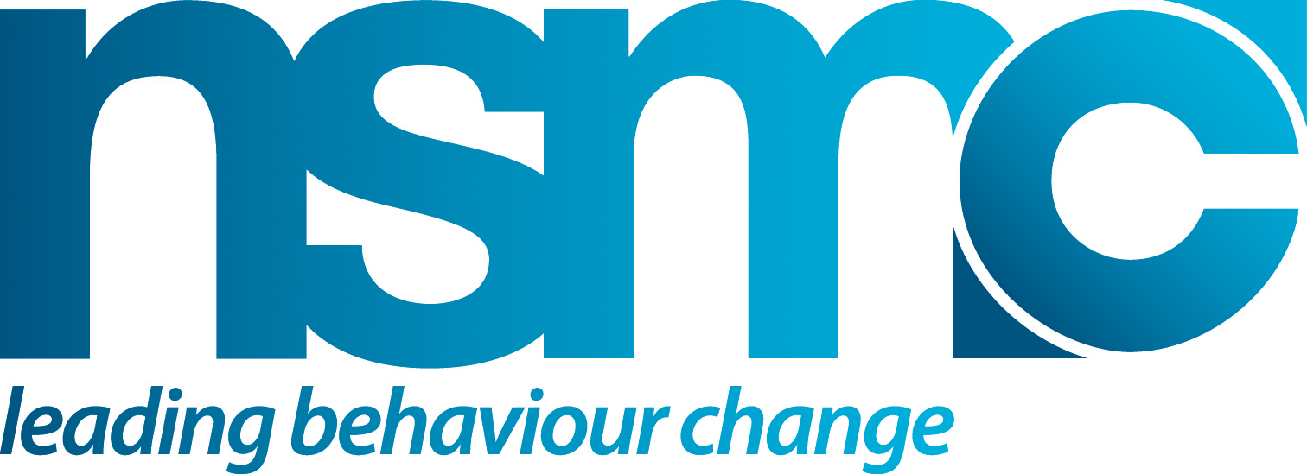

INITIAL PLANNING CHECKLIST

Purpose
To help consider what things you need to think about upfront before you start the process of developing a social marketing led intervention, including ensuring that you have the backing of your organisation for mounting the social marketing effort.

How to use or apply
Use these simple questions to ask yourself and colleagues who you expect to be working closely with.

It will be useful to run through these if you do not already have expressed support from line managers and senior staff.

Even if you understand that there is ‘some’ commitment at senior levels within your organisation, it is probably sensible to pause and double check. If you can identify any significant gaps or uncertainties, then it is very worthwhile to consider what you need to do to.

Source(s)/Reference(s)
• www.thensmc.com

Questions to ask | Answers | Possible actions you can take
Have you got senior management support? What do senior staff know about your plans?
Who else could usefully be informed at this stage?
Are you clear about the behaviour to be addressed by the intervention?
Do you know who your target group will be, or do you need to do more work on this? How much more work might be required?
Do you have a project team and a lead in place? Do they have dedicated time to develop and deliver?
Have you thought about key stakeholders and potential partners? Who might these be and why?
What resources do you have in place to support the intervention? Are they sufficient? Do you need to identify additional resource?
What about timescale? Over what period do you envisage working on the intervention? Are you under any time pressures to deliver? Do you think they are realistic?

