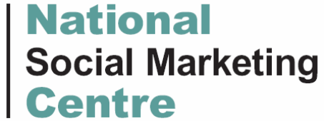

Initial Rapid Scoping Report:

Decreasing Kerbside Drinking Among Young People in North Tyneside

August 2007

Denise Ong
National Social Marketing Centre

The content of this report represents an initial rapid scoping review, to assist on-going discussion and consideration within North Tyneside and decisions on future intervention options and approaches. At this stage the views expressed are those of the author and should not necessarily be taken to represent those of either North Tyneside PCT or the National Social Marketing Centre. Comments, views and further input are welcomed.
CONTENTS

- EXECUTIVE SUMMARY

- INTRODUCTION

- BACKGROUND
  - North Tyneside
    - Demographic data
    - Health
  - Youth Alcohol Consumption
    - National
    - Regional
    - Local
  - Overview

- PROBLEM DESCRIPTION
  - Presenting Issue
  - Behavioural Challenge
  - Possible Target Group(s)

- POLITICAL CONTEXT
  - National
    - Alcohol Harm Reduction Strategy for England (AHRSE) 2004
    - Safe. Sensible. Sociable: Next Steps for the Government’s National Alcohol
Strategy 2007
    - Other key policy drivers
  - Regional Developments
    - North East Regional Alcohol Advisory Group (NERAAG) – ‘Alcohol Misuse Statement of Priorities’
  - Local Initiatives
    - North Tyneside Local Area Agreement (April 2007 – March 2010)
    - North Tyneside Public Health Alcohol Workstream
    - Children and Young People’s Alcohol Strategy 2005
  - Overview

- CURRENT SERVICES IN NORTH TYNESIDE
  - Control
    - Neighbourhood policing
    - Test purchasing
    - Proof of age cards
  - Design
    - Alcohol Free Zones (AFZs)
  - Support
    - Brief interventions (BI)
    - Alcohol treatment and youth services
    - Childsafe
    - The ‘EASE’ card
  - Educate
    - Information campaigns
    - School-based alcohol education
  - Overview
- EXISTING EVIDENCE & PRACTICE LEARNING
  - Young People and Public Spaces – Strategies for Reducing Harm
  - Strategies to Reduce Alcohol Misuse
    - Licensing
    - Sales
    - Taxation and pricing
    - Promotion
    - Public drinking bans and designated drinking areas
    - Brief Interventions
    - Educational and psychosocial interventions
    - Mass media campaigns
    - Diversionary activities
  - Case Studies
  - Overview

- STRATEGY TEAM

- STAKEHOLDER MAPPING

- INITIAL AUDIENCE SEGMENTATION

- BEHAVIOURAL ANALYSIS
  - Drinking in the Adolescent Years
  - ‘A Good Night Out’
  - Association between Alcohol, Aggression and Violence
    - Situational factors in the relationship between public drinking and violence
    - Young people and risk-taking behaviour
  - Overview

- FACTORS THAT INFLUENCE YOUNG PEOPLE’S DRINKING
  - Personal Characteristics
    - Perceived benefits of drinking alcohol
    - Perceived problems and risks related to alcohol consumption
  - Immediate Environment
    - Social context
    - Price and availability
    - Drinks retailing and marketing
    - Advertising
    - Family
    - School
    - Mass media and health protection messages
    - Law and law enforcement
  - Overview

- COMPETITION ANALYSIS
  - ‘Good’ Competition
  - ‘Bad’ Competition
  - Overview

- FORECASTING

- RECOMMENDATIONS
  - Further Research
  - Next Steps

- FINAL CONCLUSIONS

- APPENDIX
  - Appendix A – National Policy Framework
  - Appendix B – North East Alcohol Misuse Statement of Priorities
  - Appendix C – Psychosocial & Educational Interventions

- EXECUTIVE SUMMARY

AIM
To begin laying the foundations for developing a social marketing initiative to decrease kerbside alcohol drinking among young people in North Tyneside.

OBJECTIVES
- To outline patterns and trends of alcohol consumption among young people in England, the North East, and North Tyneside.
- To review the political context in which this intervention on public drinking and young people exists.
- To outline current work in North Tyneside that addresses issues related to alcohol misuse and young people.
- To establish an evidence base of good practice from various other strategies that aimed to address public drinking among young people.
- To analyse the behaviour and opinions of young people who drink on the streets.
- To identify factors that influence young people’s drinking behaviour and forms of competition for the desired behaviour (not drinking on the streets).
- To produce a report that reflects current data and evidence and makes recommendations for further primary research, which will then lead to the development and testing of a social marketing intervention to tackle kerbside drinking in young people.

DESIGN
Desk-based research consisting of gathering existing resources from key contacts and a web trawl of secondary data, including policy documents, reports, surveys and statistical databases.

FINDINGS
BACKGROUND:
- North Tyneside is a highly populated area situated in the North East of England and is 1 of the 5 metropolitan districts that make up the Tyne and Wear conurbation. It serves a population of 194,000 that is predominantly white (~98% of the population).
- The Borough has a wide range of social and economic characteristics – with some areas being amongst the most affluent in the North East and others being amongst the most deprived (i.e. Chirton, Riverside, Collingwood, Longbenton, Howdon and Wallsend). Over a quarter (26%) of the borough's population live in wards that are ranked among the most deprived 10% in England.
- The city has a low rate of employment and residents are less likely to have qualifications (16.4%) than the national average (19.8%), reducing their chances of employment.
- North Tyneside has higher numbers of lone parent households with dependent children and lower percentages of married and cohabiting couple households than the national average.
- Life expectancies at birth for males and females are significantly lower than for England. A higher proportion of people in North Tyneside considers their general health ‘not good’ or has limiting long-term illness than the national average. Death rates from heart disease and stroke, cancer, and smoking are significantly higher than England rates, which may be associated with its industrial legacy and relatively poor economic circumstances.
- In recent years, heavy drinking and harmful drinking patterns have been increasing among young people in the UK. While the proportion of 11-15 year olds who drink at all has remained at about 60% since 1988, those who drink are consuming more alcohol, more often. Drinkers under the age of 16 are drinking twice as much today as they did 15 years ago and the proportion of young people drinking at least once a week rose from 13% in 1990 to 17% in 2005. UK teenagers report some of the highest levels of binge-drinking and life-time drunkenness in Europe. While teenage boys continue to drink more, teenage girls are drinking more alcohol, more frequently, and are now equally likely to have drunk alcohol in the past week.
  - Regular heavy drinking and binge drinking behaviours are associated with a whole range of problems including severe intoxication, physical and mental health problems, unprotected sex, illegal drug use, antisocial behaviour (ASB), violence, accidents, assaults, and poor school performance. Excessive drinking costs the UK economy around £20 billion each year in health, crime and disorder, which equates to £407 per year for every person in England.
- At the regional level, data on alcohol use and associated problems among children is limited, yet among adults the North East is known to have higher average weekly alcohol consumption, more binge drinkers, and higher prevalence of hazardous or dependent alcohol consumption than any other region in the country. There is also a shortage of alcohol treatment services and a huge demand for services right across the North East.
  - The North East thus sees higher rates of hospital admissions and mortality due to alcohol-related causes than the rest of England. The overall cost of alcohol misuse in the North East is approximately £1 billion per year.
  - While data on youth drinking trends is limited for North Tyneside, local surveys reveal heavy drinking and harmful drinking patterns – about 2/3 of young people drink alcohol and over half drink at least once a week. Almost 50% of year 9 pupils (14 year olds) have been intoxicated, and 20% have drunk so much that they were out of control. There is a strong upward trend in drinking alcohol between the ages of 13-15 years for both boys and girls. Historically boys were more likely to drink than girls, but now more girls than boys drink alcohol and a higher percentage of girls drink twice a week. A significant proportion of young people drink on the streets and alcohol is quite easily obtained, usually from parents, the corner shop, or off-licences, rather than pubs.
  - North Tyneside has some of the highest rates of under-18s being admitted to hospital due to alcohol-related causes and the teenage pregnancy rate is significantly higher than for England. Up to almost 20% of young people drink alcohol and take illegal drugs.
  - In line with national trends, alcohol related crime and disorder appears to be rising in North Tyneside, despite remaining lower than the England average. Between 01/04/06 and 31/10/06 16% of the offenders attached to alcohol related crimes were aged ≤17. The main hotspots for these youth offences were Longbenton, followed by Howdon then Whitley Bay town centre.
  - While most residents do feel safe in public places during the day, only 3/10 feel comfortable outdoors after dark. Men are more likely to feel safe outside at night, and residents living in council homes are more likely to feel unsafe outside after dark and during the day. Public drinking contributes to driving people’s fear of crime, and under-18s are often seen as the biggest problem. The problem most affecting local residents is ‘teenagers hanging around streets’, often with/having consumed alcohol. Providing activities for teenagers is now a top priority among residents, and improvements in crime and streets/roads and parks/open spaces are increasing in importance.

PROBLEM DESCRIPTION:
- A large proportion of underage teenagers drink more than once a week. Young people are able to access alcohol quite freely and many of them drink unsupervised on the streets rather than indoors, which not only places them at increased risk of alcohol-related harm and environmental danger, but also contributes to residents’ fear of crime. ‘Teenagers hanging around streets’, often drinking or having drunk alcohol, is a key concern for local residents, and alcohol related incidents and crimes are on the rise. The behavioural challenge is thus to reduce kerbside drinking in under-18s.
- Possible primary target audience:
- Underage street drinkers/clients within the Childsafe programme
- 11-14/15 year olds
- Both genders
- White European/British
- Longbenton, Howdon, Whitley Bay (hotspots) – streets, parks, sea front
- Friday & Saturday nights
- Possible secondary targets:
  - Parents, siblings and friends of underage street drinkers/clients within the Childsafe programme
  - Childsafe staff/police
  - Alcohol retailers (particularly off-licenses and corner shops), bartenders, waitstaff
  - Schools?
  - GPs?

POLITICAL CONTEXT:
- England has attempted to address issues related to alcohol misuse and violence through a mix of measures in a cross-government manner. At a national level, alcohol policy is driven by the Alcohol Harm Reduction Strategy for England (AHRSE), which aims to tackle crime and ASB and the harms to health from binge and chronic drinking through education, treatment, enforcement, and collaboration with the alcohol industry. Updated in 2007, the strategy aims to create a sensible drinking environment and specifically focuses on the minority of drinkers who cause the most harm, which includes underage drinkers. The Respect drive is another important cross-government strategy that builds on current efforts to tackle ASB. Actions areas include supporting families, ensuring effective enforcement, and providing activities for young people.
- National strategic policies have been translated into regional and local strategies. The North East Regional Alcohol Advisory Group (NERAAG) launched a ‘Statement of Priorities’, which fall under 3 main aims: prevention, treatment, and enforcement. This regional strategy directs policy vision across the North East and forms the basis of North Tyneside’s Alcohol Harm Reduction Strategy.
- At a local level, ‘reducing alcohol abuse’ and creating ‘safer places and spaces’ have been included as ‘big priority’ areas in North Tyneside’s Local Area Agreement (LAA). Proposals to involve young people in developing facilities and support services for teenagers has been included in the Children and Young People’s (CYP) Plan 2006-2010 and the Play Strategy. The multi-sectoral Alcohol Workstream is currently drafting a new alcohol strategy based on NERAAG’s Statement of Priorities. Elements of the strategy that target young people are currently control-heavy (Childsafe, proof of age card), with little mention of teenagers in treatment (brief interventions, workplace training) and prevention methods. The previous CYP alcohol strategy is being integrated into this new alcohol strategy and social marketing will be used to focus on alcohol harm reduction in young people.
- This bodes well in relation to reducing alcohol harms among young people, but there is no mention of current work underway with the Blueprint project, nor of any action to increase interactive and evidence based alcohol education. There is also no mention at all of developing services for young people who are drinking at an earlier age and consuming more than before. At the moment, social marketing appears as a separate strand of the alcohol strategy that will inform an initiative that targets underage street drinkers. However, social marketing should be positioned as an underlying approach that can enhance the overall strategy’s means of reducing alcohol misuse in young people.
- The current UK system covers a wide range of approaches and there is a profusion of information initiatives, support services, regulations, guidelines, websites, marketing campaigns, case studies, and debates around alcohol misuse. While this reflects the weight that is being given to the issue and marks a positive climate for change, there is a potential for confusion, overabundance, and fragmentation within the area, and there is a need to be alert to proliferation and duplication as a potential barrier to effective communication and service provision. Policies at all levels are increasingly cross-sectoral and aim to increase coherence in tackling alcohol-related harm, but from an individual’s perspective the system still appears complex and confusing to navigate.

CURRENT SERVICES IN NORTH TYNESIDE:
  - The Borough has attempted to address issues related to alcohol misuse and young people through a mix of measures. These can be categorised in the following way:
Control | Design | Support | Educate
- Visible police patrols in city centres – Northumbria Police  - Underage test purchasing – Northumbria Police  - Proof of age cards – Trading Standards | - Alcohol Free Zones – Northumbria Police | - Brief interventions - PCT  - Alcohol misuse services for young ppl – N2L, The BASE, Connexions, Youth Service, b4 (YISP), Streetwise  - Childsafe – Northumbria Police  - EASE card | - Information campaigns – Northumbria Police  - School-based alcohol education  - Workplace training - PCT  - Retailer Awareness Pack – Trading Standards
  - Further research needs to be conducted with police, alcohol retailers, youth service providers, GPs, and schools to find out how feasible and effective these initiatives are and how success can be enhanced. The Borough’s response spans the continuum of measures, but these all need to be integrated into a comprehensive approach with the new alcohol strategy. Increased use of law and order has the potential to exclude young people. Efforts to reduce illegal sales to minors need to address the prevalence of adults purchasing alcohol on behalf of underage children. Healthcare providers also need to be trained to recognise and support young people with alcohol problems. Effective communication between all those involved in these initiatives is vital, as are more inclusive measures that work with young people.

EXISTING EVIDENCE & PRACTICE LEARNING:
- Many teenagers use local streets on a daily basis to ‘hang around with friends’ and the majority prefer to be out and about than stay in. It is commonly known that many teenagers often want to be independent of their parents and participation in the daily life of urban streets promotes a gentle transition into the adult world. Since young people have no real private space of their own, they often use public/quasi-public spaces to create their own ‘microgeographies’, attempting to gain spatial autonomy from adults’ control. In an effort to manage risk, urban development processes have gradually ‘designed out’ young people and increased tensions between the younger and older generations. Besides being marginalised and excluded from adults’ public space, young people also have to confront the hostility of other teenage groups.
- Teenagers even if not actually responsible for vandalism and violence in outdoor space, are seen as potential troublemakers and excluded or marginalised as a result from these places. Boredom, alienation, family and community breakdown, lack of leisure opportunities and youth unemployment have been associated with drug use and delinquent behaviour.
- In response to youth offending and conflict over the use of public spaces, developmental, holistic and inclusive, rather than punitive, measures are more effective and address the needs of young people. Research with young people in North Tyneside highlighted the lack of things to do for those aged 14-18. In providing youth structured activities for young people the crux is often managing to offer something that is seen as ‘cool’ and marrying this with low-level supervision. With the decline of traditional industries in North Tyneside, new job and skill-building opportunities need to be provided for young people.
- The renegotiation and redevelopment of public spaces need to occur alongside other initiatives to address the problem of street drinking. Effective strategies to reduce alcohol misuse include control measures, such as raising the minimum purchase age, increasing the price of alcohol, and implementing alcohol bans. However, there is little evidence to suggest that school-based alcohol education and mass media health promotion campaigns are effective on their own or as a main strategy. Diversionary activities can reduce risky drinking behaviours in young people, in addition to providing additional benefits such as reducing ASB and developing personal and social skills.
- A multi-faceted, cross-sectoral approach that involves the local council, community, parents and young people, and uses a comprehensive, integrated set of environmental strategies along with education, media advocacy and other community activities is likely to be most cost-effective in influencing the behaviour of young people.

STRATEGY TEAM:
Currently the social marketing intervention is led by Karen Jones, senior public health specialist at North Tyneside PCT, with support from Rowena Merritt of the NSMC There is currently no social marketing strategy team in place for this youth alcohol intervention and decisions are made by the Alcohol Workstream.

Individuals with marketing research/analysis and evaluation skills should be included in the strategy team, as well as external partners who have more contact with and understanding of the target group, e.g. schools, parenting groups, government alcohol/youth agencies, off-licence storeowners, and other businesses that can provide funding/access to the target audience or have a financial interest in reducing alcohol misuse in young people.

STAKEHOLDER MAPPING:
Early engagement with relevant stakeholders helps create allies rather than competitors and can add new points of view, resources and experience. Recognising potential opponents and enlisting their help can add fresh ideas, build support and increase credibility.

In addition to young people, stakeholders may include: Parents; Childsafe, Police/PCSOs; Alcohol retailers; Trading Standards; Schools/colleges; Youth service providers; Healthcare professionals; Public health specialists; Local policy makers; Academics; Wider community; Media; Community organisations; and Businesses.

INITIAL AUDIENCE SEGMENTATION:
Typical segmentation variables and examples relevant to this intervention are:
Segmentation variable | Examples
Geographic | Neighbourhood renewal areas; main hotspots for alcohol related offences (Longbenton, Howdon, Whitley Bay)
Demographic | Age (Pre-12 yrs, 12-13 yrs, 14-15 yrs, 16-17 yrs); Gender (males & females); education (primary school, secondary school, college, excluded pupils); race (white British); family size (single parent, looked after children)
Psychographic | Lifestyle (self-harm girls, homeless teenagers); personality; values; social norms/peer groups (e.g. neds/alternative/mainstream)
Behavioural | User status (non-drinker/drinker, indoor/street drinker); user rate (infrequent/weekend drinker, binge drinker); reason for use (to get drunk, lose control & cause trouble vs ‘accidental binge drinkers’ who plan to get drunk but retain control and get home without incident, but ‘accidentally’ go too far and get into situations they can’t control); readiness stage; attitude toward alcohol; associated problem behaviours (assault, damage, illegal drug use)

Based on the research carried out so far, underage street drinkers can be segmented by level of motivational and circumstantial ability to achieve behaviour change, which will help facilitate dedicated interventions and an appropriate marketing mix. However, further research will be required to clarify the segments using segmentation variables like those listed above and to build faithful profiles of the different groups.

Cluster 3  low motivation; high circumstances  - Not aware of illegality of underage public drinking  - Not aware of personal risks attached to public drinking  - Not aware of threat public drinking poses to the community  - Little interest in preserving own health & avoiding personal risks  - Little regard for community welfare  - Prefers to drink outdoors  - Averse to engaging with adults  - Limited knowledge of/little interest in alternative entertainment options  - Reluctant to embrace change  - Potential resources to fund & implement change  - Potential support from school staff  - Potential support from peers  - Potential support from parents  - Potential support from community  - Potential support from police | Cluster 1  high motivation; high circumstances  - Aware of illegality of underage public drinking  - Aware of personal risks attached to public drinking  - Aware of threat public drinking poses to the community  - Interested in preserving own health & avoiding personal risks  - Concerned about community welfare  - Prefers to drink indoors  - Prepared to engage with adults  - Aware of & welcomes new entertainment opportunities  - Willing to embrace change  - Potential resources to fund & implement change  - Potential support from school staff  - Potential support from peers  - Potential support from parents  - Potential support from community  Potential support from police
Cluster 4  low motivation; low circumstances  - Not aware of illegality of underage public drinking  - Not aware of personal risks attached to public drinking  - Not aware of threat public drinking poses to the community  - Little interest in preserving own health & avoiding personal risks  - Little regard for community welfare  - Prefers to drink outdoors,  - Averse to engaging with adults  - Limited knowledge of/little interest in alternative entertainment options  - Reluctant to embrace change  - Lacks resources available to fund & implement change  - Lacks support of school staff  - Lacks support of peers  - Lacks support of parents  - Lacks support of community  - Lacks support of police |  | Cluster 2  high motivation; low circumstances  - Aware of illegality of underage public drinking  - Aware of personal risks attached to public drinking  - Aware of threat public drinking poses to the community  - Interested in preserving own health & avoiding personal risks  - Concerned about community welfare  - Prefers to drink indoors  - Prepared to engage with adults  - Aware of & welcomes new entertainment opportunities  - Willing to embrace change  - Lacks resources available to fund & implement change  - Lacks support of school staff  - Lacks support of peers  - Lacks support of parents  - Lacks support of community  - Lacks support of police

BEHAVIOURAL ANALYSIS:
- Young people’s drinking behaviour progresses through several stages as they age. While older teenagers are more likely to binge drink, drinking unsupervised on the streets is more common among 14-15 year olds. By 16-17 years, drinking becomes more regular and moves into pubs and clubs. At this stage, alcohol tends to make young men engage in more aggressive behaviour.
- For many young people, ‘a good night out’ is the predominant pattern, usually on a weekly basis, and provides a focus to the week/month. The aim of drinking alcohol is often to get hedonistically drunk, otherwise there is no point in drinking. ‘Drinking moderately’ and a ‘night out’ strike many young people as a contradiction in terms and ‘being able to take your drink’ signals some sort of maturity.
- Alcohol consumption is believed to increase the risk of violence. Situational and cultural factors also influence levels of violent crime. Violent incidents in public drinking locations are characterised by subtle interactions of variables such as groups of male strangers, low comfort, high boredom, high drunkenness, as well as aggressive and unreasonable behaviour by bouncers or floor staff.
- Violence may have a functional value for young men and can add excitement to a night out. Drunken, rowdy behaviour and violence may also represent rebellion by young, disempowered males against the prevalent social order.
- Risk-taking is an integral aspect of youth developmental behaviour. Young people can be defined as ‘high risk problem drinkers’ or ‘low risk problem drinkers’, based on their levels of drinking and behaviour linked to drinking. Several types of risky/antisocial behaviour are interrelated, and problem drinking has been linked to numerous risk and protective factors that cover the areas of family, school, community and friends.
- Social exclusion is also a strong determinant of risk-taking behaviour. For some marginalised young people, the streets are the places where they experiment, explore, and claim as their own. Alcohol, alongside illicit drugs and tobacco, is used to create excitement and fun during their time on the streets and are integral parts of their street culture.

FACTORS THAT INFLUENCE YOUNG PEOPLE’S DRINKING:
A wide range of interacting factors influence young people’s drinking behaviour, and these exist as personal characteristics or in the immediate environment.
- The perceived benefits of drinking alcohol include social facilitation (e.g. generate fun, boost confidence), individual benefits (e.g. relax, appear grown up) and social norms and influences (e.g. ‘normal’ part of adolescent culture, rite of passage, response to peer pressure). Drinking tends to be seen as the main/only leisure option and is used to relieve boredom, particularly in areas that lack appropriate facilities for teenagers. Alcohol is considered a safer leisure alternative to drugs, perhaps implying a gap in knowledge of the full dangers of alcohol use.
- Perceived problems and risks related to consuming alcohol differ in their significance. ‘Spiking’ drinks, crime and ASB/fights, unprotected sex, general vulnerability, and an impact on work/study arouse some concerns among young people, while short-term physical effects, making a fool of oneself, and high financial costs are routine and accepted. Involvement with the police and long-term health implications are seen as irrelevant.
- External factors such as the relative affordability and easy availability of alcohol, and widespread targeted retailing, marketing and advertising also encourage harmful drinking in young people. Research shows that public drinking is more common in teenagers who purchase their own alcohol, get siblings, friends, or adult strangers to buy alcohol for them, or have a higher weekly income.
- Parents are frequently a source of alcohol for young people, and low parental support and extremes of control are associated with excess drinking by young people. While parents can provide role models, qualitative research suggests that in practice, young people themselves are more likely to see their drinking as an independent activity and tend not to compare their behaviour with that of their parents. There is no clear evidence that young people are less likely to drink excessively if their parents discuss it with them, and young people believe that it would be hypocritical for their parents to criticise their drinking when parents/adults in general drink excessively. Many parents also accept that drinking is part of normal teenage social activity, and are more concerned about sex, drugs, smoking, strangers and bullying than alcohol use.
- The table below lists some incentives and barriers of both the desired and problem behaviours. In developing the social marketing intervention, we will need to maximise the benefits and minimise the barriers of drinking indoors. The ideas in the table have been pulled from the findings of this report, with heavy influences from 2 Scottish studies: 1 on the influence of marketing and subculture on young people’s street drinking behaviour and another ethnographic study on male street culture. More primary research with underage street drinkers in North Tyneside is needed to confirm this list and explore the priority of benefits and barriers/costs within each of the quadrants so that a competitive advantage is created.

1. Desired behaviour - Incentives
a. What incentives currently exist that encourage/support drinking indoors? | - Sales promotions (e.g. happy hours & 2-4-1s) at licensed premises  - Comfort, safety, shelter, entertainment at home/bars/clubs  - Supportive parents - supply alcohol for consumption at home  - Designated club nights/hours for under-18s?
2. Desired behaviour - Barriers
a. What barriers/blocks currently limit/restrict drinking indoors? | - Exclusion from indoor settings due to age or drinkers’ own behaviour  - ‘Costed out’ – more expensive to drink in licensed premises  - Not aware of illegality or dangers of drinking in public  - Personality characteristics – hostile/antisocial orientation, dislikes supervision/authority?  - Parents disapproval of drinking/poor family life
3. Problem behaviour - Incentives
a. What incentives currently exist that encourage/support street drinking? | - Good value for money – drinkers can ‘preload’ on cheap alcohol before going to pubs/clubs later in the night.  - Unsupervised, ‘adult-free’ space, both geographical and social, that young people colonise and use to create their own leisure using minimal material resources. Young men's street culture simultaneously provides a practical and symbolic short-term resolution to some of the structural pressures that they encounter.  - Street life can be exciting and occasionally unpredictable. Whilst on the streets young people gather information about events or happenings that are of interest to them. There is a constant feeling that something exciting could happen at anytime, which can be instigated and/or influenced by the young people.  - The streets provide a social context in which young men can experiment with their sexuality and/or develop a particular type of masculinity. It is somewhere they could achieve peer status and recognition through conspicuous consumption, e.g. of designer labelled clothes, and/or via knowledge about and use of illicit drugs, and/or involvement in small-scale gang violence.  - Some young people have trouble at home or are living in B&Bs with strangers; drinking on the streets provides a temporary refuge.
4. Problem behaviour - Barriers
a. What barriers/blocks currently limit/restrict street drinking? | - Sense of being ‘too old’ to drink on the streets.  - Could get caught by police and reported to parents  - Street life can be boring and largely repetitive  - Involvement in alternative activities  - Fear of violent victimisation/sexual harassment by others  - Poor weather?  - Lack of benches, rubbish?

COMPETITION ANALYSIS:
The competition in social marketing environments is tough, for it includes these challenges: behaviours young people would prefer (e.g. to get really ‘buzzed’) and the benefits associated with them (e.g. to relax and have a good time), and strong messages/messengers that are counter to the desired behaviour (e.g. Smirnoff advertisements). Competition also exists from existing initiatives that also intend to reduce public drinking, e.g. AFZs. A major form of competition is the strong drinking culture which exists nationwide and will require drastic measures and many years to alter, as will the availability and affordability of alcohol. Creating a competitive advantage to the thrills and freedom of drinking on the streets will be crucial. Further research with underage street drinkers might reveal hot buttons that will guide positioning, as well as other elements of the strategic marketing mix.

FORECASTING:
- Trends in youth drinking patterns coupled with high profile stories in the media of alcohol-fuelled violence by youths will probably see the issue of public drinking rising on the agenda. The aging population of the UK could potentially encourage the ‘designing out’ of young people in public spaces and heighten tensions between the younger and older generations. The rising proportion of children living in lone-parent families could contribute to further decline in parental supervision and control of young people that can discourage delinquent behaviours like problem drinking.
- The national alcohol strategy has just been updated this year, with a sharper focus on the minority of drinkers who cause the most harm (including under-18s) and on the country’s excessive drinking culture. The recent introduction of smoking bans in all public places in England and the positive reception it received from the public after its implementation bodes well for those who call for more drastic measures from the Government to promote a more sensible drinking culture.
- At a local level, North Tyneside is in the process of drafting a new alcohol strategy that aims to coordinate a range of elements to tackle alcohol-related harm in the Borough. However it remains to be seen how the well the strategy is implemented on the ground and how coordinated the approach is. The capacities of the Alcohol Workstream and partner organisations should be assessed and monitored (via a SWOT analysis) to guide decisions and prepare for changes in circumstances.

RECOMMENDATIONS
FURTHER RESEARCH:
- Segmentation work: More work is recommended to further segment the target groups outlined in this study (e.g. young street drinkers, their parents) using segmentation variables (e.g. psychographics) and to create more accurate cluster profiles. Qualitative research should be used to confirm and characterise key clusters and quantitative research to identify the size and location of these clusters. This will help to select the most appropriate target group(s) and develop interventions that specifically address them.
- Interviews with young people who drink on the streets: A small sample of young people has already been interviewed and results are presented in a separate report. However these individuals will probably not be the target group since they have multiple problem behaviours and are probably less susceptible to change. This intervention will probably target young people with less entrenched drinking behaviours and who have not yet reached youth services. These young street drinkers could be accessed via Childsafe and semi-structured questions with them would aim to explore:
  - The barriers and benefits of the recommended behaviour and its competition – Compare and contrast local responses with those drawn from the literature review, e.g. do underage street drinkers view involvement with the police as irrelevant?
  - The aspirations and other interests of underage street drinkers – e.g. how, where and with whom do they spend their leisure time?
  - What would make the behaviour easier, more comfortable/fun and more popular – e.g. are alternative activities enough of an incentive to divert young people from drinking on the streets?
  - How, where and when the behaviour takes place – e.g. do young people typically drink on the streets only on Friday/Saturday nights, where and at what times, how much does the ‘good night out’ pattern apply?
  - Who helps create these opportunities/has influence on this audience – How much and what kind of influence do peers, siblings, parents, police and alcohol retailers have on underage street drinkers?
  - Through which media channels young street drinkers get their information and from whom they would prefer to receive interventions from (e.g. what perceptions do they have of the police and the Childsafe programme?).
These interviews will help to confirm and build on the insights gathered in this report and in the initial primary research on young street drinkers, which can then be used to select and design the most appropriate intervention elements.
- Observational data of hotspots and the behaviour of young people: Observations carried out in hotspots on Friday and Saturday nights would gather valuable information about the behaviour of young people and levels of violence and safety in public spaces that does not necessarily come to the attention of the media or police. Incorporating short semi-structured street interviews would help to gain insight on young people’s perceptions and experiences of hanging out in public spaces. Questions would aim to find out for example: what motivated the person to come into town; how frequently they came; what they did in town; what they drank (if they drank alcohol); how much and where they got it from; ideas for what else they’d do if they didn’t come into town; and ideas for making the city safer. The combination of observations and interviews would create snapshots of the nightlife in the city and help to distinguish those who drink outdoors (e.g. in terms of demographics and psychographics) from those who drink indoors.
- Interviews with parents of young people who drink on the streets: A small sample of parents has already been interviewed and results are presented in a separate report. However, more interviews need to be held with parents of teenagers who drink on the streets. Contact with this group could be made via the Childsafe programme and questions would aim to explore:
  - How, where and with whom their children spend their leisure – parents’ knowledge can then be compared with what their children describe.
  - How parents perceive their children’s’ behaviour.
  - The kinds of strategies they have used to communicate with their children about alcohol.
  - The level of supervision young street drinkers get from their parents.
  - The sorts of issues parents typically struggle with and what kind of support they would like to receive.
  - The effects of alcohol consumption within family settings and how moderate, family-based and food-based drinking patterns might be encouraged in the UK.
- Further analysis of youth services: More data (i.e. official documents/interviews with youth service providers) should be gathered to find out how joined up and consistent the approach is to young people who are isolated and in need, e.g. why were none of the young people identified as using substances by Connexions in 2003 referred to outside agencies to address these issues, and what is the detached youth intervention initiative between The BASE and the council's Youth Services that has complemented the Childsafe programme? This would help improve and tailor youth services to meet the needs of young people with harmful drinking patterns.
- Interviews with key police/Childsafe personnel: Inspectors Tony Blacklock and Dave Foy were contacted during the writing of this report but were not available for response. Interviews with key police personnel should be designed to gather information about incidents that occur, police strategies for dealing with these, and their general perceptions of violence and safety in public spaces, particularly relating to young people and alcohol.
- Further analysis of police data: Data from police and Childsafe records should be analysed further to see if alcohol-related offences committed by young people are on the rise and to identify more specifically where (in Longbenton, Howdon, and Whitley Bay), when and how often these occur, and the types of alcohol-related incidents that involve young people in public spaces. The demographic characteristics of young people involved should also be noted, which will help to us to understand young people’s offending and place it within its demographic context.
- Further research with members of the general public: Interviews/surveys could be used to investigate why adults in the community buy alcohol for young people (e.g. unaware of/unconcerned about the legal consequences, afraid to refuse in the presence of a large group of teenagers), how adults perceive local youth behaviour, which areas they consider unsafe, and how tensions between older and younger generations can be relieved.
- Audit of current facilities and activities for young people: Data collection and interviews with young street drinkers and recreation facilities managers would reveal whether new services need to be provided or current services improved, and how such facilities can be made more accessible and appealing to those young people who have the most harmful drinking patterns. It is crucial to liaise with the Play Partnership subgroup of the CYPF board to ensure that intelligence is shared and strategies are linked to avoid duplication of efforts in the provision of places and spaces for young people.

NEXT STEPS:
- Present initial scoping report to Alcohol Workstream and identify possible key stakeholders and strategy team members for the social marketing intervention.
- Contact key stakeholders to define their level of involvement and interest.
- Disseminate initial scoping report to key stakeholders and discuss primary research strategy and questions with them.
- Conduct and analyse primary research.
- Summarise and disseminate primary research results to strategy team and key stakeholders.
- Select target audience segments and define behavioural goals.
- Brainstorm and generate initial ideas for intervention, conducting a SWOT analysis and focusing on the possible theoretical base and exchange.
- Develop broad plan for intervention, including evaluation methodology.

- INTRODUCTION

Changes in the drinking patterns of young people, along with considerable media and police comment on perceived threats to public safety and increasing violent crime levels, have led to a focus on public drinking by underage teenagers.

The North Tyneside Alcohol Workstream is developing a social marketing intervention to tackle kerbside drinking in young people and is receiving free consultation services from the National Social Marketing Centre as 1 of its 10 ‘demosites’. The first phase in designing a social marketing intervention is scoping, where the presenting issue is defined and the initial behavioural analysis and provisional customer insights are described. This report constitutes the first step of the scoping phase, relying on existing data and easy-to-find literature about the problem behaviour (kerbside drinking), provisional target audience (young people, i.e. 11-17 year olds), and previous/existing work on the same area.

This report is by no means the end product of the scoping phase. Gaps in the problem description and analysis are highlighted in this report and will need to be filled in with findings from primary research. Preliminary qualitative research on a small scale has been carried out by Dr. Rowena Merritt and Helen Lloyd, but further primary research is required to confirm findings and fill in other knowledge gaps.
- BACKGROUND

This section gives some brief demographic and health information of people in North Tyneside, as well as available data on young people’s drinking behaviour nationally, regionally and locally.

North Tyneside
Demographic Data
North Tyneside is a highly populated area bordered to the south by the Tyne, to the east by the coast, to the north by the rural county of Northumberland, and to the west by Newcastle upon Tyne. The Borough covers an area of about 8,400 hectares and consists of a number of small towns, including Wallsend, Whitley Bay, Tynemouth and North Shields. There are also 3 other large settlements at Longbenton, Forest Hall and Killingworth and a number of former mining villages in the north of the Borough. Manufacturing industries such as offshore engineering, shipbuilding, ship repair, food processing, clothing and chemicals are an important element in the local economy employing over 26% of the workforce. Other major employment sectors are retail/wholesale, healthcare, financial services and education. The area has good transport links, with emphasis being given to the Metro, which enables young people to travel around North Tyneside, South Tyneside, and Newcastle.
Demographic data (source Neighbourhood Statistics)

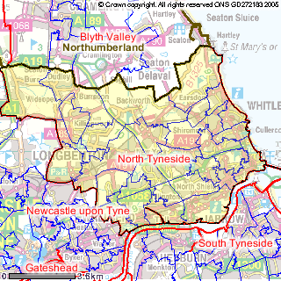
Key Facts:
- North Tyneside has a population of about 194,000, in approximately 80,000 households, 48% of whom are male and 52% female.
- Based on current trends, by 2030 the Borough is set to have an ageing population. The number of people aged over 65 is anticipated to increase from 18% to 25% of the total population, and those aged under 40 to decrease from 49% to 45%. The age profile for young people aged between 5 and 19 is described below:
Age group | North Tyneside | North East | England & Wales (%)
5 to 15 | 13.78 | 14.27 | 14.21
16 to 19 | 4.15 | 5.17 | 4.91
- Around 2% (3,688 people) of the population belongs to a non-white minority ethnic group, a very small number compared to 9% for England as a whole and 3% in Tyne and Wear.
- The city has a low rate of employment, which at 69.98% stands at 4.7% below the average for England, and significantly below the national aspiration of 80%. A legacy of disadvantage caused by the decline in traditional industries and coal mining is proving inter-generational, with new patterns of inactivity affecting the same communities that suffered most from economic dislocations in the past. The position for young people aged 17-19 mirrors ward patterns of worklessness, and the number is rising.
- People in North Tyneside are less likely to have qualifications (16.4%) and more likely to have no qualifications (32.0%) than the national average (19.8% and 29.1%). Worklessness is a particular issue amongst people with no qualifications - only 39% of unqualified adults in Tyne & Wear are in employment.
- Since 2002/3 North Tyneside has seen a 13% improvement in GCSE grades, taking the percentage of young people achieving 5+ A*-C at GCSE up to 54.2% in 2005. While this is slightly below the national average, it is higher than the North East as a whole.
- Although deprived in national terms, North Tyneside is the least deprived of the Tyne and Wear authorities. However, it still ranks as the 80th (out of 354) most deprived borough in England. There is a significant gap between the more affluent areas and those with high levels of poverty and deprivation. Over a quarter (26%) of the borough's population live in wards that are ranked among the most deprived 10% in England.
- Geographically, deprivation is concentrated along the riverside stretch between Wallsend and North Shields, and up the A19 corridor between East Howdon and Shiremoor. At a very local level, 6 wards - Chirton, Riverside, Collingwood, Longbenton, Howdon and Wallsend - rank among the most deprived 10% of wards in England. This includes 2 wards - Chirton and Riverside - which rank among the most deprived 5% in the country.

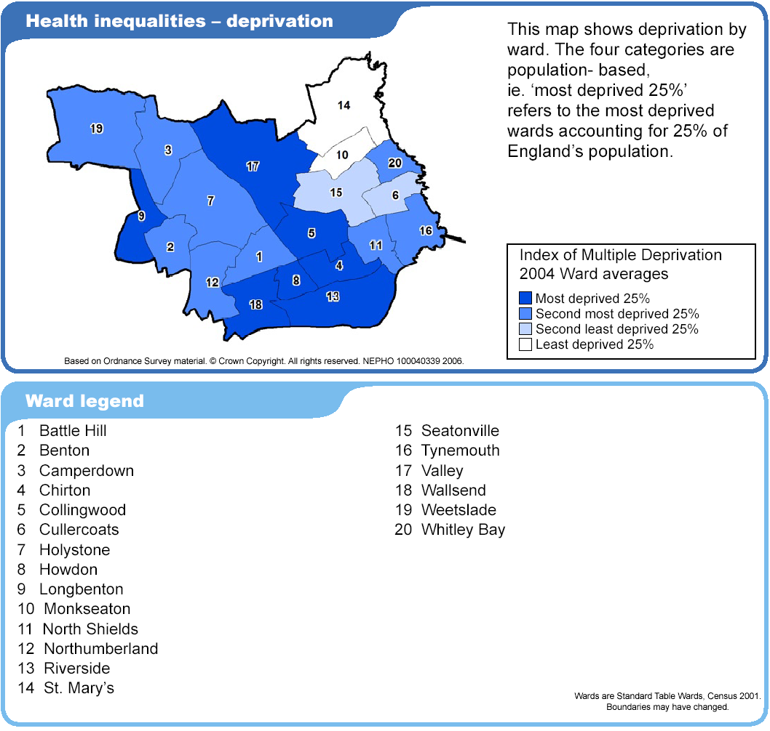
- With regard to child poverty, all 7 wards referred to above were among the most deprived 10% in the country, with over 52% of children aged under 16 living in households dependent on benefits.
- North Tyneside has higher numbers of lone parent households with dependent children (7.1%) than the national average (6.5%), and lower percentages of married and cohabiting couple households
- In April 2002 there were 90,122 residential properties in North Tyneside. The breakdown by tenure is as follows: private - 73%, council - 21%, housing association 5%. The majority of properties (75%) are houses, the rest are flats or maisonettes.

Health
- Life expectancies at birth for males (75.0 years) and females (79.9 years) are significantly lower than for England.
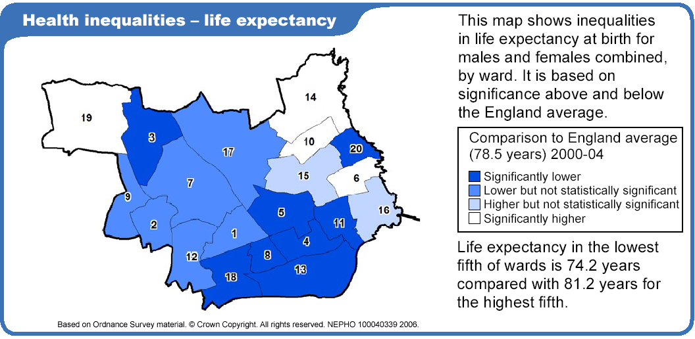
- North Tyneside has higher levels of people who consider their general health ‘not good’ (11.2%) or who have limiting long-term illness or disability (21.8%) than the national average (8.2% and 18.2% respectively).
- Death rates from heart disease & stroke, cancer, and smoking are significantly higher than England rates, which may be associated with its industrial legacy and relatively poor economic circumstances. Circulatory disease accounts for 1/3 of all deaths among men and ¼ of deaths among women. Circulatory disease mortality rates are improving across North Tyneside.
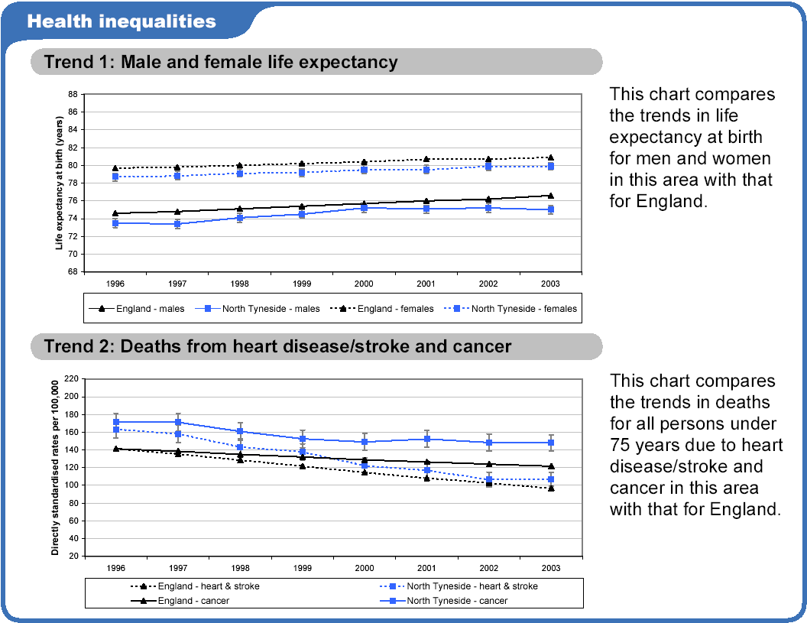
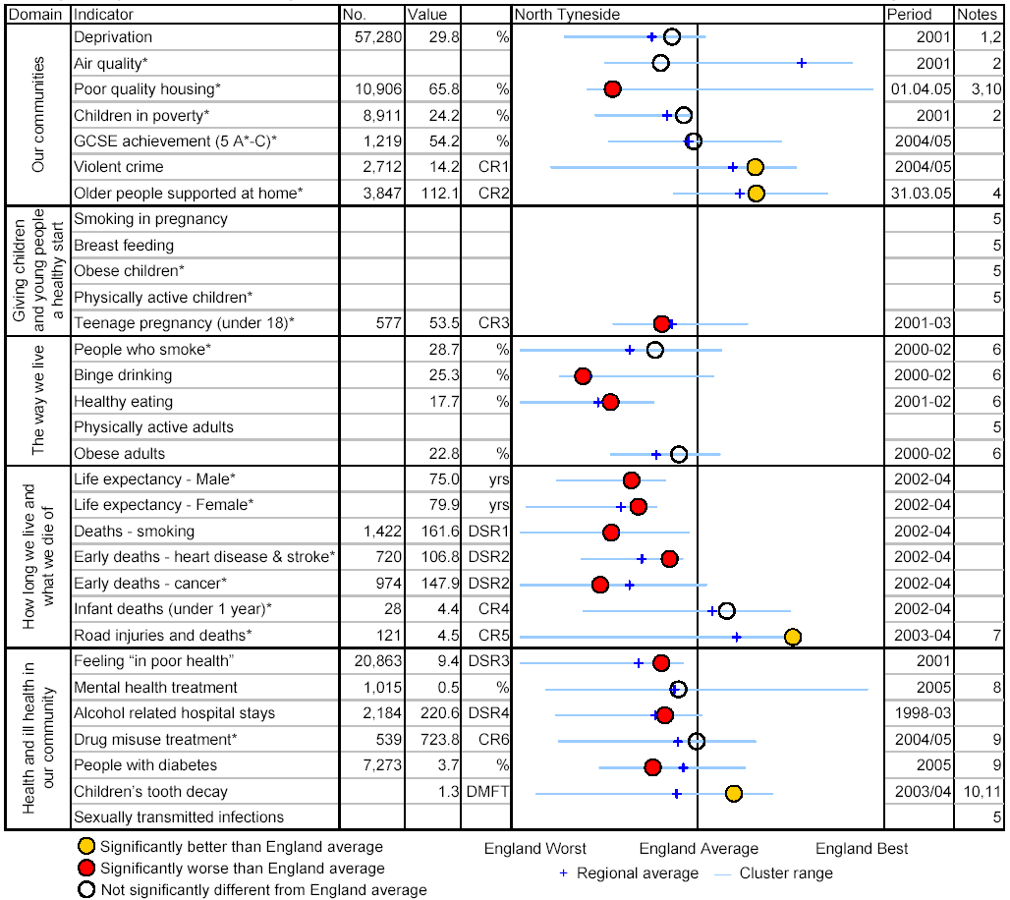
The PCT delivers services in 4 'localities':
- Whitley Bay - Cullercoats, Whitley Bay, Seatonville, Monkseaton, St Mary's and Valley
- North Shields - Riverside, Chirton, North Shields, Collingwood and Tynemouth
- Wallsend - Wallsend, Howden, Battlehill and Northumberland
- North West - Weetslade, Longbenton, Benton, Camperdown and Holystone

The PCT's work is overseen by the Northumberland, Tyne and Wear Strategic Health Authority.
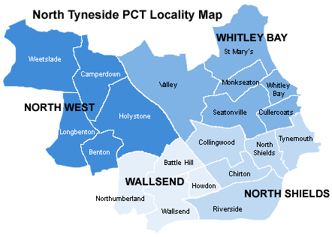

Youth Alcohol Consumption
This section outlines the national drinking landscape which can then be used to put the local picture in perspective. The available data on young people’s drinking patterns in the UK, North East of England, and in North Tyneside is presented. The existing research on crime and perceptions of safety in North Tyneside is also summarised.

National
The Department of Health uses the following alcohol consumption definitions.
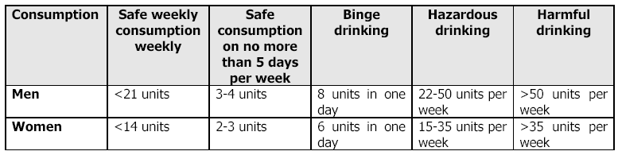

Prevalence/rates
Overall teenagers in the UK are drinking more frequently and levels of consumption are on the increase, as is binge-drinking. Increase drinking among adolescent girls is a particular matter for concern.
- According to statistics from 2005 on drinking among pupils aged 11-15 years, 58% reported ever having an alcoholic drink. The prevalence of drinking increases with age, with 22% of 11-year-olds reporting that they drank compared to 86% of 15-year-olds.
- The 2004 Smoking, Drinking and Drug Use among Young people in England survey found that 23% of pupils had consumed alcohol in the past week. While the proportion of children drinking has fallen, the decrease is greater for boys and it is the first time since the surveys began in 1988 that girls are equally likely as boys to have drunk alcohol in the last week.
- The study found half of girls who had alcohol got drunk, while 42% of boys got drunk. Young people in the UK are likely to get drunk earlier than their European peers.
- Alcohol consumption increased with age - 4% of 11 year olds had drunk alcohol in the last week, compared to 45% of 15 year olds.
Secondary School Children who drank in the last week, by age (2005)
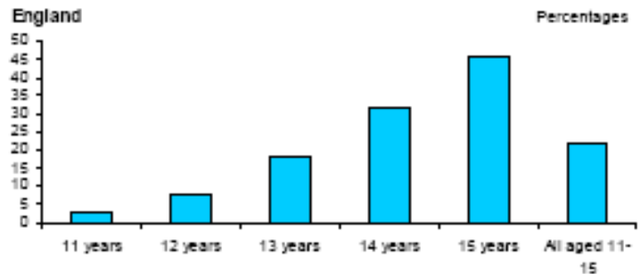
- 85% had drunk alcohol on 1 or 2 days, while 3% had done so on ≥5 days.
- 4% of 15-16 year olds report having drunk > 5 drinks on a single occasion in the last 30 days. 27% of this age group reported this level of drinking ≥3 times in the last 30 days.
- Among those who drink, mean alcohol consumption is approximately 10.5 units per week, with an average of 8.2 units among 11-year-olds and 11.8 units among 15-year-olds.

Trends
While the proportion of 11-15 year olds who drink at all has remained at about 60% since 1988, some disturbing trends have emerged in recent years.
- Among 11-15 year olds who do drink, the average weekly consumption has doubled from 5.3 units in 1990 to 10.4 units in 2005.
Mean Alcohol Consumption Among 11-15 year olds
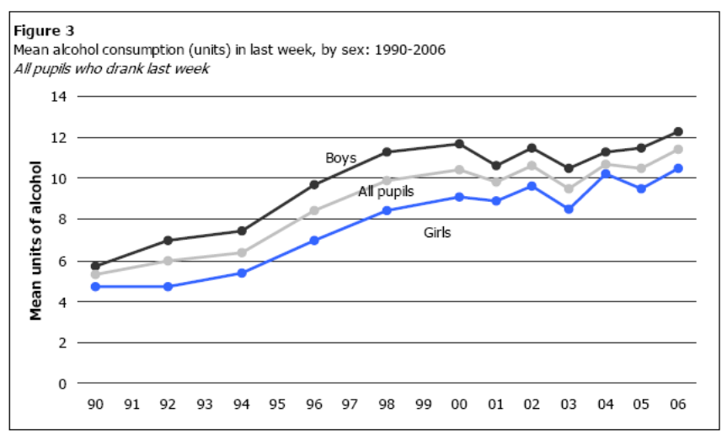

- Frequency of drinking has increased: the proportion of young people drinking at least once a week rose from 13% in 1990 to 17% in 2005.
- The gap between young male adolescents and female adolescents has narrowed over recent years. E.g. the proportion of girls drinking at least once a week has risen from 12% in 1990 to 16% in 2005 compared to the proportion of boys drinking at least once a week, which rose from 15% to 17%. In addition, the increase in mean consumption in girls is fractionally higher than boys, though boys still drink more.
- Binge-drinking is common among young people in the UK. The European Schools Project survey from 2003 found that the proportion of UK teenagers aged 15-16 years drinking at this level is one of the highest in Europe, with only Ireland (32%) and the Netherlands (28%) exceeding UK teenagers. The proportion of young people who binge in the UK increased from 22% in 1995 to 30% in 1999 and then dropped back to 27% in 2004. Binge-drinking among girls overtook binge-drinking among boys, with 29% of girls reporting binge-drinking ≥3 times in the last 30 days compared to 26% of boys.
- The UK has some of the highest levels of drunkenness among young people in Europe. In 2003, 68% of 15-16 year olds in the UK report having been drunk at least once in the last year and 24% report having been drunk ≥10 times.

Impact
A survey into adolescent health found that regular heavy drinking and binge drinking behaviours are associated with a whole range of problems including antisocial behaviour (ASB), violence, accidents, physical and mental health problems and poor school performance.

Health:
- The health burden caused by intoxication is particularly heavy among teenagers and young adults. Around 1000 young people under the age of 15 need emergency treatment for alcohol poisoning each year. Experimental drinking can lead to severe intoxication, which is more dangerous for children and adolescents than for adults, as they experience coma at lower blood alcohol levels and can develop hypoglycaemia, hypothermia and breathing difficulties.
- In 2004/5 7579 under 18 year-olds were admitted to hospital in Britain with a primary and secondary diagnosis relating to the ill-effects of alcohol. This represents a 21% increase from 2000/1 when 6288 were admitted to hospital.
- While young people would be unlikely to be admitted for chronic alcohol-related illness, intoxication puts them at risk of accidents and assaults, both due to inexperience of the effects of intoxication and the fact that drinking often takes place in secret, in locations with higher risk potential.
- Only the most severely intoxicated children need hospital treatment. For others, the health effects may range from the unpleasant (hangovers, headaches, minor accidents and falls) to the more serious. A study of risky teenage drinkers particularly noted that drunken episodes rather than consumption of alcohol “appears to mark a crucial transition to repeated episodes of excessive drinking” and recommended a greater understanding of the “process triggering the transition from first ever alcohol to first drunkenness”.
- Fortunately, deaths directly caused by alcohol in this age group are rare. In 2002 there were 9 deaths. However, older teenagers are far more likely to die from the indirect effects of alcohol than from its direct effects. It is estimated that alcohol is a factor in 20-30% of all accidents. Accidents, suicide and violence are significant causes of death in the 16-25 age groups, and alcohol is often implicated in all three. An Australian study found that deaths from acute alcohol conditions such as accidental injuries and assaults accounted for the greatest proportion (46%) of years of life lost compared to 33% for chronic alcohol-related diseases. The fact that most deaths from acute conditions usually occur among young people aged 15-29 years accounted for the high number of years of life lost.
- There is little evidence that adolescents experience the more serious chronic disorders associated with alcohol dependence e.g. liver cirrhosis, gastritis and pancreatitis. However, a few studies of adolescent humans and adolescent rats indicate that heavy drinking can impact on liver, bones and endocrine development. There are signs that it can also affect brain development. More research is needed to establish what level of consumption is required to produce these physiological changes. In particular, it is not clear if the threshold for incurring alcohol-related health problems is substantially lower for adolescents than it is for adults. There is also a question of whether this alcohol-induced damage is a straight cumulative process that starts in adolescence and culminates in adulthood as a result of chronic heavy drinking or whether serious alcohol-related health problems can emerge during adolescence.
- It is extremely difficult to establish levels of dependency for teenagers below the age of 16 years with national surveys of alcohol dependency focusing on adults aged 16 years and above. A study of dependency in the adult population indicated that nearly 15% of those aged 16-24 years are dependent on alcohol. Although the majority of these are only mildly dependent, their dependence may have developed as a result of earlier drinking patterns. Alcohol dependence results from chronic alcohol misuse so the proportion of dependent teenagers under 16 is likely to be considerably smaller.
- With the UK having one of the highest rates of teenage pregnancies in Europe there is serious concern around the link between drinking alcohol before sexual activity and not using contraception. After drinking alcohol, 1 in 7 16-24 year olds has had unprotected sex. There is also evidence that young people combine alcohol and sex, especially prior to their first sexual intercourse. Around 40% of 13 and 14 year olds were ‘drunk or stoned’ when they first experience sexual intercourse. On a survey of 14-20 year olds alcohol was identified as the main reason for first sexual experiences in 20% of young men and 13% of young women. However, it is not possible to identify a direct causal link between alcohol and unsafe sex.

Social:
- A number of recent studies and reviews have noted the pattern of excess unsupervised drinking in public places and the potential problems this causes for young people in terms of accidents, fights and assaults. This is particularly the case for younger drinkers that cannot consume alcohol in the relative safety of pubs and bars where there is a measure of control over young people’s drunken behaviour.
- Earlier studies by Parker and Measham on substance misuse by young people show a clear link between regular drinking and use of illicit drugs. The survey also noted that the most important factor in predicting whether teenagers aged 11-15 used any of these substances is whether they do at least 1 other of these. However, the recent report by the Advisory Council on the Misuse of Drugs points to the lack of reliable information on concurrent use of alcohol, illicit drugs and tobacco and recommends that future surveys question the frequency of use of these substances.
- Under-age drinkers are more likely than non-drinkers to smoke. In the Youth Lifestyles Survey, those aged 12–17 who smoked at least 1 cigarette a week were 3 times as likely to be frequent drinkers as those who had smoked occasionally or never smoked, although the association was stronger among the younger age group.

School exclusion:
- A Europe-wide study concluded that there is a strong relationship between alcohol consumption and school performance, and that alcohol can be regarded as both the result and the cause of school failure. Alcohol is a factor in many school exclusions and suspensions. Around 14% of pupils excluded from school were suspended for drinking alcohol at school. In many cases, the fact that a pupil is not at school – with time on their hands, no adult supervision, and/or spending time with a heavy drinking peer group – can lead to increased levels of drinking. Alternatively high levels of drinking will have contributed to the exclusion since both heavy drinking and being drunk can bring about behavioural problems such as violence, verbal abuse and vandalism.

Legal:
- Although some crimes like drink-driving and being drunk and disorderly are obviously caused by alcohol, there is also a range of crimes associated with alcohol but where alcohol is not the cause. Evidence indicates that alcohol is a contributory factor in many incidences of crime and ASB. However, there are indications that for some young people early onset of drinking and delinquency are associated. In addition, regular socialising in pubs and bars puts young people at increased risk of assault.
- The Youth Lifestyles Survey shows that 15% of all those aged 12–17 said they had been involved in ASB during or after drinking. Getting into a heated argument was the most frequent ASB, followed by getting into a fight. ASB during or after drinking was much more common among the 16–17 age group than 12–15’s, e.g. 11% of frequent drinkers aged 12–15 and 23% aged 16–17 got into fights. The peak age for arrests for drunkenness is 18 years. Offenders were more likely than non-offenders to be frequent drinkers (36% compared with 20% of non-offenders). Newcombe et al. also found regular drinkers were more likely to have a criminal record.
- In 2003, 16% of school attenders who had committed crime stated that they had been under the influence of drink when committing the crime. This figure increases to 26% among young people who had been excluded from school.
- A Home Office survey found that 18% of 12-13 year olds and 28% of 14-15 year olds reported damaging or destroying things after drinking. 10% of 15-16 year olds report having been in trouble with the police as a result of drinking.
- 19% of violent incidents take place in or near licensed premises. Around 1/2 of alcohol-related assaults take place around a pub, club or disco, with 1/3 of these incidents taking place inside these venues.

Economic
- The costs of alcohol consumption fall to individuals and families, employers, the economy, health and social services, police and the criminal justice system and a range of other parties. Due to this complexity it is methodologically difficult to estimate the true cost of alcohol consumption and studies are likely to underestimate the total costs. A comprehensive assessment of the costs of alcohol consumption and misuse conducted by The Prime Minister’s Strategy Unit calculated the cost of alcohol consumption in England to be between £19-£20 billion/year, which equates to £407 per year for every person in England.
- The Alcohol Needs Assessment Research Project (ANARP) estimated that annual spending on specialist alcohol treatment in England was £217 million.
The Visible and Hidden Costs of Alcohol Misuse
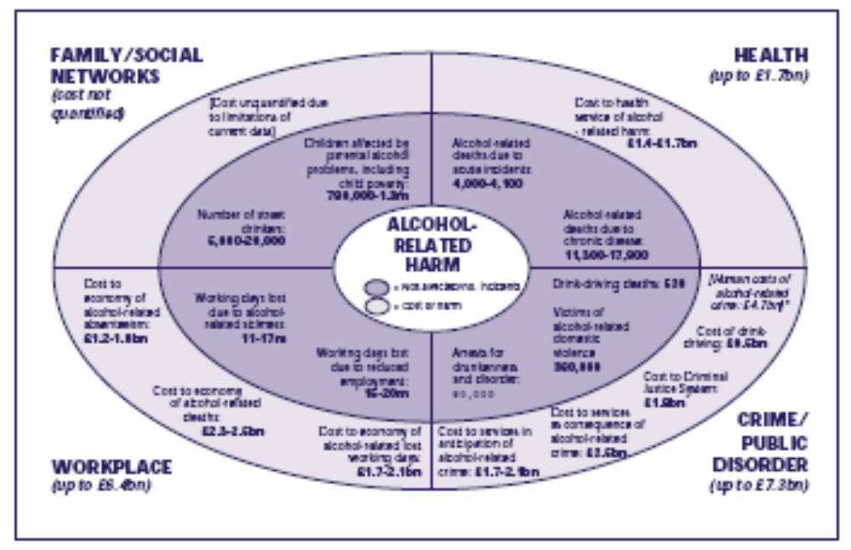

Regional
The North East is a small but diverse region, characterised by a strong and vibrant night-time economy, not merely in the main centres of population, such as Newcastle, Sunderland and Middlesbrough, but also in the largely rural counties of Durham and Northumberland. The tradition of heavy industry in the region has helped to foster a ‘drinking culture’ and it can be argued that alcohol plays a more important role in the culture and economy of the North East than of any other region.

Patterns and trends
- In England, data on alcohol use and associated problems among children at the regional level are limited, yet among adults the North East is known to have higher average weekly alcohol consumption, more binge drinkers, and higher prevalence of hazardous or dependent alcohol consumption than any other region in the country.
- The average weekly alcohol consumption in the North East is higher than in any other English region, for both men and women. Men drink an average 20.8 units a week and women 9.4 units – compared with London at the other end of the scale where men average 14.4 units and women 5.5 units.

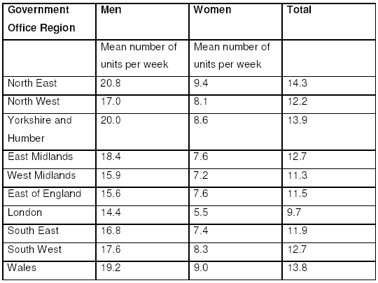
- 36% of respondents in the North East – 48% of men and 25% of women – had exceeded the recommended daily consumption limit (3-4 units for a man, 2-3 for a woman) on at least 1 day in the week prior to the survey. This is significantly higher than the national average of 39% for men, 22% for women.
- The North East Region had the lowest proportion of alcohol drinkers who had drunk <2 units in the last week and one of the highest proportions who had binge drank in the last week – around 29% of men and 17% of women regularly downing double the alcohol units advised by medical experts.

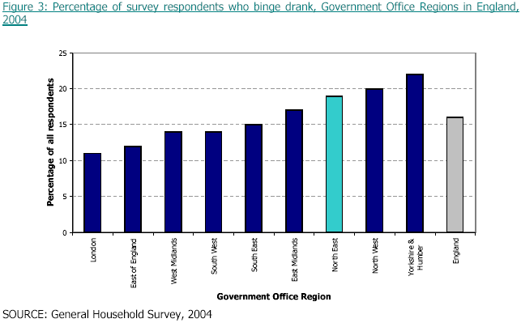
- There is a higher prevalence of hazardous or dependent alcohol consumption in the North East than in other English regions.
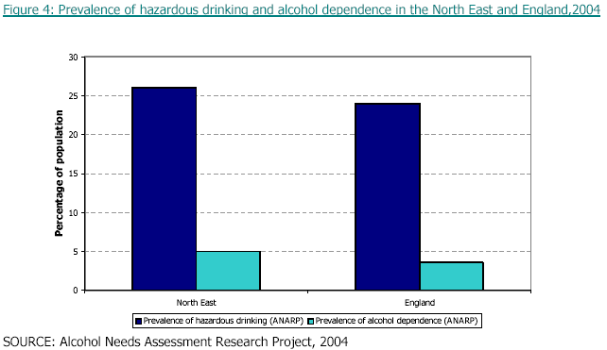
- The 2005 ANARP highlighted the shortage of alcohol treatment services and the huge demand for services right across the North East. The key findings were:
- The North East region has the fewest agencies providing specialist alcohol interventions and only 1 out of every 102 people with an alcohol problem in the North East receives appropriate treatment. This compares to a national average of 1 out of every 18
- Waiting times are the longest in the country with people waiting an average of 7.1 weeks for alcohol treatment
- The average waiting time for treatment assessment is longer in the North East than elsewhere in the country

Impact
- There are higher rates of alcohol related death and poor health in the North East among men and women than in the rest of England.
- The mortality from alcohol-related causes has increased nationally between 1997 and 2004, but the increase is greater in the North East.
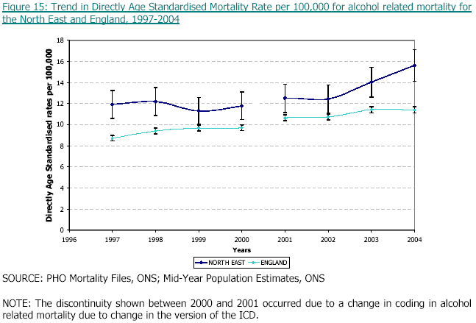
- In general, males have higher alcohol related mortality than females and the North East has higher mortality than most regions.
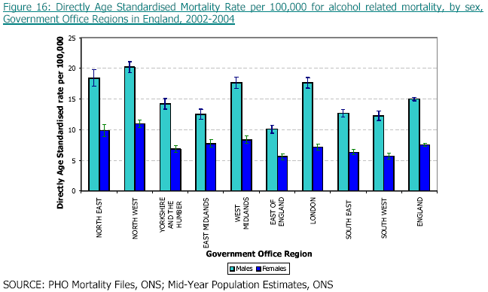
- The North East has a statistically significant higher rate of hospital admissions for alcohol related causes than England and all other regions, except the North West.
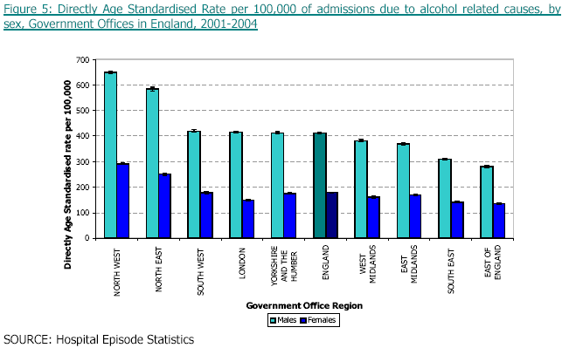
- Alcoholic liver disease is an important indicator of long-term high alcohol consumption. Both males and females in the North East have a higher rate for admission for liver disease than males and females nationally.
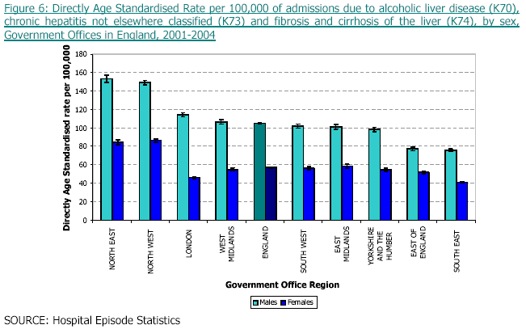
- North East males and females have a higher rate for admission for accidental poisoning and exposure to alcohol than any other region and more that double the national rate. Among men the peak age for admission is between 20 and 30 years, among women it is between 10 and 20 years.
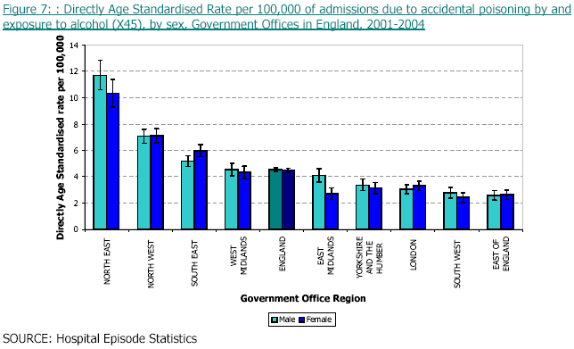
- During 2004/5, there were 9823 individuals who received drug treatment services within the North East. Approximately 10% of this group had alcohol identified as a secondary problem. The majority (73%) of those with alcohol as a secondary problem were males.
- On average 6.5 people die annually in road traffic accidents involving alcohol in the North East. The actual number of accidents involving alcohol every year has changed little over the last 10 years.
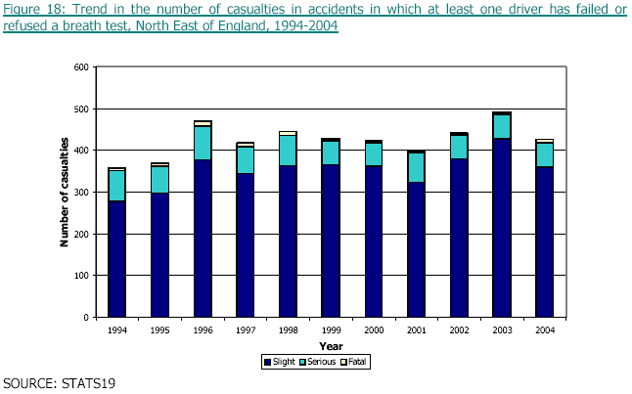
- Within the North East there is an average of 161 accidents resulting in injuries that involve alcohol between Friday and Sunday, and an average of 106 accidents resulting in injuries that involve alcohol between Monday and Thursday.
- In 2003/4 the cost of treating North East residents admitted with a primary diagnosis of alcohol related disease was approximately £5.6 million. Additional costs where alcohol related disease was a secondary diagnosis were approximately £12.0 million. Rough estimates suggest that additional health care costs are likely to be at least £100 million per annum in the North East. The overall cost of alcohol misuse in the North East is approximately £1 billion/year.

Local
North Tyneside has a high population density, heavy drinking culture, and stark health and social inequalities in some areas of the borough, which have contributed to high levels of alcohol-related harm.

Patterns and trends
In 2004, a Healthy Lifestyle Schools Survey was conducted in schools across North Tyneside with 847 (out of 2379) year 6 (11 year olds) and 721 (out of 2342) year 9 pupils (14 year olds). The survey found that:
- 13.1% of year 6 pupils consume alcohol at least 1 day a week, while 40.3% of the year 9 cohort drinks alcohol at least once a week
- 52.4% of year 9 pupils never get drunk, 38.7% get drunk occasionally and 7.4% get drunk ≥once a week
- 20% of year 9 pupils drink so much that they are out of control (18.2% occasionally and 1.8% twice a week or more)

A survey carried out for the 2005 North Tyneside Children and Young People’s (CYP) Alcohol Strategy, conducted with 10-17 year olds living in North Tyneside, found that:
- More girls (73.3%) than boys (58.4%) drink alcohol. This differs from the rest of England where more boys tend to drink than girls at all ages.
- 52.2% of boys and 51.6% of girls who drink alcohol drink on a weekly or more frequent basis.
How often young people drink by gender and percentage:
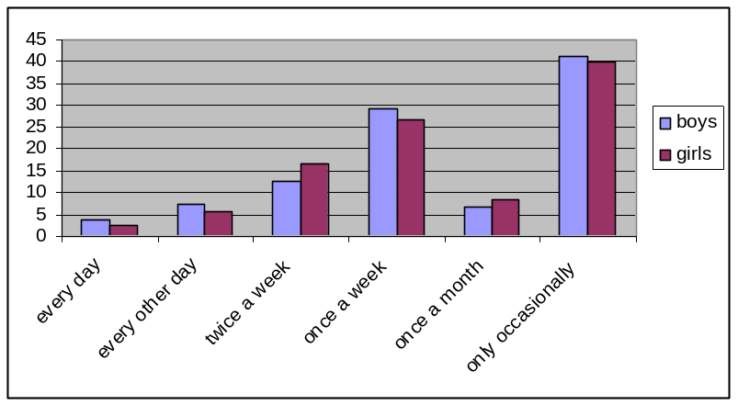
  - A strong upward trend in drinking alcohol is identified between the ages of 13-15 years for both boys and girls.
Percentage of young people who drink alcohol by age and by gender:
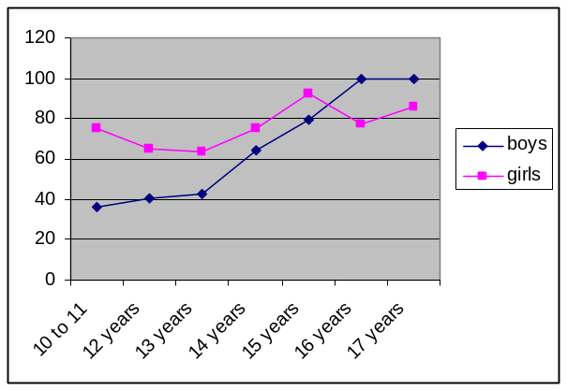
- Amongst boys, occasionally drinking alcohol steadily declines from the ages of 12 to 15, with a loosely corresponding increase in drinking to once a week.
How often boys drink alcohol by percentage and by age:
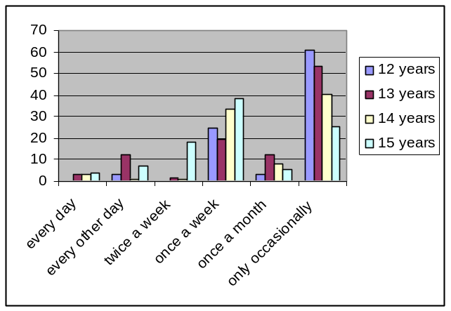
- For girls, there is a similar decrease in occasionally drinking alcohol and rise in drinking once a week, but the percentage of girls who drink twice a week is higher than the percentage of boys who drink twice a week.
How often girls drink alcohol by percentage and by age:
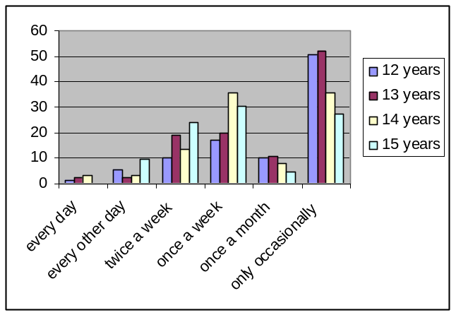

Where young people drink
- Whilst drinking at home and at friends’ homes were the most typical locations for young people to drink, a significant proportion drank in outdoor public places (e.g. streets, recreation grounds, fields, seafront, building sites) and few drank in pubs and nightclubs.
- A significant amount of binge drinking by young people takes place in unsupervised, often outdoor/hidden locations, which can be potentially dangerous for the young people involved. Greater likelihood of intoxication in outdoor settings places youths at increased risk of alcohol-related harm (e.g. accidents, hospitalisation, unsafe sex, drug use, fighting) and exposure to the environmental dangers inherent in these contexts (i.e. traffic, deep water).
Venues where young people drink by percentage and by gender:
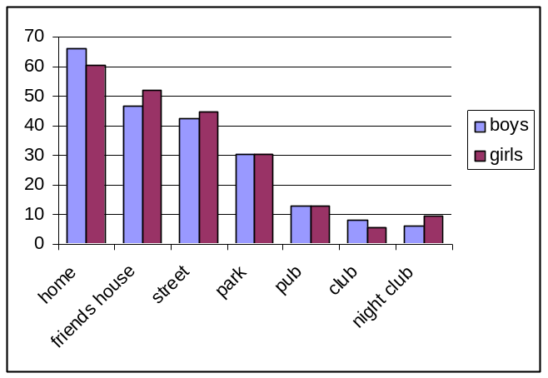

Young people’s access to alcohol
- There is a general perception that young people are able to access alcohol quite freely. Alcohol was mainly obtained from corner shops or parents.
Where young people buy alcohol:
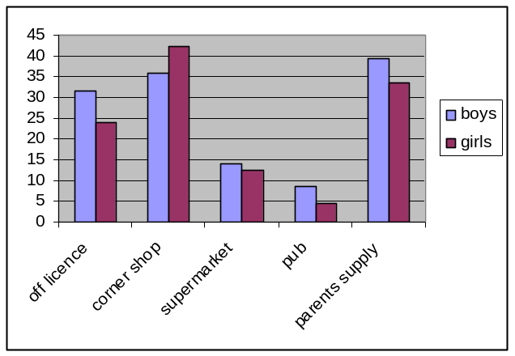
- 28.3% of boys and 28.6% of girls found it very/quite easy to buy alcohol, 17.3% of boys and 16.1% of girls found it quite or very hard to buy alcohol. Some young people didn’t know how easy or hard it was to buy alcohol (boys 14.7%, girls 19.8%), suggesting that they may not have tried to purchase alcohol themselves.
How easy or hard it is for young people to buy alcohol:
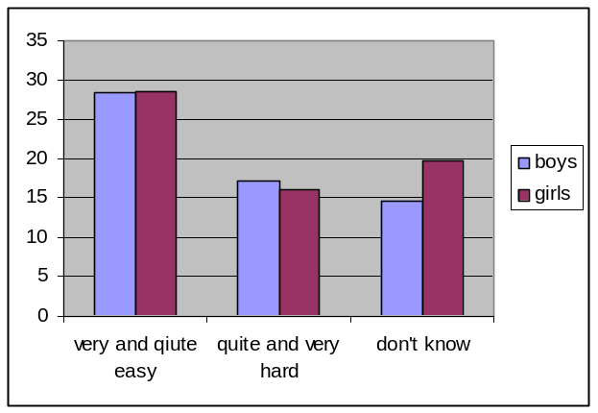
- Even more found it easy to get others to buy them alcohol - 40.7% of boys and 45.1% of girls found it very/quite easy, while 11.6% of boys and 10.6% of girls found it quite/very hard.
How easy or hard it is for young people to get others to buy their alcohol:
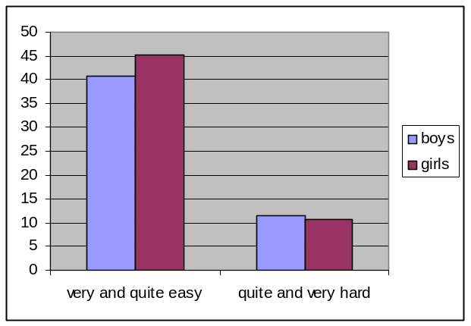
- Boys were more likely to ask friends (39.2%), strangers (32%), and parents (27.5%) to buy their alcohol, whereas girls were more likely to ask strangers (39.9%), friends (34.4%), and other family members (26.2%) to buy their alcohol.
Who would buy alcohol for young people by percentage and by gender:
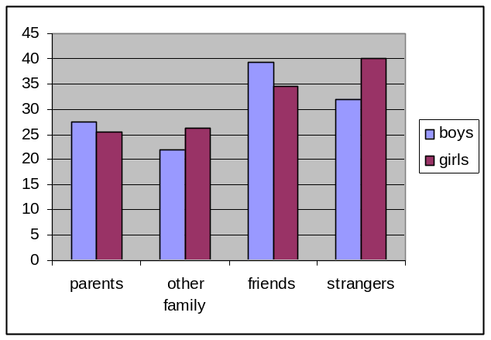

Impact
- According to figures released in 2007 by the North East Public Health Observatory (NEPHO), North Tyneside has some of the highest rates of under-18s being admitted to hospital due to alcohol-related causes.
- While the teenage pregnancy rate (under 18) in North Tyneside has been reducing gradually, it is still significantly higher than for England. From the 1998 baseline, the rates have reduced from a baseline rate of 58.4 to 51.1 for 2004: a fall of 12.4% which is higher than the fall nationally (of 11.1% in England and 11.6% in England and Wales) and also higher than the regional figure of 10.6%. The conception rate for 15-17 year olds for the year 2003 was:
Area | Conception rate per 1,000
North Tyneside | 52
North East | 51.9
England | 42.1
- In 2003/2004, there were 3 specific substance misuse services for young people in North Tyneside; the Drug Support Service in North Shields, The BASE in Whitley Bay, and the North East Council on Addictions (NECA) in Walker. The Drug Support Service saw 19 young people with alcohol issues in that year, 14 were male and 5 were female. Neither The BASE nor NECA had reliable information for 2003/2004.
- The North Tyneside CYP survey found that 19.6% of boys and 14% of girls drink alcohol and take illegal drugs.
- The same study found that 23 girls (7%) and 11 boys (4.1%) had missed school due to drinking alcohol. Unauthorised absences were noted at 0.2% in Primary schools, 1.4% in Special and other schools and 1.3% in Secondary schools.
Absence by school (2003-2004)
School | %AuthAbs | %UnauthAbs | Total Abs | Attendance Rate
LEA-Primary | 4.8% | 0.2% | 5.0% | 95.0%
LEA-Secondary | 6.5% | 1.3% | 7.7% | 92.3%
LEA-Special | 9.2% | 1.4% | 10.5% | 89.5%

There were 848 fixed term exclusions from High and Middle schools, 170 from Special and other schools, and 84 from First and primary schools. There were 28 permanent exclusions from High and Middle schools, 3 from Special and other schools, and 6 from First and Primary schools.

Exclusions by school 2003-2004
 | FIXED EXCLUSIONS 2003/2004 |  |  | PERMANENT EXCLUSIONS 2003/2004 |  |  | PUPIL NUMBERS
 | Female | Male | Total | Female | Male | Total | Female | Male | Total
Summary High/Middle | 182 | 666 | 848 | 5 | 23 | 28 | 6863 | 6958 | 13821
Summary First/Primary | 14 | 70 | 84 | 0 | 6 | 6 | 8208 | 8618 | 16826
Summary Special (inc other) | 6 | 164 | 170 | 1 | 2 | 3 | 164 | 315 | 479
TOTAL | 202 | 900 | 1102 | 6 | 31 | 37 | 15235 | 15891 | 31126

Trouble
- There is a sharp increase in the number of boys who get into trouble between the ages of 13 and 15 years.
Percentage of boys getting into trouble:
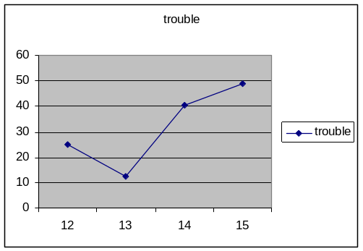
- There is a sharp increase in girls getting into trouble between the ages of 13 and 14 years, with a decline at 15 years.
Percentage of girls getting into trouble:
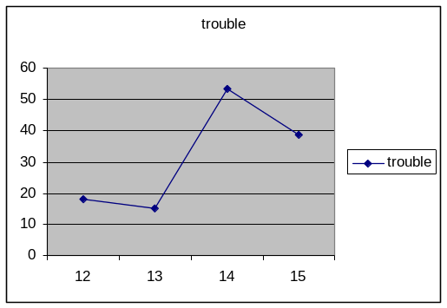

Alcohol Related Crime
- In line with national trends, alcohol related crime and disorder appears to be rising in North Tyneside, despite remaining lower than the England average. This may be due to changes and improvements in recording crimes, but given that alcohol consumption is rising in the Borough and generally across England, and that alcohol is now more affordable and widely available, it is not surprising that alcohol-related crime and disorder has risen over recent years.
- During the period 01/01/04 to 31/05/07, there were 3,738 crimes with the Alcohol Marker attached, 711 (19%) of which were domestic related. 2004-2005 saw the largest yearly percentage increase with alcohol related crimes increasing by more than 200%. Over the period 01/01/04 to 31/12/06 there was an increase of 458% in alcohol related crimes. Between 01/04/06 and 31/10/06 there were 1013 crimes where the ‘Under the Influence of Alcohol’ marker was highlighted, which accounts for 11.78% of the Area Command’s crime.
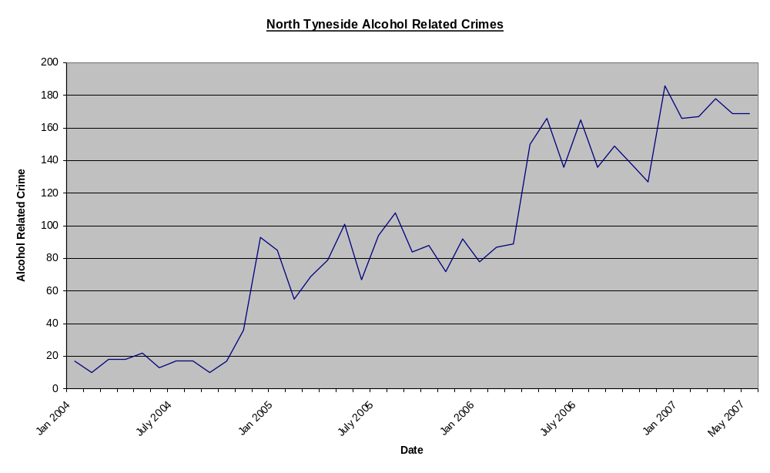
- The most common alcohol related crimes are Assault Section 47 and Public Order Section 5, which together account for >50% of all alcohol related crime.
Description | No. of alcohol related crimes | % of all alcohol related crime
Assault | 411 | 40.6
Public order | 227 | 22.4
Damage | 169 | 16.7
Possession of drugs | 40 | 3.9
Theft | 25 | 2.5
Racial | 11 | 1.1
Other | 130 | 12.8
TOTAL | 1013
- 840 offenders were attached to alcohol related crimes, 137 (16%) of these were aged ≤17.
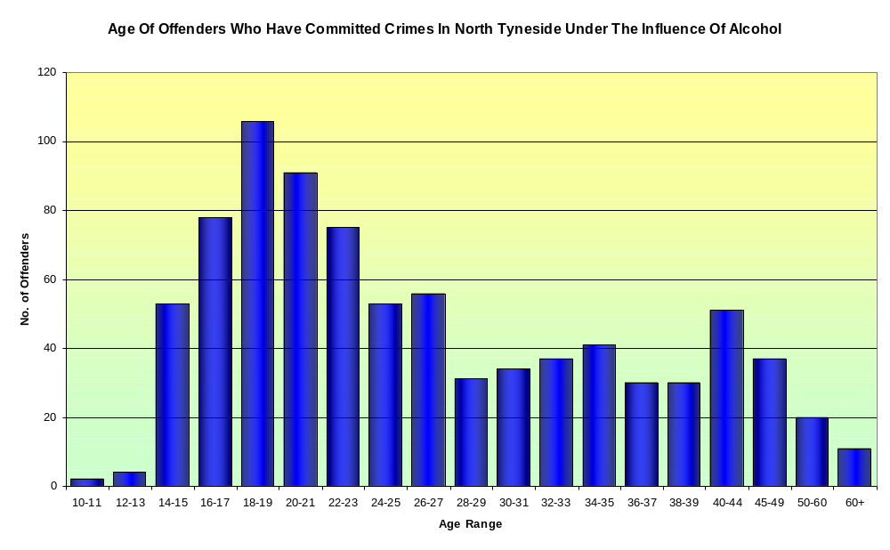

- The main hotspots for youth alcohol related offences were D4K1 – Longbenton, followed by D3M1 – Howdon and Whitley Bay town centre.
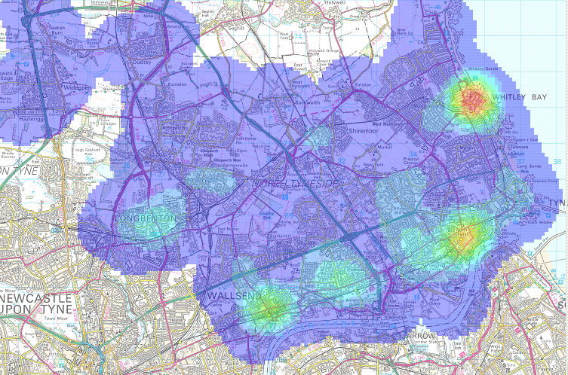

- Historically Whitley Bay has been exposed to large numbers of youths from all over North Tyneside and further afield who gather in the large open spaces around the area, often drinking and sometimes taking drugs. Some then engage in disorder which often escalates to crimes like damage and assault. The juveniles themselves run the risk of either becoming a victim of crime, or entering the criminal justice system following arrest. Crime data for Whitley Bay Town Centre:
  - 139 offences – 80 (57.7%) of these offences occurred between 21:00 – 03:59 on Friday night/Saturday morning or Saturday night / Sunday morning. The main focal area for these crimes is the area surrounding Deep nightclub, Jimmyz Bar, Time Bar and Pier 39. This area is historically the main drinking area of North Tyneside.

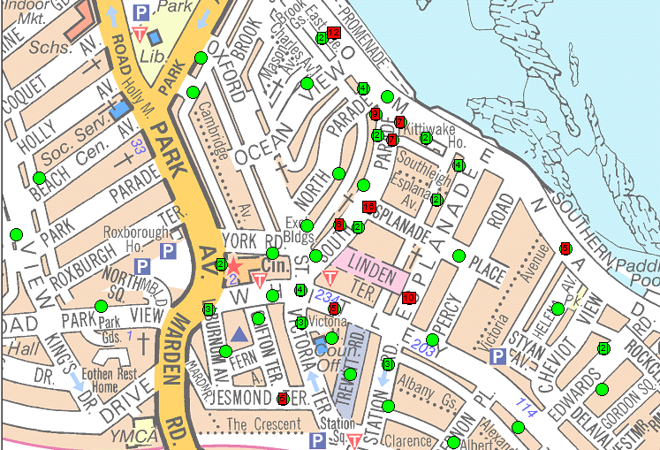

  - The locations with 16, 12 and 10 offences are offences which have taken place on the street, and although these offences may have occurred anywhere along this street they are all given the same grid reference and so all appear in one location.
  - There were 130 offenders attached to the detected crimes – of these 69 (53%) were aged between 18 and 23, 20 (15%) were female, and 99 (76%) came from either D1: North Shields (40) or D2: Whitley Bay (59), only 10 (8%) came from either D3: Wallsend or D4: Killingworth, and 20 (16%) were from outside the Area Command.
- In 2003/4, the YOT had contact with 863 young people who were usually resident in the North Tyneside area. There were 10 crimes where an offender was aged under 18 and alcohol was recorded as a factor. In the same period there were 100 alcohol-related offences (94 x Drunk & Disorderly and 6 x Excess Alcohol - Drunk in Charge) involving 92 Young Persons (11%). 18 were male and 7 were female. All young persons were recorded as either White European or White British. The distribution of offenders receiving Interventions, according to postcode, is listed below.
NE12 2
NE25 1
NE26 3
NE28 9
NE29 6
NE30 4
Total 25

Alcohol Related Incidents
During the period 01/04/2006 to 31/05/2007 there were 1,056 alcohol related incidents, which represents a 611.1% increase in alcohol related incidents. This could be partly due to better reporting of alcohol related incidents using the correct coding. The largest monthly percentage increase was observed from Aug 2006 to Sept 2006, which saw a 166.7% increase, but could also be due to more accurate reporting of incidents.
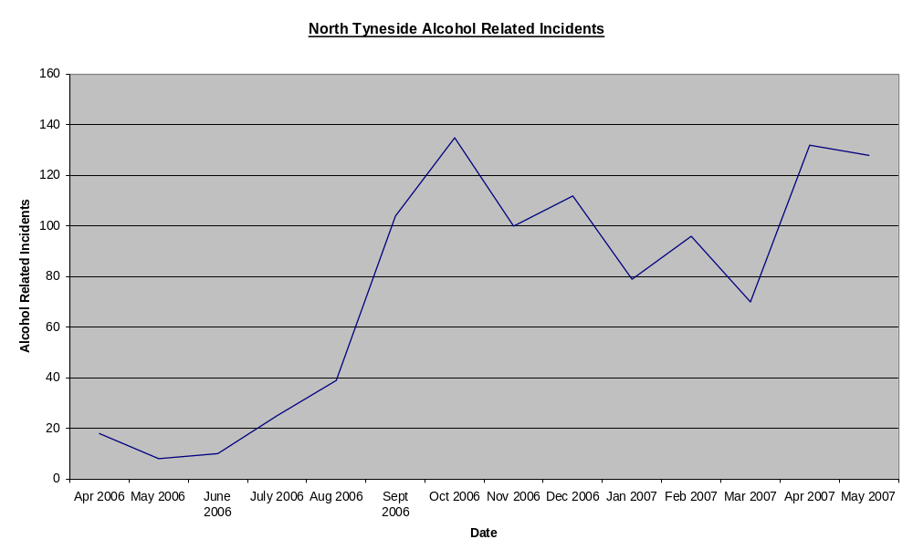
Perceptions of safety
  - Findings relating to feelings of safety in the local area present a mixed picture. While around 8 in 10 residents feel safe in the area during the day, only 3 in 10 feel safe when outside at night. Feelings of safety are similar across most groups of residents, but those aged 55-64 are more likely than average to feel safe during the day (85% compared with average 78%), and men are more likely than average to feel safe being out after dark (34% compared with average 28%). Residents who live in council homes are more likely to say they feel ‘very’ unsafe being outside after dark (25% compared with average 17%), and less safe during the day (9% unsafe compared with average 5%).
  - Public drinking is associated with ASB and can intimidate members of the public, cause disorder and nuisance and generally degrade public spaces so they become ‘no go’ areas for residents and communities. Drinking on the streets contributes to driving people’s fear of crime:
  - A recent local survey identified that the problem most affecting residents was ‘teenagers hanging around streets’ (20% of all respondents), often with or having consumed alcohol.
  - 61% of the national population think alcohol-related violence on the streets is increasing. 1 in 4 people say that drunk and rowdy behaviour is a problem in their neighbourhood. 7 in 10 say drinking in public places or on the street is a problem in their area. Concern is greater in inner city or urban areas than rural ones.
  - Under-18s are seen as the biggest problem by 57% of the public, followed by young adults/over-18s (28%), “Friday and Saturday night” drinkers (25%) and street drinkers.
  - Providing activities for teenagers is now the top priority among residents. Other factors that have grown in importance over the past 3 years to become high priorities include road and pavement repairs, the level of crime, cleanliness of streets, and improvements to parks and open spaces. The perceived need to address crime levels ties in with residents’ concerns about their safety in the area after dark. Residents often perceive links between crime/ASB and a lack of activities for teenagers.

Overview
- North Tyneside is a highly populated area situated in the North East of England and is 1 of the 5 metropolitan districts that make up the Tyne and Wear conurbation. It serves a population of 194,000 that is predominantly white (~98% of the population).
- The Borough has a wide range of social and economic characteristics – with some areas being amongst the most affluent in the North East and others being amongst the most deprived (i.e. Chirton, Riverside, Collingwood, Longbenton, Howdon and Wallsend). Over a quarter (26%) of the borough's population live in wards that are ranked among the most deprived 10% in England.
- The city has a low rate of employment and residents are less likely to have qualifications (16.4%) than the national average (19.8%), reducing their chances of employment.
- North Tyneside has higher numbers of lone parent households with dependent children and lower percentages of married and cohabiting couple households than the national average.
- Life expectancies at birth for males and females are significantly lower than for England. A higher proportion of people in North Tyneside considers their general health ‘not good’ or has limiting long-term illness than the national average. Death rates from heart disease and stroke, cancer, and smoking are significantly higher than England rates, which may be associated with its industrial legacy and relatively poor economic circumstances.
- In recent years, heavy drinking and harmful drinking patterns have been increasing among young people in the UK. While the proportion of 11-15 year olds who drink at all has remained at about 60% since 1988, those who drink are consuming more alcohol, more often. Drinkers under the age of 16 are drinking twice as much today as they did 15 years ago and the proportion of young people drinking at least once a week rose from 13% in 1990 to 17% in 2005. UK teenagers report some of the highest levels of binge-drinking and life-time drunkenness in Europe. While teenage boys continue to drink more, teenage girls are drinking more alcohol, more frequently, and are now equally likely to have drunk alcohol in the past week.
  - Regular heavy drinking and binge drinking behaviours are associated with a whole range of problems including severe intoxication, physical and mental health problems, unprotected sex, illegal drug use, antisocial behaviour (ASB), violence, accidents, assaults, and poor school performance. Excessive drinking costs the UK economy around £20 billion each year in health, crime and disorder, which equates to £407 per year for every person in England.
- At the regional level, data on alcohol use and associated problems among children is limited, yet among adults the North East is known to have higher average weekly alcohol consumption, more binge drinkers, and higher prevalence of hazardous or dependent alcohol consumption than any other region in the country. There is also a shortage of alcohol treatment services and a huge demand for services right across the North East.
  - The North East thus sees higher rates of hospital admissions and mortality due to alcohol-related causes than the rest of England. The overall cost of alcohol misuse in the North East is approximately £1 billion per year.
  - While data on youth drinking trends is limited for North Tyneside, local surveys reveal heavy drinking and harmful drinking patterns – about 2/3 of young people drink alcohol and over half drink at least once a week. Almost 50% of year 9 pupils (14 year olds) have been intoxicated, and 20% have drunk so much that they were out of control. There is a strong upward trend in drinking alcohol between the ages of 13-15 years for both boys and girls. Historically boys were more likely to drink than girls, but now more girls than boys drink alcohol and a higher percentage of girls drink twice a week. A significant proportion of young people drink on the streets and alcohol is quite easily obtained, usually from parents, the corner shop, or off-licences, rather than pubs.
  - North Tyneside has some of the highest rates of under-18s being admitted to hospital due to alcohol-related causes and the teenage pregnancy rate is significantly higher than for England. Up to almost 20% of young people drink alcohol and take illegal drugs.
  - In line with national trends, alcohol related crime and disorder appears to be rising in North Tyneside, despite remaining lower than the England average. Between 01/04/06 and 31/10/06 16% of the offenders attached to alcohol related crimes were aged ≤17. The main hotspots for these youth offences were Longbenton, followed by Howdon then Whitley Bay town centre.
  - While most residents do feel safe in public places during the day, only 3/10 feel comfortable outdoors after dark. Men are more likely to feel safe outside at night, and residents living in council homes are more likely to feel unsafe outside after dark and during the day. Public drinking contributes to driving people’s fear of crime, and under-18s are often seen as the biggest problem. The problem most affecting local residents is ‘teenagers hanging around streets’, often with/having consumed alcohol. Providing activities for teenagers is now a top priority among residents, and improvements in crime and streets/roads and parks/open spaces are increasing in importance.
- PROBLEM DESCRIPTION

Presenting Issue
A large proportion of underage teenagers drink more than once a week. Young people are able to access alcohol quite freely and many of them drink unsupervised on the streets rather than indoors, which not only places them at increased risk of alcohol-related harm and environmental danger, but also contributes to residents’ fear of crime. ‘Teenagers hanging around streets’, often drinking or having drunk alcohol, is a key concern for local residents, and alcohol related incidents and crimes are on the rise.

Behavioural Challenge
The behavioural challenge is thus to reduce kerbside drinking in under-18s.

Possible Target Group(s)
Primary target audience:
- Underage street drinkers/clients within the Childsafe programme
- 11-14/15 year olds
- Both genders
- White European/British
- Longbenton, Howdon, Whitley Bay (hotspots) – streets, parks, sea front
- Friday & Saturday nights

Secondary targets:
  - Parents, siblings and friends of underage street drinkers/clients within the Childsafe programme
  - Childsafe staff/police
  - Alcohol retailers (particularly off-licenses and corner shops), bartenders, waitstaff
  - Schools?
  - GPs?
- POLITICAL CONTEXT

National (see Annex A for more detail)

Alcohol Harm Reduction Strategy for England (AHRSE) 2004
The AHRSE, published in March 2004, was the first attempt by a Government in England, to tackle the problems associated with alcohol misuse* in a coordinated, cross government manner. The AHRSE aims to tackle the 2 major problems caused by alcohol misuse: crime and ASB in town and city centres; and harms to health as a result of binge and chronic drinking. It also seeks to address the less visible social and economic harms and costs attributed to alcohol misuse.

Key activities:
- Better education and communications
- ‘Know Your Limits’ binge drinking campaign
- ‘THINK!’ drink driving campaign
- Enforcement of Ofcom’s new code on television advertising
- ‘Code of Practice on Naming, Packaging & Promotion of Alcoholic Drinks’

- Improving health and treatment services
  - Trailblazer research trials to support harmful drinkers
  - National assessment of need for and availability of alcohol-related treatment, provided by ANARP
  - Guidance on provision of effective treatment services
  - DH published ‘Alcohol Misuse Interventions: Guidance on developing local programme improvement’
  - MoCAM published in June 2006 by DH & National Treatment Agency
  - ‘Review of Effectiveness of Treatment for Alcohol Problems’ published in November 2006 by NTA.
  - Alcohol Education & Research Council (AERC) – responsibility transferred on 2/1/07 from DCMS to DH.

- Combating alcohol-related crime and disorder
- New powers under Licensing Act 2003 & Violent Crime Reduction Act 2006
- Strategic approach to tackling alcohol misuse across correctional services
  - ‘Working with Alcohol Misusing Offenders – Strategy for Delivery’ published in May 2006 by National Probation Service
  - Complements ‘Addressing Alcohol Misuse – Prison Service Alcohol Strategy for Prisoners’ (December 2004)
- National alcohol misuse enforcement campaigns (AMECs)
- Tackling alcohol-related violence through Tackling Violent Crime Programme (TVCP)
- Alcohol disorder within A&E departments and other NHS sites.

- Working with the alcohol industry
- Improving labelling on alcohol containers
- Restrictions on alcohol advertising
- Drinkaware Trust – established in early 2007
- Responsible production and sale of alcohol drinks – ‘Social Responsibility Standards for Production and Sale of Alcoholic Drinks in the UK’ launched in November 2005 by the alcohol industry
- Best Bar None

Safe. Sensible. Sociable: Next Steps for the Government’s National Alcohol Strategy 2007
After reviewing the effectiveness of the AHRSE, the Government published this strategy in June 2007. Safe. Sensible. Social. seeks to build on the foundations laid and lessons learnt since 2004. The strategy’s long term goal is to minimise the health harms associated with alcohol and reduce levels of violent crime, disorder and ASB. Its target groups are under-18s who drink, 18-24 year old binge drinkers and importantly, harmful drinkers, described in the strategy as people who “don’t realise their drinking patterns damage their physical mental health and may be causing substantial harm to others.”

In addition to its prior commitments, the Government plans to:
- Ensure better use of law and enforcement powers for drunken behaviour
- Conduct a review of NHS spending
- Provide more help for people who want to drink less
- Toughen enforcement of underage sales
- Offer trusted guidance for parents and young people
- Launch public information campaigns to promote a new ‘sensible drinking’ culture
- Undertake a public consultation on alcohol pricing and promotion
- Ensure all local Crime and Disorder Partnerships have a strategy to address substance misuse

The government stresses that although it will take the lead in delivering the National Alcohol Strategy, responsibility for ‘making it happen’ also lies with individuals, families, communities and the alcohol industry. Several other key policy drivers have been published in recent years which strengthen and expand the drive to tackle alcohol related harm detailed in the National Alcohol Strategies.

Other key policy drivers
The Government White Paper published in November 2004, Choosing Health: Making Healthier Choices Easier, aims to build on the commitments outlined in the AHRSE. The key priorities set out in the report are: early identification and intervention in the lives of people with alcohol problems; developing a programme to improve the quality, effectiveness and delivery of alcohol treatment services; launching initiatives in partnership with the criminal justice system to reduce re-offending; and ensuring alcohol treatment needs are met alongside drug treatment needs.

In 2004, the Government introduced a change for children reform agenda, Every Child Matters: Change for Children, arising from The Children Act 2004. The Children Act 2004 introduced a statutory requirement for each Local Authority to set up partnership arrangements (Children’s Trusts) to promote cooperation to improve the well-being of children and young people and effectively deliver the Five Outcomes. The ‘Be Healthy Outcome’ aims to promote healthy lifestyles and reduce alcohol consumption among young people up to the age of 19.

The Hidden Harm Report: Realities, Challenges and Opportunities, published in 2007 by the Advisory Council for the Misuse of Drugs (ACMD), highlights the problem of children and young people born to and living with parental alcohol misusers. It builds on the first Hidden Harm report published by the ACMD in 2003, and gives greater focus to the issue of young people affected by parental alcohol misuse. The report estimates that there are between 780,000 and 1.3m children and young people affected by parental alcohol problems. It recommends that alcohol strategies take steps to identify and provide services for those children and young people affected.

The Respect drive is a cross-Government strategy that builds on what has already been achieved in combating ASB and goes broader, further and deeper to tackle the causes of ASB and prevent the next generation becoming involved. The Respect Task Force, established in September 2005, works closely with local areas to ensure that the Respect Action Plan, published in January 2006, is delivered successfully across the country as well as developing policy and communicating the Respect message to a variety of audiences. The Respect Task Force now sits within the new Department for Children, Schools and Families. Key measures of the Respect drive include:
- A new approach to tackling problem families through intensive family intervention programmes.
- A wide-ranging programme to address poor parenting. Additional investment will be available to fund parenting programmes across the country.
- Strengthening communities through more responsive public services. Local services will be encouraged to hold regular face the people sessions.
- Improving behaviour and attendance in schools. Targeted action on persistent truants and a range of new measures to tackle poor behaviour in schools.
- The funding of constructive activities for young people such as youth intervention projects and sports programmes.

Regional Developments
Taking into account the serious problems associated with alcohol misuse in the North East, statutory and voluntary agencies across the region have already carried out a wide range of alcohol related initiatives. A number of Local Authority (LA) areas have also used Local Authority Agreements (LAAs) to develop, with their partners, programmes of work for tackling alcohol-related problems. Some key examples of good practice include:
- The North East Regional Alcohol Advisory Group (NERAAG) (see Section 4.2.1 below);
- Last year, the Government Office for the North East (GONE) carried out a regional mapping exercise to establish the extent and nature of alcohol-related activity in the region. This gave an insight into the wide range of interventions and initiatives across the North East and allowed GONE to evaluate any gaps in service provision;
- Many Community Safety Partnerships, local authorities and Local Strategic Partnerships have produced ‘Alcohol Strategies’ or ‘Action Plans’ to tackle alcohol misuse in their areas;
- Regional networks have been set up for Community Safety and PCT alcohol leads, to disseminate local and national developments and share alcohol-related good practice;
- The Regional Re-Offending Strategic Board has commissioned work to identify the level of need with regard to alcohol using offenders in the North East and has set up a ‘pathway’ group to look at ways of addressing that need;
- The 3 probation areas in the region operate an accredited programme for offenders convicted of drink-driving and an accredited programme for perpetrators of domestic violence, mandated to attend by the court;
- The 3 regional Police forces have carried out a number of targeted and successful campaigns to tackle alcohol-related issues in the night-time economy (see Section 5.4.1);
- An independent peer support charity, NERAF, has been formed to provide long-term aftercare to problematic drinkers, their families and carers, the first of its kind in the country.

North East Regional Alcohol Advisory Group (NERAAG) – ‘Alcohol Misuse Statement of Priorities’
Established in 2003, under the Chairmanship of the Regional Director for Public Health, the NERAAG brings together agencies and individuals from across the region with an interest in the alcohol agenda.

The regional group launched a ‘North East Alcohol Misuse Statement of Priorities’ in February 2007, which identified a number of cross cutting initiatives aimed at driving down poor health, crime, disorder, social and economic harms associated with alcohol misuse. The Statement of Priorities is intended to support and complement local initiatives, add value and influence events at a regional level, as well as direct policy vision across the North East region. A supplementary ‘North East Alcohol Action Plan’ outlines the steps and mechanisms for delivery of the Statement of Priorities, in partnership with agencies and colleagues across the region. The regional strategy will form the basis of North Tyneside’s Alcohol Harm Reduction Strategy.

Recognising that a culture of ‘binge’ drinking is particularly strong in this region, the ‘Priorities for Action’ fall under 3 overarching aims (see Appendix B for details):
- Developing a preventative approach towards alcohol misuse throughout the North East region
- Ensuring services are provided for harmful, hazardous and dependent drinkers and for their families and carers
- Promoting public protection through law and policy enforcement

Local Initiatives

North Tyneside Local Area Agreement (April 2007 – March 2010)
The North Tyneside Strategic Partnership (NTSP) is made up of 6 ‘Theme Partnerships’ specialising in different areas.
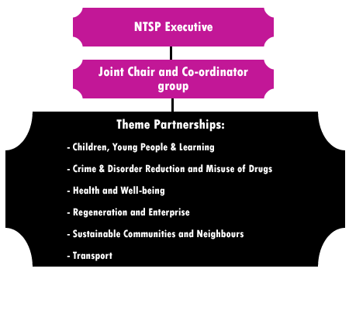
As alcohol has an impact across all themes within the NTSP and all areas of the Borough, the NTSP had identified reducing the harm caused by alcohol as 1 of its 4 priority outcomes within its LAA. To avoid duplication or the need to put new resources into performance management, the NTSP has decided to use existing systems wherever possible. The following groups are well placed and able to deliver elements of the 4 ‘big priority’ areas of the LAA:
- Reducing alcohol abuse - Alcohol workstream of the PCT Public Health Delivery Group
- Worklessness – Economic Development, Enterprise & Skills sub-group of the Regeneration Partnership)
- Reducing obesity/reducing smoking – Obesity and Tobacco control workstreams of the PCT Public Health Delivery Group
- Safer places and spaces - Play Partnership subgroup of Children, Young People & Families Board (CYPF) Board
In 2005, >13% (4123) children and young people in North Tyneside attended 4 forums to give their views on issues of concern to them. Children and young people want to see:
- Places and spaces, not just organised activities and recreational materials, but places to hang out, young people’s places, youth centres to see friends. Young people think that if they had somewhere to go this would solve other issues, e.g. ASB, drinking, drugs, bullying and gang culture.
- Parks safely secured and vandal-free, more sports facilities, skateparks.

Proposals have been included in the North Tyneside CYP Plan 2006-2010 and the Play Strategy. Children and young people will be actively involved in the planning, development and delivery of formal play sites in their localities to ensure the facilities meet their needs and to give them a sense of ownership of the facilities.

A multi-agency approach will be used to provide a range of support services for children and young people which meet their complex needs and focuses on a model of inclusion. The Partnership recognises that “place making, improving the design, maintenance and supervision of parks and other public places, is a more effective solution to anti-social behaviour than simply increasing security measures.”

Consultants were appointed to carry out a review of current provision and from this a capital investment programme has been developed to carry forward the Play Strategy. Play sites will be provided in accordance with national standards for all age groups and will include a number of sites with facilities for teenagers as well as children, e.g. provision of multi-use games areas, teenage shelters, etc.

North Tyneside Public Health Alcohol Workstream
North Tyneside’s Public Health Alcohol Workstream, which is represented on the NERAAG, has membership from the Health Partnership Board, CYPF, and the Crime & Disorder Reduction and Misuse of Drugs Partnership (CDRMDP). Membership also includes health; police; local authority – trading standards, education; voluntary sector and service user representatives.

Neighbourhood Renewal Funding Bid – Reducing the Harms Caused by Alcohol
In order to deliver national, regional and local priorities, and LAA targets, the Alcohol Workstream agreed that a Neighbourhood Renewal Funding (NRF) bid would be led by the CDRMDP and reporting accountability will be through that Partnership. The proposal included a number of elements related to treatment, prevention and control, and an element of each of these themes has been incorporated into North Tyneside’s LAA. Within the NRF proposal there are 2 key threads:

1) Childsafe
The Childsafe initiative aims to reduce levels of crime and disorder, protect vulnerable children and improve residents’ quality of life. Funded by NRF and overseen by the NTSP, it addresses the behaviour associated with gangs of youths, some intoxicated, which gather in public places, primarily in NRAs, (usually) on a Friday and/or Saturday night. These vulnerable young people are identified as a result of officers on patrol or as a result of concerns from the local community.

If a young person is found in the possession of alcohol or drunk the alcohol is seized and, to reduce the risk of their committing or becoming the victims of crime, the young person is taken home to their parent/carer in a mini bus driven by a member of staff from North Tyneside Council Security Services accompanied by 2 police officers. Video cameras are deployed and appropriate footage shown to parents. The names and addresses of those returned home and their carers are forwarded to the Local Authority Parents Coordinator who then contacts them to offer advice and support. Where an individual continues to engage in such antisocial behaviour they are dealt with progressively under Northumbria Police Antisocial Behaviour Policy.

Progress/Evaluation
Product for the period quarter 01/01/07 to 31/03/07:
- Number of operations conducted = 12
- Number of youths returned home = 41 (20 male, 21 female; 11-17 years old, average age 14 years, modal age 15 years)
- Referrals to Parenting services/N2L = 41
- Arrests - 0

Product to date:
- Number of days Operation conducted = 33
- Number of youths returned home = 124
- Referrals to Parenting services = 32 (commenced 26/09/06)
- Arrests = 3

Performance in desired outcomes within NRF areas:
- 20% reduction in Youth Disorder incidents
- 10% reduction in criminal damage reported
- 10% reduction in violent crimes

Performance to date:
  - Youth Disorder - A reduction of 9.4% has been experienced within NRF areas compared with a reduction of 5.2% in Non NRF.
  - Violent crime - In line with national trends, North Tyneside is experiencing an increase in violent crime categories. However, the rate of increase in NRF areas has lowered to 12% compared to 19.5% for the previous quarter. In non-NRF areas, there was no change in the year-on-year position. It should be noted that the current detection rate for violent crime within North Tyneside is 77%.
  - Criminal damage – This quarter saw a 19.6% decrease in criminal damage in NRF areas, which is a significant decrease over the previous quarter’s 2% increase. Non-NRF areas saw a smaller decrease of 16.1%.

2) Alcohol Harm Reduction Strategy (AHRS)
The 1st multi-agency alcohol harm reduction strategy for North Tyneside was developed to address NTSP priorities, ensure the delivery of the LAAs and reduce the harm caused to communities by alcohol, with the aim of reducing health inequalities and alcohol related crime and disorder. The strategy includes a number of elements related to treatment, prevention and control, based on the NERAAG’s Alcohol Misuse Statement of Priorities whilst concurrently taking into account local and national alcohol priorities. It was agreed that the NRF alcohol initiatives and LAA strategic aims and targets would form the backbone of the Alcohol Harm Reduction Action Plan for North Tyneside. Elements of the strategy include:
- Alcohol Strategy Manager – Matthew Hornsby was appointed in December 2006 and is responsible for coordinating and implementing Workstream decisions and activities, including further development of an overall strategy and delivery of the related action plan. Matthew has already worked closely with subgroup leads to formulate project specific action plans in order to record and monitor progress. He is now in the process of liaising with partners of the AHRS group to pull together the necessary background information to further develop the strategy. It is anticipated that the AHRS will be ready in draft form to be signed off by the AHRS group in August and relevant Partnership Boards in September.

- Workplace Training – Aims to improve the health and well-being of the workforce. A ‘Healthy Lifestyle’ Workplace Training Package for employees of the PCT/LA/selected voluntary organisation staff was successfully developed in May 2007. The programme, entitled ‘Healthy Choices Made Easy’, is designed to facilitate the promotion of healthy lifestyles and contribute to fostering a sensible drinking culture. The LA has identified 2 facilitators to deliver the initial training course which will be promoted initially to targeted staff at the LA and PCT. The course was piloted with line managers at the Council on 7th June 2007 and will be available to front line staff at the PCT and LA from mid-June.

- Alcohol Brief Interventions – Aims to improve access to alcohol prevention and treatment services by creating a non-threatening screening process, designed to identify alcohol misuse problems early.

Both ‘Workplace’ and ‘Brief Intervention’ training packages will enable onward referral, linking to the full range of health promotion activity in the community, as well as to further professional services.

- Social Marketing – The Alcohol Workstream has been awarded 10 free sessions with the NSMC to develop a relevant and appropriately targeted alcohol social marketing campaign. The Workstream has decided to focus the social marketing work on young people and their parents/carers involve with the Childsafe initiative. The decision was made on the basis that Childsafe offers access to an existing cohort that is at risk of harm from alcohol, by virtue of drinking in public places. In May 2007, an information exchange protocol was agreed between Northumbria Police and North Tyneside PCT to enable the PCT and the NSMC to access demographic information about the young people who have been involved in ChildSafe and to gain their consent to take part in interviews. The content of the interviews were determined in mid-May and the interviews were held in late June 2007. Results are available in a separate report.

- Trading Standards – An Underage Sales Project Officer took up post on 1/2/07. The primary focus of the post is to roll-out the use of a standard type of Proof of Age Card in the Borough in partnership with North Tyneside secondary schools, the local Health Authority and Citizencard.

‘Restricting the consumption of alcohol (by young people) in public places’ is an action area outlined in the LAA that will be the focus of the social marketing intervention. This may cover other LAA action areas that have not yet been highlighted in the alcohol strategy, i.e. ‘Public education messages about sensible drinking and programmes aimed at young people about the short-term effects of alcohol abuse’ (PCT); ‘Minimise under-age sales of alcohol to strengthen child protection’ (Trading Standards); and ‘Strengthen the contribution of the Healthy Schools Programme to include alcohol education’ (School Services).

Children & Young People’s Alcohol Strategy 2005
The previous North Tyneside’s Children and Young People’s Alcohol Strategy will be firmly integrated into the new overarching AHRS.

Overview
- England has attempted to address issues related to alcohol misuse and violence through a mix of measures in a cross-government manner. At a national level, alcohol policy is driven by the Alcohol Harm Reduction Strategy for England (AHRSE), which aims to tackle crime and ASB and the harms to health from binge and chronic drinking through education, treatment, enforcement, and collaboration with the alcohol industry. Updated in 2007, the strategy aims to create a sensible drinking environment and specifically focuses on the minority of drinkers who cause the most harm, which includes underage drinkers. The Respect drive is another important cross-government strategy that builds on current efforts to tackle ASB. Actions areas include supporting families, ensuring effective enforcement, and providing activities for young people.
- National strategic policies have been translated into regional and local strategies. The North East Regional Alcohol Advisory Group (NERAAG) launched a ‘Statement of Priorities’, which fall under 3 main aims: prevention, treatment, and enforcement. This regional strategy directs policy vision across the North East and forms the basis of North Tyneside’s Alcohol Harm Reduction Strategy.
- At a local level, ‘reducing alcohol abuse’ and creating ‘safer places and spaces’ have been included as ‘big priority’ areas in North Tyneside’s Local Area Agreement (LAA). Proposals to involve young people in developing facilities and support services for teenagers has been included in the Children and Young People’s (CYP) Plan 2006-2010 and the Play Strategy. The multi-sectoral Alcohol Workstream is currently drafting a new alcohol strategy based on NERAAG’s Statement of Priorities. Elements of the strategy that target young people are currently control-heavy (Childsafe, proof of age card), with little mention of teenagers in treatment (brief interventions, workplace training) and prevention methods. The previous CYP alcohol strategy is being integrated into this new alcohol strategy and social marketing will be used to focus on alcohol harm reduction in young people.
- This bodes well in relation to reducing alcohol harms among young people, but there is no mention of current work underway with the Blueprint project, nor of any action to increase interactive and evidence based alcohol education. There is also no mention at all of developing services for young people who are drinking at an earlier age and consuming more than before. At the moment, social marketing appears as a separate strand of the alcohol strategy that will inform an initiative that targets underage street drinkers. However, social marketing should be positioned as an underlying approach that can enhance the overall strategy’s means of reducing alcohol misuse in young people.
- The current UK system covers a wide range of approaches and there is a profusion of information initiatives, support services, regulations, guidelines, websites, marketing campaigns, case studies, and debates around alcohol misuse. While this reflects the weight that is being given to the issue and marks a positive climate for change, there is a potential for confusion, overabundance, and fragmentation within the area, and there is a need to be alert to proliferation and duplication as a potential barrier to effective communication and service provision. Policies at all levels are increasingly cross-sectoral and aim to increase coherence in tackling alcohol-related harm, but from an individual’s perspective the system still appears complex and confusing to navigate.
- CURRENT SERVICES IN NORTH TYNESIDE

This section outlines existing work in the Borough that attempts to address issues related to young people and alcohol misuse. This will help to identify gaps and avoid duplication of efforts. Initiatives can be categorised as Control, Design, Support and Education.

Control

Neighbourhood policing
Neighbourhood policing is the cornerstone of future policing services in Northumbria. For several years, almost 500 officers have been delivering neighbourhood policing by working in teams based in local communities. These officers work closely with partner agencies, responding to local priorities and resolving problems. To improve this service, Northumbria Police will be recruiting over 650 more Police Community Support Officers (PCSOs) throughout the force. Better communication systems will deal with residents’ concerns more rapidly and help them to be aware of and deal more effectively with issues.

Test purchasing
A draft version of a Retailer Awareness Pack has been produced. This is designed to highlight the importance of demanding proof of age and aims to tie in with the Responsible Drinks Retailing Award Standard that is referred to in the Regional Statement of Priorities.

Figures relating to test purchasing and details of licensed premises taken to review in the period 1st June 2006 - 31st January 2007 are as follows:
Test Purchasing Outcomes
- Alcohol test purchases = 127
- Resultant sales = 30 (approx 24% of total test purchases conducted)
- No. of Licensing Reviews of Premises License = 8

1 license was surrendered prior to a review hearing and in the remaining 7 the Committee attached additional conditions, e.g. implementing a 'Challenge 21' policy (where proof of age should be requested), installation of CCTV systems, and improved supervision arrangements for check-out operators.

Proof of age cards
5 schools are currently on board with the intended roll-out of a Proof of Age Card, which is due to begin in September 2007.

Design

Alcohol free zones (AFZs)
North Tyneside CDRP has used the Criminal Justice and Public Order Act 2001 to designate 49 AFZs throughout the Borough and work is underway for this to apply in all playgrounds, parks, cemeteries and other public open spaces. Police need to provide evidence to show there has been alcohol-related crime and disorder over the preceding 18-24 months before an AFZ can be set up. Breach of the rules can lead to surrender of the alcohol, its disposal and a fine of up to £500.

The most recent AFZ is in Whitley Bay where a set of by-laws restricting alcohol consumption on the streets was due to expire in 2006. Other zones include Richardson Dees Park, Marden Quarry Park, Preston Cemetery, Tynemouth Front Street and Benton Quarry. All Metro stations were designated as AFZs in 2004.

AFZs have been criticised by some alcohol workers and police who argue that they fail to tackle the core problem and that more innovative and creative solutions to alcohol abuse and addressing the wider issues of ASB and community safety are necessary.

Support

Brief interventions (BI)
Front line primary care staff from 8 general practices across the Borough containing highest neighbourhood renewal populations successfully competed training in Brief Interventions. All 8 practices have since rolled out alcohol screening and BI techniques to their clinical staff and have signed a Service Level Agreement for the delivery of BI, which were formally offered to patients in April 2007. To support this work, an alcohol unit/calorie calculator has been specially produced to help patients manage their alcohol consumption.

Alcohol treatment and youth services
Young people may require extensive support from mainstream and specialist services to help them avoid alcohol-related problems both now and in adulthood. They may also be experimenting with other substances including tobacco and illegal drugs, which is why alcohol treatment and care for young people is often bundled with other drug treatment services. They may be experiencing other difficulties causing or exacerbating their use of alcohol, e.g. family and relationship problems, peer pressure and school-related difficulties, and they may not perceive their use of alcohol as a problem. A young person's alcohol problems therefore cannot be tackled in isolation. Specialist services need to work closely with schools, social work services and youth justice agencies to ensure appropriate and integrated support. Parents and families should be informed and involved, taking into account the young person's age, stage of development and maturity and family circumstances.

National best practice frameworks now exist for the provision of children and young people’s alcohol treatment services. Since the 1990s there has been a rapid expansion in services for young people who use drugs, including alcohol. Typically, these are described within 4 tiers as follows (Health Advisory Service 2001):
Tier | Description | Interventions | Practitioners/Agencies
1 | Universal – generic and primary services | - Information/education concerning tobacco, alcohol and drugs within the education curriculum  - Educational assessment and support to maintain in school  - Identification of risk issues  - General medical services/routine health screening and advice on health risks/Hep B vaccination/ referral/parental support and advice | - Teacher  - School health  - Youth worker  - Connexions staff
2 | Youth oriented services offered by practitioners with some drug and alcohol experience and youth specialist knowledge | - Programme of activities and education to address offending  - Family support regarding parenting and general management issues  - Assessment of risk and protection issues  - Counselling / addressing lifestyle issues  - Educational assessment | - YOT/bail support  - Mentor  - Social services  - Counselling  - 1-stop shop service  - Educational psychology
3 | Services provided by specialist teams | - Specialist assessment leading to a planned package of care and treatment augmenting that already provided by Tiers 1 and 2 and integrated with them  - Specialist substance specific interventions including mental health issues  - Family assessment and involvement  - Interagency planning and communication | - Specialist YP drug & alcohol services integrated w/ CAMHS or 1-stop shops combined w/ child mental health, educational assessment and support, Statement of Special Educational Needs
4 | Very specialised services | - Short period of accommodation if crises  - Inpatient/day psychiatric or secure unit to assist detoxification if required  - Continued Tier 3 and multi-agency involvement alongside Tier 1 and Tier 2 | - Forensic child and adolescent psychiatry  - Social services  - Continued involvement from YP substance misuse services  - Substantial support for education

North Tyneside provides services to children and young people (and their parents/carers) who are vulnerable and at risk. This includes under-10s, looked after children, care leavers and those who are offending or at risk of offending. Access is through a referral process, with most referrals coming from the police. The aim of these services is to prevent children and young people from offending, targeting those most in need or at risk.

- N2L (Never Too Late), North Shields - Tier 1, Tier 2 and Tier 3 interventions
Officially opened in December 2005, N2L is a service for young people under 18 living in North Tyneside who have concerns or are experiencing difficulties associated with the use of drugs and alcohol. In relation to alcohol, N2L offers, free of charge: assessment of need; advice and information; Tier 2 and Tier 3 interventions; access to detoxification; psychosocial intervention; therapeutic interventions and harm reduction. N2L also provides support to parents worried about their children who can ring the service for an informal chat about their concerns and discuss ways to combat the problem.

Young people are referred to N2L by professionals who have contact with them (relevant professionals from health, social care, mental health and education). Referral may also be from the young person or their parents and carers. Screening and referral forms are available from the service.

N2L works in partnership with other services (e.g. schools and other education support services) and would refer on to particular ones based on identified needs in relation to health, mental health, social care, safeguarding, detoxification, housing etc.

The multi-agency team focuses on vulnerable young people, particularly those who are offending, looked after, excluded from school or who are truanting. N2L is part of North Tyneside Council's Children's services section and is funded by the local authority, North Tyneside PCT and the Home Office.

- The BASE, Whitley Bay – Tier 1 interventions
The BASE is a holistic open access youth work service, working with socially excluded unemployed young people aged 15-24. This voluntary sector agency offers free advice, information, support and active listening on any such issues that may affect them, including drug/alcohol use. The BASE also runs several activities including computer courses and a drama group.

In relation to alcohol, The BASE provides: assessment of need; a plan of work, to be delivered via internal and external services; a drug/alcohol course delivered through N2L; advice and information given via 1 to 1 or group work; support to young people in accessing Tier 2, Tier 3 and Tier 4 agencies and an outreach service allowing clients to identify and access services.

As the BASE provides a holistic service, it takes referrals from all agencies, education, health, criminal justice, social services, Connexions, employment/training and including self-referral. The service will refer on to N2L, Northumberland, Tyne and Wear Drug and Alcohol Service, Self Harm Team and CAMHS.

- Connexions, North Shields & Wallsend – Tier 1 and Tier 2 Interventions; Personal Advisers in multi-disciplinary teams at Tiers 3 and 4
Connexions aims to help young people aged 13-19 to engage in learning so as to enhance the opportunities open to them in the future. It also provides support up to the age of 25 for young people who have learning difficulties or disabilities (or both). Connexions plays an important role in the resettlement of young offenders. In particular, young people at risk of disengaging from learning will receive more intensive 1-to-1 support.

Young people come into contact with Connexions at school, college and work-based learning providers. A central component of the Connexions service is the development of a multi-disciplinary, trans-agency network of young people’s Personal Advisors (PAs), who work with e.g. the Youth Offending Team (YOT), N2L, and Care Leaver Team. In relation to alcohol, a young person having an alcohol related problem would be referred on to an appropriate agency. Connexions refers onto N2L and CAMHS.

In May 2003, 875 young people between the ages of 13 and 19 years had been assessed by North Tyneside Connexions service. Of these young people 24 had been identified as using substances (drugs and alcohol). However, none of these young people were referred to outside agencies to address these issues.

- North Tyneside Youth Service, North Shields – Tier 1 Interventions
The Youth Service supports young people in their transition from childhood to responsible adulthood, encourages their social development and individual fulfillment, and helps them engage fully in society. It offers open access sessions, detached youth work, residential activities and local events. The open access sessions do not specifically focus on alcohol issues but do offer a response by Youth Workers should the issue arise. Youth Workers on detached duties carry a range of information, including alcohol awareness. Area teams have used non-alcoholic bars/cocktails as activities with young people.

The service plays a leading role alongside partners in well developed plans to introduce integrated youth support services from April 2008. Multi-agency work such as the Howdon Youth Project has helped reduce ASB in the area. The service refers onto the N2L service.

The youth service takes a lead in supporting young people’s successful participation in decision making through the well established youth council and consultation events. In consultation events and surveys young people say that there are not enough youth centres and “things to do”. Young people are not always aware of what is available. The service acknowledges that marketing and promotion fails to have sufficient impact.

The service is responsive to young people’s needs. E.g. in Whitley Bay it worked effectively with the police and neighbourhood wardens supporting young people to build a shelter where they could meet their friends and engage with youth workers.

The Graffiti project supports young people in developing not only their creativity and skills in project management but also their social awareness through engagement with the local community. They have produced a mural for a local nursery and their work is to be displayed on the metro at Wallsend.

- B4 (North Tyneside YISP) – The B4 Project works in partnership with a range of agencies including the police, the fire service, play and urban games, as well as The BASE, Connexions, youth service, schools and children’s services. It assesses the needs of children and young people who are at risk and provides services as well as directing children and young people to appropriate leisure, social and support services. This project will target those areas where new play sites are provided to help divert children from ASB and crime.

- Streetwise – Streetwise is a young people’s (under-25s) project based in the City Centre of Newcastle upon Tyne. It offers free and confidential information, advice and counselling on issues ranging from contraception and sexual health to drug and alcohol. Streetwise offers its services through its website, telephone and drop-in centre.

- Intensive supervision and surveillance service (IPSS) – IPSS is a rigorous, non-custodial intervention available for young offenders. The service targets prolific young offenders (aged 10-17) who are subject to intensive monitoring for up to 24 hours a day, 7 days a week, if necessary, although shorter monitoring periods are more common. Electronic tagging and voice verification (telephone checking of an offender’s ‘voice print’) can be used to monitor offenders, as well as intelligence-led policing and ‘tracking’ of their movements by case workers from the YOT. Youths are commonly subject to 2 surveillance checks per day and a structured programme of activities for 25 hours a week usually for period of 3 months. Core elements include education and training, interventions to tackle offending behaviour and reparation to victims. It is available for convicted young offenders and to prevent persistent young offenders on bail from committing more crimes while awaiting trial. The service is available for persistent offenders who have been charged or convicted of an offence and have either been charged or warned for an imprisonable offence on 4 or more separate occasions within the past 12 months.

Childsafe
Operation Childsafe is run by Northumbria Police and North Tyneside Council to address issues of alcohol use and ASB by children. Initially set up as a pilot project in Whitley Bay during summer 2005, the encouraging results meant increased funding and the operation began rolling out over all of North Tyneside on 25/05/07. The scheme sees officers confiscate any alcohol from any young person but if the teenager is drunk then they are taken home where their parents are informed and support offered. In order to make the initiative more holistic, the CDRP are collaborating with the Health Partnership and CYP to fund actions that prevent young people from drinking dangerously on the streets. A detached youth intervention initiative between The BASE and the council's Youth Services has complemented the programme. Childsafe is in the best position to access the target group of this social marketing intervention.

The ‘EASE’ card
This card offers reduced rate access to sports and leisure facilities and has been launched for all pupils in North Tyneside.

Educate

Information campaigns
The Northumbria Police have carried out 3 hard-hitting, high profile campaigns that supported a co-ordinated national campaign targeting drunkenness, violence and disorder. ‘The Party’s Over’ (summer 2006), ‘Don’t Spoil the Party’ (Nov 2006-Jan 2007), and ‘When to Stop’ (May-July 2007) campaigns use a combination of tough policing and marketing activity to warn drinkers to think about their behaviour and its consequences, and encourage them to have fun without breaking the law. Underage drinkers and those who help youngsters obtain alcohol will also be targeted with a view to prosecution. Independent market research showed the campaigns reached their target audiences, helped cut crime, and increased public confidence in the police’s ability to reduce key offences. Last year, ‘The party's over’ and ‘Don't spoil the party’ campaigns led to >8,000 arrests for offences of drunkenness, violence and disorder.

School-based alcohol education
All schools have a copy of the North Tyneside Drug, Alcohol and Tobacco Policy. Having a policy is one of the criteria that have to be met by North Tyneside Healthy School Award holders. In 2003/4 48 out of 80 schools had a North Tyneside Healthy Schools Award. In North Tyneside, 69 out of 82 schools had achieved Level 3 of the National Healthy Schools Standard (NHSS). The NHSS is designed to give as much practical support as possible for schools to create an enjoyable, safe, productive learning environment and minimise potential health risks. It includes 8 key areas of activity, including drug/alcohol education.

Overview
- The Borough has attempted to address issues related to alcohol misuse and young people through a mix of measures. These can be categorised as shown on the next page.
- Further research needs to be conducted with police, alcohol retailers, youth service providers, GPs, and schools to find out how feasible and effective these initiatives are and how success can be enhanced. The Borough’s response spans the continuum of measures, but these all need to be integrated into a comprehensive approach with the new alcohol strategy. Increased use of law and order has the potential to exclude young people. Efforts to reduce illegal sales to minors need to address the prevalence of adults purchasing alcohol on behalf of underage children. Healthcare providers also need to be trained to recognise and support young people with alcohol problems. Effective communication between all those involved in these initiatives is vital, as are more inclusive measures that work with young people.

 | Control  - Legislation  - Regulation  - Enforcement  - Requirement  - Standard setting | Design  - Design & engineering for the environmental & physical context  - Increasing availability  - Improving distribution | Support  - Providing support  - Servicing support  - Responding to what people need, want and/or value | Educate  - Informing  - Advising  - Building awareness  - Persuading  - Inspiring
Local level | - Visible police patrols in city centres – Northumbria Police  - Underage test purchasing – Northumbria Police  - Proof of age cards – Trading Standards  - Enforcement of ‘Fixed Penalty Notices’?  - ‘Drinking Banning Orders’? | - AFZs – Northumbria Police  - Better recreation facilities for youths?  - ‘Alcohol Disorder Zones’?  - Reduce availability of ‘happy hrs’ & cheap promotional events?  - Provide low & non-alcoholic drinks @ competitive prices? | - Brief interventions - PCT  - Alcohol misuse services for young ppl – N2L, The BASE, Connexions, Youth Service, b4 (YISP), Streetwise  - Childsafe – Northumbria Police  - EASE card  - Late night transport + taxi marshals? | - School-based interventions  - Workplace training - PCT  - Retailer Awareness Pack – Trading Standards  - Parenting classes?
Regional level | - More flexible min. legal age @ which alcohol can be bought? |  |  | - Information campaigns – Northumbria Police
National level | - Code of Practice on Naming, Packaging + Promotion of Alcoholic Drinks  - Ofcom’s TV advertising code of practice  - Licensing laws  - Taxation + pricing |  | - Tailor-made prog for 8-17 yr olds @ high risk of offending ASB – Youth Inclusion Progs (YIPs)  - Audit of demand for alcohol treatment services  - Provide treatment services  - Help for vulnerable groups | - Sensible drinking messages, e.g. ‘Know Your Limits’ campaign  - Information for consumers on products  - Train staff to recognise alcohol misuse  - Educate school children

- EXISTING EVIDENCE & PRACTICE LEARNING

This section explores young people’s use of public spaces and provides possible responses to delinquent behaviour (including drinking) in public spaces. Specific strategies that have been employed to reduce the levels of alcohol-related harm are also reviewed.

Young People and Public Spaces—Strategies for Reducing Harm ,
The Centre for Children and Youth at Nene College of Higher Education carried out a large-scale study in Northamptonshire on investigating the environment as young people (9-16 years old) ‘see it’ and how they make use of place. The main argument of the study was that young people are seemingly invisible within the ‘4th environment’, those public spaces beyond home, school and playground, provided only with ‘token spaces’, often inappropriate to their needs and aspirations. The findings from both the questionnaire survey (1087 respondents aged 9-16 years) and the semi-structured interviews with young people ‘hanging out’ on streets revealed that >1/3 of the sample used local streets on a daily basis to 'hang around with friends' during summer, of whom 45% were girls, a finding which shows that the street is not a male-dominated terrain as the media tries to imply. The vast majority of the respondents (82%) claimed that they preferred being out and about than staying in.

The same study also showed that, for teenagers, places become imbued with cultural values and meanings, affording a sense of difference and of being special. The street corners, indoor shopping centres and vacant places of local areas may be seen as places whereby teenagers can meet, create their own identities, and wait for things to happen. In their attempts to reclaim some of these everyday public spaces, teenagers leave their own territorial markers (i.e. graffiti) as symbolic gestures of their distancing from the world of adults. According to the researchers, young people create their own ‘microgeographies’ within their local environment, trying to gain spatial autonomy from adults’ control. The phenomenon of young people socialising in groups away from immediate adult supervision is an important developmental stage; moving from the family nest to independent adulthood. This healthy socialisation process should be enabled by ensuring that there is a landscape for informal ‘hanging out’.

Unfortunately, young people’s independent mobility and spatial autonomy appears to be decreasing alarmingly as adults’ spatial control is becoming stronger. This happens because of the increased parental anxiety over children’s safety in public space. Urban development processes are having a profound impact on public spaces, particularly the increasing privatisation of public space management through the use of private security guards, the location of semi-public facilities in privately owned spaces, and the ‘cleaning up’ of public spaces. This risk management approach has 2 aims: to control movement and to segregate some groups. However, in (apparently) reducing feelings of risk, the result is that the underlying tensions around public spaces are never addressed and the views of the marginalised, in particular, young people, are never acknowledged.

Teenagers have no obvious right to spaces of their own. They often have nowhere to go except public spaces, thus are often seen as loitering rather than simply meeting with friends. They are often not welcomed by others who feel that they are going to cause some sort of problem. Parents, in particular, seem to be anxious that older children may become the perpetrators of violence and vandalism or become embroiled in delinquent acts (i.e. drug taking, underage sex). This hostile attitude towards young people’s presence in certain areas is more apparent in central business districts (CBD) which have been transformed from public spaces into private. The CBD areas, due to their nature of being ‘commercial spaces’, mainly attract people who want to consume, therefore people and particularly the young who use these spaces for non-commercial activities are seen as a nuisance by both business owners and police.

According to a report submitted by the National Affairs Research Scheme of Australia, 80% of young people aged 15-18 had been stopped by the police and of these, all but 17% had been stopped on the street. In addition, 53% of police officers who participated in the research thought that young people were causing problems in malls and shopping centres respectively. The problem lies particularly with those young people who do not or cannot consume what the commercial enterprise has to offer in these places. As a result, young people are excluded from the use of these so-called commercial spaces and are subject to heavy surveillance and regulation of their activities. The standard strategic response to groups of young people in public/communal areas is to try to force them out – either by moving them on (police, security guards, CCTV), threatening them with penalties, or removing opportunities for them to gather (e.g. removal of seating, low level walls and canopies). In Canada and East Yorkshire piped classical music has been used to prevent groups of youths congregating where they are unwanted.

Besides being marginalised and excluded from adults’ public space, young people have to confront, as well, the hostility of other teenage groups who want to control the local areas where they ‘hang out’. ‘Hassle’ from other, often older ‘kids’ and fear of assault among the girls and fear of attack and fear of fights among the boys, keep teenagers to tightly defined areas, where they feel ‘safe’ and free to do what they want. The main reason why young people fear being in their local areas while other teenage groups are present is bullying, which is believed to be an expression of young people’s contesting microgeographies: ”Different groups use particular places, such as the neighbourhood, to play out identity struggles between self and others […] in terms of shared interests, behaviours and circumstances which often give rise to multilayered microgeographies co-existing in the same location” (Percy-Smith and Matthews 2001).

Various studies have revealed that those associated with vandalism and other delinquent activities within outdoor public spaces are largely young people, particularly males. As a result, these groups are perceived as responsible for a range of petty (graffiti, drinking) to serious (sexual assaults, drug abuse) crimes in public space. The space of a woodland, particularly after dark, is often one of the few autonomous outdoor spaces that teenagers are able to carve out for themselves. Hanging around, underage drinking, petty vandalism and other forms of non-adherence to order in the park become a form of resistance to adult power. This same strategy of resistance is read as a threat to the personal safety of other user groups of these places. In the Woods Project, carried out in woodlands near London and Nottingham, all different (age, gender and ethnic) groups of respondents agreed that whenever they were alone in a forest they did not feel safe if they saw groups of teenage boys or male strangers. Women, especially, experienced a constant fear of being attacked when they were alone in the woods.

Most studies that deal with the behaviour of juvenile delinquents in public space from a psychological and criminological perspective cite boredom, alienation, family and community breakdown, lack of leisure opportunities and youth unemployment as causes of this behaviour. The Australian Institute of Criminology stresses that vandalism should not be seen as a senseless behaviour with no motivation, but as a very complex behaviour which might be the result of a number of different motivations, ranging from revenge and anger to boredom, and even to the aesthetic experience and existential exploration. One study of adolescent substance abuse associated boredom susceptibility with deviant behaviour. This research suggested that if leisure activities fail to satisfy an adolescent’s need for optimal arousal, leisure boredom results and drug use and delinquent behaviour (as vandalism) may be the only alternative. In addition, the same study showed that there is a high probability of an adolescent becoming involved in delinquent activities if her/his time is more unstructured and unoccupied.

The responses to youth offending and conflict over the use of public spaces fall into 3 main groups:
- Coercive approaches include the use of heavy street policing and curfews. Young people are perceived as a threat and the emphasis is on crime control.
- In contrast developmental approaches encourage youth participation and inclusion. The emphasis is on dealing with social problems.
- Similarly, the focus of accommodating approaches is on addressing immediate conflicts by involving a range of affected parties. This approach would include the establishment of accords or protocols for the management of public spaces.

White (1998) suggests that the best approaches to youth-related issues are ones that are holistic, community-based and which involve young people directly in the process (i.e. developmental and accommodating responses). He argues that the successful components of a youth crime prevention framework include:
- Adopting a broad social development approach, which seeks to enhance the opportunities of young people and involves them in the negotiation and decision-making processes;
- Creating a constellation of activities and programmes, which cater to a wide variety of situations and interests;
- Community ownership, which takes into consideration local conditions;
- Adopting a holistic approach to youth issues, recognising the intersection of various groups (family, school etc.); and
- Multi-agency involvement.

White argues that the rights of young people in public spaces not only need to be the strategic base for improving existing relationships, but must also become concrete measures at a practical level. These measures include:
- Providing a diverse range of options for young people, since different groups of young people use public space for different reasons;
- Providing youth outreach services;
- Providing youth-oriented public transport systems;
- Providing spaces and facilities exclusively for the use of young people and which take into account the social differences between young people;
- Adopting a range of communication strategies and undertaking proactive campaigns which attempt to break down stereotypes and barriers;
- Guaranteeing safe, confidential methods of consultation; and
- Allowing for both informal and formal means of partnership.

Qualitative research with young street drinkers in Scotland discussed how they might improve their situation. Since most street drinkers viewed drinking outside as a forced choice, many of their suggestions focused on the provision of alternatives, specifically designated areas for drinking outdoors and more resources for young people. The typical suggestion was more leisure activities for young people, which would allow them to socialise with friends of different ages. This is echoed in a consultation with the North Tyneside community that found that leisure facilities are felt to be insufficient, inadequate, and too expensive for teenagers, which result in young people congregating on streets. The CYP focus groups with local youths also highlighted the lack of things to do for those aged 14-18, particularly on Friday and Saturday nights that are close to home. Ideas included youth clubs, community centres, an entertainment centre, skateparks, leisure centre, swimming pool, football, parks safely secured and vandal free, free/cheap cinemas, and better and more affordable public transport.

The Scottish study found that the idea of having a place to go that was warm and provided entertainment was popular with young street drinkers, but they did not see such places as preventing underage drinking, but rather as a way of moving drinking into a more comfortable, indoor location. Existing arrangements for young people were generally considered too restrictive for teenagers, who are constantly striving for independence. When providing structured activities for young people the crux is often managing to offer something that is seen as ‘cool’ and marrying this with low-level supervision. It may not matter what activities are offered to young people, for a number of them the most important thing is not to be involved in a supervised activity.

The local youths interviewed felt that youth services like those provided by The BASE and IPSS should be extended and made available on weekday evenings and at weekends. Services should also be convenient to access and be segregated by age. Importantly, services should be informal with non-judgmental adults who can provide support and advice. Incorporating volunteers from the local community would help to foster positive relationships between young people and adults, and involving young people in the design and day-to-day running of activities would give them a feeling of ownership and responsibility. In contrast to the Scottish responses, the interviewees felt that a youth centre should be alcohol and drug free.

Historically, the employment in North Tyneside has been unskilled manual work and people had jobs to go to, money and a purpose in life. However, several industries (mainly ship building and associated industries) have closed, taking away 2 generations of work as the jobs disappeared. Young people need new opportunities, a purpose, and a job, and value activities that provide skills, computing and reading.

Strategies to Reduce Alcohol Misuse , ,
The renegotiation and redevelopment of public spaces needs to take place alongside other initiatives, such as reviewing alcohol policy and local liquor regulation, in order to address the problem of street drinking.

Licensing
Several controlled and uncontrolled studies in Nordic countries with state alcohol monopolies have shown that major relaxations in controls on beer strength or sales outlets were followed by increases in alcohol consumption (and in 1 study, drunkenness and alcohol related hospital admissions), or conversely that consumption fell after controls were reintroduced. US studies have also shown an association between outlet density, alcohol consumption, and fatal road crashes.

The effects of marginal changes in availability when alcohol is already widely available are much less clear; specifically, the overall evidence that changes in licensing hours affect overall consumption is mixed and very limited for young people.

Sales
2 systematic reviews of controlled before and after studies have concluded that raising the minimum purchase age reduces consumption and alcohol related road crashes among young people. Most evidence comes from US studies of varying the minimum purchase age within the range 18 to 21, but a recent Danish study has also shown a decrease in consumption and drunkenness following the introduction of a minimum purchase age of 15 for beer where previously there had been none. While raising the age limit to 21 would send “a clear message about the dangers” of drinking, some like the Home Office minister Meg Hillier dismiss the idea, saying the people are getting hold of alcohol under 18 and raising the age to 21 is not going to stop them.

On the other hand, reducing the age limit for drinking in pubs and clubs would allow drinkers earlier access to these locations and limit risk by removing them from harm’s way. This may also make alcohol consumption less of an act of rebellion for younger people keen to demonstrate their autonomy.

The effectiveness of underage sales depends considerably on compliance by retailers and intensive staff training coupled with rigorous enforcement. International evidence suggests that enforcement conducted regularly can be essential in reducing underage sales and unenforced voluntary codes of practice have not been shown to be effective.

A range of schemes haves been implemented in the UK to facilitate alcohol vendors in identifying underage individuals, e.g. Challenge 21 and PASS mark scheme. However, the most referenced problem relating to off-sales and underage drinking is not so much underage attempts but the purchasing of alcohol by older members of the community on behalf of those underage.

Recommendations:
- To minimise sales to minors, licensing regulations should be rigorously enforced through e.g. regular test purchasing to identify premises selling alcohol to minors with penalties such as fines and closures routinely imposed on offending individuals and premises.
- A better understanding or profiling of those prepared to get alcohol for young people is necessary and prosecutions with regard to 3rd party purchasing of alcohol for underage individuals need to be harsher. Increased measures to prevent proxy purchases of alcohol for children should directly target adults who buy alcohol for children outside shops and generally raise awareness of the illegality and consequences of adults illicitly buying alcohol for children.
- Encourage socially responsible practice among retailers, especially at a local level in smaller off-sales preferred by street drinkers.

Taxation and pricing
Demand for alcohol is price sensitive. Over the past 30 years in the UK, the decline in the relative cost of alcohol has corresponded to an increase in alcohol consumption. In the UK, a 10% increase in price is estimated to reduce demand for beer by about 5% (for drinking on the premises) or about 10% (in off-licences), for wine by about 8%, and for spirits by about 13%. Some, but not all, reviews have concluded that young people may be more sensitive to price than older adults. Policies that increase alcohol prices may reduce the proportion of young people who are heavy drinkers, reduce underage drinking, delay intentions among younger teenagers to start drinking and slow progression towards drinking larger amounts. The price of alcohol is also inversely associated with harmful outcomes, including drink-driving and fatal road crashes among young people (mostly in US studies) and the prevalence of problem drinkers and mortality from liver cirrhosis in the general population. There is little evidence to date about the specific influence of price on binge drinking.

Recommendations:
- Increase cost of alcohol (e.g. through taxation), especially in off-license premises.
- Competitively priced attractive alternatives to alcohol consumption (e.g. sports and other recreation) must be easily available for young people, especially in the evening and holiday periods.
- Advice should be given to parents on how to improve monitoring of their children’s income and spending, and regulate or reduce their expendable income.

Promotion
Strong evidence has came from several recent longitudinal studies which have all found small but significant effects of exposure to advertising on both whether young people drink and whether there is binge drinking. Furthermore, the effects of exposure seem cumulative and, where there is greater availability of alcohol advertising, youth are more likely to continue to increase their drinking as they move into their mid-20s while drinking declined earlier in those who are less exposed.

Other promotional activities, which often use the largest part of the marketing budget, also need to be regulated. Such activities include sponsorship, product placement and special alcohol promotions, which especially appeal to young males, the groups mostly likely to be high risk and heavy drinkers.

Public drinking bans and designated drinking areas
One local regulatory initiative that is used as a common response to disorder, violence and other problems arising from drinking in public spaces is an alcohol ban. In countries with comparable legal and administrative traditions, and comparable drinking cultures to the UK, alcohol bans or AFZs are extensively used as local community control measures. Declaration of a local liquor ban or AFZ generally covers a prescribed area - in some cases, the whole local government jurisdiction - for a set period of time and in some cases there are permitted circumstances to have alcohol such as at a barbeque or picnic. In all cases, time periods are set by councils, following community consultation although in some jurisdictions a maximum period is set by law.

Bans on outdoor drinking are sometimes considered inappropriate since not only does it prevent ‘social’ drinkers from enjoying themselves safely, but it also displaces those with more antisocial tendencies to places where they might be more likely to cause trouble. However, bans have been shown to be effective in breaking patterns of public disorder in public spaces, without merely displacing it to other locations. For example, Bath and North East Somerset Council introduced an Alcohol Consumption in Designated Public Places (Bath) Order that came into effect on 23rd April 2004 and covers the ‘built-up' areas of Bath City and is enforceable within ‘public places'. The Police have reported that the introduction of the Order has been successful both during the daytime and night-time, dramatically reducing the level of street drinking. Reaction from the public especially, has been very positive. Nevertheless, what a ban essentially does is take the problem away from the problem areas, but does not address the issue of young people drinking to excess, unsupervised in local, open community spaces.

Providing designated areas outside for drinking (e.g. in parks) could contain drinking in 1 place (e.g. well-lit ‘tolerance zones’ monitored by CCTV and/or near a police station) and reduce the trouble associated with street drinking, thus providing a safe place for drinkers to relax and enjoy good weather. However, providing a specified area for drinking (e.g. shelters) where highly territorial gangs exist might prove problematic in that this may provide a focal point for violence or increase animosity between groups by creating an imbalance in resources.

Recommendations:
- Introduce AFZs strategically in problem areas, taking care to monitor the Borough for new hotspots that may crop up.
- A blanket ban on public drinking may be inappropriate as this prevents ‘social’ drinkers from enjoying themselves safely outside.

Brief Interventions (BI)
Given that legislation, public policy, and prevention strategies aimed at reducing hazardous drinking among young people have not been sufficient to limit harms, effective strategies for assessing and treating problematic drinking in this population are needed. BI for alcohol use disorders normally lasts between 5-20 minutes and consists of a GP/health worker giving advice, setting goals, and discussing simple strategies to reduce the harms associated with drinking. This has been established as one of the most effective ways to address ongoing hazardous drinking in adults, particularly given its relative simplicity and cheapness in comparison to more intensive or complex 1-to-1 family interventions.

A recent systematic review by Dr Malathi Natarajan has looked at the evidence related to BI to reduce risky drinking in young people. This review shows that the few trials that have been carried out are from the US and have focused on college students, usually males and Caucasians. Although this review found that 7 out of 8 trials reported positive outcomes, these studies were of variable methodological quality, included a disparate group of interventions (labelled ‘brief’) and measured a wide range of different outcomes over a number of different time points.

A 2004 study undertaken by a research fellow at a New Zealand University analysed responses from 1,638 college students in 4 countries aged 15-24. The study reports that a 5-minute in-person intervention may be as effective as longer interventions and BI methods relying on mail or computers are both appealing and effective among young people. Among college students, hazardous drinkers respond well to electronic assessment and feedback about their alcohol consumption, as opposed to a discussion about their drinking with a doctor or other health professional. The use of “motivational feedback” where information is provided to an individual which draws attention to discrepancies between their health goals and their actual behaviour is most effective among college students when administered electronically as when privately mailed to the individual. Such approaches could reach even more students if disseminated through electronic means.

Recommendations:
- An audit of current BI practices and training levels targeted at young people is required.
- Primary research on the perceptions of the target group and various health workers on the feasibility and effectiveness of BI is recommended.

Educational and psychosocial interventions
All schools are encouraged by the Department for Education and Skills to adopt a whole school approach to alcohol. Alcohol education in England and Wales is currently facilitated through the non-statutory frameworks for Personal, Social and Health Education (PSHE). This provides an effective context for alcohol education because pupils’ focus on developing skills and exploring attitudes as well as learning about healthy and safe lifestyles.

However, the legal status of alcohol and the socially acceptable nature of this drug may mean that the health messages which young people receive relating to alcohol are diluted or ignored. Feedback from statutory and non-statutory organisations suggests that an increased emphasis on alcohol in drug education is required. An Ofsted Report published in 2005 reported that the drug young people are most concerned about is alcohol.

A systematic review of educational and psychosocial (counselling) interventions aimed at the primary prevention of alcohol misuse in young people found that 20/56 studies included showed evidence of ineffectiveness and interventions with short or medium term results were only partially effective at best. 3 longer-term studies reported effective interventions, based on life skills training, a school and community intervention, and a family based intervention. 5 other studies with longer term follow up, including the 4 year follow up of Project Northland, showed no effect (see Annex C).

The impact of drug and alcohol education in terms of reducing harm is particularly difficult to assess. Alcohol education in schools is considered within the context of drug education and this has meant that it is especially difficult to determine the effectiveness of particular approaches to alcohol education alone. Research carried out by Hobsons Publishing in 1996 showed that alcohol education has been delivered in a patchy way by schools for many years. It is only in recent years that an evidence base of good practice for drug and alcohol education has begun to be established. A government research programme into the effectiveness of drug and alcohol education entitled ‘The Blueprint Programme’ is currently underway and expected to publish its findings in 2007. The National Institute for Clinical Excellence (NICE) is also expected to issue guidance on school-based interventions in November 2007.

Whilst educational approaches might seem valid, unfortunately, a number of careful systematic reviews of evaluations of school-based education which aimed to reduce alcohol related harm, concluded that there is little evidence that alcohol education delivered in school settings alone can reduce alcohol-related harm amongst young people, despite increasing knowledge of alcohol and improving attitudes. School-based prevention programmes also do not reach those young people who have been excluded from school. Combining school and community interventions appears to have more impact, not least because the community intervention may be successful in restricting access to alcohol by young people.

Recommendations:
- Disseminate ‘The Blueprint Programme’ and NICE guidance on school-based interventions to relevant educators.
- Assess whether SFP can be adapted for use in the UK and how effective it may be with young people in the UK.
- Ensure that alcohol education in schools is not conducted in isolation, but is incorporated as part of wider community interventions aimed at addressing factors that influence harmful alcohol use among young people.
- Ensure young people are more aware of potential harms of drinking outdoors and dangers of rapid alcohol consumption, how to recognise symptoms of dangerous levels of consumption and how to deal with such emergencies through educational programmes.

Mass media campaigns
Mass media campaigns aim to communicate health promotion messages to the general population through a variety of media. Mass media interventions specifically for underage drinkers are rare. Before the age of 15 or 16, messages on alcohol can be provided in a very targeted way through schools, which is compulsory up to this age. By the age of 15 or 16, a significant proportion of young people are binge drinking, but a mass media campaign targeted just at very young binge drinkers would not be particularly cost effective, since they mostly drink for similar reasons to binge drinkers aged 16–24. They can therefore be covered within a broader binge drinking campaign.

Using mass media campaigns to discourage binge drinking in underage drinkers is also notoriously difficult:
- Underage drinkers classified as ‘risk-takers’ are unlikely to be effected by a mass media campaign since the reasons for their behaviour (social exclusion, parenting) cannot be addressed by a single issue mass media campaign.
- Underage drinkers may not find messages credible if they suggest they will get alcohol poisoning or liver damage, which many are at least vaguely aware of but are not concerned about.
- Many underage drinkers consider other risks (e.g. injury from fighting) worth taking, avoidable (by moving around in groups), or only applying to other people. Young people do not dismiss advice on how to avoid risks and welcome attempts to provide safer drinking areas for people their own age, but there is no evidence that the risks themselves prevent them from drinking heavily. Images of facial injuries may encourage young people to be more careful to avoid fights when they go out drinking, but may not have any impact on drinking itself.
- Images of silly behaviour may be ineffective as they can be turned around and positioned as markers of a good night out. Images of social humiliation (e.g. vomiting) are effective with 14-15 year olds boys, but rapidly become acceptable thereafter.

Studies of mass media health promotion campaigns on alcohol and other drugs show that while they may influence knowledge or campaign awareness and recall, there is often little change in behaviour. Overall, Babor et al. (2003) found the weight of the negative evidence was more convincing than some small positive findings in some studies. They concluded that mass media alcohol health promotion campaigns on their own or as a main strategy show poor cost-effectiveness and cost-benefit. WHO’s 2002 alcohol policy evaluation shows that complementary strategies that seek to restructure the total drinking environment (e.g. availability restrictions, taxation and enforcement of alcohol laws) are more likely to be effective than single strategies. Their role can be to raise awareness of the issues and increase the legitimacy of policy strategies being put in place, such as increased law enforcement.

Recommendations:
- Mass media campaigns should be used as part of a package of policy strategies, not in isolation, to for example, raise awareness or encourage support for new policies/initiatives.

Diversionary activities
There is currently little evidence that providing specifically alcohol-free diversionary activities will reduce youth alcohol consumption. However, studies have shown that individuals involved in youth groups and sporting activities are less likely to exhibit risky drinking behaviours. Interventions have been developed in the UK providing activities like sports, theatre and crafts to encourage youths away from ASB, including substance use. However, such programmes are typically targeted at highly deprived areas, even though risky drinking occurs across all deprivation levels. Consequently, wider population approaches including school-based after-school activities and parental roles in encouraging participation in sports and other social ventures should be explored.

Research shows that simply giving young people a place to hang out without organised activities or effective supervision can do more harm than good. However, youth clubs can be improving when structured activities, like sport, art or drama are laid on. Youth activities that take place regularly, in a group setting, with a clear hierarchy and well defined aims help children to develop social and emotional skills and can offer structure to children who lack it at home. Youth workers who build a relationship with the children without a hidden agenda can help to develop respect and discipline. There needs to be a sense of ownership or belonging as well as discipline, but this is a hard balance to achieve.

There are a number of national initiatives that provide youth diversion activities and aim to support young people according to their age, specific needs and level of involvement in ASB:
- Positive Activities for Young People (PAYP) - diversionary and developmental activities for young people during school holidays and after school.
- Youth Inclusion Programme (YIP) - for 13-16 year olds most at risk of offending in 70 of the most deprived and high-crime estates in England and Wales.
- Youth Inclusion Support Panels (YISP) - targeted support for 8-13 year olds at risk of offending or committing ASB.
- Splash
- In the summer of 2000, the YJB administered 105 ‘Splash’ schemes in disadvantaged estates in England and Wales, targeting youths aged 13-17 who were at risk of offending. These provided a programme of events and activities during the school summer holidays with the intention of reducing the incidence of crime and disorder in the areas concerned. Activities ranged from arts and crafts, drama and football to DJ workshops, dry slope skiing, graffiti projects, kayaking, quad biking, sea fishing and video making. In a July 2002 report by the Policing and Reducing Crime Unit, 6 of these schemes were evaluated.
- While there was limited evidence to show that Splash schemes reduced youth related incidences reported to the police in the short term, the schemes examined were set up at very short notice, which very likely affected what they could achieve in the time available. Further, no assessment has been possible of any longer term crime reduction effects that might result from the opportunity of youth workers building relationships with the young people at risk of offending. Other potentially beneficial aspects of these schemes should also be recognised, such as the opportunity to try new activities, acquire new skills and forge new relationships.
- Recommendations:
- Target high crime areas and ‘greenfield’ sites (i.e. areas where there are little existing youth provision)
- Target the right young people (only 16% of youths attending Splash were known to be at risk of offending by the YOT)
- Allow time for planning
- Market Splash locally
- Select an appropriate location for Splash
- Run Splash at the optimum times
- Ensure resources are available on demand
- Tailor activities to meet the interests of young people.

  - Positive Futures
  - Launched in 2000, Positive Futures is a national sports and activity based social inclusion programme, funded by the Home Office Crime & Drug Strategy Directorate and now managed on its behalf by Crime Concern. Currently operating through 120 local projects across England and Wales, 24 of which are funded through the Football Foundation, it aims to support 10-19 year olds living in some of the most socially and economically deprived communities in the country by helping them to find routes back into education, volunteering and employment.
  - In contrast to many other sports-based social policy initiatives Positive Futures is clear in its assertion that it is not a ‘diversionary’ or even a sports development programme as traditionally understood and practiced. Rather, it describes itself as a ‘relationship strategy’ which seeks to engage with young people through teaching or helping them learn something they think is worthwhile. Working in neighbourhoods identified as amongst the 20% most deprived in the country, it seeks to use sport and other activities as a basis for establishing relationships with young people who have otherwise become alienated and distanced from mainstream social policy agencies and ‘authority’ figures.
  - Key findings from the Impact Report on the delivery of the Government’s 3-year strategy show that:
  - 109,546 young people have been involved in Positive Futures since 2002, with more than 46,000 currently involved in projects
  - Between March and September 2005, 736 young people have returned to full time education
  - Over 4,000 participants signed up for, or completed, training or awards
  - 509 participants have been involved in volunteering projects and around 600 have secured employment
  - 50% of project partners identified lower levels of drug use as a result of Positive Futures
  - 76% of project partners suggest that ASB rates have fallen as a result of their local projects and 68% suggest a fall in crime.

Case Studies
Taken from the RESPECT website, the examples on the following page are of initiatives that aim to tackle alcohol misuse and/or ASB among young people. Most of these used a multifaceted approach to achieve success.

Overview
- Many teenagers use local streets on a daily basis to ‘hang around with friends’ and the majority prefer to be out and about than stay in. It is commonly known that many teenagers often want to be independent of their parents and participation in the daily life of urban streets promotes a gentle transition into the adult world. Since young people have no real private space of their own, they often use public/quasi-public spaces to create their own ‘microgeographies’, attempting to gain spatial autonomy from adults’ control. In an effort to manage risk, urban development processes have gradually ‘designed out’ young people and increased tensions between the younger and older generations. Besides being marginalised and excluded from adults’ public space, young people also have to confront the hostility of other teenage groups.
- Teenagers even if not actually responsible for vandalism and violence in outdoor space, are seen as potential troublemakers and excluded or marginalised as a result from these places. Boredom, alienation, family and community breakdown, lack of leisure opportunities and youth unemployment have been associated with drug use and delinquent behaviour.
- In response to youth offending and conflict over the use of public spaces, developmental, holistic and inclusive, rather than punitive, measures are more effective and address the needs of young people. Research with young people in North Tyneside highlighted the lack of things to do for those aged 14-18. In providing youth structured activities for young people the crux is often managing to offer something that is seen as ‘cool’ and marrying this with low-level supervision. With the decline of traditional industries in North Tyneside, new job and skill-building opportunities need to be provided for young people.
- The renegotiation and redevelopment of public spaces need to occur alongside other initiatives to address the problem of street drinking. Effective strategies to reduce alcohol misuse include control measures, such as raising the minimum purchase age, increasing the price of alcohol, and implementing alcohol bans. However, there is little evidence to suggest that school-based alcohol education and mass media health promotion campaigns are effective on their own or as a main strategy. Diversionary activities can reduce risky drinking behaviours in young people, in addition to providing additional benefits such as reducing ASB and developing personal and social skills.
- A multi-faceted, cross-sectoral approach that involves the local council, community, parents and young people, and uses a comprehensive, integrated set of environmental strategies along with education, media advocacy and other community activities is likely to be most cost-effective in influencing the behaviour of young people.
Location | Intelligence | Partners | Intervention | Impact | Notes | Contact
Valley Park, Hampshire | - Rising levels of ASB by local youths recorded b/w March & August 2002, w/ alcohol being major contributing factor  - Main cause of complaints = large # of juveniles, male & female aged 12-18, often drinking, congregating outside convenience store in groups of 40-50 at a time.  - Boredom through inadequate local leisure facilities cited as common problem behind ASB. | - Eastleigh Police  - Test Valley Borough Council  - Valley Leisure Ltd  - Hampshire Youth Service  Partnership Steering group:  - Local Residents' Association  - Youth Service  - Local Community Representatives  - Local retailers  - Parish Council  - Local media | - Targeted high visibility police patrols  - Removing flowerbed from in front of row of shops  - Community clean up of litter in local streets  - Youth shelter  - Mobile recreation unit  - Arresting/cautioning of ASB offenders  - Drop in centre for youths  - Healthy living centre for youths  - Forest location as alternative place for youths | - ~44% net reductions in ASB incidents due to project  - Quote from resident - “Thank you for restoring our quality of life - my neighbours & I do not wish to move anymore.”  - Partnership agencies tackling ASB established good links for future action & improved confidence in each agency's ability to contribute & deliver should a problem arrive.  - Improved community confidence w/ police, more people willing to report incidents to local police straight away if problem arises.  - Police continuing to use residents' association newsletter as way of information sharing.  - Youth shelter & skate boarding ramps at leisure centre still well used. No evidence of groups from other neighbourhoods using these facilities.  - Problem of gathering around shop has not returned. Young people gathering around shop now older, store has undergone refit & change of management which has contributed to improved ambience.  - Unfortunately youth service could not sustain support initially, valuable opportunities missed to build on their relationship w/ young people. Connection has been resumed & youth services now take a mobile unit to the site once a week, now looking at setting up a drop in centre at the leisure centre. | - Still shortage of recreational facilities & activities to engage & develop 12-17 year olds in the area.  - During operation, only a small # of young people canvassed due to limited youth worker hours.  - For future, greater youth involvement supported by increased resources & involvement of local schools would achieve better outcome for young people.  - Setting up a youth council could be beneficial. | - Barbara White (Crime Reduction Officer)  - Ian Wilson (Beat Constable)
Norfolk Square, Brighton |  | - Police  - Street Outreach Workers, substance misuse & social care workers, & Rough Sleepers Team patrolled streets to identify drinkers & assess their needs.  - Solicitor/ASB team coordinator  - Equinox, Drink Crisis Centre | - ASBOs used to displace & prohibit perpetrators from location.  - Diary Sheets  - Intervention groups  - Dedicated police officers & targeted arrests.  - Replanted garden & made it more attractive  - Encouraged flower seller to locate in square & change use of public toilet (where drug misuse took place) to a flower store  - Improved lighting  - Relayed pathway in the square.  - Walls at each side of the square that drinkers regularly used as seating area redesigned w/ angled bricks so they could no longer be used in such a way. | - 2 years on Norfolk Square still clear of drinkers, leaving the area to be enjoyed by residents & local community w/out fear of crime, disorder or ASB.  - Evidence powerful enough to achieve ASBOs against 3 individuals.  - ASBOs sent extremely powerful message to those engaged in street drinking in the area that behaviour no longer tolerated. The ASB Team has helped return Norfolk Square to residents & wider community & will continue working w/ community. |  | Aaron Devereaux aaron.devereaux@brighton-hove.gov.uk
Lincoln | Large groups of youths aged 13-16 congregating in streets, particularly on Friday nights, getting involved in:  - underage binge drinking/drunkenness  - rowdy, disorderly behaviour  - intimidation  - generally increasing fear of crime | - Lincolnshire County Council  - Police Youth Service  - Connexions community panel  - Police Community Support Officers | A consultation of young people in the area indicated there were very few activities to help divert them from ASB. Diversion & education via:  - 8-wk football project  - Educational workshops on ASB & alcohol  - Young people with ASB & alcohol issues referred to project by Connexions community panel & by local youth service. | - Effected communities have seen large decrease in young people drinking on streets & # incidents has fallen as much as 60% in some areas.  - Verbal feedback from residents suggests things have improved greatly since project was started, w/ fear of crime & ASB reduced on a local level.  - Many of the young people involved in the football have changed their habits as a consequence of participation in the project, & some have gone on to become mentors themselves to other groups. | Project now being extended, w/ 3 pilot groups going into schools & engaging & educating young people this way. | Youth Crime Reduction Co-ordinator
Staffordshire | In 2005 Staffordshire County Council entered into a Public Service Agreement w/ Government w/ aim of reducing alcohol consumption in 11-15 year olds in the county.  Behavioural objectives of project:  - To reduce by 5% the # of 11-15 year olds in the county who drink alcohol by March 2008.  - To reduce alcohol consumption level of 11-15 year olds in the county by 1 unit by March 2008. | Project built on existing initiatives w/in the County. LA worked closely w/ local PCT, Youth Service, Youth Offending Service, Staffordshire Police, Trading Standards & local secondary schools. | - Web-based intervention  - Interactive youth bus w/ non-alcoholic cocktail bar  - Creation of alcohol free zones in city centres  - School resources for teachers  - Parenting classes | Evaluation currently taking place. However, full results won’t be available until December 2007. |  | Brian Camfield (Head of Public Health) 01785 223121 or 01785 277893, brian.camfield@staffordshire.gov.uk,Staffordshire County Council, Western Area Office, 14 Martin Street, Stafford, ST16 2LG.

- STRATEGY TEAM

Currently the social marketing intervention is led by Karen Jones, senior public health specialist at North Tyneside PCT, with support from Rowena Merritt of the NSMC. There is currently no social marketing strategy team in place for this youth alcohol intervention and decisions are made by the Alcohol Workstream (members listed below).

Organisation | Contact details
The BASE | Carla Franchi 0191 253 2127 carla.franchi@barnardos.org.uk
Childsafe/Police Whitley Bay | PC Dave Foy (Childsafe coord) Mob: 07899 064 566 or Tel:08456 043 043 ext 63211 david.foy.684@northumbria.pnn.police.uk; Inspector Tony Blacklock 08456 043 043 ext 63331 or Tel: 0191 214 5444 ext 63237 tony.blacklock.7567@northumbria.pnn.police.uk
Connexions | Martin Lightfoot (Area Mgr for N. Tyneside) 0191 287 8603
Drug Action Team | Oonagh Mallon (DAT coord) Oonagh.mallon@northtyneside.gov.uk
N2L | Les Tate (Strategic + Commissioning Mgr) 0191 200 1256 Les.Tate@northtyneside.gov.uk
Newcastle University | Eileen Kaner (PH) 0191 222 7884 e.f.s.kaner@newcastle.ac.uk
NSMC | Rowena Merritt (Sr. SM assoc) r.merritt@ncc.org.uk; Denise Ong (Proj. Officer) d.ong@ncc.org.uk
PCT | Karen Jones (Sr. PH specialist) 0191 291 9312 karen.jones@northtyneside-pct.nhs.uk; Matthew Hornsby (Alc. Strategy Mgr) 291 9468 matthew.hornsby@northtyneside-pct.nhs.uk
Safer Communities Unit, Devt Directorate | Lynne Crowe (Community Safety Officer) 0191 200 6667 lynne.crowe@northtyneside.gov.uk
SIPS | Dorothy Newbury-Birch (SIPS coord) dorothy.newbury-birch@newcastle.ac.uk
Youth offending service | Alison Lawson 0191 200 6001
Youth Offending Team | Jen Harrison (YOT Mgr) 0191 200 6001 jen.harrison@northtyneside.gov.uk
Youth Service | Norman Maines (Youth Services Mgr) / Paula Holland 0191 200 5174 Paula.Holland@northtyneside.gov.uk

Individuals with marketing research/analysis and evaluation skills should be included in the strategy team, as well as external partners who have more contact with and understanding of the target group, e.g. schools, parenting groups, government alcohol/youth agencies, off-licence storeowners, and other businesses that can provide funding/access to the target audience or have a financial interest in reducing alcohol misuse in young people.
- STAKEHOLDER MAPPING

Early engagement with relevant stakeholders helps create allies rather than competitors and can add new points of view, resources and experience. Recognising potential opponents and enlisting their help can add fresh ideas, build support and increase credibility.

In addition to young people, stakeholders may include: Parents; Childsafe, Police/PCSOs; Alcohol retailers; Trading Standards; Schools/colleges; Youth service providers; Healthcare professionals; Public health specialists; Local policy makers; Academics; Wider community; Media; Community organisations; and Businesses.

A list of key stakeholders and their contact information should be compiled. Discussions should be held with each stakeholder to define their level of interest and involvement.
- INITIAL AUDIENCE SEGMENTATION

By grouping the broad target group of young people in North Tyneside into homogenous groups based on 1 or more common characteristics related to the health problem, we can tailor strategies to their wants and needs and increase the odds of success. Typical segmentation variables are:

Segmentation variable | Examples
Geographic | Neighbourhood renewal areas; main hotspots for alcohol related offences (Longbenton, Howdon, Whitley Bay)
Demographic | Age (Pre-12 yrs?, 12-13 yrs, 14-15 yrs, 16-17 yrs); Gender (males & females); education (primary school?, secondary school, college?, excluded pupils); race (white British); family size (single parent?, looked after children)
Psychographic | Lifestyle (self-harm girls?, homeless teenagers?); personality; values; social norms/peer groups (e.g. neds/alternative/mainstream)
Behavioural | User status (non-drinker/drinker, indoor/street drinker); user rate (infrequent/weekend drinker, binge drinker); reason for use (to get drunk, lose control & cause trouble vs ‘accidental binge drinkers’ who plan to get drunk but retain control and get home without incident, but ‘accidentally’ go too far and get into situations they can’t control); readiness stage; attitude toward alcohol; associated problem behaviours (assault, damage, illegal drug use)

Based on the research carried out so far, underage street drinkers can be segmented by level of motivational and circumstantial ability to achieve behaviour change, which will help facilitate dedicated interventions and an appropriate marketing mix. However, further research will be required to clarify the segments using segmentation variables like those listed above and to build faithful profiles of the different groups. By recognising which groups are most affected by the problem, most likely to change their behaviour, and most feasible to reach, we can identify which audiences we may want to target. More quantitative research will be required to recognise how big the segments are.

Cluster 3  low motivation; high circumstances  - Not aware of illegality of underage public drinking  - Not aware of personal risks attached to public drinking  - Not aware of threat public drinking poses to the community  - Little interest in preserving own health & avoiding personal risks  - Little regard for community welfare  - Prefers to drink outdoors  - Averse to engaging with adults  - Limited knowledge of/little interest in alternative entertainment options  - Reluctant to embrace change  - Potential resources to fund & implement change  - Potential support from school staff  - Potential support from peers  - Potential support from parents  - Potential support from community  - Potential support from police | Cluster 1  high motivation; high circumstances  - Aware of illegality of underage public drinking  - Aware of personal risks attached to public drinking  - Aware of threat public drinking poses to the community  - Interested in preserving own health & avoiding personal risks  - Concerned about community welfare  - Prefers to drink indoors  - Prepared to engage with adults  - Aware of & welcomes new entertainment opportunities  - Willing to embrace change  - Potential resources to fund & implement change  - Potential support from school staff  - Potential support from peers  - Potential support from parents  - Potential support from community  Potential support from police
Cluster 4  low motivation; low circumstances  - Not aware of illegality of underage public drinking  - Not aware of personal risks attached to public drinking  - Not aware of threat public drinking poses to the community  - Little interest in preserving own health & avoiding personal risks  - Little regard for community welfare  - Prefers to drink outdoors,  - Averse to engaging with adults  - Limited knowledge of/little interest in alternative entertainment options  - Reluctant to embrace change  - Lacks resources available to fund & implement change  - Lacks support of school staff  - Lacks support of peers  - Lacks support of parents  - Lacks support of community  - Lacks support of police |  | Cluster 2  high motivation; low circumstances  - Aware of illegality of underage public drinking  - Aware of personal risks attached to public drinking  - Aware of threat public drinking poses to the community  - Interested in preserving own health & avoiding personal risks  - Concerned about community welfare  - Prefers to drink indoors  - Prepared to engage with adults  - Aware of & welcomes new entertainment opportunities  - Willing to embrace change  - Lacks resources available to fund & implement change  - Lacks support of school staff  - Lacks support of peers  - Lacks support of parents  - Lacks support of community  - Lacks support of police
- BEHAVIOURAL ANALYSIS

Section 4: Background has already summarised prevalence and rates of drinking and identified where young people drink and the ASB/crime associated with drinking. This section contains a review of the relevant literature concerning the drinking styles of young people and the relationship between alcohol consumption and violence and risk taking. This will help to create a picture of harmful drinking patterns and to distinguish ‘high risk’ drinkers from ‘low risk’ drinkers.

Drinking in the Adolescent Years ,
Age plays a major role in determining drinking behaviour. Researchers have identified several stages in young people’s drinking behaviour which changes with age. These are supported by findings from the local research described in Section 3.2: Youth Alcohol Consumption.

12-13 years
- Start tentatively experimenting with alcohol, usually within the family environment.
- Most have tried alcohol, with drinkers starting to outnumber non-drinkers from the age of 12, but only a minority drink >once/week.
- Peer pressure is greater for boys, but the rate of ASB is low.
- Parents play a mixed role – whilst some are more open to the idea of their children drinking alcohol in a controlled environment, some are opposed to it entirely.

14-15 years
- Drinking is becoming more regular, although not daily.
- Drinking is taking place away from adult influences in parks, down by the shore or in the woods, or in private houses when parents are away.
- Drinking without parental supervision is a secretive habit, although some parents purchase drinks for moderate home drinking.
- Alcohol is symbolic of a more ‘mature’ activity. Recreational activities involving alcohol are not seen as anti-social and health concerns are not considered seriously.
- This age group tends to drink to get drunk, with the aim of testing their limits and having fun. Friends are seen as a support structure if drinking gets out of control.
- Drinks are purchased in off-licences by one of the group, often the oldest looking, or by a passer-by. It is common knowledge which shops sell alcohol to underage purchasers.
- Drink choice is determined by need for low cost and the need for quick and effective drunkenness, namely strong ciders, wines, and vodka. However, almost “anything” is acceptable and drinks are frequently mixed depending on what is available.

16-17 years
- The majority in this age group are drinking regularly and more responsibly, knowing their limits. Earlier excesses are seen as part of growing up.
- Alcohol at this stage makes young men engage in more aggressive behaviour due to peer pressure encouraging tough images.
- By this age, respondents feel “too old” to be drinking in parks, although they continue to drink in private houses, either at planned parties, or in more impromptu sessions.
- Again, parents would often be out of the house on these occasions, although some parents begin to explicitly accept the role of alcohol in the social life of their children as young adults.
- Importantly by this age, most have gained access to licensed premises. The girls especially regularly go to clubs at the weekend, often weekly or at least fortnightly. It is widely felt that girls have easier access to clubs than boys, who may have been to clubs, although not on a regular basis. Opportunities are enhanced by living in an urban area, with better transport facilities and choices of venue.
- Access to pubs is seen as more difficult for this age group than for clubs, and perhaps a less attractive option. However, it is known that specific pubs are less rigid in enforcing the age limit, in spite of occasional police clampdowns.
- The North Tyneside CYP study revealed that boys tend to drink beer, spirits and Alcopops, while girls tend to drink Alcopops, Bella (a cheap wine) and spirits.
Alcoholic drinks consumed by percentage
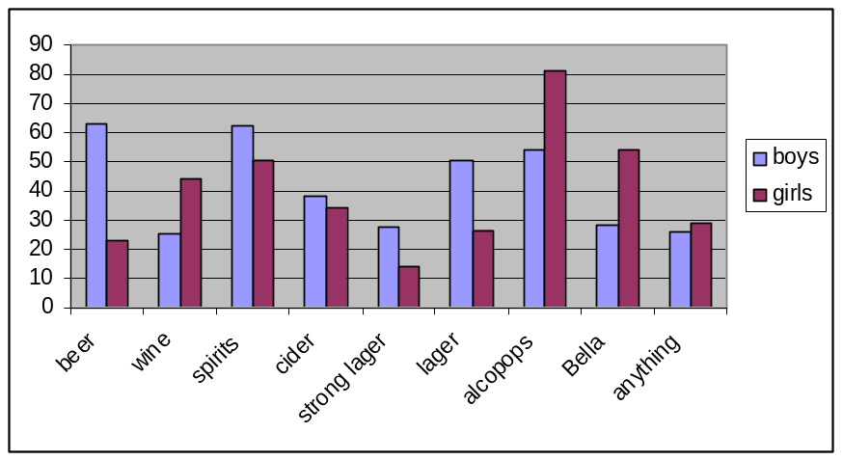

18-25 years
- This age group have limited demands on their leisure time and an increasing disposable income.
- Access to licensed premises is taken for granted and pubs and clubs are visited regularly. At home, drinking is not confined to parties but is diversifying into other recreational situations, e.g. watching videos or sports programmes with friends.
- Social life is largely concentrated around drinking and binge drinking appears to be at its heaviest, although most of this age group believe this is a pattern of drinking that they would grow out of.
- Between the ages of 25 and 35 years, after going through the transitional phase of youth, most people moderate their drinking as other aspects of their life (e.g. family, career, financial concerns) become priorities. Above this age individual patterns of drinking are increasingly diverse; some, especially women, hardly drink at all, while others clearly regard alcohol as a vital means of relaxing and rewarding themselves.
- Even among those who have less external demands, there is a feeling that as they get older they are less able to physically cope with continued drinking at heavy levels, e.g. they report experiencing longer hangovers, or they feel increasing recognition of risk situations they put themselves in while drinking.

‘A Good Night Out’
For young people, big nights out provide a focus to the week or the month. Drinking to excess once or twice a week is common, but drinking daily is unusual, as is drinking during the day or alone. ‘A good night out’ is the predominant pattern, usually on a weekly basis. The aim is hedonistic intoxication rather than serious drunkenness. The CYP research also revealed that most of the local youths interviewed binge on a weekly basis, especially at weekends.

Many young people drink to get drunk and if they are not going to get drunk then there is no reason for drinking. Drunkenness is often not an accidental by-product of the enjoyment of drinking, or of high spirits, it is the objective, with its own identified benefits, from the start.

However, it is also true that many young people are not so much determined to get drunk, as unable to make an attractive case for moderation. ‘Drinking moderately’ and ‘a night out’ strike them as a contradiction in terms. Young people do not usually suffer grievously from hangovers, and excessive drinking is generally confined to weekends when they can stay in bed anyway. There is an assumption that ‘being able to take your drink’ signals some sort of maturity. Consequently a stigma has developed around drinking moderately and there is a desire and pressure to prove oneself through drunkenness.

Association between Alcohol, Aggression and Violence
There are complex but strong statistical relationships between alcohol consumption and crimes of violence in most western countries. There is now an extensive body of research that concludes that alcohol consumption increases the risk of violence and is a link in a causal chain resulting in violence. Patterns of drinking are gendered, as are patterns of violence. However, intoxicated behaviour varies between different cultures, and social contexts within these cultures also shape the likelihood of violent actions.

The effects of alcohol are pharmacological, depressing the higher brain centres involved in judgment, and psychological, often described as ‘dis-inhibiting’. The effects of moderate intoxication on cognition combines with situational factors to prompt impulsive behaviour, aggressive reactions and violence, rather than prudence, avoidance tactics or acceptance. In situations that arouse feelings of frustration, loss of control or confrontation, intoxication increases risk of violent incidents.

Situational factors in the relationship between public drinking and violence
In a study on situational factors in the relationship between public drinking environments (in and around licensed premises) and violence, Homel et al (1992) found that there is a complex relationship between the key situational variables of patron type, social atmosphere, drinking patterns, and behaviour of doormen and security staff. Although this study examined violent incidents involving patrons on and around licensed premises and not young people on the streets per se the findings can potentially be extrapolated to the street scene. Many of the same characteristics occur in street drinking and the research literature also indicates that a high percentage of violent incidents occur in the vicinity of licensed premises, particularly clustered around the closing time of bars.

Homel’s study found that violent incidents in public drinking locations are characterised by the combinations of subtle interactions of variables such as groups of male strangers, low comfort, high boredom, high drunkenness (frequently fuelled by cheap spirits), as well as aggressive and unreasonable behaviour by bouncers or floor staff. There is often a climate of indifference to violence and a tendency to describe violent incidents as fights or brawls when they are clearly assaults, usually on quite intoxicated victims. Homel recommended improved management and regulatory practices particularly in the non-promotion of cheap drinks, training of door staff and tight enforcement including license cancellation of premises that are associated with violent incidents.

Young people and risk-taking behaviour ,
Some researchers conclude that violence has functional value for young men. For thrill-seeking young men, risk of violence can add an exciting component of a ‘top night out’. Drunken, rowdy behaviour and violence may also represent rebellion by young, disempowered males against the prevalent social order varying in form and meaning between peer group contexts. Such findings may also be relevant in considering gatherings of young drinkers in public places in the UK.
Risk-taking is an integral aspect of youth developmental behaviour. Chang et al (2001) identified the main risk-taking behaviours amongst youth as drug and alcohol consumption, unsafe sex, unsafe driving in cars, violence and graffiti. In relation to young people and public space, Chang et al found that young people were highly visible and that a lack of facilities for young people led to them congregating in public spaces. This high visibility in turn attracted negative community attention, public anxiety, and an obvious focus for police intervention.

Research suggests that young people can be defined as ‘high risk problem drinkers’ and ‘low risk problem drinkers’, based on their levels of drinking and behaviour linked to drinking. Young people in these 2 groups have very different perspectives on the role of alcohol in their lives, which greatly influences their pattern of drinking. Wright has found that the opinions of drinkers and non-drinkers and frequent and occasional drinkers differed substantially. Nearly 3/4 (70%) of frequent drinkers aged 12–15 thought people drank because they liked getting drunk compared with 1/2 of those who drank less often.

There is evidence that certain subgroups have serious problems with alcohol and that certain risk factors dispose young people to problematic use of alcohol and other drugs. The Communities that Care Report (2002) lists a number of risk and protective factors for problem drinking derived from longitudinal research studies. Both the identified risk and protective factors cover the areas of family, school, community and friends.
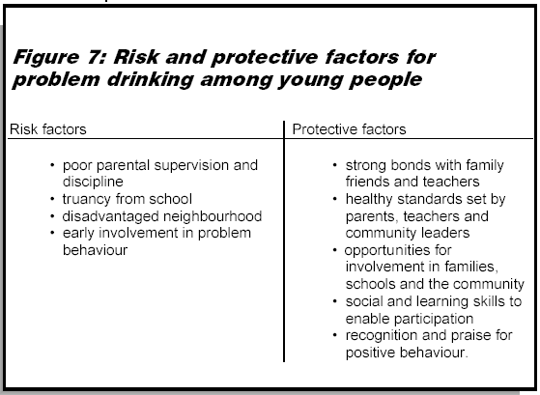

The study finds that for every risk factor, an increased exposure to risk, as measured by the survey, was found to relate significantly to an increased likelihood of reported involvement in problem behaviour. Conversely, the more young people were exposed to protective factors, the less likely they were to report taking part in antisocial activities such as problem drinking. Studies of young people with alcohol problems such as the Avon Longitudinal study of Parents and Children (ALSPAC) generally show that these are a vulnerable group with pre-existing problems such as early family adversity, parental drug use and poor academic performance. Within this small sample there was evidence of smoking and drinking at a very young age (8-10 years) and that this was associated with an increase likelihood of smoking cannabis at age 12 years. In fact, there is a steady literature that argues that several types of risky or anti-social adolescent behaviour (e.g. alcohol misuse, using illegal drugs, sexual experimentation and delinquency) are interrelated.

Social exclusion is also a strong determinant of risk-taking behaviour. In a study related to the socio-economic context of marginalised’ young people, Pavis and Cunningham-Burley (1999) found that young people’s use of alcohol was closely related to their desire to create excitement and fun during their time on the streets. The young men they researched were generally more boisterous and confident while drinking. Although most remained orderly they still appeared intimidating. The use of alcohol, alongside illicit drugs and tobacco, were integral parts of these young men’s street culture. The young men in their study were ‘alienated and marginalised’; the streets were the places where they experimented and explored.

There are parallels with the work of O’Neill (2002), who highlights issues of marginalisation and the importance of enhancing young peoples’ access to public spaces. With reference to the United States context, she argues that young, poor, urban people of colour are more likely to use public spaces for leisure activities because they do not have access to basements, backyards and other private spaces for their leisure activities. O’Neill also suggests that attempts to limit young people’s access to public space may have a detrimental affect because:
“Public spaces provide the possibility for young people to rehearse, re-develop, and affirm identities and communities of their own; identities and communities that may violate the approved hierarchical order.”

There are implications from both these studies that that the high involvement of marginalised groups in public spaces (creating their own street culture) may put them more at risk of being involved in incidents and further marginalise them from the rest of the community.

Overview
- Young people’s drinking behaviour progresses through several stages as they age. While older teenagers are more likely to binge drink, drinking unsupervised on the streets is more common among 14-15 year olds. By 16-17 years, drinking becomes more regular and moves into pubs and clubs. At this stage, alcohol tends to make young men engage in more aggressive behaviour.
- For many young people, ‘a good night out’ is the predominant pattern, usually on a weekly basis, and provides a focus to the week/month. The aim of drinking alcohol is often to get hedonistically drunk, otherwise there is no point in drinking. ‘Drinking moderately’ and a ‘night out’ strike many young people as a contradiction in terms and ‘being able to take your drink’ signals some sort of maturity.
- Alcohol consumption is believed to increase the risk of violence. Situational and cultural factors also influence levels of violent crime. Violent incidents in public drinking locations are characterised by subtle interactions of variables such as groups of male strangers, low comfort, high boredom, high drunkenness, as well as aggressive and unreasonable behaviour by bouncers or floor staff.
- Violence may have a functional value for young men and can add excitement to a night out. Drunken, rowdy behaviour and violence may also represent rebellion by young, disempowered males against the prevalent social order.
- Risk-taking is an integral aspect of youth developmental behaviour. Young people can be defined as ‘high risk problem drinkers’ or ‘low risk problem drinkers’, based on their levels of drinking and behaviour linked to drinking. Several types of risky/antisocial behaviour are interrelated, and problem drinking has been linked to numerous risk and protective factors that cover the areas of family, school, community and friends.
- Social exclusion is also a strong determinant of risk-taking behaviour. For some marginalised young people, the streets are the places where they experiment, explore, and claim as their own. Alcohol, alongside illicit drugs and tobacco, is used to create excitement and fun during their time on the streets and are integral parts of their street culture.
- FACTORS THAT INFLUENCE YOUNG PEOPLE’S DRINKING

This section aims to identify young people’s perceptions of the benefits and disadvantages of consuming alcohol and the factors that can affect their alcohol use. These influences exist at the personal level and within the immediate environment. This will help to formulate an exchange that may be used to discourage young people from street drinking.

Findings are drawn primarily from qualitative research carried out with 15-24 year olds in Scotland by the Centre for Social Marketing (CSM) at the University of Strathclyde. These are supplemented by other studies on young drinkers as well as the CYP’s qualitative research.

Personal Characteristics
Perceived benefits of drinking alcohol
Alcohol fits extremely positively with the needs and aspirations of young people - particularly to have fun and to be included in peer groups and activities. Many young people are attracted by the liberation of being drunk and the thrills it offers and the perception is that the more that is drunk the more these benefits are enhanced.

Research for the Home Office by Honess suggests 3 main reasons why young people drink, which are reinforced by findings from the focus groups with young people in North Tyneside:
1) Social facilitation – This is more common for 15-17 year olds and is clearly identified with young people rather than adults. Drinking plays a part in: generating fun and increasing enjoyment; facilitating and reaffirming relationships through shared experiences; overcoming inhibitions and promoting confidence, especially to ‘chat up’ members of the opposite sex; “making a night out go smoother”; and providing an excuse for ‘bad behaviour’.
2) Individual benefits – These include “escapism”, “feeling happy”, “getting a buzz”, “feeling older and more grown up”, “makes me look & feel harder than I am”, or “switching off”. Alcohol is also used as a way to cope with stress and relax, and as a solution to worries or a cure for adolescent troubles.
3) Social norms and influences – See Section 12.2.1: Social Context

Drinking tends to be seen as the main and often only leisure option, which is linked to boredom and apathy because there is “nothing better to do at the weekends”. It “relieves boredom, fills the time” and is “something to do in life”. This perception is not new, and is perhaps a simple understanding of a more complicated picture.

Drinking alcohol also has a number of perceived advantages compared with illicit drug taking, which is often seen as a parallel leisure alternative: “Alcohol is legal and accepted by society and drugs aren’t, so drugs must be worse”; “Drugs are done by dodgy dealers alcohol is done by shop keepers”; “Taking drugs can give you a criminal record”; “Drugs have far more drastic consequences. They can permanently damage your body and mess up your head. Alcohol takes a longer period of time to make people ill and doesn’t do as much damage as drugs. There is a miniscule chance of disease, but you can’t die from drinking alcohol”; “Alcohol is better because it isn’t addictive and you can control drinking alcohol”; “The effects of drugs are unpredictable, but the effects of alcohol are predictable.”

Perceived problems and risks related to alcohol consumption
CSM’s report claims that while young people could compile a formidable list of things that might go wrong when drinking alcohol, they tended not to acknowledge these alcohol-related risks on a personal basis. The study also distinguishes those problems that are accepted by young people from those that cause concerns. What might objectively be seen as risks, tended to be seen as transitory difficulties and even part of the fun and targets to aim for. So any potential negative factors were far outweighed by the benefits of drinking.

Routine and Accepted Consequences
- Short-term physical effects e.g. vomiting and hangovers were accepted as routine and part of the process of drinking and did not act as deterrents. Indeed, they enhanced stories reviewing past nights out and paradoxically some said vomiting was part of the fun. Young people were more likely to sympathise with sufferers rather than condemn them. Even extreme consequences which required medical attention did not act as a long-term deterrent, such as ‘poisoning’ requiring a stomach pump, head injury and coma following falls, and broken limbs. However, stories of young people dying following heavy drinking sessions had some impact on teenagers.
- “Making a fool of yourself” could be turned around and positioned as markers of a good night out, especially by men, with alcohol providing an excuse for outrageous behaviour. However the potential for unwelcome embarrassment following drunken episodes does have some deterrent potential, particularly among young women.
- High financial costs were reported (£30-£50 for a night out) but were accepted because drinking was the main social activity. Teenagers mitigated the problem of limited funds by changing what and where they drank, thereby avoiding reducing their consumption.

Problems Which Aroused Some Concerns
- ‘Spiking’ drinks was clearly believed to be widespread, based both on rumours and on personal experiences. Most serious was drugging by strangers or casual acquaintances in public locations in order to facilitate enticing girls to have sex (‘date rape’ drugs).
- Crime and ASB/fights are aspects of drinking that even young binge drinkers thought needed tackling. However, few young people admit personal involvement or guilt, even if they themselves have been involved in fights and ASB.
- Unplanned and unprotected sex was not readily recognised or spontaneously listed as a problem. However, when the issue was raised, many acknowledged they had been in situations which risked leading to unprotected sex. Going to pubs and clubs with the aim of meeting members of the opposite sex and if possible having opportunistic sexual intercourse was a more overt aim among working class males, but it was indirectly acknowledged across genders and social class groups.
- A general vulnerability related to drinking was acknowledged, again mainly in retrospect. This included walking home alone or being tempted to accept lifts from strangers, especially for girls.
- An impact on work or study was acknowledged in relation to heavy drinking incidents, either through hangovers or continued drinking, but most structured their drinking to fit in with their other responsibilities.

Potential Effects Perceived as Irrelevant
- Involvement with the police, although having potentially long-term effects from having a criminal record, tended to be described as humorous anecdotes rather than being a deterrent.
- Long-term health implications including addiction and death were acknowledged but seen to be personally irrelevant, potentially affecting ‘others’. These tended to reflect distant and fatalistic concerns about health risk behaviours in general. Many young people also expect their alcohol intake to reduce as they get older.

Immediate Environment
The main influences encouraging drinking alcohol in the immediate environment are the social context and commercial activity. Potential moderating factors, such as the family, schools, mass media health and protection messages and legal implications have much weaker influences.

Social context
- Drinking is seen as a common activity and part of a wider social norm – “all my friends do and everyone else does it”, “it’s normal”, “I don’t want to feel left out”. Stakeholders in North Tyneside commented that “It’s a North East thing. Drinking alcohol is both culturally and socially accepted.” The culture in the North East is not to go out to enjoy a couple of drinks but to go out to get drunk. In North Tyneside there is a very strong social scene in Whitley Bay with lots of pubs and clubs quite close together. There are a lot of young people coming into the Borough e.g. Whitley Bay on Friday and Saturday nights. It is a party capital for hen parties and stag nights, which add to the atmosphere – having a good time equates with drinking a lot, and young people emulate this. There is a culture of “Friday night out with the lads, Saturday night out with your lass.”, although this has recently changed with groups of young women also going out on a Friday night into pubs and clubs and drinking more that ever.
- Teenage years are a time when family influences wane and the importance of external friends increases, so peer pressure is often accepted as a major factor influencing drinking behaviour. However, there is also evidence pointing to a reverse phenomenon – peer association: young people who are already experimenting with certain behaviours such as using alcohol are likely to choose as friends those who share similar interests.
- Drinking is seen as a common adult behaviour. Young people have grown up seeing family and adult friends drinking and being drunk. Alcohol is an assumed part of celebrations, even just on “Friday nights to celebrate the weekend” and many had their 1st drink at a family gathering.
- With the new ‘Safe. Sensible. Social.’ campaign, ministers are hoping to change the “English drinking culture” and the willingness to accept drunkenness and ASB as a “normal” part of life (see Section 4.1.2).

Price and availability
- Although it is unusual for 11-15 year olds to buy their own alcohol, survey data shows that by the age of 15 years 20% of those who drink buy alcohol from shops and 17% buy from pubs. Ease of purchase increases between the ages of 15 and 18. Despite the Home Office AMECs of targeted test purchasing across England and Wales, 29% of on-licensees, 21% of off-licensees and 18% of supermarkets are selling to under 18 year olds.
- Children who purchase their own alcohol are almost 6 times more likely to drink in public places, nearly 3 times more likely to drink frequently and almost twice as likely to binge drink than those who drink but do not buy their own alcohol.
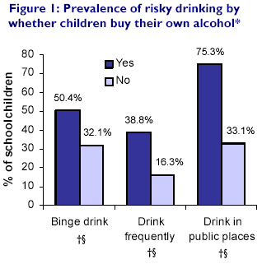
- Older siblings and friends, and adults contacted outside of shops, are frequent sources of alcohol for schoolchildren. All such access methods are related to increased binge drinking, frequency and public drinking.
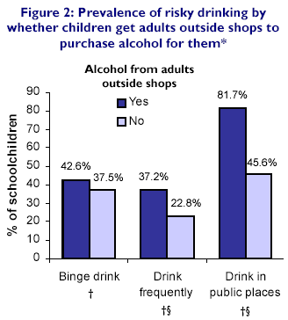
- The local qualitative research suggests that adults feel pressured into buying drinks for young people because they feel threatened by large groups of youths or are worried about the possible repercussions of refusing to buy alcohol for them.
- With the improvement in household incomes over the last 30 years, alcohol has become progressively more affordable so teenagers with jobs or allowances can now purchase alcohol more easily. Research studies in the North West show that teenagers with a weekly income of £30 a week are twice as likely as those with £10 a week to drink frequently and in public places.

Drinks retailing and marketing
- The heavy drinking culture is supported by happy hours, cheap drinks, and drink-all-you-like promotions. While such promotions may not affect young people’s choice of venue, they would change their drink choice and drink more during a promotion period, and often for the rest of the night. Similarly, promotions in off-sales are attractive and often affect product choice as well as increasing consumption by encouraging more purchase.
- After the 1st appearance of alcoholic lemonades and other ‘alcopops’ or ‘ready to drink’ (RTD) brands, the drinks industry focused a great deal of energy on the development of new ‘designer drinks’ due to their apparent appeal to the youth market. Branding is a key influence and popular ‘youth’ brands are heavily advertised.

Advertising
- Young people are thought to be particularly susceptible to drinks advertising. Econometric studies in the US have found that higher levels of local advertising were associated with increased binge drinking.

Family
- Children’s attitude and behaviour are initially shaped by families – both directly, in that parents act as role models and are a main source of alcohol, and indirectly, in that levels of family support, control and conflict are linked to teenage drinking. Moderate levels of support and control and attitudes that support sensible drinking are thought to provide a setting that is conducive to the development of “socially competent drinking behaviour” in a young person. Conversely low parental support and extremes of control (high or low levels of control) combined with heavy parental drinking and attitudes that condone heavy drinking are associated with excess drinking by young people.
- While parents can provide role models, qualitative research has shown that in practice, young people themselves were more likely to see their drinking as an independent activity, in isolation from their family. While recognising family influences to some extent, alcohol consumption and related social activities tended to occur in parallel to any parental interaction, rather than be strongly linked to it.
- For this reason, the family was rarely an influential factor in moderating drinking and behaviour, and any formal control was tenuous. In addition, although most said their parents would drink, young people tended not to compare their behaviour with that of their parents, which often seemed to be irrelevant.
- In contrast to other teenage issues such as sexual health, there is no clear evidence that young people are less likely to drink excessively if their parents discuss it with them. In a consultation exercise for the ‘Scottish Plan for Action on Alcohol Misuse’, parental disapproval ranked lowest amongst the worries and concerns young people have about drinking.
- In fact, young people stated that it would be hypocritical for their parents to criticise their drinking when the parents themselves or adults in general drank excessively. This makes it much more difficult for parents to admonish their children for excessive alcohol consumption, than, say, for illegal drug use (which is less prevalent amongst parents).
- Local services have noted an increasing numbers of children with alcohol problems and an increasing number of parents with alcohol problems. Some parents are buying alcohol and selling it cheaply to their children at £5 a bottle and telling them to “get lost”. Children with alcohol misusing parents are likely to lack supervision, be physically abused, wander the streets, and have poor school attendance.
- Honess et al. also found explicit acceptance from parents of 16-17 year olds that drinking is part of normal teenage social activity. Taken further, qualitative research for Diageo by Egg showed that some parents feel that excessive drinking is quite normal, and that heavy drinking by their children is a “rite of passage”. They would prefer to know that their children are in a pub and “safe” (even if underage) than hanging around on the street or in parks. They also feel that a more strict approach would lead to rebellion. Recent research for the Portman Group found that parents are more worried about sex, drugs (even though in the longer term young people often ‘grow out’ of drug use but not alcohol use), smoking, strangers and bullying than about alcohol misuse by their own children.

School
- Only a minority of those interviewed by CSM reported experiencing any educational input about alcohol and drinking in school. The low prominence of alcohol education compared with drugs or tobacco education reinforced the perception that alcohol consumption is not a problem issue.
- Where the topic had been addressed, the young people responded favourably to approaches which acknowledged that they were going to drink, but which also raised issues they should think about. As the discussions progressed, respondents appeared increasingly receptive to receiving information about drinking and felt that schools were an appropriate setting, provided the tone was right. ‘Cool’ teachers or outside speakers who had had problems with drinking were acceptable, but talks from policemen were regarded with amusement.

Mass media health and protection messages
- Young people in the CSM study had little knowledge or internalisation of formal health promotion and protection messages in relation to alcohol use and misuse. There was some confusion about whether moderation or abstinence was the ‘official’ recommendation.
- Interestingly, however, many were aware of advice that drinking alcohol in moderation can have a beneficial health effect, without recognising that this applied to older age groups (men over 40 years old and post-menopausal women). This also tended to result in perceptions of mixed messages.
- Young people were not actively looking for information, because drinking was an activity about which they felt confident. In the course of the discussions, however, respondents did express an interest in ‘new facts’ on drinking, such as the ill effects of binge drinking or the potential impact on sexual prowess. It appeared that acquiring additional information was equally beneficial to increasing their credibility as drinkers, as to avoiding alcohol misuse.
- The key positive features identified included: the visual appearance of the cover and internal design, which generated positive identification with the material and an impression of “not preaching”; the bullet point presentation rather than “going on and on”; and the content, which was seen to give relevant information, providing both new facts and confirming current ‘common sense’ beliefs.
- There were very low levels of awareness and specific knowledge about recommended units of consumption, apart from the recommended unit limits for drinking and driving. A small minority was aware of unit recommendations in relation to pregnancy and to dieting. Young people in the study were more likely to judge strength and effect of different drinks by their own experiences and those of others.
- Importantly, when the recommendations were outlined by the moderator, they were seen to contradict the main aims of drinking and a night out, namely to get intoxicated and to be unrestricted by outside rules.

Law and law enforcement
- In the context of underage access to alcohol, it was felt that the legal restrictions had minimal impact. In addition, local interventions such as Proof of Age and curfews were seen to have been ineffective. E.g. ID cards could be borrowed from others or even might not be asked for, and those drinking outside would know where to hide to avoid curfews.
- On the other hand some older respondents felt that more active enforcement could enhance risky consumption behaviours, e.g. hidden drinking in parks.
- Police intervention was often seen as inconsistent and selective, provoking anger and frustration. E.g. they might ‘turn a blind eye’ in some situations which respondents felt were threatening and react ‘heavily’ in others, e.g. invoking ‘breach of the peace’ too readily, especially in less well off areas.
- Young people did however acknowledge some of the difficulties faced by police, and recognised that alcohol can be linked to ‘trouble’ which was difficult to deal with. Among one group of working class males it was also recognised that the police taking intoxicated people into custody could be a positive intervention, ensuring their safety from fights or exposure until they sobered up.
- In contrast to attitudes to the legal age limit, restrictions on drink driving were well known and generally respected.

Overview
A wide range of interacting factors influence young people’s drinking behaviour, and these exist as personal characteristics or in the immediate environment.
- The perceived benefits of drinking alcohol include social facilitation (e.g. generate fun, boost confidence), individual benefits (e.g. relax, appear grown up) and social norms and influences (e.g. ‘normal’ part of adolescent culture, rite of passage, response to peer pressure). Drinking tends to be seen as the main/only leisure option and is used to relieve boredom, particularly in areas that lack appropriate facilities for teenagers. Alcohol is considered a safer leisure alternative to drugs, perhaps implying a gap in knowledge of the full dangers of alcohol use.
- Perceived problems and risks related to consuming alcohol differ in their significance. ‘Spiking’ drinks, crime and ASB/fights, unprotected sex, general vulnerability, and an impact on work/study arouse some concerns among young people, while short-term physical effects, making a fool of oneself, and high financial costs are routine and accepted. Involvement with the police and long-term health implications are seen as irrelevant.
- External factors such as the relative affordability and easy availability of alcohol, and widespread targeted retailing, marketing and advertising also encourage harmful drinking in young people. Research shows that public drinking is more common in teenagers who purchase their own alcohol, get siblings, friends, or adult strangers to buy alcohol for them, or have a higher weekly income.
- Parents are frequently a source of alcohol for young people, and low parental support and extremes of control are associated with excess drinking by young people. While parents can provide role models, qualitative research suggests that in practice, young people themselves are more likely to see their drinking as an independent activity and tend not to compare their behaviour with that of their parents. There is no clear evidence that young people are less likely to drink excessively if their parents discuss it with them, and young people believe that it would be hypocritical for their parents to criticise their drinking when parents/adults in general drink excessively. Many parents also accept that drinking is part of normal teenage social activity, and are more concerned about sex, drugs, smoking, strangers and bullying than alcohol use.
- The table below lists some incentives and barriers of both the desired and problem behaviours. In developing the social marketing intervention, we will need to maximise the benefits and minimise the barriers of drinking indoors. The ideas in the table have been pulled from the findings of this report, with heavy influences from 2 Scottish studies: 1 on the influence of marketing and subculture on young people’s street drinking behaviour and another ethnographic study on male street culture. More primary research with underage street drinkers in North Tyneside is needed to confirm this list and explore the priority of benefits and barriers/costs within each of the quadrants so that a competitive advantage is created.

1. Desired behaviour - Incentives
a. What incentives currently exist that encourage/support drinking indoors? | - Sales promotions (e.g. happy hours & 2-4-1s) at licensed premises  - Comfort, safety, shelter, entertainment at home/bars/clubs  - Supportive parents - supply alcohol for consumption at home  - Designated club nights/hours for under-18s?
2. Desired behaviour - Barriers
a. What barriers/blocks currently limit/restrict drinking indoors? | - Exclusion from indoor settings due to age or drinkers’ own behaviour  - ‘Costed out’ – more expensive to drink in licensed premises  - Not aware of illegality or dangers of drinking in public  - Personality characteristics – hostile/antisocial orientation, dislikes supervision/authority?  - Parents disapproval of drinking/poor family life
3. Problem behaviour - Incentives
a. What incentives currently exist that encourage/support street drinking? | - Good value for money – drinkers can ‘preload’ on cheap alcohol before going to pubs/clubs later in the night.  - Unsupervised, ‘adult-free’ space, both geographical and social, that young people colonise and use to create their own leisure using minimal material resources. Young men's street culture simultaneously provides a practical and symbolic short-term resolution to some of the structural pressures that they encounter.  - Street life can be exciting and occasionally unpredictable. Whilst on the streets young people gather information about events or happenings that are of interest to them. There is a constant feeling that something exciting could happen at anytime, which can be instigated and/or influenced by the young people.  - The streets provide a social context in which young men can experiment with their sexuality and/or develop a particular type of masculinity. It is somewhere they could achieve peer status and recognition through conspicuous consumption, e.g. of designer labelled clothes, and/or via knowledge about and use of illicit drugs, and/or involvement in small-scale gang violence.  - Some young people have trouble at home or are living in B&Bs with strangers; drinking on the streets provides a temporary refuge.
4. Problem behaviour - Barriers
a. What barriers/blocks currently limit/restrict street drinking? | - Sense of being ‘too old’ to drink on the streets.  - Could get caught by police and reported to parents  - Street life can be boring and largely repetitive  - Involvement in alternative activities  - Fear of violent victimisation/sexual harassment by others  - Poor weather?  - Lack of benches, rubbish?

- COMPETITION ANALYSIS

In developing this social marketing intervention, it is important to consider the competition, which includes behaviours and benefits young people would prefer over the one we are promoting (i.e. don’t drink on the streets), and organisations/individuals who send messages that counter/oppose the desired behaviour. Competition also exists from existing initiatives with the same intention of reducing public drinking, e.g. legislations, media campaigns, or education, which compete for the target audiences attention and could potentially confuse or duplicate our efforts. From the intervention and behavioural analyses above, competition can be classified as ‘good’ or ‘bad’.

‘Good’ Competition

YOUNG PEOPLE
Drinking laws – Minimum drinking age prohibits under-18s from drinking on licensed premises and in public spaces

PCSOs, Childsafe, Police - How effective are they in managing/reducing underage street drinking, what are the strengths & weaknesses/barriers of their service?

National ‘Know Your Limits’ & regional ‘Don’t Spoil the Party’, ‘The Party’s Over’& ‘When to Stop’ campaigns – Is the right message being conveyed or are stereotypes of young people as binge drinkers being reinforced?
School-based alcohol education – Is it widely available & does it convey adequate information in an approachable way, particularly regarding the harms of drinking outdoors? Are msgs consistent w/ mass media campaigns?

Youth services - While there seem to be a lot of connections btw agencies, how joined up & consistent is the approach to young ppl who are isolated & in need? How well is information shared?

Restrictions on commercial advertising & promotion
Alternative activities & EASE card - How is the card made available, what does it provide & where? Do new facilities need to be provided or do current facilities need to be improved? Are alternative activities enough of an incentive to discourage public drinking? Will they reach & affect those young ppl who are most likely to drink in public?
Test purchases, Proof of Age card, Retailer Awareness Pack - Who will the pack & card be made available to & how? Will the card be available to those outside of the school system? How will compliance be ensured? How will proxy purchases by adults be addressed?

AFZs - How easy are they to enforce? What/how much effect will they have on underage street drinking? Do AFZs just shift hotspots to different areas which may be more secluded & risky?

Brief Interventions - Available to young ppl? Do young ppl who enter A&E for alcohol-related problems get followed-up/referred to relevant agencies?

‘Bad’ Competition
YOUNG PEOPLE
Frequent sensationalist media coverage of YOBs – Reinforces social expectations of young ppl as disrespectful, binge drinking offenders, strains tensions btw older & younger generations.

Minimum age limit for drinking in licensed premises prevents young ppl from drinking in supervised indoor locations
Strong drinking culture & social acceptability of public drinking & drunken behaviour – Want to fit in w/ friends, family & society, desire to get really ‘buzzed’ & have ‘good night out’’
Illegal sales – Off-licenses/premises don’t request proof of age or respect licensing laws. Adults are willing to purchase alcohol on behalf of minors & fear repercussions of refusing.
Desire for risk-taking & freedom from adult supervision that can be provided by the streets
Advertising & promotional offers on alcohol – Brands & products created to appeal to youth market.

Price – Alcohol widely availability & affordable
Parents – Extremes of control can encourage harmful drinking behaviour in children. Accept binge drinking as ‘normal’ adolescent behaviour & rite of passage.

Overview
The competition in social marketing environments is tough, for it includes these challenges: behaviours young people would prefer (e.g. to get really ‘buzzed’) and the benefits associated with them (e.g. to relax and have a good time), and strong messages/messengers that are counter to the desired behaviour (e.g. Smirnoff advertisements). Competition also exists from existing initiatives that also intend to reduce public drinking, e.g. AFZs. A major form of competition is the strong drinking culture which exists nationwide and will require drastic measures and many years to alter, as will the availability and affordability of alcohol. Creating a competitive advantage to the thrills and freedom of drinking on the streets will be crucial. Further research with underage street drinkers might reveal hot buttons that will guide positioning, as well as other elements of the strategic marketing mix.

- FORECASTING

In choosing social marketing initiatives, it is important to be aware of events that may unfold in the future and have an effect on the issue we are addressing. Data on drinking trends has already been presented in Section 3.2 – young people in the UK are drinking larger quantities of alcohol more frequently and there is a growing perception of teenagers hanging around and of people behaving in an antisocial way by being drunk or rowdy as problems. These trends coupled with high profile stories in the media of alcohol-fuelled violence by youths will probably see the issue of public drinking rising on the agenda. The aging population of the UK could potentially encourage the ‘designing out’ of young people in public spaces and heighten tensions between the younger and older generations. The rising proportion of children living in lone-parent families could contribute to further decline in parental supervision and control of young people that can discourage delinquent behaviours like problem drinking.

The national alcohol strategy has just been updated this year, with a sharper focus on the minority of drinkers who cause the most harm (including under-18s) and on the country’s excessive drinking culture. The recent introduction of smoking bans in all public places in England and the positive reception it received from the public after its implementation bodes well for those who call for more drastic measures from the Government to promote a more sensible drinking culture.

At a local level, North Tyneside is in the process of drafting a new alcohol strategy that aims to coordinate a range of elements to tackle alcohol-related harm in the Borough. Work is underway for AFZs to apply in all playgrounds, parks, cemeteries and other public open spaces. Northumbria Police will be recruiting over 650 more Police Community Support Officers (PCSOs) throughout the force. Better communication systems will deal with residents’ concerns more rapidly and help them to be aware of and deal more effectively with issues. Roll-out of a Proof of Age Card is due to begin in September 2007. Proposals have also been included in the North Tyneside CYP Plan 2006-2010 and the Play Strategy to actively involve young people in the provision of more age-appropriate play sites. However it remains to be seen how the well the strategy is implemented on the ground and how coordinated the approach is. The capacities of the Alcohol Workstream and partner organisations should be assessed and monitored (via a SWOT analysis) to guide decisions and prepare for changes in circumstances.

- RECOMMENDATIONS

Further Research
- Segmentation work: More work is recommended to further segment the target groups outlined in this study (e.g. young street drinkers, their parents) using segmentation variables (e.g. psychographics) and to create more accurate cluster profiles. Qualitative research should be used to confirm and characterise key clusters and quantitative research to identify the size and location of these clusters. This will help to select the most appropriate target group(s) and develop interventions that specifically address them.
- Interviews with young people who drink on the streets: A small sample of young people has already been interviewed and results are presented in a separate report. However these individuals will probably not be the target group since they have multiple problem behaviours and are probably less susceptible to change. This intervention will probably target young people with less entrenched drinking behaviours and who have not yet reached youth services. These young street drinkers could be accessed via Childsafe and semi-structured questions with them would aim to explore:
  - The barriers and benefits of the recommended behaviour and its competition – Compare and contrast local responses with those drawn from the literature review, e.g. do underage street drinkers view involvement with the police as irrelevant?
  - The aspirations and other interests of underage street drinkers – e.g. how, where and with whom do they spend their leisure time?
  - What would make the behaviour easier, more comfortable/fun and more popular – e.g. are alternative activities enough of an incentive to divert young people from drinking on the streets?
  - How, where and when the behaviour takes place – e.g. do young people typically drink on the streets only on Friday/Saturday nights, where and at what times, how much does the ‘good night out’ pattern apply?
  - Who helps create these opportunities/has influence on this audience – How much and what kind of influence do peers, siblings, parents, police and alcohol retailers have on underage street drinkers?
  - Through which media channels young street drinkers get their information and from whom they would prefer to receive interventions from (e.g. what perceptions do they have of the police and the Childsafe programme?).
These interviews will help to confirm and build on the insights gathered in this report and in the initial primary research on young street drinkers, which can then be used to select and design the most appropriate intervention elements.
- Observational data of hotspots and the behaviour of young people: Observations carried out in hotspots on Friday and Saturday nights would gather valuable information about the behaviour of young people and levels of violence and safety in public spaces that does not necessarily come to the attention of the media or police. Incorporating short semi-structured street interviews would help to gain insight on young people’s perceptions and experiences of hanging out in public spaces. Questions would aim to find out for example: what motivated the person to come into town; how frequently they came; what they did in town; what they drank (if they drank alcohol); how much and where they got it from; ideas for what else they’d do if they didn’t come into town; and ideas for making the city safer. The combination of observations and interviews would create snapshots of the nightlife in the city and help to distinguish those who drink outdoors (e.g. in terms of demographics and psychographics) from those who drink indoors.
- Interviews with parents of young people who drink on the streets: A small sample of parents has already been interviewed and results are presented in a separate report. However, more interviews need to be held with parents of teenagers who drink on the streets. Contact with this group could be made via the Childsafe programme and questions would aim to explore:
  - How, where and with whom their children spend their leisure – parents’ knowledge can then be compared with what their children describe.
  - How parents perceive their children’s’ behaviour.
  - The kinds of strategies they have used to communicate with their children about alcohol.
  - The level of supervision young street drinkers get from their parents.
  - The sorts of issues parents typically struggle with and what kind of support they would like to receive.
  - The effects of alcohol consumption within family settings and how moderate, family-based and food-based drinking patterns might be encouraged in the UK.
- Further analysis of youth services: More data (i.e. official documents/interviews with youth service providers) should be gathered to find out how joined up and consistent the approach is to young people who are isolated and in need, e.g. why were none of the young people identified as using substances by Connexions in 2003 referred to outside agencies to address these issues, and what is the detached youth intervention initiative between The BASE and the council's Youth Services that has complemented the Childsafe programme? This would help improve and tailor youth services to meet the needs of young people with harmful drinking patterns.
- Interviews with key police/Childsafe personnel: Inspectors Tony Blacklock and Dave Foy were contacted during the writing of this report but were not available for response. Interviews with key police personnel should be designed to gather information about incidents that occur, police strategies for dealing with these, and their general perceptions of violence and safety in public spaces, particularly relating to young people and alcohol.
- Further analysis of police data: Data from police and Childsafe records should be analysed further to see if alcohol-related offences committed by young people are on the rise and to identify more specifically where (in Longbenton, Howdon, and Whitley Bay), when and how often these occur, and the types of alcohol-related incidents that involve young people in public spaces. The demographic characteristics of young people involved should also be noted, which will help to us to understand young people’s offending and place it within its demographic context.
- Further research with members of the general public: Interviews/surveys could be used to investigate why adults in the community buy alcohol for young people (e.g. unaware of/unconcerned about the legal consequences, afraid to refuse in the presence of a large group of teenagers), how adults perceive local youth behaviour, which areas they consider unsafe, and how tensions between older and younger generations can be relieved.
- Audit of current facilities and activities for young people: Data collection and interviews with young street drinkers and recreation facilities managers would reveal whether new services need to be provided or current services improved, and how such facilities can be made more accessible and appealing to those young people who have the most harmful drinking patterns. It is crucial to liaise with the Play Partnership subgroup of the CYPF board to ensure that intelligence is shared and strategies are linked to avoid duplication of efforts in the provision of places and spaces for young people.

Next Steps
- Present initial scoping report to Alcohol Workstream and identify possible key stakeholders and strategy team members for the social marketing intervention.
- Contact key stakeholders to define their level of involvement and interest.
- Disseminate initial scoping report to key stakeholders and discuss primary research strategy and questions with them.
- Conduct and analyse primary research.
- Summarise and disseminate primary research results to strategy team and key stakeholders.
- Select target audience segments and define behavioural goals.
- Brainstorm and generate initial ideas for intervention, conducting a SWOT analysis and focusing on the possible theoretical base and exchange.
- Develop broad plan for intervention, including evaluation methodology.
- FINAL CONCLUSIONS

A sizeable number of young people drink on the streets, which not only poses a threat to their personal safety, but also contributes towards lowering perceptions of safety in the community. Research indicates that there are links between young people’s drinking in public spaces and increased risk of violence. Some groups may be more prone to be involved in incidents in public spaces than others, particularly those who are more marginalised and have less access to alternative leisure activities and places to gather and socialise.

North Tyneside has adopted an intersectoral partnership approach to address community issues, including alcohol misuse and lack of safe spaces. The council is currently engaged in a range of activities to address alcohol issues that are to be integrated into a new alcohol strategy. Specific initiatives outlined in the literature are already in use. For example liquor licensing regulations along with strategic use of alcohol bans are effective elements to reduce the incidence of alcohol-related violence. However, the strategy in its draft form appears to be short on prevention elements and approaches that specifically target young people. This social marketing intervention will help to redress this by taking a holistic approach to reducing street drinking in underage teenagers.

Many different groups of young people use public spaces and this suggests that urban planning needs to take into account strategies to accommodate young people on a variety of levels. The emphasis on safety in public spaces has to heed young people’s needs for public spaces to gather in and socialise. Providing facilities and events closer to where young people live will help meet a range of needs but it is important not to ignore young people as key participants in the night life of vibrant city centres.

There are a complex range of factors to be addressed and balanced in creating safer public spaces, from the responsibilities of liquor outlets, to monitoring and enforcement issues, the role of regulatory activities and meeting the social and leisure needs of young people. This report has identified some of the major elements through bringing together relevant data to inform the development of a social marketing intervention, but these need to be supplemented by more primary research.
- APPENDIX

Appendix A - National Policy Framework
‘Know Your Limits’ campaign
  - Launched in October 2006, this is the Governments 1st national alcohol awareness campaign. The £4 million joint Department of Health and Home Office campaign targets18-24 year-old binge drinkers and is designed to show young adults the possibly tragic consequences of excess drinking. Home Office minister Vernon Coaker said: "The campaign dramatises the consequences of drinking irresponsibly by showing that it makes you feel invincible when you are actually more vulnerable." The campaign to deter hard-drinking adopts shock tactics similar to those used to raise awareness of the dangers of drugs and smoking.
  - Messages are delivered across a range of media, including television, cinema, print, radio, online, further supported by PR activity.
  - The overarching aims are to: increase awareness and consideration of the consequences of drinking responsibly; increase knowledge and understanding of sensible drinking levels; and highlight where to get more help or treatment. The campaign played on the vulnerability of binge drinkers and emphasised both physical and criminal consequences that can arise from irresponsible alcohol consumption.
  - Evaluation of the campaign demonstrated that it was highly effective in raising awareness and had a high level of recall among young people.
  - The Government is committed to continuing its investment in the campaign and will run activity before peak drinking times, e.g. Christmas and New Year. It will also seek ways to broaden messages and widen audience reach.
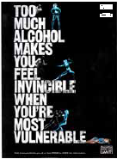

‘THINK!’ drink-driving campaign
  - The Department for Transport has been active in developing effective, targeted anti-drink-driving publicity campaigns under the ‘THNK!’ banner.
  - The Department will continue to monitor effectiveness of campaigns, consider ways of targeting hard-to-reach groups and develop a new multimedia campaign for 2007/08.
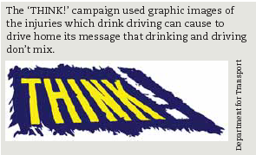

Restriction on alcohol advertising 2005
- The alcohol industry is now regulated by a mix of statutory and self-regulation. In 2005, following review and consultation by Ofcom, the statutory codes for broadcast advertising of alcohol was tightened. In response to the AHRS, the Committee of Advertising Practice, under the Advertising Standards Authority (ASA), also strengthened its self-regulatory regime for non-broadcast advertising to bring it broadly in line with new television rules. In particular, rules concerning appeal to young people, sexual content and irresponsible or ASB were strengthened. ASA maintains and enforces codes on broadcast and non-broadcast advertising.
- Research commissioned by ASA is already underway and will assess the extent to which changes to codes have substantially reduced the appeal of advertising to under-18s.

Code of Practice on Naming, Packaging & Promotion of Alcoholic drinks
- Much of the alcohol industry is self-regulated, e.g. the Portman Group has a Code of Practice on Naming, Packaging and Promotion of Alcoholic Drinks that covers naming of products, packaging, websites, press releases, branded merchandise, sampling and sponsorship. The Code states that a drink’s naming, packaging and promotion should not appeal specifically to under-18s. Furthermore, they should not encourage immoderate consumption; be associated with ASB, illegal drugs or sexual success; or suggest that drinking leads to popularity. The Code is supported by virtually the whole industry, including producers, importers, wholesalers, retailers and trade associations. Drinks found in breach of the code are not sold by retailers until they are re-branded to comply with it. All complaints are considered by an independent complaints panel. Members of this panel have no connections with the alcohol industry.
- In November 2005 representatives of the alcohol industry published a set of Social Responsibility Standards for the Production and Sale of Alcoholic Drinks in UK. These set out a wide range of principles for the production, distribution, marketing and retailing of alcoholic drinks. These are supported by member companies of trade associations and commended by non-members involved in these sectors.
- Signatories of the Social Responsibility Standards document reported on progress in late 2006. There are many examples of good practice (e.g. the Best Bar None scheme) where this has been implemented and instances of effective local joint working.

The Alcohol Needs Assessment Research Project (ANARP) 2005
The Alcohol Needs Assessment Research Project gave the first detailed national picture of the need for treatment and the provision of alcohol services across the country. The key findings are as follows:
- There is a high level of need for treatment across different categories of drinker. 38% of men and 16% of women aged 16-64 (approximately 8.2m people) have an alcohol-related disorder in England.
- The North East region was identified as having the fewest agencies providing specialist alcohol interventions.
- The average waiting time for treatment assessment is longer in the North East than elsewhere in the country.
- The number of alcohol dependent individuals accessing treatment nationally per annum is approximately 63,000, providing a ‘Prevalence Service Utilisation Ratio’ of 18 (i.e. 1 in 18 of the alcohol dependent population access treatment on a national basis – by contrast, the figure for the North East is approximately 1 in 100).

Alcohol Misuse Interventions 2005
The Alcohol Misuse Interventions report, published by the Department of Health in 2005, builds on the findings of the ANARP report. It presents powerful economic arguments for action to tackle alcohol misuse, and offers guidance on developing and implementing programmes that can improve the care of hazardous, harmful and dependent drinkers.

Models of Care for Alcohol Misusers (MoCAM) 2006
- In June 2006, The National Treatment Agency published a Models of Care Framework designed to enhance the planning, commissioning, design and delivery of alcohol treatment services.
- This was shortly followed in November 2006 by the publication of the Review of the Effectiveness of Treatment for Alcohol Problems, a comprehensive review of the evidence base and cost-effectiveness of alcohol treatment.

The reform of the Licensing Laws 2003
In 2003, the UK Government announced a series of reforms to the Licensing Laws, which took effect in November 2005. The Act establishes a single integrated scheme for licensing premises, which are used for the supply of alcohol, to provide regulated entertainment or to provide late night refreshment. Enforcement of the new offences and controls fall mainly on 4 agencies – the police, licensing authorities, environmental health officers and trading standards officers – though others are involved.

The 4 licensing objectives are:
- Preventing crime and disorder;
- Ensuring public safety;
- Preventing public nuisance;
- Protecting children and young people under the age of 18 from physical, psychological and moral harm.

Key measures contained in the Act include:
- Flexible opening hours – to help minimise public disorder resulting from fixed closing times;
- Changes in the identity and accountability of the licensing authority – to empower the police, environmental health officers, trading standards, local residents, and others to request reviews of licences at any time where problems occur;
- Flexibility in issuing licensing conditions – to provide much greater scope for further development of rich culture of live music, dancing and theatre.
  - Strong punitive measures against license holders contravening licensing regulations;
  - Expanded police powers to close down disorderly and noisy licensed premises;
  - Increased fines and penalties for breach of licence conditions/selling alcohol to children;
  - Prosecution.

These reforms give licensing authorities (usually local councils) more flexibility and encourage licensees to work together with the authorities to tackle related crime. The intention is to ensure that problem pubs, nightclubs, off-licences and other licensed premises are dealt with swiftly and effectively.

Importantly the new licensing law for England and Wales does not consider public health as a goal for licensing. Licensing does not consider the health of customers beyond direct physical safety.

Violent Crime Reduction Act 2006
Includes a range of additional measures to complement the powers in the 2003 Licensing Laws to tackle irresponsible individual licensed premises, reinforce local alcohol retailers’ collective responsibility for alcohol-related crime and disorder and tackle behaviour of individuals. Powers include alcohol disorder zones, directions to leave, enabling police and/or trading standards officers to ban sale of alcohol for up to 48 hours, expedited licence reviews, drinking banning orders.

Working with Alcohol Misusing Offenders – Strategy for Delivery (2006)
The National Probation Service (NPS) has a long history of working with problem alcohol misusers. It published a strategy in May 2006 setting out the following key aims:
  - Establishing a consistent approach to tackling alcohol-related offending across the Probation Service, based upon evidence of good practice;
  - Complementing the MoCAMs and related work under the Department of Health’s Programme of Improvement for Alcohol Misuse; and
  - Ensuring consistency with the developing role of the Regional Offender Managers in commissioning on a regional basis.

Tackling Violent Crime Programme (TVCP)
- The Tackling Violent Crime Programme (TVCP) was launched in November 2004. It is run jointly by the Police Standards Unit (PSU) and the Violent Crime Unit (VCU) in the Home Office.
- The purpose of the programme is to support local efforts in reducing alcohol-related crime and domestic violence in particular to: work intensively with practitioners in small number local areas with high levels more serious violent crime; improve police and other agencies’ performances and partnership working; improve local strategies; and develop good practice, which could then be disseminated nationally.
- TVCP worked with 32 of 373 Crime and Disorder Reduction Partnerships (CDRPs) in England and Wales in 2006/07; this number subject to expansion in 2007/08, when GORs take over regional delivery of programme.
- Activity to tackle alcohol-related violence through the TVCP is mainly enforcement-based and focuses on implementing the lessons from the AMECs run by the Home Office (see below).
- Other activity taking place in the TVCP areas has included setting up dedicated alcohol taskforces or Night Time Economy (NTE) groups to oversee work to reduce alcohol-related violence; taxi marshalling and targeted publicity campaigns to encourage people to think about how they will be getting home at the start of the evening; intelligence gathering via A&E departments to ascertain hotspots for alcohol-related injuries.
- Independent evaluation of TVCP conducted in November 2006 shown that “Anecdotal evidence together with reductions in serious violent crime…provide reassurance of programme’s effectiveness.”

National Alcohol Misuse Enforcement Campaigns (AMECs)
- As part of the Government’s TVCP, the Home Office, through the Police Standards Unit (PSU) ran a series of targeted AMECs across England and Wales. Launched on 11th June 2004, AMECs have taken place in Summer 2004, Christmas 2004, Christmas 2005 and Summer 2006.
- The campaigns focused on:
- Binge drinking and chronic drinkers;
- Irresponsible drinks promotions;
- Promoting social responsibility to licensees;
- Carrying out on and off-licence test-purchasing; and
- Embedding the powers of the 2003 Licensing Act.
- The campaigns have largely focused on addressing alcohol-related violence in town and city centres during a vigorous 8-week drive. Main elements have been:
- Making smarter use of CCTV
- Test-purchase operations for 'under-age' sales at both on and off-licensed premises
- Focused multi-agency visits to targeted premises
- Targeted enforcement, including early intervention through targeted arrests and the use of fixed penalty notices, to address night-time economy issues.
- The most recent campaign, which ran between January and March 2006, additionally involved working with licensees and providing a high visibility presence on estates, particularly in the early evening when anti-social behaviour often starts.
- During the campaign over 30,000 visits to licensed premises were conducted by participating partners, i.e. Trading Standards, Fire Service, Environmental Health and Police, resulting in over 1200 offences being detected. Around 1800 Test Purchases operations were conducted with over a third resulting in an offence being committed. Over 4000 fixed penalty notices were issued and over 9500 alcoholic containers were confiscated, with more than a third of these being confiscated from children.
- Police developed good practice tactics in dealing with alcohol-related incidents, which will now form part of mainstream policing. Poster campaign produced and launched by Home Office and Assoc of Chief Police Officers (ACPO) warning public of new fines for disorder.
- As consequence of test-purchase component of campaigns, retailers strengthened procedures and training of staff in relation to alcohol sales. Most retailers have now adopted ‘Challenge 21’ policy, whereby anyone appearing to be under 21 asked to produce valid form of id prior to any sale of alcohol. Test-purchase failure rates have dropped accordingly, indicating increasingly difficult for under-18s to purchase alcohol illegally.
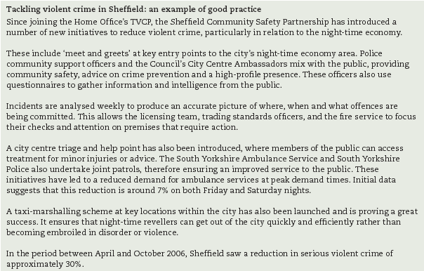

Drinkaware Trust
The Drinkaware Trust, formerly the charitable arm of The Portman Group, was restructured to fulfil the educational, community and awareness campaigning role envisaged in the Alcohol Harm Reduction Strategy for a fund to tackle alcohol misuse and alcohol-related harm. Established on 1st January 2007, the new Drinkaware Trust is supported by the alcoholic drinks industry, government and a wide range of stakeholders in the health, education, alcohol-related voluntary sector and other NGOs.

This independent UK-wide, public-facing body is tasked with positively changing public behaviour and the national drinking culture to help reduce alcohol misuse and minimise alcohol-related harm.

The programme of activities may include:
  - Educational and campaigning work to promote responsible drinking among the general public and targeted at particular groups;
  - Project aid for local and national initiatives which accord with the purpose of Drinkaware; and
  - Commissioned market research and evaluation to inform the development of and assess the impact of its campaigns and project aid programmes, and the running and evaluation of pilot programmes or commissioning of relevant research.

Grants
The Drinkaware Trust awards small grants to local community (and occasionally national) initiatives designed to promote responsible drinking and reduce alcohol related harm. The Trust funds numerous projects ranging from public education campaigns, peer-led education schemes, educational theatre work, conferences, provision for educational materials, training, workshops to other educational events. Since being awarded Big Lottery funding in 2005 for peer-led alcohol education initiatives, they have been able to support an even greater number of projects. Some examples are listed below:
  - Hertfordshire Young People’s Substance Misuse and Crime Prevention Team – 100% Hangover Free - The above project title is in fact a brand, aimed at 11- to 18-year-olds, that will be attached to various upcoming initiatives planned for the county to combat alcohol misuse. Drinkaware's donation allowed the Hertfordshire team to produce various branded resources promoting the benefits of being 100% hangover free. These serve both to kick-start the holistic usage of the brand and spread general knowledge of alcohol and sensible drinking to thousands of people.
  - Hampshire Police – Red Hot Summer Discos - This project takes place in August 2007 and will be coordinated by The Rushmoor Youth Summer Activities Committee, a partnership of local agencies. This series of open-air discos serves both as a diversion for young people and a simple means for them to access information on alcohol. Drinkaware’s grant contributed towards the educational component of this year’s events and enabled young people in the borough of Rushmoor to enhance their awareness whilst having fun in an alcohol-free environment.
  - Nottinghamshire Connections – Nottinghamshire Midnight Basketball - This initiative consists of 12 weekly alcohol workshops run in conjunction with basketball training sessions aimed at up to 30 young people aged 13-19. Professionals from a local basketball team do the coaching while youth workers teach them about alcohol. Among other things, they cover what alcohol actually is, its various effects, the law, dependence, units, sensible and binge drinking and more specific areas such as the differing risks for men and women. They use games, discussions and videos throughout to ensure variety and do a quiz at the beginning and end of the course to assess the amount of knowledge attained.
  - Dorset County Council – Re-juice Project - Drinkaware part-funded an alcohol awareness project for 13-17 year-olds implemented by the Wareham Youth Service. It comprises 4 weekly sessions after school covering the various risks of alcohol and resisting peer pressure. They mix traditional teaching methods with activities such as making non-alcoholic cocktails. These are coupled with 4 fun alcohol free events where the education is less formal and emphasis is placed on having fun without alcohol. The grant contributed to the purchase of teaching materials and funded a performance of the Last Orders play and workshop which kick-starts the programme and is used to recruit candidates.
  - Northumbria Police- Newcastle young people's alcohol road show - This is a 2-part event toured to all Newcastle's secondary schools, reaching some 3000 year 10 pupils. A multi-agency partnership of education, health, enforcement and entertainment bodies collaborate to deliver key messages surrounding alcohol. It comprises a theatre production, part-funded by Drinkaware, tackling the consequences of alcohol abuse, alongside a Market Place event where young people can discuss all alcohol issues with professionals working within the above spheres. Follow-up work provided by the theatre company will also enable attendees to cement their knowledge in school and pass it on to friends and families.
  - The Drinkaware Challenge is a new module of the Youth Achievement Awards, the flagship peer educational programme of the charity UK Youth, developed in partnership with The Drinkaware Trust. It will be launched on 21st June 2007 at the ‘Young People and Alcohol’ Conference’. The Challenge will empower young people to influence alcohol education themselves and will present them with the challenge of how to change attitudes and behaviour though developing and promoting innovative non-formal education programmes.

Campaigns
  - The drinkaware.co.uk website features an interactive unit calculator with real brands; a self assessment test; and lots of useful hints and tips on responsible drinking. The central feature of the site is a unique unit calculator, using real brands, serving sizes and alcoholic strengths, which allows consumers to see accurately how many units they are drinking, thereby taking the information from cans and bottles and putting this into the context of the government's sensible drinking message. The site offers specific information for people at different life stages, ages or situations. There are sections on: the effects of alcohol, information for people in different walks of life, hints, tips and links to other sites.
  - Drink OR Drive...You Decide - A key part of the Government's Alcohol Harm Reduction Strategy for England is tackling drink driving. In 2006, Drinkaware developed a new range of drink-drive campaign materials, especially designed for a pub/club environment though equally suitable for use in the off trade. The campaign materials included eye catching posters, window stickers, and beer mats that carry stark reminders of the risks that drink drivers face. More information can be found on the campaign microsite www.drinkordrive.co.uk.
  - Streetwise - In May 2006, the Trust launched Streetwise, an interactive resource for 11-16 year olds. Developed in consultation with teachers, parents, police representatives and students, this resource complies with curriculum guidelines in England, Scotland, Wales and Northern Ireland, Streetwise consists of: a) An interactive CD-Rom containing videos and a virtual town allowing students to learn about the role of alcohol use and misuse in an engaging and informative way; b) Activities to reinforce and aid students' learning supported by teachers' notes, lesson plans and curriculum references for Personal Social and Health Education (PSHE), Personal and Social Education (PSE), Personal and Social Development (PSD), citizenship and science. The University of Bath is evaluating the effectiveness of Streetwise. Full details will be posted here once the evaluation is completed in Summer 2007.

Best Bar None
Schemes locally initiated, voluntary awards for on-licence trade based. Based on partnership working btw police and local retailers to promote responsible management of on-licence premises and reduce incidents of crime and disorder assoc with alcohol.
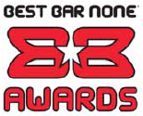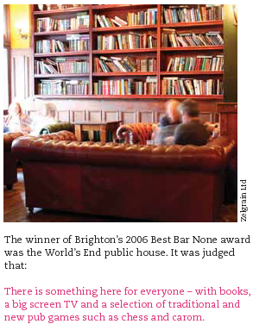

Safe. Sensible. Social
The Strategy delivers 3 things:
- Sharpens the focus on that minority of drinkers who cause the most harm – to themselves, communities, and families.
- Ensure the laws and licensing powers introduced to tackle alcohol-fuelled crime and disorder, protect young people and bear down on irresponsibly managed premises, are being used widely and effectively.
- Work together to shape an environment that actively promotes sensible drinking.

Specifically the Government’s aims are to reduce the level of violent crime, disorder and anti-social behaviour, reduce the public’s perception of drunken and rowdy behaviour and to reduce chronic ill-health, in order to achieve fewer accidents and hospital admissions.

The strategy’s objectives (described in the paper as “outcomes”) are to:
- Increase the proportion of those drinking sensibly
- Reduce the number of those drinking above 50 units (men) and 35 units (women) per week, or drinking more than twice the recommended guideline on a regular basis; and
- Reduce the number of under-18s who drink and the amount of alcohol they consume

Key areas of focus:
Reducing harm
- Local partnerships
  - There is positive work planned to increase support for Government Offices (GOs) to further support local initiatives to tackle alcohol related crime and disorder and to ensure strategic co-ordination on this. Following the Police and Justice Act 2006, Crime and Disorder Reduction Partnership (CDRP) strategies will be required to address alcohol related issues and from April 2008, GOs will ensure that CDRPs are supported to deliver local strategies and improve targets via Local Area Agreements (LAAs).
  - However, while the focus here is rightly on GOs’ ability to support local strategies tackling crime and disorder, there is no mention of increased GO monitoring, guidance or support for action to reduce health harms. This is an omission which could have supported public health groups within GOs to have a more strategic role in ensuring primary care trusts (PCTs) and other health providers and commissioners meet the Strategy’s objectives. It is unclear why the Home Office will support Government Offices to tackle crime and disorder, but no mention is made of how the Department of Health will do likewise to tackle health harms.
- Offending
  - The strategy is strangely non-committal about new actions to reduce alcohol related offending. Most of the actions mentioned are already underway, although there will be revised ATR (Alcohol Treatment Referral) guidelines and much needed new work to share the learning from new alcohol arrest referral schemes. The greater emphasis on interventions for offenders is to be welcomed.
- Underage sales
  - The Government will continue to prioritise a reduction in test-purchase failure rate and ensure enforcement agencies are making use of good practice and applying tactics and powers effectively.
- Responsible retailing and promotions
  - The Government will commission an independent review of the evidence on the relationship between alcohol price, promotion and harm. This will also include a review of whether current advertising restrictions are sufficient to protect children and young people.
  - The strategy rightly states that there is concern that “deep” discounting of alcohol can result in harmful drinking. The Competition Commission is looking into discounting in general (including alcohol), with a report expected later on this year, however there is no other action to address this area. This is a missed opportunity for Government to have come down harder on irresponsible retailers, although the results of the Competition Commission paper may possibly yield some follow up action.

Raising awareness
- Promoting sensible drinking
  - Government have committed to a sustained awareness campaign to be launched in April 2008 to raise awareness of units, and targeted work to raise awareness of the risks of harmful drinking and the dangers of drinking during pregnancy. There is further mention of mainstreaming awareness raising through GPs, NHS health trainers and schools via help-lines or self-help materials. There is also work planned to raise awareness of the calorific content of alcohol. There is no indication of the duration of this work or the level of resources that will be committed to it.

- Under-18s
  - The Strategy identifies 3 key actions to reduce levels of under-age drinking:
    - A sustained awareness raising campaign using social marketing to be launched in April 2008
    - Further guidance to parents
    - Convening a panel from March-June 2008 to look at the latest evidence on the effects of alcohol on young people’s physical and mental health.

Appendix B – North East Alcohol Misuse Statement of Priorities
1) Prevention - Developing a preventative approach towards alcohol misuse throughout the North East region.
Traditional alcohol education programmes have had little impact upon ‘binge’ drinking and as a society we are drinking more, with serious social and health consequences.
- Launch targeted information campaigns, which improve knowledge and raise awareness, supplemented with interactive interventions.
- Disseminate consistent and effective ‘sensible drinking’ and ‘better health’ messages, highlighting the potential impacts of alcohol misuse, and targeting specific groups of drinkers (e.g. ‘binge’ or underage drinkers) in a range of environments (including A&E, GP surgeries, licensed premises, prisons and the workplace).
- Promote effective school based interventions from primary school and upwards, based upon needs assessment and feedback from students, and supported by social influence and skills training, parental training, industry, local media and community groups.
- Adopt credible messengers (e.g. ‘peer’ groups, such as NERAF or the ‘OutThere’ project) and focus upon drinking patterns that cause the most harm.
- Target alcohol education and interventions at vulnerable groups of people, including young offenders, socially excluded groups and children in the ‘looked after’ system.

2) Treatment - Ensuring that services are provided for harmful, hazardous and dependent drinkers and for their families and carers.
Although demand for alcohol treatment is particularly high in the North East, the region has the fewest agencies providing specialist alcohol interventions and the average waiting time for treatment is longer than anywhere else in the country.
Young people in this region binge drink more regularly than older people and have higher admission rates for accidental alcohol poisoning or exposure to alcohol. White ethnic groups tend to have higher alcohol consumption and alcohol related morbidity and mortality than black and minority ethnic groups.
- Identify people with alcohol problems as early as possible.
- Act upon the findings of ANARP, assess needs in terms of treatment and ensure commissioning of services in line with MoCAM and care pathways.
- Carry out effective screening and ‘brief interventions’, in primary and secondary care, A&E and the workplace, to reduce alcohol consumption, especially amongst hazardous drinkers.
- Refer people with alcohol related problems to appropriate pathways for assessment diagnosis and care planning.
- Provide treatment tailored to differing individual needs and motivations, with support for carers and families, including children, where appropriate.
- Offer effective and accessible services, based upon user feedback.
- Examine the usage and value of alcohol treatment orders issued via the Criminal Justice System.
- Evidence good practice in relation to treatment services for children and young people.
- Seek active service user involvement during commissioning and evaluation processes.

3) Control - Promoting public protection through law and policy enforcement.
Consumption of alcohol is a socially accepted norm in the UK and alcohol plays a vital role in our leisure and tourism industries. However, alcohol misuse also inflicts large social and economic costs on most aspects of our communities. This is particularly the case in the North East, where the night-time economy is vibrant and alcohol related disorder is high.
- Understand the full range of options available to them under the new Licensing Laws and to implement them as effectively as possible.
- Disseminate information about the dangers of drink driving and reduce the number of people exceeding drink driving limits on our region’s roads.
- Manage the night-time economy strategically, including by developing safe, late night transport systems and reviewing the roles of Police Community Safety Officers (PCSOs) and ‘Taxi Marshals’.
- Implement the ‘Working with Alcohol Misusing Offenders’ strategy, aimed primarily at reducing crime and anti-social behaviour in our town and city-centres.
- Deploy visible police patrols in city and town centres to deter the potential for crime and disorder and enforce ‘Fixed Penalty Notices’ and early intervention measures where necessary.
- Highlight the problem of domestic violence and take steps to reduce repeat offences.
- Examine options for increasing security to prevent theft of alcohol from off-licensed premises.
- Encourage effective use, in the future, of the powers set out in the Violent Crime Bill, especially around ‘Drinking Banning Orders’ and ‘Alcohol Disorder Zones’.
- Monitor and control the illegal supply and sale of contraband alcohol and review potential contamination effects.
- Reduce illegal sales of alcohol to under-18s, target adults who buy alcohol for under-18s, and promote ‘Challenge 21’ as the preferred model of underage sales model.
- Enforce the child protection clauses set out in the Licensing Laws to safeguard children and young people from alcohol-related harms.

Appendix C – Psychosocial & Educational Interventions
 | Participants | Setting | Intervention | Design & outcome measures | Results | Author/Year
PRIMARY PREVENTION
Life Skills Training (LST) | Age: 7th Grade (ages 12-13)  Sex: 52% male  Size: N=5954  Mostly white middle class suburban sample. | Setting: School  Country: U.S.A | Focus: Tobacco, alcohol and drugs  Programme type: Knowledge, social & life skills  Theoretical base: Social learning theory; problem behaviour theory; communication theory  Key components: Cognitive-behavioural skills to raise self-esteem, resistance, assertiveness, relationship, anxiety management & communication skills  Duration: 15 sessions + 10 + 5 booster sessions in following years  Primary staff: Teachers | Design: RCT (by school, stratified by smoking behaviour)  Follow-up: 3 years and 6 years  Attrition: 3 years: 25%; 6 years: 40% (no diffs between Groups) Remaining N at 6 years = 3597, Hi-fidelity sample (i.e. those S's who attended 60% or more of the intervention sessions) = 2752 | 3 year follow-up:  Significant improvements in knowledge & attitudes reported.  No clear effect for drinking behaviour: No sig. differences for frequency or quantity measures.  Sig. less drunkenness in teens who received intervention compared w/ control grp.  6 year Follow-up:  (Hi-fidelity sample: caution, see comments)  Sig. differences on all drinking measures.  Intervention most effective in reducing frequency of drunkenness, although magnitude of effect is quite small.  Effect sizes small - unclear public health benefit | Botvin 1995a
Culturally focused skills & community-based prevention for Native American Youth | Age: 3rd-5th Grades (mean age = 10.28 at pre-test)  Sex: 49% female  Size: N=1396 from 27 schools & 5 states | Setting: School & community  Country: USA | Focus: Alcohol & other drugs  Programme type: Societal life skills (culturally focused)  Key components: Problem-solving, personal coping, interpersonal communication - all incorporating native American myths, legends & stories | Design: RCT (by school)  Follow-up: 3.5 years  Attrition: 14.11% from pre-test sample (and no differential attrition) | Strong design & low attrition. No details of randomisation procedure but baseline equivalence in all groups.  Allocation by school but analysis by individual - could compromise results  Skills based group approx 7% less likely than control grp to be weekly drinkers 3.5 yrs after baseline measurement.  Public health impact of this effect size in reducing alcohol misuse/problems is not known | Schinke 2000
Iowa Strengthening Families Programme (ISFP) | Age: 6th Grade at baseline  Sex: 54% female  Size: 846 families recruited, 446 completed baseline tests (238 ISFP, 208 controls) | Setting: Universal, family focused interventions (with allocation & recruitment through schools)  Country: USA | Focus: Drugs including alcohol  Programme type: Parenting/family socialisation  Theoretical base: Bio psychosocial model  Key components: ISFP: Parents & children taught to clarify expectations, appropriate discipline, manage strong emotions & communicate effectively. Children also taught peer skills  Ctrls: information leaflets only  Duration: 7 family sessions/once per week (av. 2 hours each)  Primary Staff: 2-3 person teams | Design: RCT (by school)  Follow-up: 2 & 4 years  Attrition: Moderate | After 3 yrs, students who received intervention btw ages 10-14 were much less likely to have started drinking or to have ever been drunk 4 yrs later than students in control grp.  Effectiveness of intervention seemed to increase over time, reflecting developmentally oriented intervention outcome model on which intervention is based.  Although sample size not as large as Botvin study, family-based intervention does seem to offer more promise as a prevention programme → deserves further consideration & study in UK. | Spoth 2001
COMMUNITY INTERVENTIONS
Community Prevention Trials Project | Target: Underage alcohol purchases  Sex: N/A  Size: 3 experimental communities: South Carolina, Southern & Northern California.  Random samples of 100 off-sale outlets in each community for purchase survey | Setting: Community trial  Country: USA | Focus: Underage purchase of alcohol  Programme type: Legislative, community  Theoretical base: None stated  Key components:  (i) Enforcement of underage sales laws  (ii) Retailer training & retail policy development  (iii) Media advocacy for enforcement efforts  Duration: 148 outlets visits by police to enforce sales laws (22 citations issued) over study period; newspaper & TV coverage during study period  Primary staff: Police & local instructors | Design: Complex interrupted Times Series  Follow-up: 1 year  Attrition: NA | Greater reduction in number of retail outlets selling alcohol to apparent underage buyers in intervention communities (~30%) than in control communities (12%) in 1st yr of follow-up.  Cost-effectiveness analysis estimated that for each $1 spent on interventions there was a saving of $2.88.  Large and complex trial. However, unclear whether change in underage sales will result in reduced alcohol use & misuse (i.e. will young people obtain alcohol elsewhere). | Holder 1997
Project Northland | Age: 6th grade at baseline  Sex: 51.3% male  Size: 2351 students at baseline | Setting: Community intervention  Country: USA | Focus: Alcohol  Programme type: Social skills & parental socialisation  Theoretical base: N/A  Key components:  6th grade: "Slick Tracy Home Team Program" - 4 sessions of activity story books completed as homework with parents - Notes for parents also issued.  7th grade: "Amazing Alternatives! Program" - parents evening; 3 week peer-led classroom sessions; home programme booklets mailed to parents; further notes for parents  8th grade: "Powerlines" - 8 session classroom curriculum, theatre production, further notes for parents & continuation of peer-led/participation programmes  Community intervention task force: Comprising civic leaders, law enforcers, parents & volunteers, focused on law enforcement & underage alcohol sales, plus business involvement  Primary Staff: Teachers, peer leaders & community based adults | Design: RCT (by school district)  Follow-up: 2.5 & 4 years  Attrition: 19% (no significant differences in attrition analysis) | Sig. effects of intervention on drinking behav. Whilst intervention ongoing, but this effect dissipated once intervention halted. At 4yr follow-up, no sig. effects on intervention over control grp.  Good design with low attrition rates  Analysis by individual but allocation by school district | Perry 1996
Communities Mobilising for Change on Alcohol (CMCA) | Age: 18-20 year olds;  Sex: A. N/A; B. (1995) 12th grade: 48% male, 18-20 year olds: 51% male  Size: 15 Mid-western counties,  1982 (baseline): N=5885 (92.8%)  1995: N=3694 (83.5%) | Setting: Community trial  Country: USA | Focus: Reducing youth access to alcohol  Programme type: Legislative/behavioural (policy & norms of alcohol retailers re: underage sales)  Theoretical base: N/A  Key components: Community organisers worked with local public officials, alcohol merchants, media & other community institutions to change policies & practices re: youth access to alcohol (7 communities)  Duration: 2-5 years intervention period  Primary staff: Community alcohol worker | Design: RCT (by community after matching for population size & presence of a college) with nested ITS  Follow-up: 6 year baseline data & 3 year follow-up data (during intervention) (1987- 1995)  Attrition: N/A | No clear statistically sig. effects in intervention communities compared to control communities for underage retail sales, self-reported drinking or heavy drinking.  Statistically sig. effect on arrests fro drinking & driving amongst 18-20 yr-olds. ~30 fewer arrests per 100,000 population per yr in intervention communities than in control communities.  Strong design & sophisticated analysis  Longer follow-up & cost-effectiveness analysis would be useful. | Wagenaar 2000

http://www.aphru.ac.nz/projects/publicSpaces.pdf (June 2002)
http://www.aerc.org.uk/documents/pdf/finalReports/044Steet_Drinking.pdf Feb 2007
http://her.oxfordjournals.org/cgi/content/full/14/5/583 Oct 1999
http://www.statistics.gov.uk/census2001/profiles/00CK-A.asp 2001
http://www.northtynesidepct.nhs.uk/documents/Health_Profile_North_Tyneside_-_PCT_response.pdf
DRAFT: The North Tyneside Children & Young People’s Alcohol Strategy 2005
http://www.northtynesidepct.nhs.uk/documents/Health_Profile_North_Tyneside_-_PCT_response.pdf
http://www.alcoholconcern.org.uk/files/20070315_153945_Young%20people%20nov%202006.pdf Autumn 2006
Alcohol & Health in North East England, Occasional Paper No. 21 – January 2006 (North East Public Health Observatory) http://www.nepho.org.uk/view_file.php?c=1098
Smoking, drinking and drug use among young people In England 2006, The NHS Health and Social care Information Centre
http://www.alcoholconcern.org.uk/files/20070315_153945_Young%20people%20nov%202006.pdf Autumn 2006
http://www.alcoholconcern.org.uk/files/20070315_153945_Young%20people%20nov%202006.pdf Autumn 2006
Smoking, drinking and drug use among young people In England 2006, NHS Health and Social Care Information Centre
http://www.alcoholconcern.org.uk/files/20070315_153945_Young%20people%20nov%202006.pdf Autumn 2006
Boreham, R., Blenkinsop, S. (2004), Drug use, smoking & alcohol among young people in England in 2003, ONS
Harrington V. (2000) Underage Drinking: Findings from the 1998-1999 Youth Lifestyles Survey, Home Office Research Findings No. 125
Newcombe, R., Measham, F. and Parker, H. (1995), A survey of drinking and deviant behaviour among 14/15 year olds in North West England, Addiction Research, vol.2, no.4
Alcohol & Health in North East England, Occasional Paper No. 21 – January 2006 (North East Public Health Observatory) http://www.nepho.org.uk/view_file.php?c=1098
The National Alcohol Harm Reduction Strategy for England, 2004
Alcohol & Health in North East England, Occasional Paper No. 21 – January 2006 (North East Public Health Observatory) http://www.nepho.org.uk/view_file.php?c=1098
http://www.alcoholconcern.org.uk/servlets/doc/793 10 June 2004
Alcohol & Health in North East England, Occasional Paper No. 21 – January 2006 (North East Public Health Observatory) http://www.nepho.org.uk/view_file.php?c=1098
http://www.alcoholconcern.org.uk/servlets/doc/793 10 June 2004
Alcohol & Health in North East England, Occasional Paper No. 21 – January 2006 (North East Public Health Observatory) http://www.nepho.org.uk/view_file.php?c=1098
The North Tyneside Children & Young People’s Alcohol Strategy – Focus Group Summary 2005
http://www.aerc.org.uk/documents/pdf/finalReports/044Steet_Drinking.pdf Feb 2007
Draft North Tyneside Alcohol Harm Reduction Strategy (2007)
http://www.northtynesidepct.nhs.uk/documents/Health_Profile_North_Tyneside_-_PCT_response.pdf
The North Tyneside Children & Young People’s Alcohol Strategy – Focus Group Summary 2005
Northumbria Police, 2007
Northumbria Police, 2007
N. Tyneside Best Value General User Survey 2006/7 Key Findings http://www.northtyneside.gov.uk/docs/research/North%20Tyneside_BVPI_Report%20D2.pdf (01/03/07)
http://www.aerc.org.uk/documents/pdf/finalReports/044Steet_Drinking.pdf Feb 2007
http://www.publications.parliament.uk/pa/cm200405/cmselect/cmhaff/80ii/80we02.htm 18/10/04
* Using alcohol in a way that results in social, psychological, physical or legal problems related to intoxication and or regular consumption (Drugscope, 2007)
http://www.homeoffice.gov.uk/documents/Alcohol-strategy.pdf?view=Binary (June 2007)
http://www.respect.gov.uk/default.aspx
http://www.go-ne.gov.uk/nestore/docs/peoplecomms/506115/alcohol_misuse.pdf Feb 2007
http://www.lgar.local.gov.uk/idk/aio/6303309
CDRMP Alcohol Workstream Update Report June 2007
CDRMP Alcohol Workstream Update Report June 2007
CDRMP Alcohol Workstream Update Report June 2007
http://ww1.northumbria.police.uk/ePolicing/Web/WMS.nsf/ACPlansContentDocs/ACP000387
http://www.northtyneside.gov.uk/ntsp/meetings/crime/CDR%20&%20Misuse%20of%20Drugs%20meeting%20papers%2021%20Mar%2007.pdf
North Tyneside Youth Service Report (May 2007) http://www.northtyneside.gov.uk/ed1/docs/North%20Tyneside%20Draft%20EYI%20report%20-%2021%20May%2007.pdf
http://www.aphru.ac.nz/projects/publicSpaces.pdf (June 2002)
http://www.openspace.eca.ac.uk/rtf/teenagerslitrev.rtf (July 2003)
http://www.aerc.org.uk/documents/pdf/finalReports/044Steet_Drinking.pdf Feb 2007
Crime & Disorder Reduction & Misuse of Drugs Strategy 2005-2008 http://www.northtyneside.gov.uk/docs/crimedisord/crime%20strategy%20booklet.pdf
Understanding Alcohol Use & Drinking Patterns of Young People in North Tyneside: A Qualitative Study – Helen Lloyd & Dr. Rowena Merritt (August 2007)
http://www.aphru.ac.nz/projects/publicSpaces.pdf
Young people’s access to tobacco, alcohol, and other drugs – Ogilvie et al (Aug 2005) http://www.bmj.com/cgi/content/full/331/7513/393
Alcohol Policy & Young People – Ann Hope (2004) http://www.ias.org.uk/resources/publications/theglobe/globe200401-02/gl200401-02_p15.html
Police chief urges alcohol action. http://news.bbc.co.uk/1/hi/uk/6947224.stm (15/08/07)
http://www.bathnes.gov.uk/committee_papers/OandSHCSC/HCS050510/10Report%20on%20Street%20Drinking%20Ban%20(OS%2010.5.05).htm May 2005
Interventions for Young People: Overview of Available Evidence – EISS, University of Kent (April 2005) http://www.kdaat.org.uk/yp/YP%20Docs/Young%20people%20practice%20review.pdf
Primary prevention for alcohol misuse in young people – Foxcroft et al (2002) http://www.mrw.interscience.wiley.com/cochrane/clsysrev/articles/CD003024/pdf_fs.html
Portman Group (1997), Under the Influence, the report of the taskforce on underage alcohol misuse, Portman Group
Alcohol health promotion via mass media: The evidence on (in)effectiveness – Linda Hill (June 2004) http://www.eurocare.org/btg/conf0604/papers/hill.pdf
http://www.cph.org.uk/cph_pubs/reports/SM/Alcohol_NWteenagers.pdf (Sept 2006)
Do youth clubs help stop crime? http://news.bbc.co.uk/1/hi/magazine/6917077.stm (26/07/07)
Summer Splash Schemes 2000: Findings from 6 case studies – Loxley et al (July 2002) http://www.homeoffice.gov.uk/rds/pdfs2/crrs12.pdf
Knowing the score. Positive Futures Case Study Research: Final Report – Positive Futures Team & Crime Concern (Nov 2006) http://www.drugs.gov.uk/publication-search/young-people/0607_YPSMPG11?view=Binary
http://www.aphru.ac.nz/projects/publicSpaces.pdf (June 2002)
http://www.scotland.gov.uk/Resource/Doc/159102/0043266.pdf (August 2001)
http://www.alcoholconcern.org.uk/files/20070315_153945_Young%20people%20nov%202006.pdf (Autumn 2006)
Alcohol Harm Reduction Strategy: Qualitative research to inform development of communications – Cragg Ross Dawson (May 2004)
http://www.aphru.ac.nz/projects/publicSpaces.pdf
http://www.aphru.ac.nz/projects/publicSpaces.pdf
http://www.alcoholconcern.org.uk/files/20070315_153945_Young%20people%20nov%202006.pdf Autumn 2006
Boys, A. et al. (2001) Survey 2000: a follow-up study of alcohol use amongst 15-17 year olds, National Addiction Centre
Wright, L. (1999) Young People and Alcohol. What 11-24 year olds know, think and do. London: Health Education Authority.
Review of the evidence base around effective alcohol harm reduction communications – COI Communications (06/09/05)
http://www.scotland.gov.uk/Resource/Doc/159102/0043266.pdf (August 2001)
Honess, J. et al. (2000), The Social Contexts of Underage Drinking, Home Office
North Tyneside Children & Young People’s Alcohol Strategy 2005
http://www.alcoholconcern.org.uk/files/20070315_153945_Young%20people%20nov%202006.pdf Autumn 2006
http://www.cph.org.uk/cph_pubs/reports/SM/Alcohol_NWteenagers.pdf Sept 2006
http://www.cph.org.uk/cph_pubs/reports/SM/Alcohol_NWteenagers.pdf Sept 2006
http://www.cph.org.uk/cph_pubs/reports/SM/Alcohol_NWteenagers.pdf Sept 2006
http://www.alcoholconcern.org.uk/files/20070315_153945_Young%20people%20nov%202006.pdf Autumn 2006
Egg Research & Consultancy (2003), Social Responsibility Advertising Development Research, Diageo
Research Works (2005), Mind the gap: alcohol education and the role of parents, The Portman Group
http://www.aerc.org.uk/documents/pdf/finalReports/044Steet_Drinking.pdf Feb 2007
http://her.oxfordjournals.org/cgi/content/full/14/5/583 Oct 1999
Social Trends No. 37 – Office for National Statistics http://www.statistics.gov.uk/downloads/theme_social/Social_Trends37/Social_Trends_37.pdf (2007)
Safe. Sensible. Social. The next steps in the National Alcohol Strategy (Jan 2007)
Safe. Sensible. Social. The next steps in the National Alcohol Strategy (Jan 2007)
Safe. Sensible. Social. The next steps in the National Alcohol Strategy (Jan 2007)
Safe. Sensible. Social. The next steps in the National Alcohol Strategy (Jan 2007)
http://www.culture.gov.uk/what_we_do/Alcohol_entertainment/licensing_act_2003_explained
Safe. Sensible. Social. The next steps in the National Alcohol Strategy (Jan 2007)
http://www.crimereduction.gov.uk/tvcp/tvcp03.htm
Safe. Sensible. Social. The next steps in the National Alcohol Strategy (Jan 2007)
Safe. Sensible. Social. The next steps in the National Alcohol Strategy (Jan 2007)
http://www.drinkawaretrust.org.uk/grants.html
http://www.drinkawaretrust.org.uk/campaigns.html
Safe. Sensible. Social. The next steps in the National Alcohol Strategy (Jan 2007)
http://www.homeoffice.gov.uk/documents/Alcohol-strategy.pdf?view=Binary (June 2007)
http://www.alcoholconcern.org.uk/files/20031016_135155_Research%20forum%20Foxcroft.pdf Sep 2003

